UNITED STATES
SECURITIES AND EXCHANGE COMMISSION
WASHINGTON, D.C. 20549
FORM 8-K
CURRENT REPORT
PURSUANT TO SECTION 13 OR 15(D) OF THE
SECURITIES EXCHANGE ACT OF 1934
Date of Report (date of earliest event reported): October 1, 2026
vTv Therapeutics Inc.
(Exact name of registrant as specified in its charter)
Delaware |  |  | 001-37524 |  |  | 47-3916571
(State or other jurisdiction  of incorporation) |  |  | (Commission File No.) |  |  | (IRS Employer  Identification No.)
3980 Premier Drive, Suite 110
High Point, NC 27265
(Address of principal executive offices)
(336) 841-0300
(Registrant’s telephone number, including area code)
NOT APPLICABLE
(Former name or former address, if changed since last report)
Check the appropriate box below if the Form 8-K filing is intended to simultaneously satisfy the filing obligation of the registrant under any of the following provisions (see General Instruction A.2. below):
☐ |  |  | Written communications pursuant to Rule 425 under the Securities Act (17 CFR 230.425)
☐ |  |  | Soliciting material pursuant to Rule 14a-12 under the Exchange Act (17 CFR 240.14a-12)
☐ |  |  | Pre-commencement communications pursuant to Rule 14d-2(b) under the Exchange Act (17 CFR 240.14d-2(b))
☐ |  |  | Pre-commencement communications pursuant to Rule 13e-4(c) under the Exchange Act (17 CFR 240.13e-4(c))
Securities registered pursuant to Section 12(b) of the Act:
Title of each class |  |  | Trading Symbol(s) |  |  | Name of each exchange on which registered
Class A common stock, par value $0.01 per share |  |  | VTVT |  |  | Nasdaq Capital Market
Indicate by check mark whether the registrant is an emerging growth company as defined in Rule 405 of the Securities Act of 1933 (§ 230.405 of this chapter) or Rule 12b-2 of the Securities Exchange Act of 1934 (§ 240.12b-2 of this chapter).
Emerging growth company ☐
If an emerging growth company, indicate by check mark if the registrant has elected not to use the extended transition period for complying with any new or revised financial accounting standards provided pursuant to Section 13(a) of the Exchange Act. ☐

Item 5.03 Amendments to Articles of Incorporation or By-Laws
On October 1, 2026, the Board of Directors of vTv Therapeutics Inc. (the “Company”) approved the adoption of the Company’s Third Amended and Restated By-Laws (the “Amended By-Laws”). The Amended By-Laws were amended and restated, among other things, to:
•revise the procedures and requirements for the nomination of directors at meetings of stockholders, including by adding a requirement that a stockholder seeking to nominate one or more directors at a meeting of stockholders deliver to the Company reasonable evidence that such stockholder has complied with the requirements of Rule 14a-19 of the Securities Exchange Act of 1934, as amended, no later than five business days before the meeting;
•revise the voting standard for stockholder meetings such that, in all matters other than the election of directors, the affirmative vote of a majority of the voting power of the shares cast affirmatively or negatively shall be the act of the stockholders (except as otherwise provided by Company’s Certificate of Incorporation, the Amended By-Laws, any applicable law or the rules of any applicable stock exchange on which the Company’s securities are listed);
•revise certain additional procedures related to stockholder meetings to conform to the current provisions of the Delaware General Corporation Law;
•designate the federal district courts of the United States as the exclusive forum for the resolution of any complaint asserting a cause of action arising under the Securities Act of 1933, as amended, unless the Company consents in writing to the selection of an alternative forum; and
•make certain other ministerial changes, clarifications, and conforming revisions.
The foregoing description is qualified in its entirety to the Amended By-Laws, a copy of which is attached to this Form 8-K as Exhibit 3.1 and incorporated herein by reference.

Item 9.01 Financial Statements and Exhibits
(d)Exhibits
Exhibit No. |  |  |  |  |  | Description
3.1 |  |  |  |  |  | Third Amended and Restated By-Laws of vTv Therapeutics Inc.
104 |  |  |  |  |  | Cover Page Interactive Data File (embedded within Inline XBRL document)

SIGNATURES
Pursuant to the requirements of the Securities Exchange Act of 1934, the registrant has duly caused this report to be signed on its behalf by the undersigned, hereunto duly authorized.
 |  |  | VTV THERAPEUTICS INC.
 |  |  | By: |  |  | /s/ Paul J. Sekhri
 |  |  | Name: |  |  | Paul J. Sekhri
 |  |  | Title: |  |  | President and Chief Executive Officer
Dated: October 6, 2026
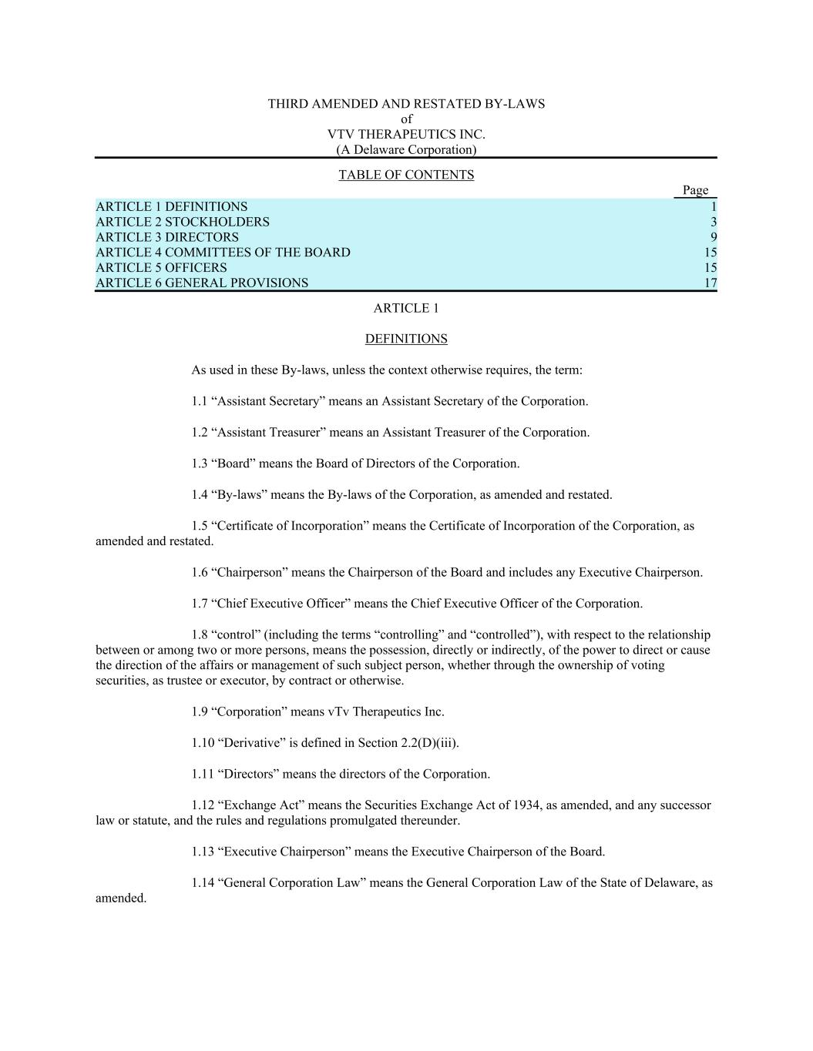

THIRD AMENDED AND RESTATED BY-LAWS of VTV THERAPEUTICS INC. (A Delaware Corporation) TABLE OF CONTENTS Page ARTICLE 1 DEFINITIONS 1 ARTICLE 2 STOCKHOLDERS 3 ARTICLE 3 DIRECTORS 9 ARTICLE 4 COMMITTEES OF THE BOARD 15 ARTICLE 5 OFFICERS 15 ARTICLE 6 GENERAL PROVISIONS 17 ARTICLE 1 DEFINITIONS As used in these By-laws, unless the context otherwise requires, the term: 1.1 “Assistant Secretary” means an Assistant Secretary of the Corporation. 1.2 “Assistant Treasurer” means an Assistant Treasurer of the Corporation. 1.3 “Board” means the Board of Directors of the Corporation. 1.4 “By-laws” means the By-laws of the Corporation, as amended and restated. 1.5 “Certificate of Incorporation” means the Certificate of Incorporation of the Corporation, as amended and restated. 1.6 “Chairperson” means the Chairperson of the Board and includes any Executive Chairperson. 1.7 “Chief Executive Officer” means the Chief Executive Officer of the Corporation. 1.8 “control” (including the terms “controlling” and “controlled”), with respect to the relationship between or among two or more persons, means the possession, directly or indirectly, of the power to direct or cause the direction of the affairs or management of such subject person, whether through the ownership of voting securities, as trustee or executor, by contract or otherwise. 1.9 “Corporation” means vTv Therapeutics Inc. 1.10 “Derivative” is defined in Section 2.2(D)(iii). 1.11 “Directors” means the directors of the Corporation. 1.12 “Exchange Act” means the Securities Exchange Act of 1934, as amended, and any successor law or statute, and the rules and regulations promulgated thereunder. 1.13 “Executive Chairperson” means the Executive Chairperson of the Board. 1.14 “General Corporation Law” means the General Corporation Law of the State of Delaware, as amended.

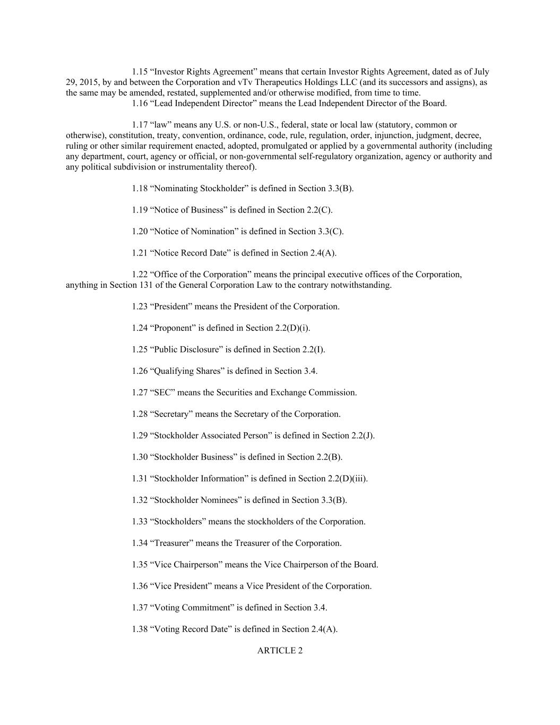
1.15 “Investor Rights Agreement” means that certain Investor Rights Agreement, dated as of July 29, 2015, by and between the Corporation and vTv Therapeutics Holdings LLC (and its successors and assigns), as the same may be amended, restated, supplemented and/or otherwise modified, from time to time. 1.16 “Lead Independent Director” means the Lead Independent Director of the Board. 1.17 “law” means any U.S. or non-U.S., federal, state or local law (statutory, common or otherwise), constitution, treaty, convention, ordinance, code, rule, regulation, order, injunction, judgment, decree, ruling or other similar requirement enacted, adopted, promulgated or applied by a governmental authority (including any department, court, agency or official, or non-governmental self-regulatory organization, agency or authority and any political subdivision or instrumentality thereof). 1.18 “Nominating Stockholder” is defined in Section 3.3(B). 1.19 “Notice of Business” is defined in Section 2.2(C). 1.20 “Notice of Nomination” is defined in Section 3.3(C). 1.21 “Notice Record Date” is defined in Section 2.4(A). 1.22 “Office of the Corporation” means the principal executive offices of the Corporation, anything in Section 131 of the General Corporation Law to the contrary notwithstanding. 1.23 “President” means the President of the Corporation. 1.24 “Proponent” is defined in Section 2.2(D)(i). 1.25 “Public Disclosure” is defined in Section 2.2(I). 1.26 “Qualifying Shares” is defined in Section 3.4. 1.27 “SEC” means the Securities and Exchange Commission. 1.28 “Secretary” means the Secretary of the Corporation. 1.29 “Stockholder Associated Person” is defined in Section 2.2(J). 1.30 “Stockholder Business” is defined in Section 2.2(B). 1.31 “Stockholder Information” is defined in Section 2.2(D)(iii). 1.32 “Stockholder Nominees” is defined in Section 3.3(B). 1.33 “Stockholders” means the stockholders of the Corporation. 1.34 “Treasurer” means the Treasurer of the Corporation. 1.35 “Vice Chairperson” means the Vice Chairperson of the Board. 1.36 “Vice President” means a Vice President of the Corporation. 1.37 “Voting Commitment” is defined in Section 3.4. 1.38 “Voting Record Date” is defined in Section 2.4(A). ARTICLE 2

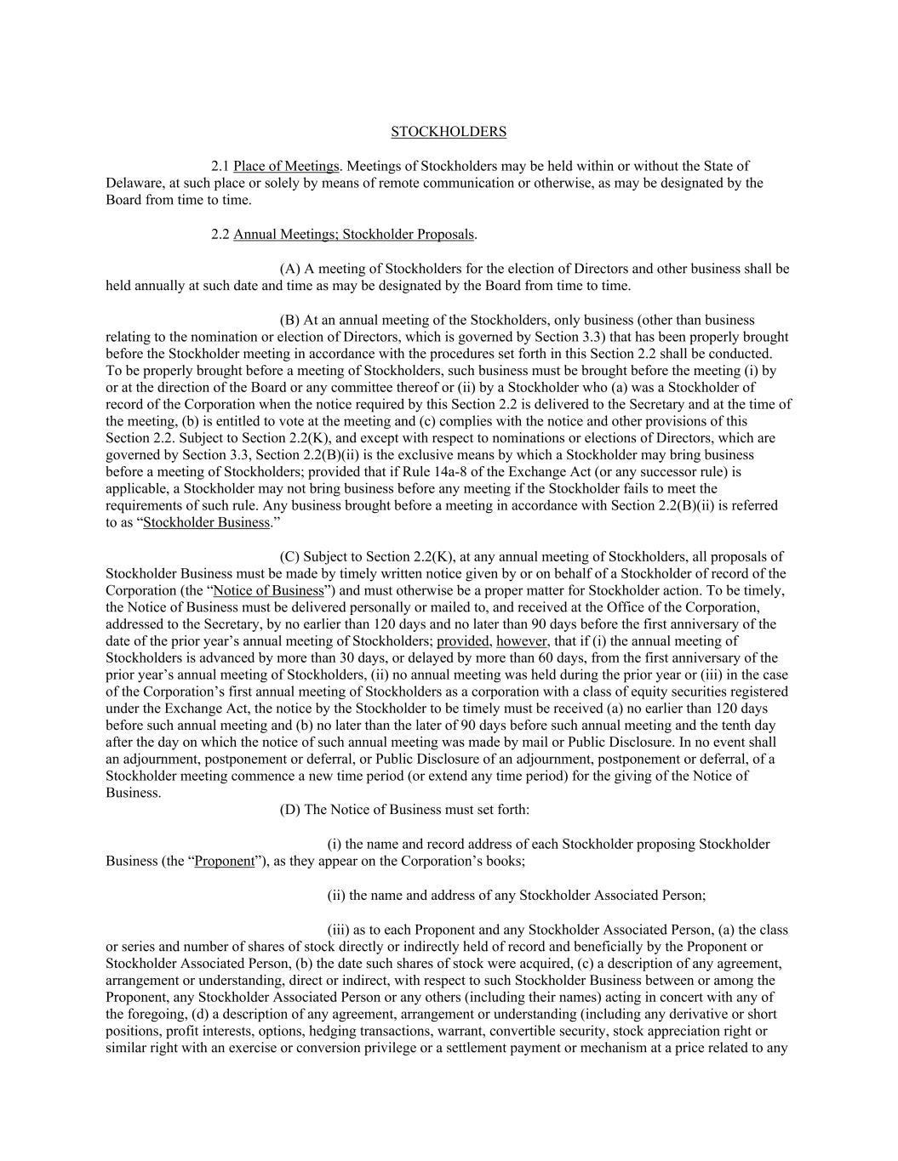
STOCKHOLDERS 2.1 Place of Meetings. Meetings of Stockholders may be held within or without the State of Delaware, at such place or solely by means of remote communication or otherwise, as may be designated by the Board from time to time. 2.2 Annual Meetings; Stockholder Proposals. (A) A meeting of Stockholders for the election of Directors and other business shall be held annually at such date and time as may be designated by the Board from time to time. (B) At an annual meeting of the Stockholders, only business (other than business relating to the nomination or election of Directors, which is governed by Section 3.3) that has been properly brought before the Stockholder meeting in accordance with the procedures set forth in this Section 2.2 shall be conducted. To be properly brought before a meeting of Stockholders, such business must be brought before the meeting (i) by or at the direction of the Board or any committee thereof or (ii) by a Stockholder who (a) was a Stockholder of record of the Corporation when the notice required by this Section 2.2 is delivered to the Secretary and at the time of the meeting, (b) is entitled to vote at the meeting and (c) complies with the notice and other provisions of this Section 2.2. Subject to Section 2.2(K), and except with respect to nominations or elections of Directors, which are governed by Section 3.3, Section 2.2(B)(ii) is the exclusive means by which a Stockholder may bring business before a meeting of Stockholders; provided that if Rule 14a-8 of the Exchange Act (or any successor rule) is applicable, a Stockholder may not bring business before any meeting if the Stockholder fails to meet the requirements of such rule. Any business brought before a meeting in accordance with Section 2.2(B)(ii) is referred to as “Stockholder Business.” (C) Subject to Section 2.2(K), at any annual meeting of Stockholders, all proposals of Stockholder Business must be made by timely written notice given by or on behalf of a Stockholder of record of the Corporation (the “Notice of Business”) and must otherwise be a proper matter for Stockholder action. To be timely, the Notice of Business must be delivered personally or mailed to, and received at the Office of the Corporation, addressed to the Secretary, by no earlier than 120 days and no later than 90 days before the first anniversary of the date of the prior year’s annual meeting of Stockholders; provided, however, that if (i) the annual meeting of Stockholders is advanced by more than 30 days, or delayed by more than 60 days, from the first anniversary of the prior year’s annual meeting of Stockholders, (ii) no annual meeting was held during the prior year or (iii) in the case of the Corporation’s first annual meeting of Stockholders as a corporation with a class of equity securities registered under the Exchange Act, the notice by the Stockholder to be timely must be received (a) no earlier than 120 days before such annual meeting and (b) no later than the later of 90 days before such annual meeting and the tenth day after the day on which the notice of such annual meeting was made by mail or Public Disclosure. In no event shall an adjournment, postponement or deferral, or Public Disclosure of an adjournment, postponement or deferral, of a Stockholder meeting commence a new time period (or extend any time period) for the giving of the Notice of Business. (D) The Notice of Business must set forth: (i) the name and record address of each Stockholder proposing Stockholder Business (the “Proponent”), as they appear on the Corporation’s books; (ii) the name and address of any Stockholder Associated Person; (iii) as to each Proponent and any Stockholder Associated Person, (a) the class or series and number of shares of stock directly or indirectly held of record and beneficially by the Proponent or Stockholder Associated Person, (b) the date such shares of stock were acquired, (c) a description of any agreement, arrangement or understanding, direct or indirect, with respect to such Stockholder Business between or among the Proponent, any Stockholder Associated Person or any others (including their names) acting in concert with any of the foregoing, (d) a description of any agreement, arrangement or understanding (including any derivative or short positions, profit interests, options, hedging transactions, warrant, convertible security, stock appreciation right or similar right with an exercise or conversion privilege or a settlement payment or mechanism at a price related to any

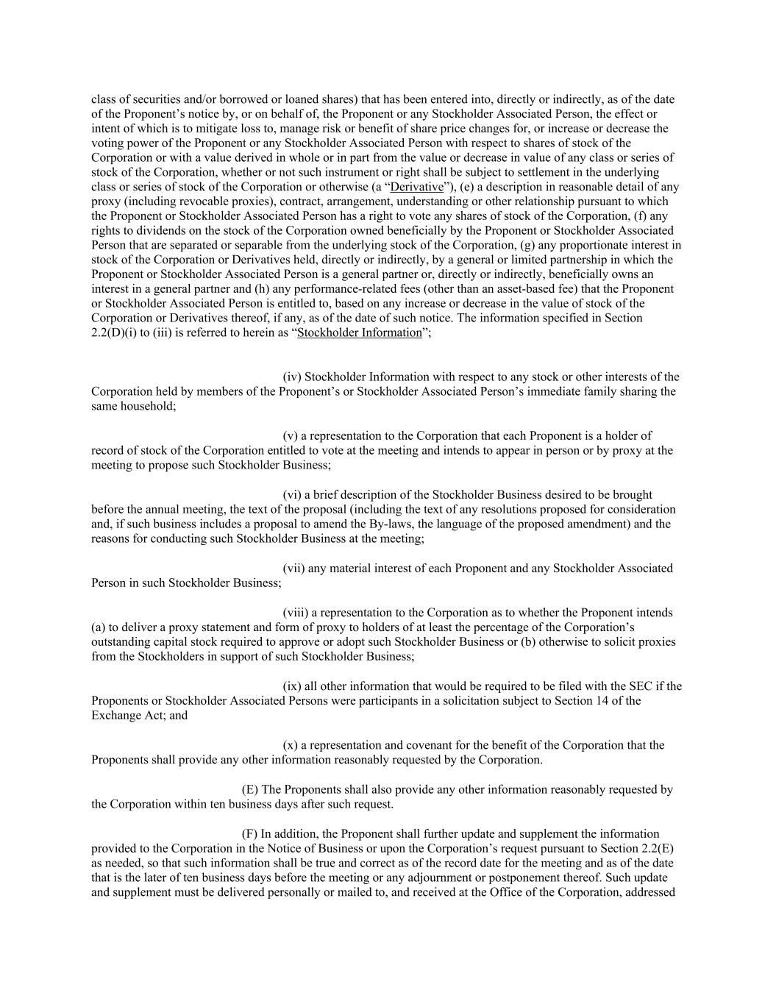
class of securities and/or borrowed or loaned shares) that has been entered into, directly or indirectly, as of the date of the Proponent’s notice by, or on behalf of, the Proponent or any Stockholder Associated Person, the effect or intent of which is to mitigate loss to, manage risk or benefit of share price changes for, or increase or decrease the voting power of the Proponent or any Stockholder Associated Person with respect to shares of stock of the Corporation or with a value derived in whole or in part from the value or decrease in value of any class or series of stock of the Corporation, whether or not such instrument or right shall be subject to settlement in the underlying class or series of stock of the Corporation or otherwise (a “Derivative”), (e) a description in reasonable detail of any proxy (including revocable proxies), contract, arrangement, understanding or other relationship pursuant to which the Proponent or Stockholder Associated Person has a right to vote any shares of stock of the Corporation, (f) any rights to dividends on the stock of the Corporation owned beneficially by the Proponent or Stockholder Associated Person that are separated or separable from the underlying stock of the Corporation, (g) any proportionate interest in stock of the Corporation or Derivatives held, directly or indirectly, by a general or limited partnership in which the Proponent or Stockholder Associated Person is a general partner or, directly or indirectly, beneficially owns an interest in a general partner and (h) any performance-related fees (other than an asset-based fee) that the Proponent or Stockholder Associated Person is entitled to, based on any increase or decrease in the value of stock of the Corporation or Derivatives thereof, if any, as of the date of such notice. The information specified in Section 2.2(D)(i) to (iii) is referred to herein as “Stockholder Information”; (iv) Stockholder Information with respect to any stock or other interests of the Corporation held by members of the Proponent’s or Stockholder Associated Person’s immediate family sharing the same household; (v) a representation to the Corporation that each Proponent is a holder of record of stock of the Corporation entitled to vote at the meeting and intends to appear in person or by proxy at the meeting to propose such Stockholder Business; (vi) a brief description of the Stockholder Business desired to be brought before the annual meeting, the text of the proposal (including the text of any resolutions proposed for consideration and, if such business includes a proposal to amend the By-laws, the language of the proposed amendment) and the reasons for conducting such Stockholder Business at the meeting; (vii) any material interest of each Proponent and any Stockholder Associated Person in such Stockholder Business; (viii) a representation to the Corporation as to whether the Proponent intends (a) to deliver a proxy statement and form of proxy to holders of at least the percentage of the Corporation’s outstanding capital stock required to approve or adopt such Stockholder Business or (b) otherwise to solicit proxies from the Stockholders in support of such Stockholder Business; (ix) all other information that would be required to be filed with the SEC if the Proponents or Stockholder Associated Persons were participants in a solicitation subject to Section 14 of the Exchange Act; and (x) a representation and covenant for the benefit of the Corporation that the Proponents shall provide any other information reasonably requested by the Corporation. (E) The Proponents shall also provide any other information reasonably requested by the Corporation within ten business days after such request. (F) In addition, the Proponent shall further update and supplement the information provided to the Corporation in the Notice of Business or upon the Corporation’s request pursuant to Section 2.2(E) as needed, so that such information shall be true and correct as of the record date for the meeting and as of the date that is the later of ten business days before the meeting or any adjournment or postponement thereof. Such update and supplement must be delivered personally or mailed to, and received at the Office of the Corporation, addressed

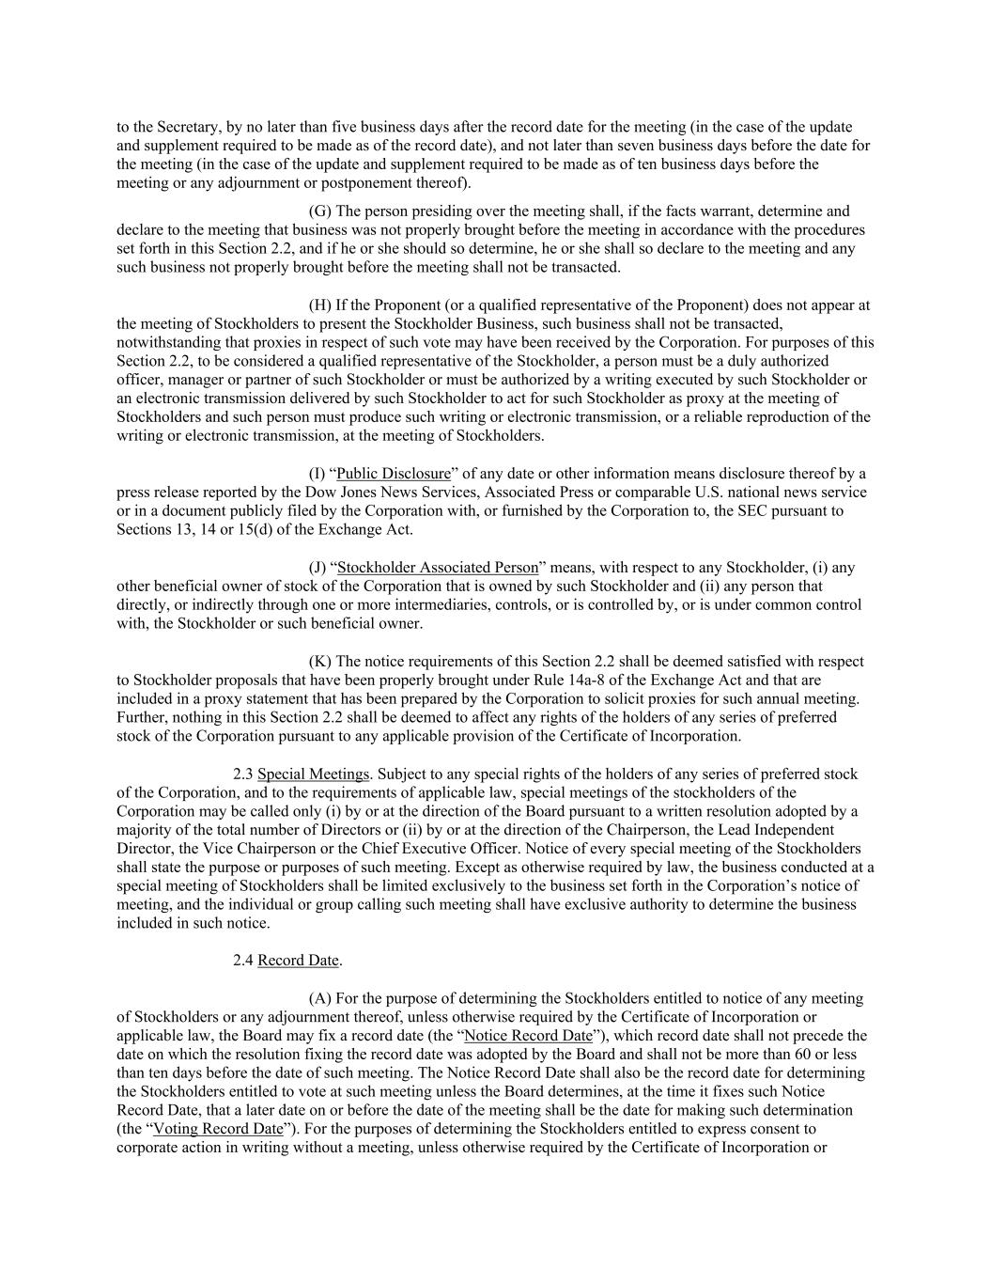
to the Secretary, by no later than five business days after the record date for the meeting (in the case of the update and supplement required to be made as of the record date), and not later than seven business days before the date for the meeting (in the case of the update and supplement required to be made as of ten business days before the meeting or any adjournment or postponement thereof). (G) The person presiding over the meeting shall, if the facts warrant, determine and declare to the meeting that business was not properly brought before the meeting in accordance with the procedures set forth in this Section 2.2, and if he or she should so determine, he or she shall so declare to the meeting and any such business not properly brought before the meeting shall not be transacted. (H) If the Proponent (or a qualified representative of the Proponent) does not appear at the meeting of Stockholders to present the Stockholder Business, such business shall not be transacted, notwithstanding that proxies in respect of such vote may have been received by the Corporation. For purposes of this Section 2.2, to be considered a qualified representative of the Stockholder, a person must be a duly authorized officer, manager or partner of such Stockholder or must be authorized by a writing executed by such Stockholder or an electronic transmission delivered by such Stockholder to act for such Stockholder as proxy at the meeting of Stockholders and such person must produce such writing or electronic transmission, or a reliable reproduction of the writing or electronic transmission, at the meeting of Stockholders. (I) “Public Disclosure” of any date or other information means disclosure thereof by a press release reported by the Dow Jones News Services, Associated Press or comparable U.S. national news service or in a document publicly filed by the Corporation with, or furnished by the Corporation to, the SEC pursuant to Sections 13, 14 or 15(d) of the Exchange Act. (J) “Stockholder Associated Person” means, with respect to any Stockholder, (i) any other beneficial owner of stock of the Corporation that is owned by such Stockholder and (ii) any person that directly, or indirectly through one or more intermediaries, controls, or is controlled by, or is under common control with, the Stockholder or such beneficial owner. (K) The notice requirements of this Section 2.2 shall be deemed satisfied with respect to Stockholder proposals that have been properly brought under Rule 14a-8 of the Exchange Act and that are included in a proxy statement that has been prepared by the Corporation to solicit proxies for such annual meeting. Further, nothing in this Section 2.2 shall be deemed to affect any rights of the holders of any series of preferred stock of the Corporation pursuant to any applicable provision of the Certificate of Incorporation. 2.3 Special Meetings. Subject to any special rights of the holders of any series of preferred stock of the Corporation, and to the requirements of applicable law, special meetings of the stockholders of the Corporation may be called only (i) by or at the direction of the Board pursuant to a written resolution adopted by a majority of the total number of Directors or (ii) by or at the direction of the Chairperson, the Lead Independent Director, the Vice Chairperson or the Chief Executive Officer. Notice of every special meeting of the Stockholders shall state the purpose or purposes of such meeting. Except as otherwise required by law, the business conducted at a special meeting of Stockholders shall be limited exclusively to the business set forth in the Corporation’s notice of meeting, and the individual or group calling such meeting shall have exclusive authority to determine the business included in such notice. 2.4 Record Date. (A) For the purpose of determining the Stockholders entitled to notice of any meeting of Stockholders or any adjournment thereof, unless otherwise required by the Certificate of Incorporation or applicable law, the Board may fix a record date (the “Notice Record Date”), which record date shall not precede the date on which the resolution fixing the record date was adopted by the Board and shall not be more than 60 or less than ten days before the date of such meeting. The Notice Record Date shall also be the record date for determining the Stockholders entitled to vote at such meeting unless the Board determines, at the time it fixes such Notice Record Date, that a later date on or before the date of the meeting shall be the date for making such determination (the “Voting Record Date”). For the purposes of determining the Stockholders entitled to express consent to corporate action in writing without a meeting, unless otherwise required by the Certificate of Incorporation or

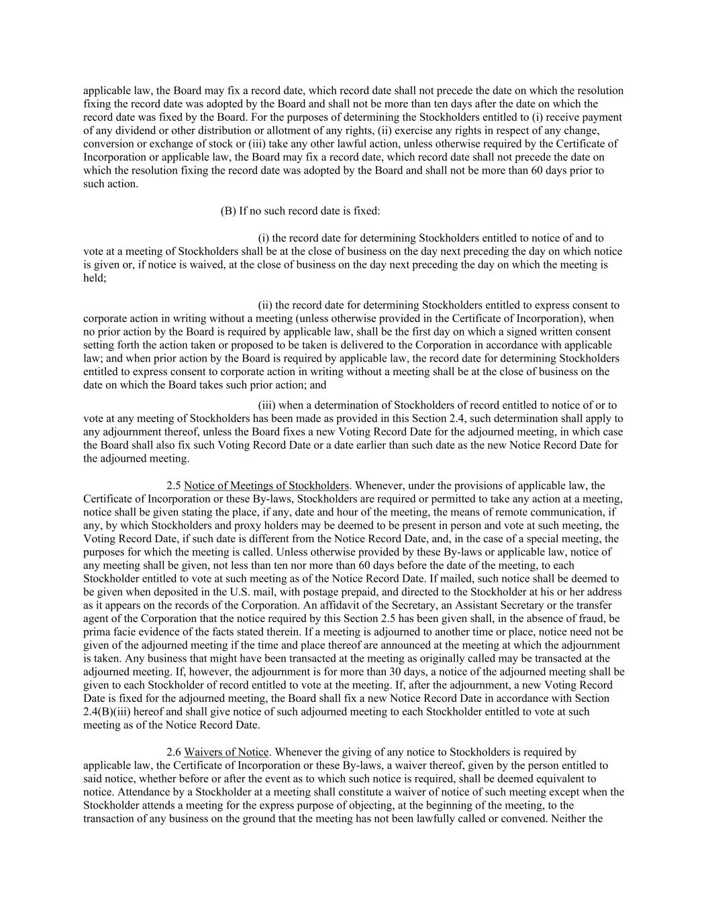
applicable law, the Board may fix a record date, which record date shall not precede the date on which the resolution fixing the record date was adopted by the Board and shall not be more than ten days after the date on which the record date was fixed by the Board. For the purposes of determining the Stockholders entitled to (i) receive payment of any dividend or other distribution or allotment of any rights, (ii) exercise any rights in respect of any change, conversion or exchange of stock or (iii) take any other lawful action, unless otherwise required by the Certificate of Incorporation or applicable law, the Board may fix a record date, which record date shall not precede the date on which the resolution fixing the record date was adopted by the Board and shall not be more than 60 days prior to such action. (B) If no such record date is fixed: (i) the record date for determining Stockholders entitled to notice of and to vote at a meeting of Stockholders shall be at the close of business on the day next preceding the day on which notice is given or, if notice is waived, at the close of business on the day next preceding the day on which the meeting is held; (ii) the record date for determining Stockholders entitled to express consent to corporate action in writing without a meeting (unless otherwise provided in the Certificate of Incorporation), when no prior action by the Board is required by applicable law, shall be the first day on which a signed written consent setting forth the action taken or proposed to be taken is delivered to the Corporation in accordance with applicable law; and when prior action by the Board is required by applicable law, the record date for determining Stockholders entitled to express consent to corporate action in writing without a meeting shall be at the close of business on the date on which the Board takes such prior action; and (iii) when a determination of Stockholders of record entitled to notice of or to vote at any meeting of Stockholders has been made as provided in this Section 2.4, such determination shall apply to any adjournment thereof, unless the Board fixes a new Voting Record Date for the adjourned meeting, in which case the Board shall also fix such Voting Record Date or a date earlier than such date as the new Notice Record Date for the adjourned meeting. 2.5 Notice of Meetings of Stockholders. Whenever, under the provisions of applicable law, the Certificate of Incorporation or these By-laws, Stockholders are required or permitted to take any action at a meeting, notice shall be given stating the place, if any, date and hour of the meeting, the means of remote communication, if any, by which Stockholders and proxy holders may be deemed to be present in person and vote at such meeting, the Voting Record Date, if such date is different from the Notice Record Date, and, in the case of a special meeting, the purposes for which the meeting is called. Unless otherwise provided by these By-laws or applicable law, notice of any meeting shall be given, not less than ten nor more than 60 days before the date of the meeting, to each Stockholder entitled to vote at such meeting as of the Notice Record Date. If mailed, such notice shall be deemed to be given when deposited in the U.S. mail, with postage prepaid, and directed to the Stockholder at his or her address as it appears on the records of the Corporation. An affidavit of the Secretary, an Assistant Secretary or the transfer agent of the Corporation that the notice required by this Section 2.5 has been given shall, in the absence of fraud, be prima facie evidence of the facts stated therein. If a meeting is adjourned to another time or place, notice need not be given of the adjourned meeting if the time and place thereof are announced at the meeting at which the adjournment is taken. Any business that might have been transacted at the meeting as originally called may be transacted at the adjourned meeting. If, however, the adjournment is for more than 30 days, a notice of the adjourned meeting shall be given to each Stockholder of record entitled to vote at the meeting. If, after the adjournment, a new Voting Record Date is fixed for the adjourned meeting, the Board shall fix a new Notice Record Date in accordance with Section 2.4(B)(iii) hereof and shall give notice of such adjourned meeting to each Stockholder entitled to vote at such meeting as of the Notice Record Date. 2.6 Waivers of Notice. Whenever the giving of any notice to Stockholders is required by applicable law, the Certificate of Incorporation or these By-laws, a waiver thereof, given by the person entitled to said notice, whether before or after the event as to which such notice is required, shall be deemed equivalent to notice. Attendance by a Stockholder at a meeting shall constitute a waiver of notice of such meeting except when the Stockholder attends a meeting for the express purpose of objecting, at the beginning of the meeting, to the transaction of any business on the ground that the meeting has not been lawfully called or convened. Neither the

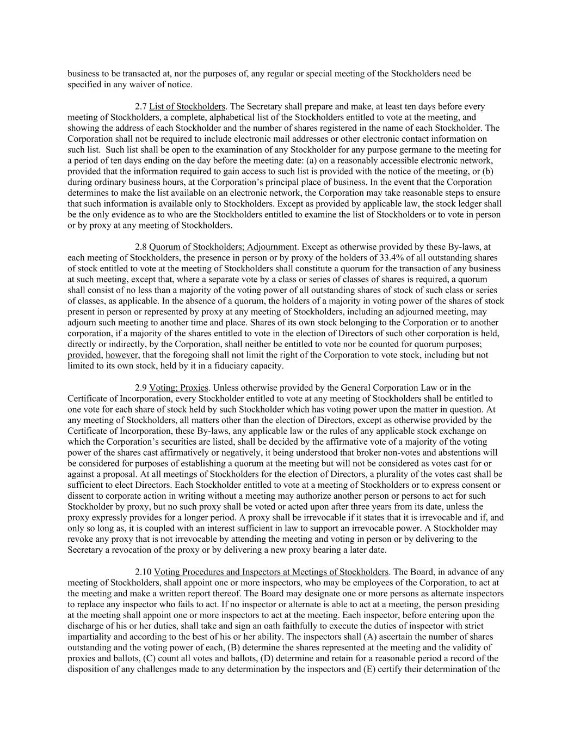
business to be transacted at, nor the purposes of, any regular or special meeting of the Stockholders need be specified in any waiver of notice. 2.7 List of Stockholders. The Secretary shall prepare and make, at least ten days before every meeting of Stockholders, a complete, alphabetical list of the Stockholders entitled to vote at the meeting, and showing the address of each Stockholder and the number of shares registered in the name of each Stockholder. The Corporation shall not be required to include electronic mail addresses or other electronic contact information on such list. Such list shall be open to the examination of any Stockholder for any purpose germane to the meeting for a period of ten days ending on the day before the meeting date: (a) on a reasonably accessible electronic network, provided that the information required to gain access to such list is provided with the notice of the meeting, or (b) during ordinary business hours, at the Corporation’s principal place of business. In the event that the Corporation determines to make the list available on an electronic network, the Corporation may take reasonable steps to ensure that such information is available only to Stockholders. Except as provided by applicable law, the stock ledger shall be the only evidence as to who are the Stockholders entitled to examine the list of Stockholders or to vote in person or by proxy at any meeting of Stockholders. 2.8 Quorum of Stockholders; Adjournment. Except as otherwise provided by these By-laws, at each meeting of Stockholders, the presence in person or by proxy of the holders of 33.4% of all outstanding shares of stock entitled to vote at the meeting of Stockholders shall constitute a quorum for the transaction of any business at such meeting, except that, where a separate vote by a class or series of classes of shares is required, a quorum shall consist of no less than a majority of the voting power of all outstanding shares of stock of such class or series of classes, as applicable. In the absence of a quorum, the holders of a majority in voting power of the shares of stock present in person or represented by proxy at any meeting of Stockholders, including an adjourned meeting, may adjourn such meeting to another time and place. Shares of its own stock belonging to the Corporation or to another corporation, if a majority of the shares entitled to vote in the election of Directors of such other corporation is held, directly or indirectly, by the Corporation, shall neither be entitled to vote nor be counted for quorum purposes; provided, however, that the foregoing shall not limit the right of the Corporation to vote stock, including but not limited to its own stock, held by it in a fiduciary capacity. 2.9 Voting; Proxies. Unless otherwise provided by the General Corporation Law or in the Certificate of Incorporation, every Stockholder entitled to vote at any meeting of Stockholders shall be entitled to one vote for each share of stock held by such Stockholder which has voting power upon the matter in question. At any meeting of Stockholders, all matters other than the election of Directors, except as otherwise provided by the Certificate of Incorporation, these By-laws, any applicable law or the rules of any applicable stock exchange on which the Corporation’s securities are listed, shall be decided by the affirmative vote of a majority of the voting power of the shares cast affirmatively or negatively, it being understood that broker non-votes and abstentions will be considered for purposes of establishing a quorum at the meeting but will not be considered as votes cast for or against a proposal. At all meetings of Stockholders for the election of Directors, a plurality of the votes cast shall be sufficient to elect Directors. Each Stockholder entitled to vote at a meeting of Stockholders or to express consent or dissent to corporate action in writing without a meeting may authorize another person or persons to act for such Stockholder by proxy, but no such proxy shall be voted or acted upon after three years from its date, unless the proxy expressly provides for a longer period. A proxy shall be irrevocable if it states that it is irrevocable and if, and only so long as, it is coupled with an interest sufficient in law to support an irrevocable power. A Stockholder may revoke any proxy that is not irrevocable by attending the meeting and voting in person or by delivering to the Secretary a revocation of the proxy or by delivering a new proxy bearing a later date. 2.10 Voting Procedures and Inspectors at Meetings of Stockholders. The Board, in advance of any meeting of Stockholders, shall appoint one or more inspectors, who may be employees of the Corporation, to act at the meeting and make a written report thereof. The Board may designate one or more persons as alternate inspectors to replace any inspector who fails to act. If no inspector or alternate is able to act at a meeting, the person presiding at the meeting shall appoint one or more inspectors to act at the meeting. Each inspector, before entering upon the discharge of his or her duties, shall take and sign an oath faithfully to execute the duties of inspector with strict impartiality and according to the best of his or her ability. The inspectors shall (A) ascertain the number of shares outstanding and the voting power of each, (B) determine the shares represented at the meeting and the validity of proxies and ballots, (C) count all votes and ballots, (D) determine and retain for a reasonable period a record of the disposition of any challenges made to any determination by the inspectors and (E) certify their determination of the

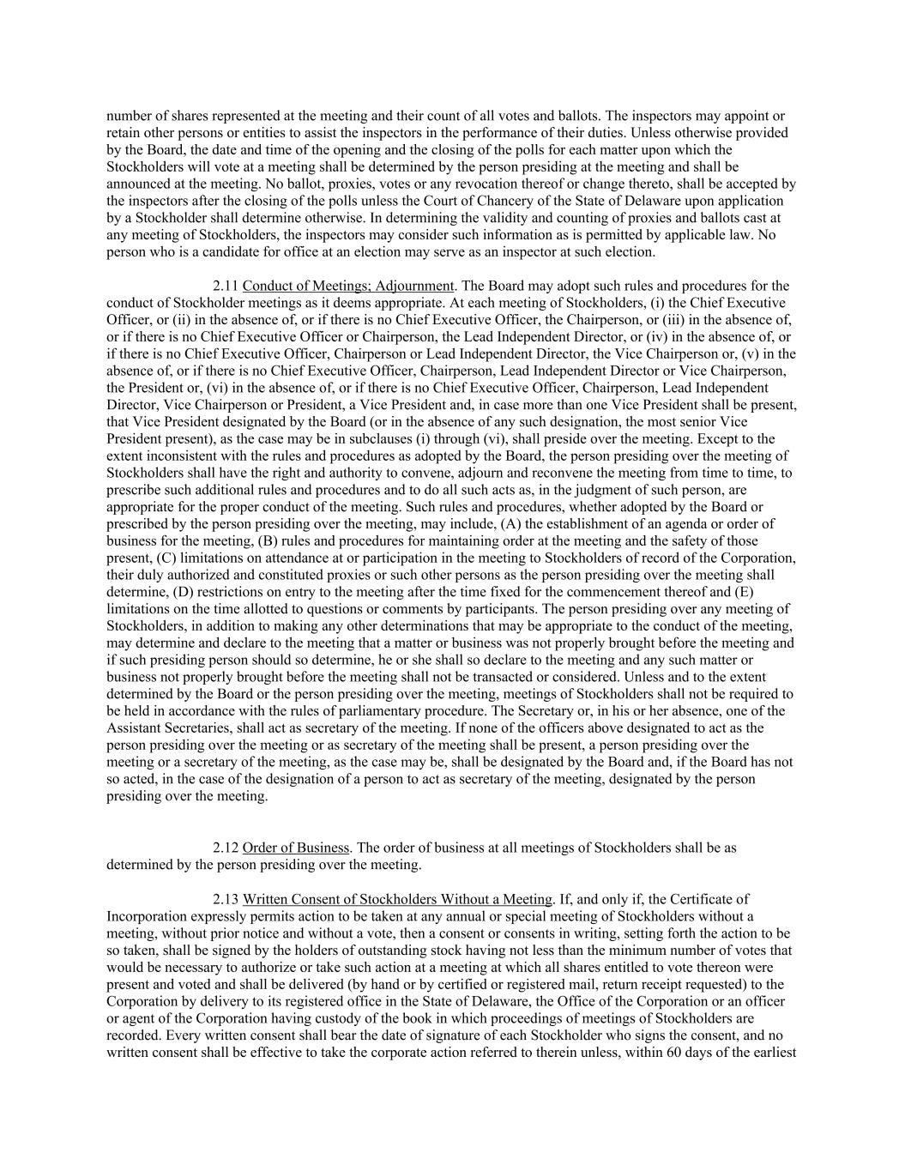
number of shares represented at the meeting and their count of all votes and ballots. The inspectors may appoint or retain other persons or entities to assist the inspectors in the performance of their duties. Unless otherwise provided by the Board, the date and time of the opening and the closing of the polls for each matter upon which the Stockholders will vote at a meeting shall be determined by the person presiding at the meeting and shall be announced at the meeting. No ballot, proxies, votes or any revocation thereof or change thereto, shall be accepted by the inspectors after the closing of the polls unless the Court of Chancery of the State of Delaware upon application by a Stockholder shall determine otherwise. In determining the validity and counting of proxies and ballots cast at any meeting of Stockholders, the inspectors may consider such information as is permitted by applicable law. No person who is a candidate for office at an election may serve as an inspector at such election. 2.11 Conduct of Meetings; Adjournment. The Board may adopt such rules and procedures for the conduct of Stockholder meetings as it deems appropriate. At each meeting of Stockholders, (i) the Chief Executive Officer, or (ii) in the absence of, or if there is no Chief Executive Officer, the Chairperson, or (iii) in the absence of, or if there is no Chief Executive Officer or Chairperson, the Lead Independent Director, or (iv) in the absence of, or if there is no Chief Executive Officer, Chairperson or Lead Independent Director, the Vice Chairperson or, (v) in the absence of, or if there is no Chief Executive Officer, Chairperson, Lead Independent Director or Vice Chairperson, the President or, (vi) in the absence of, or if there is no Chief Executive Officer, Chairperson, Lead Independent Director, Vice Chairperson or President, a Vice President and, in case more than one Vice President shall be present, that Vice President designated by the Board (or in the absence of any such designation, the most senior Vice President present), as the case may be in subclauses (i) through (vi), shall preside over the meeting. Except to the extent inconsistent with the rules and procedures as adopted by the Board, the person presiding over the meeting of Stockholders shall have the right and authority to convene, adjourn and reconvene the meeting from time to time, to prescribe such additional rules and procedures and to do all such acts as, in the judgment of such person, are appropriate for the proper conduct of the meeting. Such rules and procedures, whether adopted by the Board or prescribed by the person presiding over the meeting, may include, (A) the establishment of an agenda or order of business for the meeting, (B) rules and procedures for maintaining order at the meeting and the safety of those present, (C) limitations on attendance at or participation in the meeting to Stockholders of record of the Corporation, their duly authorized and constituted proxies or such other persons as the person presiding over the meeting shall determine, (D) restrictions on entry to the meeting after the time fixed for the commencement thereof and (E) limitations on the time allotted to questions or comments by participants. The person presiding over any meeting of Stockholders, in addition to making any other determinations that may be appropriate to the conduct of the meeting, may determine and declare to the meeting that a matter or business was not properly brought before the meeting and if such presiding person should so determine, he or she shall so declare to the meeting and any such matter or business not properly brought before the meeting shall not be transacted or considered. Unless and to the extent determined by the Board or the person presiding over the meeting, meetings of Stockholders shall not be required to be held in accordance with the rules of parliamentary procedure. The Secretary or, in his or her absence, one of the Assistant Secretaries, shall act as secretary of the meeting. If none of the officers above designated to act as the person presiding over the meeting or as secretary of the meeting shall be present, a person presiding over the meeting or a secretary of the meeting, as the case may be, shall be designated by the Board and, if the Board has not so acted, in the case of the designation of a person to act as secretary of the meeting, designated by the person presiding over the meeting. 2.12 Order of Business. The order of business at all meetings of Stockholders shall be as determined by the person presiding over the meeting. 2.13 Written Consent of Stockholders Without a Meeting. If, and only if, the Certificate of Incorporation expressly permits action to be taken at any annual or special meeting of Stockholders without a meeting, without prior notice and without a vote, then a consent or consents in writing, setting forth the action to be so taken, shall be signed by the holders of outstanding stock having not less than the minimum number of votes that would be necessary to authorize or take such action at a meeting at which all shares entitled to vote thereon were present and voted and shall be delivered (by hand or by certified or registered mail, return receipt requested) to the Corporation by delivery to its registered office in the State of Delaware, the Office of the Corporation or an officer or agent of the Corporation having custody of the book in which proceedings of meetings of Stockholders are recorded. Every written consent shall bear the date of signature of each Stockholder who signs the consent, and no written consent shall be effective to take the corporate action referred to therein unless, within 60 days of the earliest

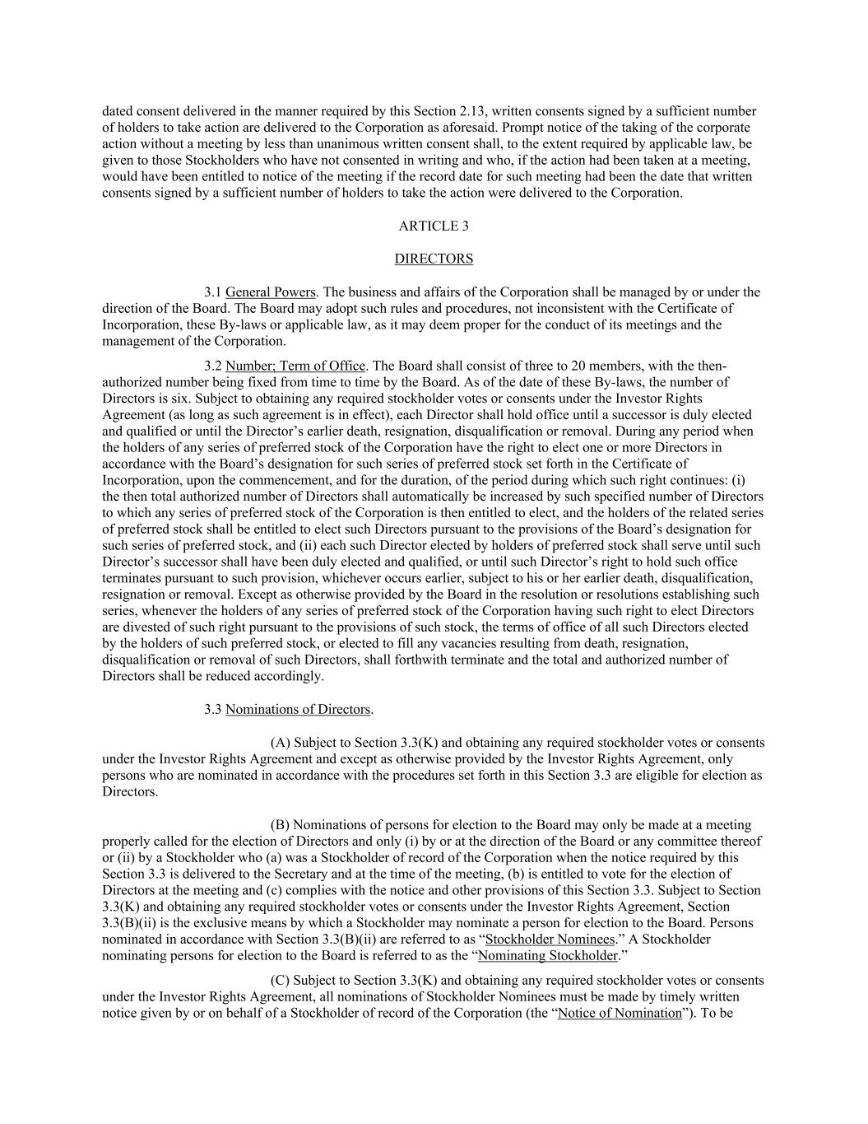
dated consent delivered in the manner required by this Section 2.13, written consents signed by a sufficient number of holders to take action are delivered to the Corporation as aforesaid. Prompt notice of the taking of the corporate action without a meeting by less than unanimous written consent shall, to the extent required by applicable law, be given to those Stockholders who have not consented in writing and who, if the action had been taken at a meeting, would have been entitled to notice of the meeting if the record date for such meeting had been the date that written consents signed by a sufficient number of holders to take the action were delivered to the Corporation. ARTICLE 3 DIRECTORS 3.1 General Powers. The business and affairs of the Corporation shall be managed by or under the direction of the Board. The Board may adopt such rules and procedures, not inconsistent with the Certificate of Incorporation, these By-laws or applicable law, as it may deem proper for the conduct of its meetings and the management of the Corporation. 3.2 Number; Term of Office. The Board shall consist of three to 20 members, with the then- authorized number being fixed from time to time by the Board. As of the date of these By-laws, the number of Directors is six. Subject to obtaining any required stockholder votes or consents under the Investor Rights Agreement (as long as such agreement is in effect), each Director shall hold office until a successor is duly elected and qualified or until the Director’s earlier death, resignation, disqualification or removal. During any period when the holders of any series of preferred stock of the Corporation have the right to elect one or more Directors in accordance with the Board’s designation for such series of preferred stock set forth in the Certificate of Incorporation, upon the commencement, and for the duration, of the period during which such right continues: (i) the then total authorized number of Directors shall automatically be increased by such specified number of Directors to which any series of preferred stock of the Corporation is then entitled to elect, and the holders of the related series of preferred stock shall be entitled to elect such Directors pursuant to the provisions of the Board’s designation for such series of preferred stock, and (ii) each such Director elected by holders of preferred stock shall serve until such Director’s successor shall have been duly elected and qualified, or until such Director’s right to hold such office terminates pursuant to such provision, whichever occurs earlier, subject to his or her earlier death, disqualification, resignation or removal. Except as otherwise provided by the Board in the resolution or resolutions establishing such series, whenever the holders of any series of preferred stock of the Corporation having such right to elect Directors are divested of such right pursuant to the provisions of such stock, the terms of office of all such Directors elected by the holders of such preferred stock, or elected to fill any vacancies resulting from death, resignation, disqualification or removal of such Directors, shall forthwith terminate and the total and authorized number of Directors shall be reduced accordingly. 3.3 Nominations of Directors. (A) Subject to Section 3.3(K) and obtaining any required stockholder votes or consents under the Investor Rights Agreement and except as otherwise provided by the Investor Rights Agreement, only persons who are nominated in accordance with the procedures set forth in this Section 3.3 are eligible for election as Directors. (B) Nominations of persons for election to the Board may only be made at a meeting properly called for the election of Directors and only (i) by or at the direction of the Board or any committee thereof or (ii) by a Stockholder who (a) was a Stockholder of record of the Corporation when the notice required by this Section 3.3 is delivered to the Secretary and at the time of the meeting, (b) is entitled to vote for the election of Directors at the meeting and (c) complies with the notice and other provisions of this Section 3.3. Subject to Section 3.3(K) and obtaining any required stockholder votes or consents under the Investor Rights Agreement, Section 3.3(B)(ii) is the exclusive means by which a Stockholder may nominate a person for election to the Board. Persons nominated in accordance with Section 3.3(B)(ii) are referred to as “Stockholder Nominees.” A Stockholder nominating persons for election to the Board is referred to as the “Nominating Stockholder.” (C) Subject to Section 3.3(K) and obtaining any required stockholder votes or consents under the Investor Rights Agreement, all nominations of Stockholder Nominees must be made by timely written notice given by or on behalf of a Stockholder of record of the Corporation (the “Notice of Nomination”). To be

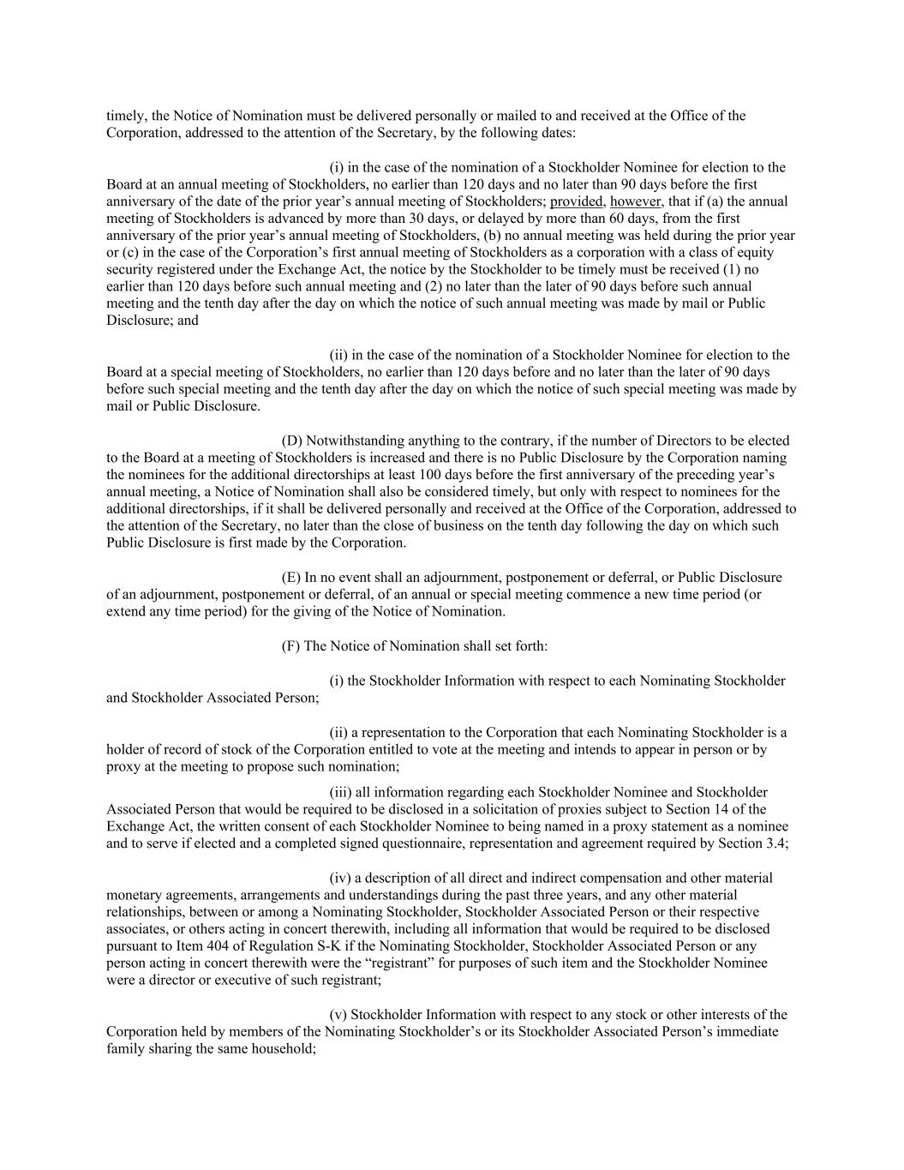
timely, the Notice of Nomination must be delivered personally or mailed to and received at the Office of the Corporation, addressed to the attention of the Secretary, by the following dates: (i) in the case of the nomination of a Stockholder Nominee for election to the Board at an annual meeting of Stockholders, no earlier than 120 days and no later than 90 days before the first anniversary of the date of the prior year’s annual meeting of Stockholders; provided, however, that if (a) the annual meeting of Stockholders is advanced by more than 30 days, or delayed by more than 60 days, from the first anniversary of the prior year’s annual meeting of Stockholders, (b) no annual meeting was held during the prior year or (c) in the case of the Corporation’s first annual meeting of Stockholders as a corporation with a class of equity security registered under the Exchange Act, the notice by the Stockholder to be timely must be received (1) no earlier than 120 days before such annual meeting and (2) no later than the later of 90 days before such annual meeting and the tenth day after the day on which the notice of such annual meeting was made by mail or Public Disclosure; and (ii) in the case of the nomination of a Stockholder Nominee for election to the Board at a special meeting of Stockholders, no earlier than 120 days before and no later than the later of 90 days before such special meeting and the tenth day after the day on which the notice of such special meeting was made by mail or Public Disclosure. (D) Notwithstanding anything to the contrary, if the number of Directors to be elected to the Board at a meeting of Stockholders is increased and there is no Public Disclosure by the Corporation naming the nominees for the additional directorships at least 100 days before the first anniversary of the preceding year’s annual meeting, a Notice of Nomination shall also be considered timely, but only with respect to nominees for the additional directorships, if it shall be delivered personally and received at the Office of the Corporation, addressed to the attention of the Secretary, no later than the close of business on the tenth day following the day on which such Public Disclosure is first made by the Corporation. (E) In no event shall an adjournment, postponement or deferral, or Public Disclosure of an adjournment, postponement or deferral, of an annual or special meeting commence a new time period (or extend any time period) for the giving of the Notice of Nomination. (F) The Notice of Nomination shall set forth: (i) the Stockholder Information with respect to each Nominating Stockholder and Stockholder Associated Person; (ii) a representation to the Corporation that each Nominating Stockholder is a holder of record of stock of the Corporation entitled to vote at the meeting and intends to appear in person or by proxy at the meeting to propose such nomination; (iii) all information regarding each Stockholder Nominee and Stockholder Associated Person that would be required to be disclosed in a solicitation of proxies subject to Section 14 of the Exchange Act, the written consent of each Stockholder Nominee to being named in a proxy statement as a nominee and to serve if elected and a completed signed questionnaire, representation and agreement required by Section 3.4; (iv) a description of all direct and indirect compensation and other material monetary agreements, arrangements and understandings during the past three years, and any other material relationships, between or among a Nominating Stockholder, Stockholder Associated Person or their respective associates, or others acting in concert therewith, including all information that would be required to be disclosed pursuant to Item 404 of Regulation S-K if the Nominating Stockholder, Stockholder Associated Person or any person acting in concert therewith were the “registrant” for purposes of such item and the Stockholder Nominee were a director or executive of such registrant; (v) Stockholder Information with respect to any stock or other interests of the Corporation held by members of the Nominating Stockholder’s or its Stockholder Associated Person’s immediate family sharing the same household;

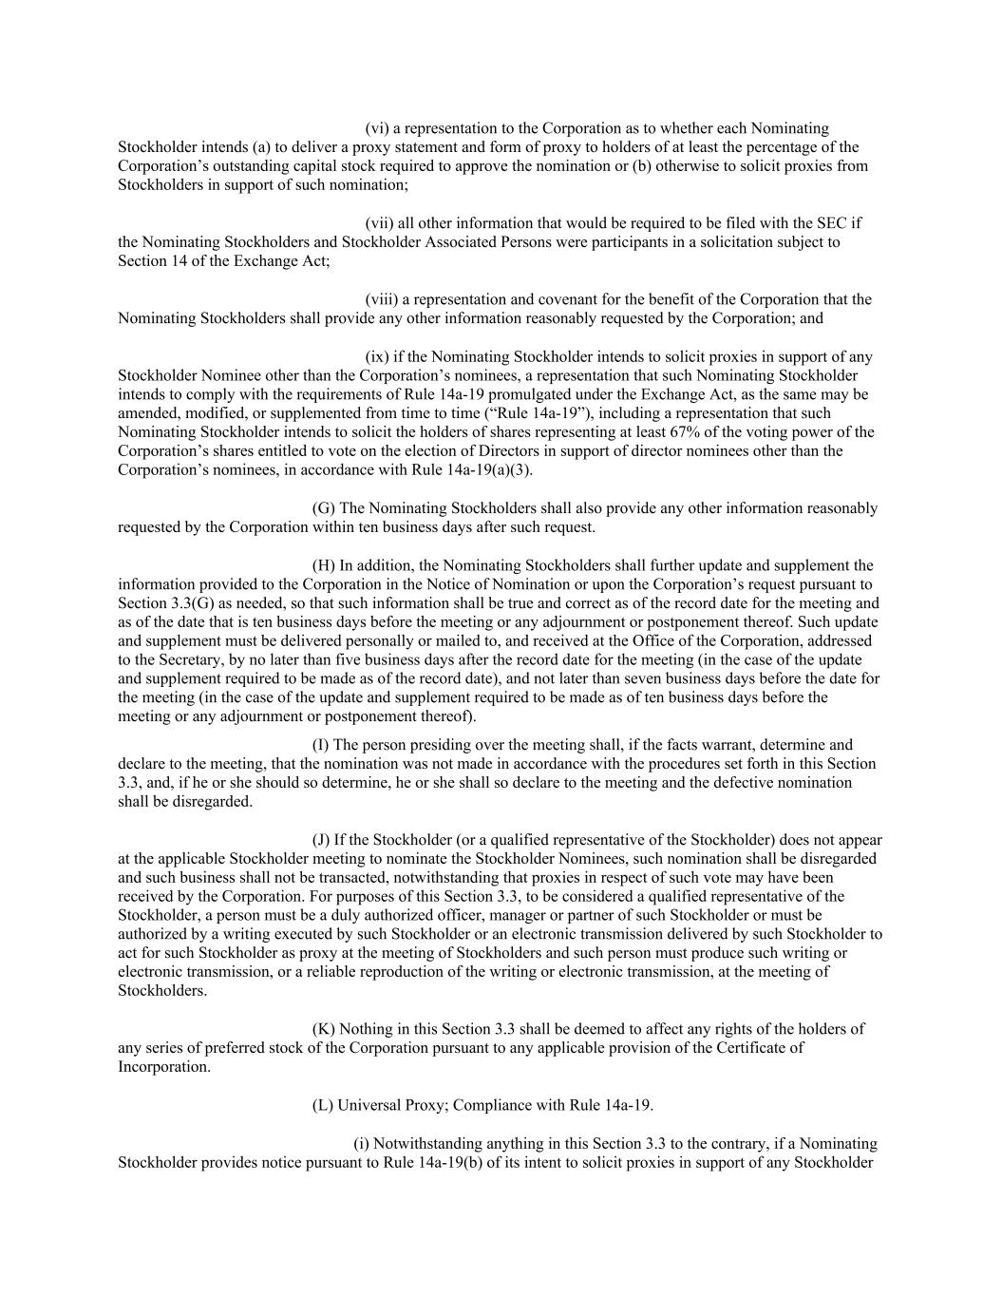
(vi) a representation to the Corporation as to whether each Nominating Stockholder intends (a) to deliver a proxy statement and form of proxy to holders of at least the percentage of the Corporation’s outstanding capital stock required to approve the nomination or (b) otherwise to solicit proxies from Stockholders in support of such nomination; (vii) all other information that would be required to be filed with the SEC if the Nominating Stockholders and Stockholder Associated Persons were participants in a solicitation subject to Section 14 of the Exchange Act; (viii) a representation and covenant for the benefit of the Corporation that the Nominating Stockholders shall provide any other information reasonably requested by the Corporation; and (ix) if the Nominating Stockholder intends to solicit proxies in support of any Stockholder Nominee other than the Corporation’s nominees, a representation that such Nominating Stockholder intends to comply with the requirements of Rule 14a-19 promulgated under the Exchange Act, as the same may be amended, modified, or supplemented from time to time (“Rule 14a-19”), including a representation that such Nominating Stockholder intends to solicit the holders of shares representing at least 67% of the voting power of the Corporation’s shares entitled to vote on the election of Directors in support of director nominees other than the Corporation’s nominees, in accordance with Rule 14a-19(a)(3). (G) The Nominating Stockholders shall also provide any other information reasonably requested by the Corporation within ten business days after such request. (H) In addition, the Nominating Stockholders shall further update and supplement the information provided to the Corporation in the Notice of Nomination or upon the Corporation’s request pursuant to Section 3.3(G) as needed, so that such information shall be true and correct as of the record date for the meeting and as of the date that is ten business days before the meeting or any adjournment or postponement thereof. Such update and supplement must be delivered personally or mailed to, and received at the Office of the Corporation, addressed to the Secretary, by no later than five business days after the record date for the meeting (in the case of the update and supplement required to be made as of the record date), and not later than seven business days before the date for the meeting (in the case of the update and supplement required to be made as of ten business days before the meeting or any adjournment or postponement thereof). (I) The person presiding over the meeting shall, if the facts warrant, determine and declare to the meeting, that the nomination was not made in accordance with the procedures set forth in this Section 3.3, and, if he or she should so determine, he or she shall so declare to the meeting and the defective nomination shall be disregarded. (J) If the Stockholder (or a qualified representative of the Stockholder) does not appear at the applicable Stockholder meeting to nominate the Stockholder Nominees, such nomination shall be disregarded and such business shall not be transacted, notwithstanding that proxies in respect of such vote may have been received by the Corporation. For purposes of this Section 3.3, to be considered a qualified representative of the Stockholder, a person must be a duly authorized officer, manager or partner of such Stockholder or must be authorized by a writing executed by such Stockholder or an electronic transmission delivered by such Stockholder to act for such Stockholder as proxy at the meeting of Stockholders and such person must produce such writing or electronic transmission, or a reliable reproduction of the writing or electronic transmission, at the meeting of Stockholders. (K) Nothing in this Section 3.3 shall be deemed to affect any rights of the holders of any series of preferred stock of the Corporation pursuant to any applicable provision of the Certificate of Incorporation. (L) Universal Proxy; Compliance with Rule 14a-19. (i) Notwithstanding anything in this Section 3.3 to the contrary, if a Nominating Stockholder provides notice pursuant to Rule 14a-19(b) of its intent to solicit proxies in support of any Stockholder

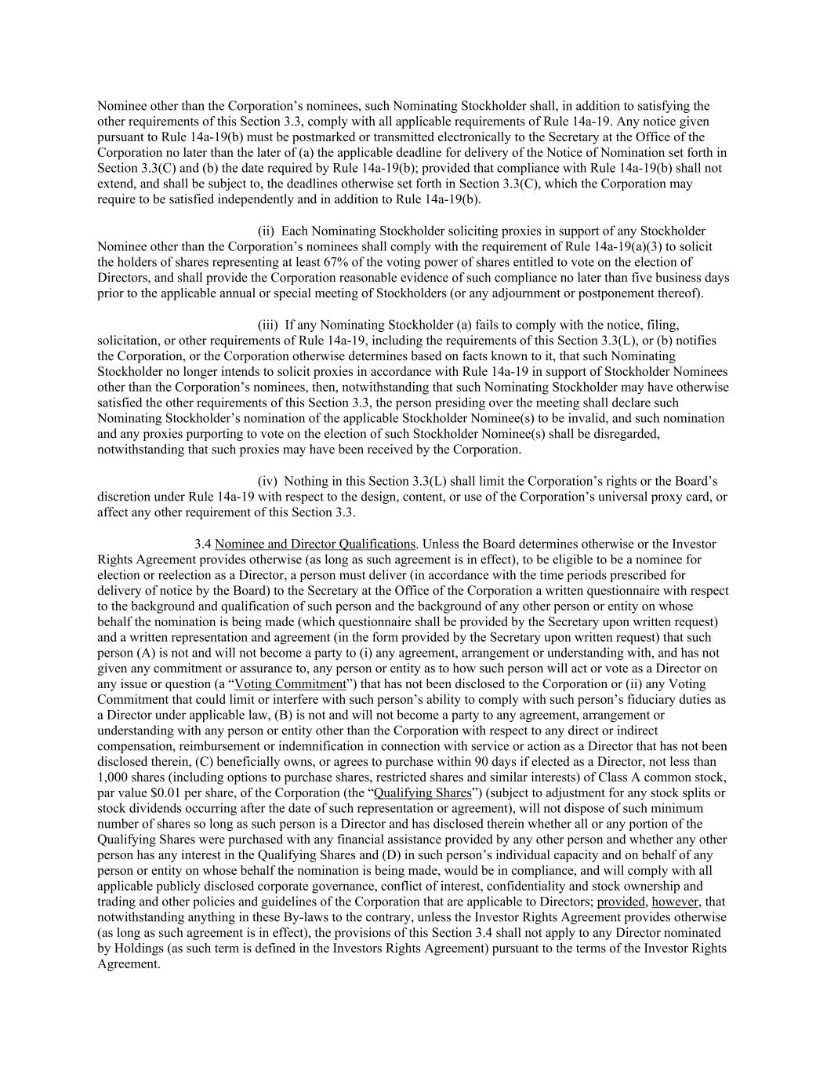
Nominee other than the Corporation’s nominees, such Nominating Stockholder shall, in addition to satisfying the other requirements of this Section 3.3, comply with all applicable requirements of Rule 14a-19. Any notice given pursuant to Rule 14a-19(b) must be postmarked or transmitted electronically to the Secretary at the Office of the Corporation no later than the later of (a) the applicable deadline for delivery of the Notice of Nomination set forth in Section 3.3(C) and (b) the date required by Rule 14a-19(b); provided that compliance with Rule 14a-19(b) shall not extend, and shall be subject to, the deadlines otherwise set forth in Section 3.3(C), which the Corporation may require to be satisfied independently and in addition to Rule 14a-19(b). (ii) Each Nominating Stockholder soliciting proxies in support of any Stockholder Nominee other than the Corporation’s nominees shall comply with the requirement of Rule 14a-19(a)(3) to solicit the holders of shares representing at least 67% of the voting power of shares entitled to vote on the election of Directors, and shall provide the Corporation reasonable evidence of such compliance no later than five business days prior to the applicable annual or special meeting of Stockholders (or any adjournment or postponement thereof). (iii) If any Nominating Stockholder (a) fails to comply with the notice, filing, solicitation, or other requirements of Rule 14a-19, including the requirements of this Section 3.3(L), or (b) notifies the Corporation, or the Corporation otherwise determines based on facts known to it, that such Nominating Stockholder no longer intends to solicit proxies in accordance with Rule 14a-19 in support of Stockholder Nominees other than the Corporation’s nominees, then, notwithstanding that such Nominating Stockholder may have otherwise satisfied the other requirements of this Section 3.3, the person presiding over the meeting shall declare such Nominating Stockholder’s nomination of the applicable Stockholder Nominee(s) to be invalid, and such nomination and any proxies purporting to vote on the election of such Stockholder Nominee(s) shall be disregarded, notwithstanding that such proxies may have been received by the Corporation. (iv) Nothing in this Section 3.3(L) shall limit the Corporation’s rights or the Board’s discretion under Rule 14a-19 with respect to the design, content, or use of the Corporation’s universal proxy card, or affect any other requirement of this Section 3.3. 3.4 Nominee and Director Qualifications. Unless the Board determines otherwise or the Investor Rights Agreement provides otherwise (as long as such agreement is in effect), to be eligible to be a nominee for election or reelection as a Director, a person must deliver (in accordance with the time periods prescribed for delivery of notice by the Board) to the Secretary at the Office of the Corporation a written questionnaire with respect to the background and qualification of such person and the background of any other person or entity on whose behalf the nomination is being made (which questionnaire shall be provided by the Secretary upon written request) and a written representation and agreement (in the form provided by the Secretary upon written request) that such person (A) is not and will not become a party to (i) any agreement, arrangement or understanding with, and has not given any commitment or assurance to, any person or entity as to how such person will act or vote as a Director on any issue or question (a “Voting Commitment”) that has not been disclosed to the Corporation or (ii) any Voting Commitment that could limit or interfere with such person’s ability to comply with such person’s fiduciary duties as a Director under applicable law, (B) is not and will not become a party to any agreement, arrangement or understanding with any person or entity other than the Corporation with respect to any direct or indirect compensation, reimbursement or indemnification in connection with service or action as a Director that has not been disclosed therein, (C) beneficially owns, or agrees to purchase within 90 days if elected as a Director, not less than 1,000 shares (including options to purchase shares, restricted shares and similar interests) of Class A common stock, par value $0.01 per share, of the Corporation (the “Qualifying Shares”) (subject to adjustment for any stock splits or stock dividends occurring after the date of such representation or agreement), will not dispose of such minimum number of shares so long as such person is a Director and has disclosed therein whether all or any portion of the Qualifying Shares were purchased with any financial assistance provided by any other person and whether any other person has any interest in the Qualifying Shares and (D) in such person’s individual capacity and on behalf of any person or entity on whose behalf the nomination is being made, would be in compliance, and will comply with all applicable publicly disclosed corporate governance, conflict of interest, confidentiality and stock ownership and trading and other policies and guidelines of the Corporation that are applicable to Directors; provided, however, that notwithstanding anything in these By-laws to the contrary, unless the Investor Rights Agreement provides otherwise (as long as such agreement is in effect), the provisions of this Section 3.4 shall not apply to any Director nominated by Holdings (as such term is defined in the Investors Rights Agreement) pursuant to the terms of the Investor Rights Agreement.

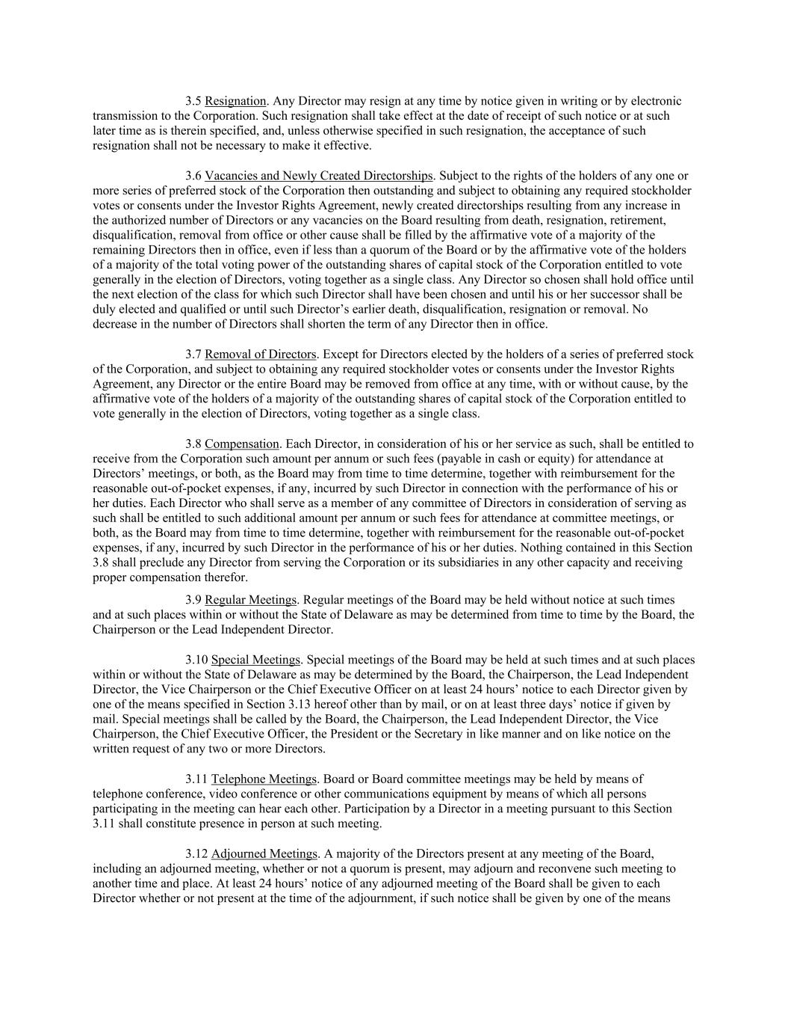
3.5 Resignation. Any Director may resign at any time by notice given in writing or by electronic transmission to the Corporation. Such resignation shall take effect at the date of receipt of such notice or at such later time as is therein specified, and, unless otherwise specified in such resignation, the acceptance of such resignation shall not be necessary to make it effective. 3.6 Vacancies and Newly Created Directorships. Subject to the rights of the holders of any one or more series of preferred stock of the Corporation then outstanding and subject to obtaining any required stockholder votes or consents under the Investor Rights Agreement, newly created directorships resulting from any increase in the authorized number of Directors or any vacancies on the Board resulting from death, resignation, retirement, disqualification, removal from office or other cause shall be filled by the affirmative vote of a majority of the remaining Directors then in office, even if less than a quorum of the Board or by the affirmative vote of the holders of a majority of the total voting power of the outstanding shares of capital stock of the Corporation entitled to vote generally in the election of Directors, voting together as a single class. Any Director so chosen shall hold office until the next election of the class for which such Director shall have been chosen and until his or her successor shall be duly elected and qualified or until such Director’s earlier death, disqualification, resignation or removal. No decrease in the number of Directors shall shorten the term of any Director then in office. 3.7 Removal of Directors. Except for Directors elected by the holders of a series of preferred stock of the Corporation, and subject to obtaining any required stockholder votes or consents under the Investor Rights Agreement, any Director or the entire Board may be removed from office at any time, with or without cause, by the affirmative vote of the holders of a majority of the outstanding shares of capital stock of the Corporation entitled to vote generally in the election of Directors, voting together as a single class. 3.8 Compensation. Each Director, in consideration of his or her service as such, shall be entitled to receive from the Corporation such amount per annum or such fees (payable in cash or equity) for attendance at Directors’ meetings, or both, as the Board may from time to time determine, together with reimbursement for the reasonable out-of-pocket expenses, if any, incurred by such Director in connection with the performance of his or her duties. Each Director who shall serve as a member of any committee of Directors in consideration of serving as such shall be entitled to such additional amount per annum or such fees for attendance at committee meetings, or both, as the Board may from time to time determine, together with reimbursement for the reasonable out-of-pocket expenses, if any, incurred by such Director in the performance of his or her duties. Nothing contained in this Section 3.8 shall preclude any Director from serving the Corporation or its subsidiaries in any other capacity and receiving proper compensation therefor. 3.9 Regular Meetings. Regular meetings of the Board may be held without notice at such times and at such places within or without the State of Delaware as may be determined from time to time by the Board, the Chairperson or the Lead Independent Director. 3.10 Special Meetings. Special meetings of the Board may be held at such times and at such places within or without the State of Delaware as may be determined by the Board, the Chairperson, the Lead Independent Director, the Vice Chairperson or the Chief Executive Officer on at least 24 hours’ notice to each Director given by one of the means specified in Section 3.13 hereof other than by mail, or on at least three days’ notice if given by mail. Special meetings shall be called by the Board, the Chairperson, the Lead Independent Director, the Vice Chairperson, the Chief Executive Officer, the President or the Secretary in like manner and on like notice on the written request of any two or more Directors. 3.11 Telephone Meetings. Board or Board committee meetings may be held by means of telephone conference, video conference or other communications equipment by means of which all persons participating in the meeting can hear each other. Participation by a Director in a meeting pursuant to this Section 3.11 shall constitute presence in person at such meeting. 3.12 Adjourned Meetings. A majority of the Directors present at any meeting of the Board, including an adjourned meeting, whether or not a quorum is present, may adjourn and reconvene such meeting to another time and place. At least 24 hours’ notice of any adjourned meeting of the Board shall be given to each Director whether or not present at the time of the adjournment, if such notice shall be given by one of the means

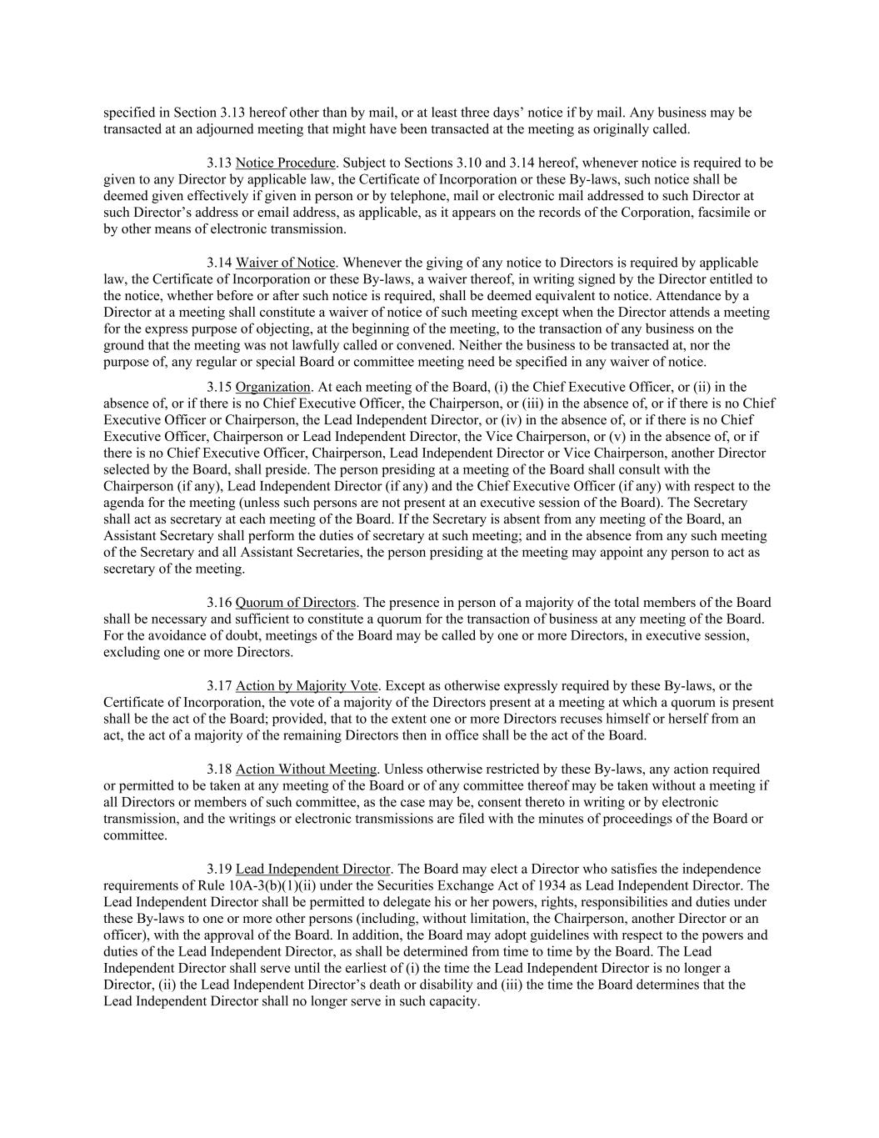
specified in Section 3.13 hereof other than by mail, or at least three days’ notice if by mail. Any business may be transacted at an adjourned meeting that might have been transacted at the meeting as originally called. 3.13 Notice Procedure. Subject to Sections 3.10 and 3.14 hereof, whenever notice is required to be given to any Director by applicable law, the Certificate of Incorporation or these By-laws, such notice shall be deemed given effectively if given in person or by telephone, mail or electronic mail addressed to such Director at such Director’s address or email address, as applicable, as it appears on the records of the Corporation, facsimile or by other means of electronic transmission. 3.14 Waiver of Notice. Whenever the giving of any notice to Directors is required by applicable law, the Certificate of Incorporation or these By-laws, a waiver thereof, in writing signed by the Director entitled to the notice, whether before or after such notice is required, shall be deemed equivalent to notice. Attendance by a Director at a meeting shall constitute a waiver of notice of such meeting except when the Director attends a meeting for the express purpose of objecting, at the beginning of the meeting, to the transaction of any business on the ground that the meeting was not lawfully called or convened. Neither the business to be transacted at, nor the purpose of, any regular or special Board or committee meeting need be specified in any waiver of notice. 3.15 Organization. At each meeting of the Board, (i) the Chief Executive Officer, or (ii) in the absence of, or if there is no Chief Executive Officer, the Chairperson, or (iii) in the absence of, or if there is no Chief Executive Officer or Chairperson, the Lead Independent Director, or (iv) in the absence of, or if there is no Chief Executive Officer, Chairperson or Lead Independent Director, the Vice Chairperson, or (v) in the absence of, or if there is no Chief Executive Officer, Chairperson, Lead Independent Director or Vice Chairperson, another Director selected by the Board, shall preside. The person presiding at a meeting of the Board shall consult with the Chairperson (if any), Lead Independent Director (if any) and the Chief Executive Officer (if any) with respect to the agenda for the meeting (unless such persons are not present at an executive session of the Board). The Secretary shall act as secretary at each meeting of the Board. If the Secretary is absent from any meeting of the Board, an Assistant Secretary shall perform the duties of secretary at such meeting; and in the absence from any such meeting of the Secretary and all Assistant Secretaries, the person presiding at the meeting may appoint any person to act as secretary of the meeting. 3.16 Quorum of Directors. The presence in person of a majority of the total members of the Board shall be necessary and sufficient to constitute a quorum for the transaction of business at any meeting of the Board. For the avoidance of doubt, meetings of the Board may be called by one or more Directors, in executive session, excluding one or more Directors. 3.17 Action by Majority Vote. Except as otherwise expressly required by these By-laws, or the Certificate of Incorporation, the vote of a majority of the Directors present at a meeting at which a quorum is present shall be the act of the Board; provided, that to the extent one or more Directors recuses himself or herself from an act, the act of a majority of the remaining Directors then in office shall be the act of the Board. 3.18 Action Without Meeting. Unless otherwise restricted by these By-laws, any action required or permitted to be taken at any meeting of the Board or of any committee thereof may be taken without a meeting if all Directors or members of such committee, as the case may be, consent thereto in writing or by electronic transmission, and the writings or electronic transmissions are filed with the minutes of proceedings of the Board or committee. 3.19 Lead Independent Director. The Board may elect a Director who satisfies the independence requirements of Rule 10A-3(b)(1)(ii) under the Securities Exchange Act of 1934 as Lead Independent Director. The Lead Independent Director shall be permitted to delegate his or her powers, rights, responsibilities and duties under these By-laws to one or more other persons (including, without limitation, the Chairperson, another Director or an officer), with the approval of the Board. In addition, the Board may adopt guidelines with respect to the powers and duties of the Lead Independent Director, as shall be determined from time to time by the Board. The Lead Independent Director shall serve until the earliest of (i) the time the Lead Independent Director is no longer a Director, (ii) the Lead Independent Director’s death or disability and (iii) the time the Board determines that the Lead Independent Director shall no longer serve in such capacity.

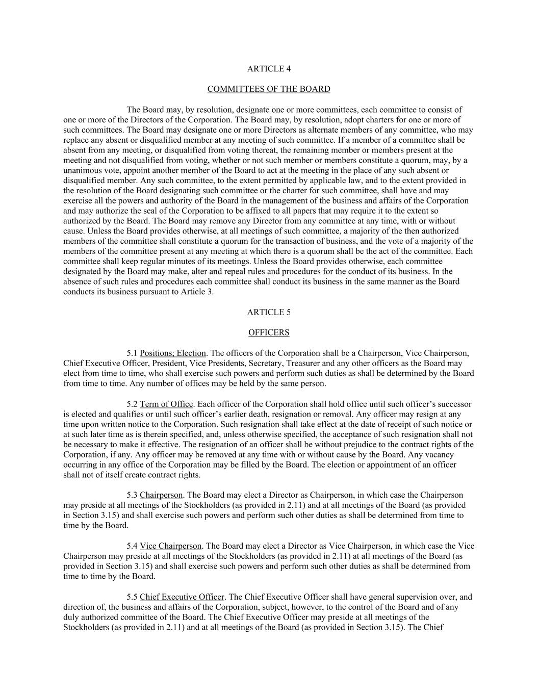
ARTICLE 4 COMMITTEES OF THE BOARD The Board may, by resolution, designate one or more committees, each committee to consist of one or more of the Directors of the Corporation. The Board may, by resolution, adopt charters for one or more of such committees. The Board may designate one or more Directors as alternate members of any committee, who may replace any absent or disqualified member at any meeting of such committee. If a member of a committee shall be absent from any meeting, or disqualified from voting thereat, the remaining member or members present at the meeting and not disqualified from voting, whether or not such member or members constitute a quorum, may, by a unanimous vote, appoint another member of the Board to act at the meeting in the place of any such absent or disqualified member. Any such committee, to the extent permitted by applicable law, and to the extent provided in the resolution of the Board designating such committee or the charter for such committee, shall have and may exercise all the powers and authority of the Board in the management of the business and affairs of the Corporation and may authorize the seal of the Corporation to be affixed to all papers that may require it to the extent so authorized by the Board. The Board may remove any Director from any committee at any time, with or without cause. Unless the Board provides otherwise, at all meetings of such committee, a majority of the then authorized members of the committee shall constitute a quorum for the transaction of business, and the vote of a majority of the members of the committee present at any meeting at which there is a quorum shall be the act of the committee. Each committee shall keep regular minutes of its meetings. Unless the Board provides otherwise, each committee designated by the Board may make, alter and repeal rules and procedures for the conduct of its business. In the absence of such rules and procedures each committee shall conduct its business in the same manner as the Board conducts its business pursuant to Article 3. ARTICLE 5 OFFICERS 5.1 Positions; Election. The officers of the Corporation shall be a Chairperson, Vice Chairperson, Chief Executive Officer, President, Vice Presidents, Secretary, Treasurer and any other officers as the Board may elect from time to time, who shall exercise such powers and perform such duties as shall be determined by the Board from time to time. Any number of offices may be held by the same person. 5.2 Term of Office. Each officer of the Corporation shall hold office until such officer’s successor is elected and qualifies or until such officer’s earlier death, resignation or removal. Any officer may resign at any time upon written notice to the Corporation. Such resignation shall take effect at the date of receipt of such notice or at such later time as is therein specified, and, unless otherwise specified, the acceptance of such resignation shall not be necessary to make it effective. The resignation of an officer shall be without prejudice to the contract rights of the Corporation, if any. Any officer may be removed at any time with or without cause by the Board. Any vacancy occurring in any office of the Corporation may be filled by the Board. The election or appointment of an officer shall not of itself create contract rights. 5.3 Chairperson. The Board may elect a Director as Chairperson, in which case the Chairperson may preside at all meetings of the Stockholders (as provided in 2.11) and at all meetings of the Board (as provided in Section 3.15) and shall exercise such powers and perform such other duties as shall be determined from time to time by the Board. 5.4 Vice Chairperson. The Board may elect a Director as Vice Chairperson, in which case the Vice Chairperson may preside at all meetings of the Stockholders (as provided in 2.11) at all meetings of the Board (as provided in Section 3.15) and shall exercise such powers and perform such other duties as shall be determined from time to time by the Board. 5.5 Chief Executive Officer. The Chief Executive Officer shall have general supervision over, and direction of, the business and affairs of the Corporation, subject, however, to the control of the Board and of any duly authorized committee of the Board. The Chief Executive Officer may preside at all meetings of the Stockholders (as provided in 2.11) and at all meetings of the Board (as provided in Section 3.15). The Chief

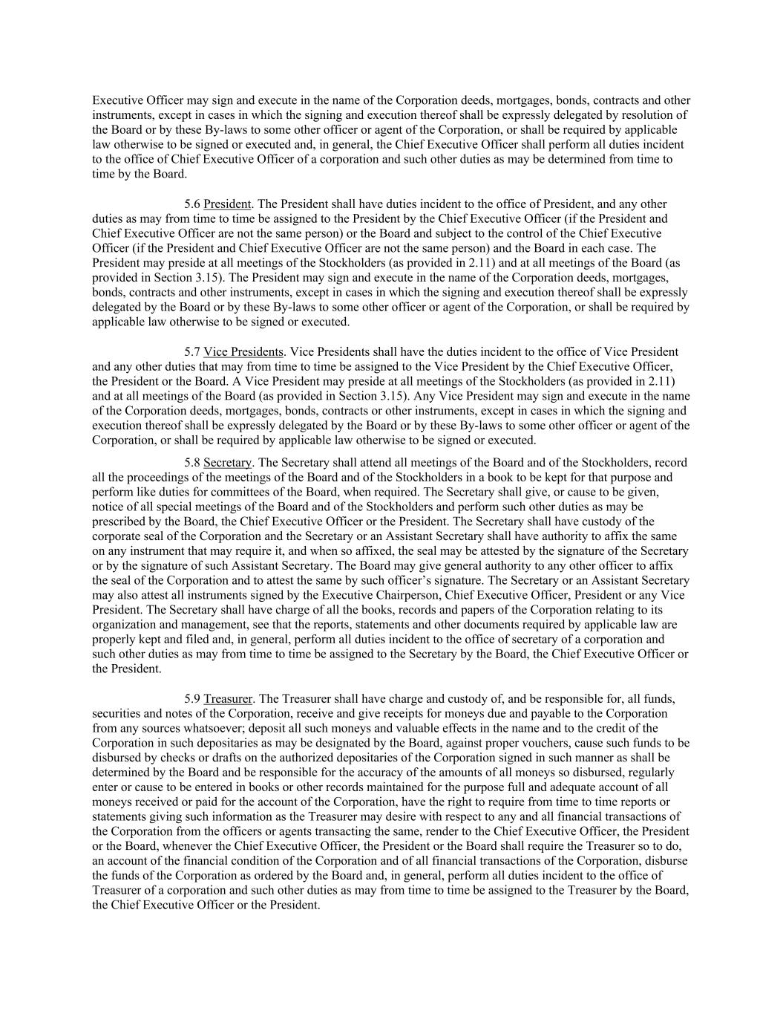
Executive Officer may sign and execute in the name of the Corporation deeds, mortgages, bonds, contracts and other instruments, except in cases in which the signing and execution thereof shall be expressly delegated by resolution of the Board or by these By-laws to some other officer or agent of the Corporation, or shall be required by applicable law otherwise to be signed or executed and, in general, the Chief Executive Officer shall perform all duties incident to the office of Chief Executive Officer of a corporation and such other duties as may be determined from time to time by the Board. 5.6 President. The President shall have duties incident to the office of President, and any other duties as may from time to time be assigned to the President by the Chief Executive Officer (if the President and Chief Executive Officer are not the same person) or the Board and subject to the control of the Chief Executive Officer (if the President and Chief Executive Officer are not the same person) and the Board in each case. The President may preside at all meetings of the Stockholders (as provided in 2.11) and at all meetings of the Board (as provided in Section 3.15). The President may sign and execute in the name of the Corporation deeds, mortgages, bonds, contracts and other instruments, except in cases in which the signing and execution thereof shall be expressly delegated by the Board or by these By-laws to some other officer or agent of the Corporation, or shall be required by applicable law otherwise to be signed or executed. 5.7 Vice Presidents. Vice Presidents shall have the duties incident to the office of Vice President and any other duties that may from time to time be assigned to the Vice President by the Chief Executive Officer, the President or the Board. A Vice President may preside at all meetings of the Stockholders (as provided in 2.11) and at all meetings of the Board (as provided in Section 3.15). Any Vice President may sign and execute in the name of the Corporation deeds, mortgages, bonds, contracts or other instruments, except in cases in which the signing and execution thereof shall be expressly delegated by the Board or by these By-laws to some other officer or agent of the Corporation, or shall be required by applicable law otherwise to be signed or executed. 5.8 Secretary. The Secretary shall attend all meetings of the Board and of the Stockholders, record all the proceedings of the meetings of the Board and of the Stockholders in a book to be kept for that purpose and perform like duties for committees of the Board, when required. The Secretary shall give, or cause to be given, notice of all special meetings of the Board and of the Stockholders and perform such other duties as may be prescribed by the Board, the Chief Executive Officer or the President. The Secretary shall have custody of the corporate seal of the Corporation and the Secretary or an Assistant Secretary shall have authority to affix the same on any instrument that may require it, and when so affixed, the seal may be attested by the signature of the Secretary or by the signature of such Assistant Secretary. The Board may give general authority to any other officer to affix the seal of the Corporation and to attest the same by such officer’s signature. The Secretary or an Assistant Secretary may also attest all instruments signed by the Executive Chairperson, Chief Executive Officer, President or any Vice President. The Secretary shall have charge of all the books, records and papers of the Corporation relating to its organization and management, see that the reports, statements and other documents required by applicable law are properly kept and filed and, in general, perform all duties incident to the office of secretary of a corporation and such other duties as may from time to time be assigned to the Secretary by the Board, the Chief Executive Officer or the President. 5.9 Treasurer. The Treasurer shall have charge and custody of, and be responsible for, all funds, securities and notes of the Corporation, receive and give receipts for moneys due and payable to the Corporation from any sources whatsoever; deposit all such moneys and valuable effects in the name and to the credit of the Corporation in such depositaries as may be designated by the Board, against proper vouchers, cause such funds to be disbursed by checks or drafts on the authorized depositaries of the Corporation signed in such manner as shall be determined by the Board and be responsible for the accuracy of the amounts of all moneys so disbursed, regularly enter or cause to be entered in books or other records maintained for the purpose full and adequate account of all moneys received or paid for the account of the Corporation, have the right to require from time to time reports or statements giving such information as the Treasurer may desire with respect to any and all financial transactions of the Corporation from the officers or agents transacting the same, render to the Chief Executive Officer, the President or the Board, whenever the Chief Executive Officer, the President or the Board shall require the Treasurer so to do, an account of the financial condition of the Corporation and of all financial transactions of the Corporation, disburse the funds of the Corporation as ordered by the Board and, in general, perform all duties incident to the office of Treasurer of a corporation and such other duties as may from time to time be assigned to the Treasurer by the Board, the Chief Executive Officer or the President.

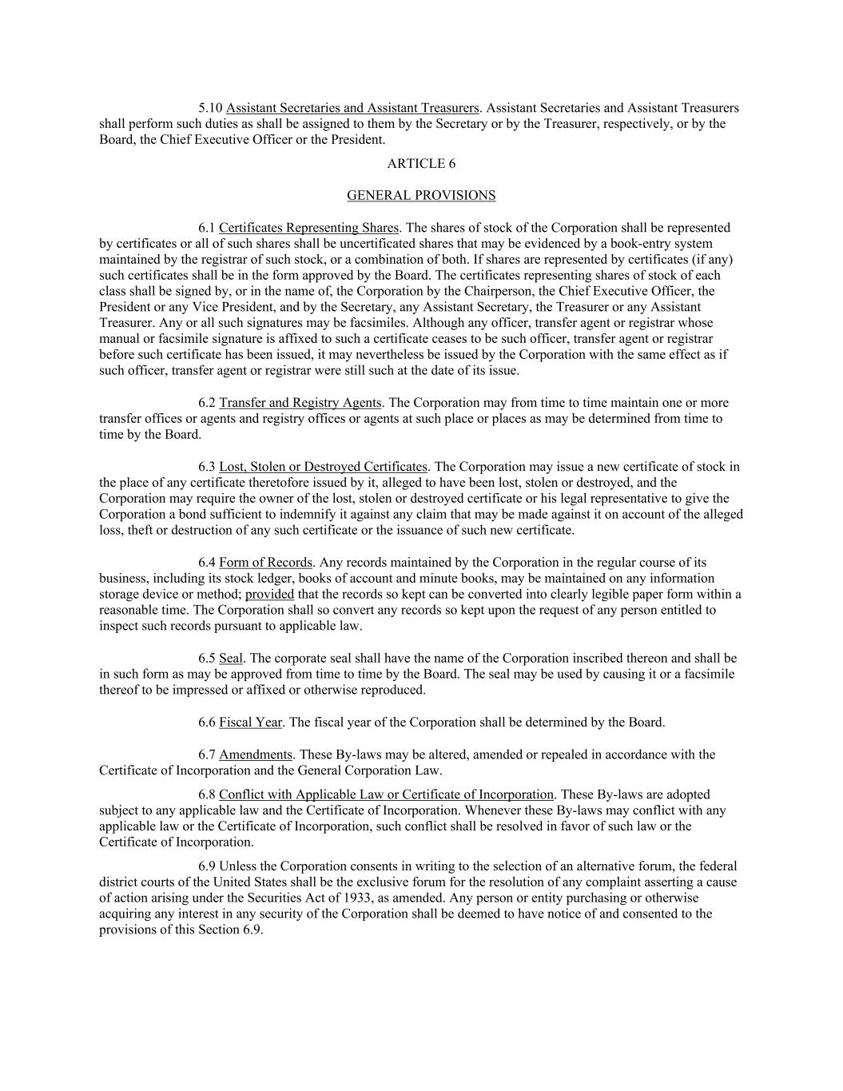
5.10 Assistant Secretaries and Assistant Treasurers. Assistant Secretaries and Assistant Treasurers shall perform such duties as shall be assigned to them by the Secretary or by the Treasurer, respectively, or by the Board, the Chief Executive Officer or the President. ARTICLE 6 GENERAL PROVISIONS 6.1 Certificates Representing Shares. The shares of stock of the Corporation shall be represented by certificates or all of such shares shall be uncertificated shares that may be evidenced by a book-entry system maintained by the registrar of such stock, or a combination of both. If shares are represented by certificates (if any) such certificates shall be in the form approved by the Board. The certificates representing shares of stock of each class shall be signed by, or in the name of, the Corporation by the Chairperson, the Chief Executive Officer, the President or any Vice President, and by the Secretary, any Assistant Secretary, the Treasurer or any Assistant Treasurer. Any or all such signatures may be facsimiles. Although any officer, transfer agent or registrar whose manual or facsimile signature is affixed to such a certificate ceases to be such officer, transfer agent or registrar before such certificate has been issued, it may nevertheless be issued by the Corporation with the same effect as if such officer, transfer agent or registrar were still such at the date of its issue. 6.2 Transfer and Registry Agents. The Corporation may from time to time maintain one or more transfer offices or agents and registry offices or agents at such place or places as may be determined from time to time by the Board. 6.3 Lost, Stolen or Destroyed Certificates. The Corporation may issue a new certificate of stock in the place of any certificate theretofore issued by it, alleged to have been lost, stolen or destroyed, and the Corporation may require the owner of the lost, stolen or destroyed certificate or his legal representative to give the Corporation a bond sufficient to indemnify it against any claim that may be made against it on account of the alleged loss, theft or destruction of any such certificate or the issuance of such new certificate. 6.4 Form of Records. Any records maintained by the Corporation in the regular course of its business, including its stock ledger, books of account and minute books, may be maintained on any information storage device or method; provided that the records so kept can be converted into clearly legible paper form within a reasonable time. The Corporation shall so convert any records so kept upon the request of any person entitled to inspect such records pursuant to applicable law. 6.5 Seal. The corporate seal shall have the name of the Corporation inscribed thereon and shall be in such form as may be approved from time to time by the Board. The seal may be used by causing it or a facsimile thereof to be impressed or affixed or otherwise reproduced. 6.6 Fiscal Year. The fiscal year of the Corporation shall be determined by the Board. 6.7 Amendments. These By-laws may be altered, amended or repealed in accordance with the Certificate of Incorporation and the General Corporation Law. 6.8 Conflict with Applicable Law or Certificate of Incorporation. These By-laws are adopted subject to any applicable law and the Certificate of Incorporation. Whenever these By-laws may conflict with any applicable law or the Certificate of Incorporation, such conflict shall be resolved in favor of such law or the Certificate of Incorporation. 6.9 Unless the Corporation consents in writing to the selection of an alternative forum, the federal district courts of the United States shall be the exclusive forum for the resolution of any complaint asserting a cause of action arising under the Securities Act of 1933, as amended. Any person or entity purchasing or otherwise acquiring any interest in any security of the Corporation shall be deemed to have notice of and consented to the provisions of this Section 6.9.

