UNITED STATES

SECURITIES AND EXCHANGE COMMISSION
Washington, DC 20549

SCHEDULE 14A

Proxy Statement Pursuant to Section 14(a) of the

Securities Exchange Act of 1934

Filed by the Registrant ☒ Filed by a Party other than the Registrant

Check the appropriate box:

- Preliminary Proxy Statement.

- Confidential, for Use of the Commission Only (as permitted by Rule 14a-6(e)(2)). ☒ Definitive Proxy Statement.

- Definitive Additional Materials.

- Soliciting Material Pursuant to §240.14a-12.

vTv Therapeutics Inc.

(Name of Registrant as Specified in its Charter)

N/A

(Name of Person(s) Filing Proxy Statement, if Other Than the Registrant)

Payment of Filing Fee (Check the appropriate box):

- No fee required.

- Fee paid previously with preliminary materials.

- Fee computed on table in exhibit required by Item 25(b) per Exchange Act Rules 14a-6(i)(1) and 0-11



3980 Premier Drive, Suite 110
High Point, North Carolina 27265
NOTICE OF ANNUAL MEETING OF STOCKHOLDERS

TO BE HELD JUNE 10, 2026

To the Stockholders of vTv Therapeutics Inc.:

Notice is hereby given that the Annual Meeting of Stockholders of vTv Therapeutics Inc. will be held on June 10, 2026, at 9:00 a.m. Eastern time as a virtual-only meeting that will be held via live audio webcast with no physical in-person meeting. The meeting is called for the following purposes:

- To elect the seven director nominees named in the Proxy Statement to serve until our next annual meeting or until their successors have been duly elected and qualified; and

- To ratify the appointment of Ernst & Young LLP as our independent registered public accounting firm for the fiscal year ending December 31, 2026.

We will also consider and take action upon such other matters as may properly come before the meeting or any adjournment or postponement thereof.

These matters are more fully described in the Proxy Statement accompanying this Notice.

To participate in the Annual Meeting virtually via the Internet, please visit www.virtualshareholdermeeting.com/VTVT2026. Because the Annual Meeting is being held virtually only, you will not be able to attend the Annual Meeting in person.

If you were a stockholder of record of vTv Therapeutics Inc. Class A common stock or Class B common stock as of the close of business on April 14, 2026, you are entitled to receive this Notice and vote at the Annual Meeting of Stockholders and any adjournments or postponements thereof. Our stock transfer books will not be closed. A list of the stockholders entitled to vote at the meeting may be examined at our principal executive offices in High Point, North Carolina during ordinary business hours or on a reasonably accessible electronic network as provided by applicable law in the 10-day period preceding the meeting and during the meeting for any purposes related to the meeting.

You are cordially invited to attend the meeting conducted via live webcast by visiting www.virtualshareholdermeeting.com/VTVT2026. You will not be able to attend the Annual Meeting in person. Whether or not you expect to attend, the Board of Directors respectfully requests that you
vote your stock in the manner described in the Proxy Statement. You may revoke your proxy in the manner described in the Proxy Statement at any time before it has been voted at the meeting.

By Order of the Board of Directors of vTv Therapeutics Inc.,
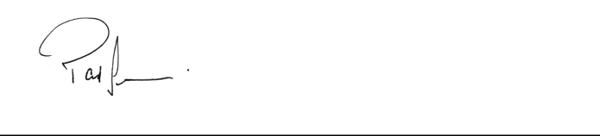

Paul Sekhri

Chairman, President and Chief Executive Officer

High Point, North Carolina

April 28, 2026

 |  |  | VTV THERAPEUTICS INC.
 |  |  | Proxy Statement
 |  |  | for the
 |  |  | Annual Meeting of Stockholders
 |  |  | To Be Held June 10, 2026
 |  |  | TABLE OF CONTENTS
 |  |  |  | Page
 | Information Concerning Solicitation and Voting |  |  |  |  | 1
 | Questions and Answers about the 2026 Annual Meeting |  |  | 2
 | Proposal 1 – Election of Directors |  |  | 7
 | Executive Officers |  |  | 10
 | Corporate Governance Matters |  |  | 11
 | Director Compensation |  |  | 15
 | Executive Compensation |  |  | 16
 | Proposal 2 - Ratification of Appointment of Independent Registered Public Accounting Firm |  |  | 22
 | Audit Committee Report |  |  | 24
 | Security Ownership of Certain Beneficial Owners and Management |  |  | 25
 | Delinquent Section 16(a) Reports |  |  |  | 29
 | Certain Relationships and Related-Party Transactions |  |  |  | 29
 | Stockholder Proposals |  |  | 33
 | Householding Matters |  |  | 33
 | Other Matters |  |  | 33
 | How to Attend the Annual Meeting |  |  | 34

VTV THERAPEUTICS INC.

PROXY STATEMENT

ANNUAL MEETING OF STOCKHOLDERS
TO BE HELD JUNE 10, 2026

Information Concerning Solicitation and Voting

This Proxy Statement is furnished to the holders of our Class A common stock and Class B common stock in connection with the solicitation of proxies on behalf of the Board of Directors of vTv Therapeutics, Inc. (the "Company", "we", "us" and "our") for use at the Annual Meeting of Stockholders to be held on June 10, 2026, at 9:00 a.m. Eastern time as a virtual-only meeting that will be held via live audio webcast, or for use at any adjournment or postponement thereof, for the purposes set forth herein and in the accompanying Notice of Annual Meeting of Stockholders. Only stockholders of record at the close of business on April 14, 2026 (the "record date"), are entitled to notice of and to vote at our Annual Meeting of Stockholders (the “Annual Meeting”).

We have elected to provide access to our proxy materials over the Internet under the U.S. Securities and Exchange Commission’s “notice and access” rules. As a result, we are mailing to our stockholders a Notice of Internet Availability of Proxy Materials instead of paper copies of this Proxy Statement and our Annual Report on Form 10-K for the year ended December 31, 2025 (the "2025 Annual Report"). The Notice contains instructions on how to access those documents over the Internet. The Notice also contains instructions on how stockholders can receive a paper copy of our proxy materials, including this Proxy Statement, our 2025 Annual Report and a proxy card or voting instruction form. We believe that providing our proxy materials over the Internet increases the ability of our stockholders to connect with the information they need, while reducing the environmental impact and cost of our Annual Meeting.

Each holder of our Class A common stock and Class B common stock is entitled to one vote for each share held as of the record date with respect to all matters that may be considered at the Annual Meeting. Stockholder votes will be tabulated by persons appointed by the Board of Directors to act as inspectors of election for the Annual Meeting.

We bear the expense of soliciting proxies. Our directors, officers, or employees may also solicit proxies personally or by telephone, telegram, facsimile, or other means of communication. We do not intend to pay additional compensation for doing so. In addition, we might reimburse brokers, banks, and other nominees for their expenses in forwarding soliciting materials to beneficial owners of our Class A common stock and Class B common stock.

1

QUESTIONS AND ANSWERS ABOUT THE 2026 ANNUAL MEETING Q: Why am I receiving these proxy materials?

- We are furnishing you these proxy materials in connection with the solicitation of proxies on behalf of our Board of Directors for use at the Annual Meeting. This Proxy Statement includes information that we are required to provide under the rules of the Securities and Exchange Commission (the "SEC") and is designed to assist you in voting your shares.

Proxies in proper form received by us at or before the time of the Annual Meeting will be voted as specified. Stockholders may specify their choices by marking the appropriate boxes on your proxy card. If a proxy card is dated, signed and returned without specifying choices, the proxies will be voted in accordance with the recommendations of the Board of Directors set forth in this Proxy Statement, and, in their discretion, upon such other business as may properly come before the Annual Meeting. Business transacted at the Annual Meeting will be confined to the purposes stated in the Notice of Annual Meeting of Stockholders. Shares of our Class A common stock and Class B common stock cannot be voted at the Annual Meeting unless the holder is present or represented by proxy.

Q: Who may vote at the Annual Meeting?

- The Board of Directors set April 14, 2026, as the record date for the Annual Meeting. If you owned shares of our Class A common stock or Class B common stock at the close of business on April 14, 2026, you may attend and vote at the Annual Meeting. On all matters to be voted on, each stockholder is entitled to one vote for each share of Class A common stock and one vote for each share of Class B common stock held by such stockholder. As of April 14, 2026, there were 3,938,654 shares of our Class A common stock and 241 shares of our Class B common stock outstanding and entitled to vote at the Annual Meeting.

Q: Are any stockholders entitled to nominate any directors for election to the Board of Directors?

- Based upon certain agreements entered into by the Company at the time of its initial public offering ("IPO") in 2015 and a financing completed in February 2024, certain investors have the right to nominate directors for election to the Board of Directors.

Under the Investor Rights Agreement, dated as of July 29, 2015, as amended by the First Amendment to Investor Rights Agreement the ("First Amendment"), dated as of February 27, 2024 (as so amended, the “Amended Investor Rights Agreement”), M&F TPP Holdings Two LLC, as successor in interest to vTv Therapeutics Holdings LLC (“M&F”) and an affiliate of MacAndrews & Forbes Incorporated (together with its affiliates other than vTv Therapeutics Inc., “MacAndrews”), has the right to designate as nominees (the “MacAndrews Nominees”) two of the seven director nominees for election to the Board of Directors so long as certain MacAndrews parties continue to beneficially own in the aggregate at least 50% of the shares of common stock of the Company owned by them as of the date of the First Amendment. Mr. Nelson and Dr. Al Marzooqi, who are presently serving as directors and are named in this Proxy Statement for re-election to the Board of Directors at the Annual Meeting, are the MacAndrews Nominees.

Under the Securities Purchase Agreement dated February 27, 2024 (the "2024 Securities Purchase Agreement"), the Company agreed that the lead investors named in the 2024 Securities Purchase Agreement (the "2024 Lead Investors") would have the right to nominate an aggregate of three directors for election to the Board of Directors, provided they continued to hold at least 50% of the shares and pre-funded warrants acquired via the 2024 Securities Purchase Agreement. Drs. Akkaraju, Cheong and Phillips, who are presently serving as directors and are named in this Proxy Statement for re-election to the Board of Directors at the Annual Meeting, are the nominees of the 2024 Lead Investors.

Q: What is the difference between holding shares as a stockholder of record and as a beneficial owner?

- If your shares are registered directly in your name with our transfer agent, Equiniti Trust Company LLC, you are considered, with respect to those shares, a stockholder of record. As a stockholder of record, you have the right to vote during the virtual Annual Meeting if you have registered.

If your shares are held by a broker, bank or other nominee, you are considered the beneficial owner of shares held in street name. In that case, the proxy materials have been forwarded to you by your broker, bank or other nominee who is considered, with respect to those shares, the stockholder of record. As the beneficial owner, you have the right to

2

direct your broker, bank or other nominee on how to vote your shares by using the voting instructions included in the proxy materials. Q: What is the quorum requirement for the Annual Meeting?

- Holders of at least 33.4% of our outstanding shares of capital stock entitled to vote as of the record date must be present at the Annual Meeting in order for us to hold the Annual Meeting and conduct business. This is called a quorum. Your shares will be counted as present at the Annual Meeting if you:

  - Are present and entitled to vote at the Annual Meeting; or

  - Properly submit a proxy card or voter instruction card.

If you are present or represented by proxy at the Annual Meeting but withhold your vote or abstain from voting on any or all proposals, your shares are still counted as present and entitled to vote. Each of the proposals listed in this Proxy Statement identifies the votes needed to approve the proposed action.

Q: What proposals will be voted on at the Annual Meeting?

- The two proposals to be voted on at the Annual Meeting are as follows:

  - To elect the seven director nominees named in the Proxy Statement to serve until our next annual meeting or until their successors have been duly elected and qualified; and

  - To ratify the appointment of Ernst & Young LLP as our independent registered public accounting firm for the fiscal year ending December 31, 2026.

We will also consider any other business that properly comes before the Annual Meeting. As of the record date, we are not aware of any other matters to be submitted for consideration at the Annual Meeting. If any other matters are properly brought before the Annual Meeting, the proxy named in the proxy card or voter instruction card will vote the shares.

Q: What is the vote required for each proposal and what are my voting choices?

- With respect to Proposal 1, the election of directors, you may vote FOR or WITHHOLD. A plurality of the votes cast is required to be elected as a director. A “plurality of the votes cast” means that the seven director nominees that receive the greatest number of votes cast “FOR” will be elected. If you WITHHOLD from voting on any of the nominees presented in Proposal 1, the withhold vote will have no effect on the outcome of the vote .

With respect to Proposal 2, you may vote FOR or AGAINST the proposal, or you may indicate that you wish to ABSTAIN from voting on the proposal. The proposal requires the affirmative vote of a majority in voting power of shares of stock present in person or represented by proxy and entitled to vote on the proposal. If you ABSTAIN from voting, it will have the same effect as a vote AGAINST the proposal.

- How does our Board of Directors recommend that I vote?

- Our Board of Directors recommends that you vote:

  - FOR the election of the seven director nominees named in this Proxy Statement.

  - FOR the ratification of the appointment of Ernst & Young LLP as our independent registered public accounting firm for the fiscal year ending December 31, 2026.

Q: What is the effect of a broker non-vote?

- Brokers, banks or other nominees who hold shares for a beneficial owner have the discretion to vote only on proposals that are considered to be "routine" when they have not received voting instructions from a beneficial owner of shares at least 10 days prior to the Annual Meeting. A broker non-vote occurs when a broker, bank or other nominee does not receive voting instructions from the beneficial owner and does not have the discretion to direct the voting of the shares. We believe Proposal 1 will be considered non-routine, meaning brokers, banks and other nominees will not have discretionary authority to vote on this matter, while Proposal 2 will be considered a routine matter and brokers, banks and other nominees will have discretionary voting authority with respect to such proposal. Therefore, broker non-votes will occur with respect to Proposal 1 if you do not instruct your broker, bank or other nominee how to vote your

3

shares, but any such broker non-votes will not affect the voting on Proposal 1 because they are not considered entitled to vote on this proposal. We do not expect to receive broker non-votes on Proposal 2 because brokers, banks and other nominees will have discretionary authority to vote uninstructed shares on this proposal, but to the extent broker non-votes are recorded they will have no effect on Proposal 2.

Q: Why did I receive a Notice of Internet Availability of Proxy Materials instead of a full set of Proxy Materials?

- Pursuant to rules adopted by the SEC we have elected to provide access to our proxy materials over the Internet. Accordingly, on or about April 28, 2026, we have sent you a Notice of Internet Availability of Proxy Materials (the "Notice of Internet Availability") to provide you with the website address where you may access the Notice of 2026 Annual Meeting of Stockholders (the "Notice of Annual Meeting"), this Proxy Statement and proxy card, and our 2025 Annual Report (collectively the "Proxy Materials"). The Proxy Materials are available to stockholders on our website at https://shareholder.broadridge.com/vtvt2026. The Notice of Internet Availability will provide instructions as to how stockholders may access and review the Proxy Materials or, alternatively, how to request that a copy of the Proxy Materials, including a proxy card, be sent to them by mail. The Notice of Internet Availability will also provide voting instructions. Please note that website addresses referenced herein are intended to provide inactive, textual references only, and the information on these websites is not incorporated by reference in or considered to be a part of this document.

- Can I access these Proxy Materials on the Internet?

- Yes. The Notice of Annual Meeting, Proxy Statement, and 2025 Annual Report are available for viewing and downloading at https://shareholder.broadridge.com/vtvt2026. They are also available under the sections of our website, www.vtvtherapeutics.com, Media and Investors—Financial Information—Annual Reports & Proxy, as well as through the SEC’s EDGAR system at www.sec.gov. All materials will remain posted on https://shareholder.broadridge.com/vtvt2026 at least until the conclusion of the Annual Meeting.

- How do I attend the Annual Meeting?

- The 2026 Annual Meeting will be held on Tuesday, June 10, 2026, at 9:00 a.m. Eastern Time and will be conducted solely by remote communication, in a virtual meeting format. vTv stockholders of record as of April 14, 2026, will be able to participate in the Annual Meeting online by visiting www.virtualshareholdermeeting.com/VTVT2026, where you will be able to vote electronically and submit questions. You will not be able to attend the Annual Meeting in person. You will need the 16-digit control number on your notice or your proxy card to participate in the Annual Meeting.

- How can I participate and ask questions at the Annual Meeting?

- In order to submit a question at the 2026 Annual Meeting, you will need your 16-digit control number that is printed on the notice or proxy card that you received in the mail, or via email if you have elected to receive material electronically. You may log in 15 minutes before the start of the Annual Meeting and submit questions online. If you would like to submit a question during the Annual Meeting, once you have logged into the webcast, simply click on the “Q&A” icon on the screen, type in your question, then click “Send” to submit. You can submit a question up until the time we indicate that the question-and-answer session is concluded.

- How may I vote my shares at the Annual Meeting?

- If your shares were registered directly in your name with our transfer agent, Equiniti Trust Company, LLC, on the record date, you are considered, with respect to those shares, the stockholder of record. As the stockholder of record, you have the right to vote during the live webcast of the Annual Meeting. If your shares are held by a broker, bank or other nominee, you are considered the beneficial owner of shares held in street name. As the beneficial owner, you are also invited to attend the Annual Meeting. Because a beneficial owner is not the stockholder of record, you may not vote these shares during the live webcast of the Annual Meeting unless you obtain a “legal proxy” from the broker, bank or other nominee that holds your shares, giving you the right to vote the shares at the Annual Meeting. Please contact your broker, bank or other nominee if you wish to obtain such a “legal proxy”.

To vote during the live webcast of the Annual Meeting, visit www.virtualshareholdermeeting.com/VTVT2026. You may also visit this web site to submit questions before or during the meeting. Please be sure to follow instructions

4

found on your proxy card and/or voting instruction form. Stockholders will be able to attend via the Annual Meeting platform beginning 15 minutes prior to the meeting start time of 9:00 a.m. Eastern time on June 10, 2026.

Q; What if I have technical or other “IT” problems logging into or participating in the Annual Meeting webcast?

- The virtual meeting platform is fully supported across browsers (MS Edge, Firefox, Chrome and Safari) and devices (desktops, laptops, tablets and cell phones) running the most up-to-date version of applicable software and plugins. Participants should ensure that they have a strong WIFI connection wherever they intend to participate in the meeting. Stockholders are encouraged to log into the webcast at least 15 minutes prior to the start of the meeting to test their Internet connectivity. If you experience technical difficulties during the check-in process, call one of the appropriate numbers noted at the bottom of the login page.

- How can I vote my shares without attending the Annual Meeting?

- If your shares are held by a broker, bank or other nominee, they should send you instructions that you must follow in order to have your shares voted. If you hold shares in your own name, you may vote by proxy in any one of the following ways:

  - Via the Internet by accessing the Proxy Materials on the secured website www.proxyvote.com and following the voting instructions on that website; or

  - Via telephone by calling toll free 800-690-6903 and following the recorded instructions; or

  - Via mail by completing, dating, signing and returning the proxy card in the postage-paid envelope provided to you.

Even if you plan to attend the live webcast of the Annual Meeting, we encourage you to vote in advance by Internet, telephone or mail so that your vote will be counted if you later decide not to attend the Annual Meeting.

The Internet and telephone voting procedures are designed to authenticate stockholders’ identities by use of a control number to allow stockholders to vote their shares and to confirm that stockholders’ instructions have been properly recorded. Voting via the Internet or telephone must be completed before the commencement of the Annual Meeting at 9:00 a.m. Eastern time on June 10, 2026. Of course, as described in the immediately preceding question and answer, you can always attend the live webcast of the Annual Meeting and vote your shares at that time. If you submit or return a proxy card without giving specific voting instructions, your shares will be voted as recommended by the Board of Directors, as permitted by law.

- How can I change my vote after submitting it?

- If you are a stockholder of record, you can revoke your proxy before your shares are voted at the Annual Meeting by:

  - Filing a written notice of revocation bearing a later date than the proxy with our Secretary at 3980 Premier Drive, Suite 110, High Point, North Carolina 27265 at or before the taking of the vote at the Annual Meeting; or

  - Duly executing a later-dated proxy relating to the same shares and delivering it to our Secretary at 3980 Premier Drive, Suite 110, High Point, North Carolina 27265 at or before the taking of the vote at the Annual Meeting; or

  - Attending the Annual Meeting and voting during the live webcast (although attendance during the live webcast of the Annual Meeting will not in and of itself constitute a revocation of a proxy); or

  - If you voted by telephone or via the Internet, voting again by the same means prior to the commencement of the Annual Meeting at 9:00 a.m. Eastern time on June 10, 2026 (your latest telephone or Internet vote, as applicable, will be counted and all earlier votes will be disregarded).

If you are a beneficial owner of shares, you may submit new voting instructions by contacting your broker, bank or other nominee that is the record holder of your shares. You may also vote at the Annual Meeting if you obtain a legal proxy from them.

Q: Where can I find the voting results of the Annual Meeting?

- We will announce the preliminary voting results at the Annual Meeting. We will publish the results in a Current Report on Form 8-K filed with the SEC within four business days of the Annual Meeting. If the official results are not

5

available at that time, we will provide preliminary voting results in the Form 8-K and will provide the final results in an amendment to the Form 8-K as soon as they become available.

Q: What are the implications of being a “smaller reporting company?”

- We are a “smaller reporting company” as that term is defined in Rule 12b-2 under the Securities Exchange Act of 1934 (the "Exchange Act") and therefore are permitted to take advantage of certain reduced reporting requirements. We provide in this Proxy Statement the scaled disclosure permitted, including certain executive compensation disclosures required by a smaller reporting company. We will continue to qualify as a smaller reporting company as long as 1) our public float is less than $250 million, or 2) we have less than $100 million in annual revenues and public float of less than $700 million.

6

PROPOSAL ONE

ELECTION OF DIRECTORS

Nominees

At the Annual Meeting, stockholders will vote to elect the seven nominees named in this Proxy Statement as directors, each of whom will serve until his or her successor is duly elected and qualified or until such director’s earlier death, resignation, disqualification or removal. If you are a stockholder of record, unless you mark your proxy card to withhold authority to vote for any of the nominees, the proxy holder will vote the proxies received by it for the seven nominees named below. All of the nominees are currently directors and each has consented to be named in this Proxy Statement and to serve if elected. In the event that any nominee is unable or declines to serve as a director at the time of the Annual Meeting, your proxy will be voted for any nominee designated by the Board of Directors to fill the vacancy and subject to any required consents under the Amended Investor Rights Agreement and 2024 Securities Purchase Agreement described below. We do not expect that any nominee will be unable or will decline to serve as a director. If you are a beneficial owner of shares held in street name and you do not provide your broker, bank or other nominee with voting instructions, your broker, bank or other nominee may not vote your shares on the election of directors. Therefore, it is important that you vote.

Certain stockholders of the Company have the right to nominate directors for election to the Board of Directors. Under the Amended Investor Rights Agreement, MacAndrews, subject to applicable corporate governance rules of the SEC and the Nasdaq Stock Market listing rules (which may require MacAndrews to designate independent directors), has the right to designate two nominees for election to the Board of Directors, so long as certain MacAndrews parties continue to beneficially own in the aggregate at least 50% of the shares of common stock of the Company owned by them as of the date of the First Amendment. In addition, the 2024 Lead Investors have the right to designate an aggregate of three nominees for election to the Board of Directors, provided they continue to hold at least 50% of the shares and pre-funded warrants acquired via the 2024 Securities Purchase Agreement. Mr. Nelson and Dr. Al Marzooqi are the MacAndrews Nominees; Drs. Akkaraju, Cheong, and Phillips are the nominees of the 2024 Lead Investors.

The name of and certain information regarding each director nominee as of April 28, 2026, is set forth below. This information is based on data furnished to us by the nominees. There is no family relationship between any director, executive officer or person nominated to become a director or executive officer. The business address for each nominee for matters regarding the Company is 3980 Premier Drive, Suite 110, High Point, North Carolina 27265.

Director Nominees

Name |  | Age |  | Position(s) with vTv Therapeutics Inc. |  | Director Since
Srinivas Akkaraju |  | 58 |  | Director |  | February 2024
Raymond Cheong |  | 44 |  | Director |  | February 2024
Fahed Al Marzooqi |  | 48 |  | Director |  | July 2022
Richard S. Nelson |  | 56 |  | Director |  | November 2020
Anne M. Phillips |  | 72 |  | Director |  | March 2024
Paul Sekhri |  | 68 |  | Director |  | August 2022
Daniel K. Spiegelman |  | 67 |  | Director |  | June 2024

7

Director Nominees

Srinivas Akkaraju, M.D., Ph.D.

Dr. Akkaraju has served as a director on our board since February 2024. Dr. Akkaraju is the founder and managing general partner at Samsara BioCapital. Previously, from April 2013 to February 2016, he served as a general partner of Sofinnova Ventures. From January 2009 until April 2013, he served as managing director of New Leaf Venture Partners. Previously, he served as a managing director at Panorama Capital, LLC, a private equity firm. Prior to co-founding Panorama Capital, Dr. Akkaraju was with J.P. Morgan Partners, which he joined in 2001 and of which he became a partner in 2005. From October 1998 to April 2001, he was in business and corporate development at Genentech, Inc. (now a wholly owned member of The Roche Group), a biotechnology company, most recently as senior manager. Prior to joining Genentech, Dr. Akkaraju was a graduate student at Stanford University, where he received his M.D. and a Ph.D. in immunology. He received his undergraduate degrees in biochemistry and computer science from Rice University. Dr. Akkaraju serves as a director of Scholar Rock Holding Corporation, Mineralys Therapeutics, Inc., Kalaris Therapeutics, Inc., Inventiva Pharma, and several private biotechnology companies and previously served as a director of Intercept Pharmaceuticals, Inc. (a wholly owned biopharmaceutical subsidiary of Alfasigma S.p.A.), Syros Pharmaceuticals, Inc., aTyr Pharma, Inc., and Amarin Corporation plc. Given his education and extensive experience in investing in and advising public and private companies in our industry, we believe Dr. Akkaraju is well qualified to serve on our Board of Directors.

Raymond Cheong, M.D., Ph.D.

Dr. Cheong has served as a director on our board since February 2024. Dr. Cheong is a managing director at Baker Brothers Advisors LP. Prior to joining Baker Brothers in 2013, Dr. Cheong completed an M.D. and a Ph.D. in biomedical engineering from Johns Hopkins University, where he was awarded the Michael A. Shanoff Award for best thesis research within the School of Medicine. Prior to attending Johns Hopkins, he earned a B.S. in chemical engineering from the University of Maryland, College Park. He serves on the boards of Istari Oncology, Inc., a private biotechnology company, and Madrigal Pharmaceuticals, Inc. Given his education and experience in advising public and private life sciences companies, we believe Dr. Cheong is well qualified to serve on our Board of Directors.

Fahed Al Marzooqi, M.D.

Dr. Al Marzooqi has served as a director on our board since July 2022. Since January 2025, Dr. Al Marzooqi has held the position of chief executive officer of the Integrated Health Solutions platform at M42. Prior to his current role, he was the chief operating officer of G42 Healthcare, M42 Deputy Group Chief Operating Officer since June 2023, and was the chairman of the board of Malaffi – Abu Dhabi Health Information Exchange from October 2021 to March 2023. Prior to joining G42 Healthcare, from February 2018 to April 2021 he was the chief administrative officer at Cleveland Clinic Abu Dhabi where he was an integral part of multiple high-impact strategic programs for the hospital. Dr. Al Marzooqi graduated with a B.S. in mathematics and an M.D. from Dalhousie University in Canada, and completed a five-year residency program in anaesthesiology at the University of British Columbia in Vancouver. Given his clinical and business experience, we believe Dr. Al Marzooqi is well qualified to continue serving our Board of Directors.

Richard S. Nelson

Mr. Nelson has served as a director on our board since November 2020. Since May 2024, Mr. Nelson has served as our chief business officer and previously served as our executive vice president, corporate development since August 2022. Previously, Mr. Nelson served as our interim chief executive officer from March 2022 until August 2022. Mr. Nelson also has served as executive vice president, corporate development for Vericast from August 2015 to the present. Prior to joining Vericast, Mr. Nelson held senior corporate and business development positions with multiple public and private companies, including The Nielsen Company, IAC/InterActive Corp. and Trendum. Mr. Nelson began his career as a mergers and acquisition attorney at Skadden, Arps, Slate, Meagher & Flom, LLP. Mr. Nelson earned his B.A. of business administration in finance from the Ross School of Business at the University of Michigan and a J.D. from New York University School of Law. Mr. Nelson is a member of the National Advisory Board for the University of Michigan Rogel Cancer Center and a member of the board of directors of Think Pink Rocks breast cancer charity. Given his experience in advising public and private companies on business development matters, we believe Mr. Nelson is well qualified to continue serving on our Board of Directors.

8

Anne M . Phillips, M.D.

Dr. Phillips has served as a director on our board since March 2024. Dr. Phillips was senior vice president of clinical, medical and regulatory affairs at Novo Nordisk Inc., a pharmaceutical company, from 2011 until her retirement in August 2022. Previously, she served as a vice president in various positions at GlaxoSmithKline plc, which she joined in 1998, and prior to this, Dr. Phillips was head of the infectious diseases program and deputy physician-in-chief at Wellesley Central Hospital/St. Michael’s Hospital in Toronto. She is a Fellow of The Royal College of Physicians and Surgeons of Canada, earned an M.D. from the University of Toronto, and received a B.Sc. in zoology from the University of Western Ontario. Dr. Phillips currently serves on the board of directors of Barinthus Biotherapeutics plc and Sagimet Biosciences Inc. Based upon her education and extensive experience in advising companies, we believe Dr. Phillips is well qualified to serve on our Board of Directors.

Paul Sekhri

Mr. Sekhri's biography is provided below. See Executive Officers. Based upon his extensive experience in leading and advising life sciences and biotechnology companies, we believe Mr. Sekhri is well qualified to serve on our Board of Directors.

Dan Spiegelman

Mr. Spiegelman has served as a director on our board since June 2024. Mr. Spiegelman was most recently chief financial officer and executive vice president of BioMarin Pharmaceutical Inc (2012-2020), a company focused on developing, manufacturing and commercializing treatments for rare genetic disorders. Prior to BioMarin, Mr. Spiegelman served as chief financial officer and senior vice president of CV Therapeutics, Inc. for 11 years through its sale in 2009 to Gilead, and before that was treasurer at Genentech, Inc. Mr. Spiegelman currently serves as a Venture Partner at Samsara BioCapital and provides consulting and board services to various life sciences companies. He currently serves on the board of directors of Spruce Biosciences, Inc., Maze Therapeutics, Inc., and several private biotechnology companies. Mr. Spiegelman received his M.B.A. from the Stanford Graduate School of Business and a B.S. in economics from Stanford University. Given his education and extensive experience in serving as a financial expert and advisor for public and private companies, we believe Mr. Spiegelman is well qualified to serve on our Board of Directors.

Required Vote

The seven director nominees receiving the highest number of affirmative votes of our Class A common stock and Class B common stock, present or represented by proxy and voting as a single class, shall be elected as directors. Votes withheld from any nominee and broker non-votes will be counted for purposes of determining the presence or absence of a quorum for the transaction of business at the Annual Meeting, but they will have no legal effect on the election of directors.

The Board of Directors unanimously recommends that stockholders vote FOR each of the seven director nominees listed above.

9

 |  |  |  | EXECUTIVE OFFICERS
Our executive officers as of April 28, 2026, are set forth below:
Name |  | Age |  |  | Position(s)
Paul Sekhri |  | 68 |  |  | Chief Executive Officer
Michael Tung |  | 50 |  |  | Executive Vice President and Chief Financial Officer

Set forth below is certain additional information concerning our executive officers, including their respective positions with us and prior business experience.

Paul Sekhri

Mr. Sekhri serves as our president and chief executive officer and is a member of our Board of Directors, positions he has held since August 2022. In March 2024, Mr. Sekhri was appointed Chairman of the Board of Directors. Mr. Sekhri also began serving as an operating partner for Petrichor LP in April 2026. Before joining the Company, from January 2019 through April 2022, Mr. Sekhri was president and chief executive officer of eGenesis, Inc. and from February 2015 to January 2019, he was president and chief executive officer of Lycera Corporation. Earlier in his career Mr. Sekhri held senior leadership positions with multiple, global pharmaceutical companies including Sanofi S.A., Teva Pharmaceutical Industries, Ltd., ARIAD Pharmaceuticals, Inc., and Novartis Pharma A.G. Mr. Sekhri led the biotechnology operating group at TPG Biotech, the life sciences venture capital arm of TPG Capital, and founded and served as chief executive officer of Cerimon Pharmaceuticals. Mr. Sekhri is also a member of the board of directors of AdhereTech, LLC, Likeminds, Veeva Systems Inc., Violet Therapeutics, Inc., and Deep Genomics, Inc. Mr. Sekhri is also the chairman of the board of directors of Resolution Therapeutics, Ltd. and Kaerus Bioscience. Mr. Sekhri also serves on the boards of various charitable organizations, including the Advisory Council of the New York Philharmonic and is chairman of Young Concert Artists, Inc. Mr. Sekhri previously served on the board of The Metropolitan Opera. Mr. Sekhri received his B.S. from University Maryland and also completed postgraduate studies in clinical anatomy and neuroscience from University of Maryland.

Michael Tung

Dr. Tung serves as our executive vice president and chief financial officer, a position he has held since May 2025. Before joining the Company, Dr. Tung was the chief financial officer of AdvanCell Pty Limited, an Australian clinical-stage radiopharmaceutical company from August 2023 to January 2025. From April 2020 until July 2023, Dr. Tung held the position of vice president-corporate strategy/investor relations with FibroGen Inc., a publicly traded biopharmaceutical company. From July 2016 to September 2019 he held the position of senior vice president-corporate strategy/investor relations at Aclaris Therapeutics, Inc., a publicly traded biopharmaceutical company. Before joining Aclaris, he led the portfolio construction and risk management of healthcare-dedicated funds as a portfolio manager at several firms. Dr. Tung earned B.A. and B.S. degrees in economics and biology, respectively, from The George Washington University, and a combined M.D./MBA from Tufts University School of Medicine. He is a licensed physician in the states of Massachusetts and New York.

10

CORPORATE GOVERNANCE MATTERS

Information about the Board

Our Board of Directors currently consists of seven directors. In accordance with our Amended and Restated Certificate of Incorporation, as amended, and our Second Amended and Restated By-laws (our "By-laws"), a majority of our Board of Directors may fix the number of directors; provided, however, that the 2024 Securities Purchase Agreement provides that the number of directors may not be increased beyond seven without the consent of the 2024 Lead Investors until the 2024 Lead Investors no longer own at least 50% of the securities they originally purchased pursuant to the 2024 Securities Purchase Agreement. Each director is to hold office until his or her successor is duly elected and qualified or until his or her earlier death, resignation, disqualification or removal. At any meeting of our Board of Directors, the presence in person of a majority of the total number of directors then in office will constitute a quorum for all purposes. Pursuant to the Amended Investor Rights Agreement, MacAndrews currently has the right to designate two director nominees and has so designated Mr. Nelson and Dr. Al Marzooqi as the nominees to stand for election at the Annual Meeting. Under the 2024 Securities Purchase Agreement the 2024 Lead Investors have the right to designate as nominees an aggregate of three directors. Drs. Akkaraju, Cheong, and Phillips are the nominees of the 2024 Lead Investors.

In compliance with the terms of the 2024 Securities Purchase Agreement, at least five directors to approve certain Company actions, including a sale of all or substantially all of the assets of the Company, a merger or other combination of the Company or the issuance of new debt, equity, or debt- or equity-like instruments. The vote of four directors, not inclusive of our chief executive officer, is required to terminate the services of our current chief executive officer or to appoint a different chief executive officer. These requirements apply for the three years following the date of the 2024 Securities Purchase Agreement.

Our Board of Directors has established an Audit Committee, Compensation Committee and Nominating and Corporate Governance Committee. Our Audit Committee currently consists of Mr. Spiegelman (Chair) and Drs. Akkaraju and Phillips. Our Compensation Committee consists of Dr. Phillips (Chair) and Drs. Cheong and Al Marzooqi. Our Nominating and Corporate Governance Committee currently consists of Dr. Cheong (Chair) and Mr. Spiegelman.

Our Board of Directors has undertaken a review of the independence of our directors and has determined that Drs. Akkaraju, Cheong, Al Marzooqi, and Phillips and Mr. Spiegelman are independent within the meaning of the Nasdaq Stock Market listing rules and meet the additional test for independence for Audit Committee members imposed by SEC regulation and Nasdaq Stock Market listing rules.

Family Relationships

There is no family relationship between any director, executive officer or person nominated to become our director or executive officer.

Selection of Nominees for the Board of Directors

The Nominating and Corporate Governance Committee of our Board of Directors has the responsibility of identifying individuals qualified to become members of our Board of Directors, consistent with criteria approved by our Board of Directors. The committee also recommends to our Board of Directors for approval director nominees, consistent with our director qualification criteria and any obligations under our contractual arrangements. Our corporate governance guidelines call for the committee to consider diversity to be an additional desirable characteristic in potential nominees. Although the Nominating and Corporate Governance Committee does not have a formal diversity policy concerning membership of the Board of Directors, it does consider diversity in its broadest sense when evaluating candidates, including persons diverse in gender, ethnicity, experience and background.

With respect to director nominee procedures, the Nominating and Corporate Governance Committee utilizes a broad approach for identification of director nominees and may seek recommendations from our directors, officers or stockholders, or it may choose to engage a search firm. In evaluating and determining whether to ultimately recommend a person as a candidate for election as a director, the Nominating and Corporate Governance Committee considers the qualifications set forth in our corporate governance guidelines, including the highest personal and professional ethics, integrity and values, demonstrated business acumen, experience and ability to use sound judgment to contribute to effective oversight of our business or financial affairs, strategic planning, and independence from management. It also takes into account specific characteristics and expertise that it believes will enhance the diversity of knowledge, expertise, background and personal

11

characteristics of the Board of Directors. The Nominating and Corporate Governance Committee may engage a third party to conduct or assist with the evaluation. Ultimately, the Nominating and Corporate Governance Committee seeks to recommend to the Board of Directors those nominees whose specific qualities, experience and expertise will augment the current Board of Directors’ composition and whose past experience evidences that they will:

- dedicate sufficient time, energy and attention to ensure the diligent performance of his or her duties; (2) comply with the duties and responsibilities set forth in our Corporate Governance Guidelines and in our By-laws; (3) comply with all duties of care, loyalty and confidentiality applicable to them as directors of publicly traded corporations organized in our jurisdiction of incorporation; and (4) adhere to our Code of Conduct and Ethics, including, but not limited to, the policies on conflicts of interest expressed therein.

The Nominating and Corporate Governance Committee considers stockholder recommendations of qualified nominees when such recommendations are submitted in accordance with the procedures described in our By-laws. To have a nominee considered by the Nominating and Corporate Governance Committee for election at the 2027 Annual Meeting of Stockholders, a stockholder must submit the recommendation in writing to the attention of our Secretary at our corporate headquarters no earlier than February 10, 2027 and no later than March 12, 2027. Any such recommendation must include the information as required by our By-laws and Rule 14a-19 under the Exchange Act. Once we receive the recommendation, we will deliver to the stockholder nominee a questionnaire that requests additional information about his or her independence, qualifications and other matters that would assist the Nominating and Corporate Governance Committee in evaluating the stockholder nominee, as well as certain information that must be disclosed about him or her in our Proxy Statement or other regulatory filings, if nominated. Stockholder nominees must complete and return the questionnaire within the timeframe provided to be considered for nomination by the Nominating and Corporate Governance Committee. See our By-laws for additional information regarding stockholder nominees.

The Nominating and Corporate Governance Committee received no recommendation for a director nominee from any stockholder for the director election to be held at the Annual Meeting.

Information Regarding Meetings of the Board and Committees

During 2025, our Board of Directors held five meetings and all of our directors attended at least 98% of the aggregate board and committee meetings for which they were eligible to attend. Under our Corporate Governance Guidelines, a copy of which is available on our website at www.vtvtherapeutics.com, members of our Board of Directors are expected to attend the annual meeting of stockholders. All but one of the Company's directors as of the 2025 Annual Meeting of Stockholders held on June 10, 2025, attended the meeting.

Committees of our Board of Directors

Our Board of Directors has adopted written charters for each of its permanent committees, all of which are available in the Media and Investors— Corporate Governance—Documents & Charters section of our website at www.vtvtherapeutics.com. The following table provides membership information of our directors in each committee of our Board of Directors.
 |  |  |  | Nominating &
 |  |  |  | Corporate
Audit |  | Compensation |  | Governance
Committee |  | Committee |  | Committee

Srinivas Akkaraju

Raymond Cheong

Fahed Al Marzooqi

Anne Phillips

Dan Spiegelman

= Committee Chair

= Member

12

Audit Committee

Our Audit Committee currently consists of Mr. Spiegelman (Chair), and Drs. Akkaraju and Phillips. The Board of Directors has determined that Mr. Spiegelman qualifies as an “audit committee financial expert” as such term is defined in Item 407(d)(5) of Regulation S-K. Our Board of Directors has determined that all members of the Audit Committee are independent within the meaning of the Nasdaq Stock Market listing rules and meet the additional test for independence for Audit Committee members imposed by SEC regulation and the Nasdaq Stock Market listing rules.

Our Audit Committee met four times during 2025. Our Audit Committee assists the Board of Directors in monitoring the audit of our financial statements, our independent registered public accounting firm’s qualifications and independence, the performance of our independent auditors and our compliance with legal and regulatory requirements. The Audit Committee has direct responsibility for the appointment, compensation, retention (including termination) and oversight of our independent auditors, and our independent auditors report directly to the Audit Committee. The Audit Committee also reviews and approves related party transactions as required by the applicable Nasdaq rules.

Compensation Committee

Our Compensation Committee consists of Dr. Phillips (Chair) and Drs. Cheong and Al Marzooqi. Our Board of Directors has determined that all members of the Compensation Committee are independent within the meaning of the Nasdaq Stock Market listing rules and meet the additional test for independence for Compensation Committee members imposed by SEC Regulation and Nasdaq Stock Market listing rules. Our Compensation Committee met five times during 2025. Our Compensation Committee is responsible for reviewing and recommending policies relating to the compensation and benefits of our directors and employees, including our chief executive officer and other executive officers.

The Compensation Committee has the sole authority to retain and terminate any compensation consultant to assist in the evaluation of employee compensation and to approve the consultant’s fees and the other terms and conditions of the consultant’s retention. The Compensation Committee may form and delegate authority to subcommittees where appropriate, provided that the subcommittees are composed entirely of directors who satisfy the applicable independence requirement of our Corporate Governance Guidelines and the Nasdaq Stock Market listing rules, subject to any applicable controlled company or other exemption.

In accordance with the Compensation Committee’s charter, our president and chief executive officer may not be present during voting or deliberations of the Compensation Committee regarding his or her compensation.

Nominating and Corporate Governance Committee

Our Nominating and Corporate Governance Committee currently consists of Dr. Cheong (Chair) and Mr. Spiegelman. Our Nominating and Corporate Governance Committee met once during 2025. Our Nominating and Corporate Governance Committee is responsible for selecting or recommending that the Board of Directors select candidates for election to our Board of Directors, developing and recommending to the Board of Directors corporate governance guidelines that are applicable to us and overseeing Board of Directors and management evaluations.

Finance Committee

In 2025, the Board formed the Finance Committee in connection with the 2025 Private Placement. During 2025, the Finance Committee consisted of Mr. Sekhri (Chair), Dr. Phillips, and Mr. Spiegelman. The Finance Committee met once in 2025.

Risk Oversight

Our Board of Directors has an oversight role, as a whole and at the committee level, in overseeing management of our risks. Our Board of Directors regularly reviews information regarding our credit, liquidity and operations, as well as the risks associated with each. The Compensation Committee is responsible for overseeing the management of risks relating to its employee compensation plans and arrangements, and the Audit Committee oversees the management of financial risks. While each committee is responsible for evaluating certain risks and overseeing the management of such risks, the entire Board of Directors is regularly informed through committee reports about such risks.

Code of Conduct and Ethics

Our Board of Directors has adopted a Code of Conduct and Ethics that applies to all of our directors, officers and employees and is intended to comply with the relevant listing requirements for a code of conduct as well as qualify as a “code

13

of ethics” as defined by the rules of the SEC. The Code of Conduct and Ethics contains general guidelines for conducting our business consistent with the highest standards of business ethics. We intend to disclose any future amendments to certain provisions of our Code of Conduct and Ethics, or waivers of such provisions applicable to any principal executive officer, principal financial officer, principal accounting officer and controller, or persons performing similar functions, and our directors, on our website at www.vtvtherapeutics.com. The Code of Conduct and Ethics is available on our website under Documents & Charters in the Media and Investors—Corporate Governance section of our website at www.vtvtherapeutics.com.

Communications with the Board of Directors

Stockholders who wish to communicate with members of our Board of Directors, including the independent directors individually or as a group, may send correspondence to them in care of our Secretary at our principal executive offices at 3980 Premier Drive, Suite 110, High Point, North Carolina 27265. Such communication will be forwarded to the intended recipient(s). We currently do not intend to have our Secretary screen this correspondence, but we may change this policy if directed by our Board of Directors due to the nature or volume of the correspondence.

Securities Trading Policy

We have adopted a Securities Trading Policy (the “Trading Policy”) that applies to all employees, consultants, contractors, officers and directors of the Company with respect to engaging in transactions in our securities and securities of other publicly traded companies. The Trading Policy is designed to prevent insider trading and ensure compliance with federal securities laws and Nasdaq listing standards and prohibits transactions in the Company’s securities or the securities of third parties while in possession of material non-public information. The Trading Policy also prohibits providing material non-public information about the Company or third parties to others who may trade while in possession of such information. The Trading Policy further prohibits insiders from engaging in short sales of our securities and from trading in public options or other derivative securities and also restricts directors, executive officers, employees and certain other persons who are likely to have access to material nonpublic information from trading during quarterly blackout periods. In addition, the Trading Policy requires directors, executive officers and designated others to obtain pre-clearance prior to trading in any Company securities and prior to entering into any Rule 10b5-1 trading plan.

The foregoing summary does not purport to be complete and is qualified by reference to the Trading Policy, a copy of which is filed as Exhibit 19.1 to our 2025 Annual Report, filed with the SEC on March 10, 2026.

14

DIRECTOR COMPENSATION

The following table sets forth the total compensation paid to each of our non-employee directors for the fiscal year ended December 31, 2025.

 | Fees Earned or | Option |  | Total | Option Awards
Name | Paid in Cash | Awards (1) |  | Total | Option Awards
Name | ($) | ($) |  | ($) | Outstanding
Fahed Al Marzooqi | 45,558 | 50,296 | (2) | 95,854 | 13,555
Srinivas Akkaraju | 47,500 | 50,296 | (2) | 97,796 | 10,983
Raymond Cheong | 68,558 | 50,296 | (2) | 118,854 | 10,983
Anne M. Phillips | 58,615 | 50,296 | (2) | 108,911 | 10,860
Daniel Spiegelman | 64,000 | 50,296 | (2) | 114,296 | 10,000

- The amounts reported in the table above represent the aggregate grant date fair value of the award, computed in accordance with FASB ASC Topic 718. Assumptions used in the calculation of these amounts are included in Note 4 of the financial statements included in our 2025 Annual Report.

- Amount reflects an option to purchase 4,000 shares of our Class A common stock granted on June 10, 2025, that will vest on the one-year anniversary of the date of grant or the AGM following the date of grant, whichever is sooner.

In 2025, our Board of Directors amended the compensation program for our non-employee directors. Under the policy as amended, each non-employee member of the board is entitled to receive:

- Upon appointment, an option to purchase 8,000 option shares of our Class A common stock (or the equivalent value thereof in restricted stock, restricted stock units or cash). The option will vest monthly over the three-year period following the date of grant.
- Upon election and/or re-election at each annual meeting of stockholders, an option to purchase 4,000 option shares of our Class A common stock (or the equivalent value thereof in restricted stock, restricted stock units or cash), prorated to reflect the number of months served as a director if such elected director was initially appointed during the 12-month period preceding such meeting. The option shares or other equity or equity-based compensation will generally vest on the one-year anniversary of the date of grant.

- Upon appointment as chairperson of our Board of Directors, the initial grant shall consist of an option to purchase 4,375 option shares of our Class A common stock (or the equivalent value thereof in restricted stock, restricted stock units or cash). The option shares or other equity or equity-based compensation will generally vest on the one-year anniversary of the date of grant.

- An annual cash retainer of $40,000 paid quarterly for each member of the Board of Directors with the non-executive chairperson paid an additional annual cash retainer of $35,000 paid quarterly.
- An annual cash retainer of $20,000 for the chair of the Audit Committee, $12,000 for the chair of the Compensation Committee and $8,000 for the chair of the Nominating and Corporate Governance Committee, other than the chairperson of the Board of Directors.
- An annual cash retainer of $7,500 for members of the Audit Committee, $6,000 for members of the Compensation Committee and $4,000 for members of the Nominating and Corporate Governance Committee, other than the chairperson of the Board of Directors.

In addition, in the event a lead independent director is appointed, the lead independent director will be entitled to receive a cash retainer of $15,000 paid quarterly. Dr. Cheong was appointed the lead independent director in March 2024.

In addition, all directors will be reimbursed for out-of-pocket expenses incurred in connection with their services. All amounts payable, including vesting of equity grants, are subject to continued service as a member of our Board of Directors.

15

EXECUTIVE COMPENSATION

Summary Compensation Table

The following summary compensation table sets forth information regarding the compensation paid, awarded to or earned by our president and chief executive officer and our executive vice president and chief financial officer, our two most highly compensated executive officers during the year ended December 31, 2025. This table also includes information about our former executive vice president and chief financial officer, who served in an executive officer capacity until his resignation effective March 21, 2025. These three individuals were the only executive officers during the year ended December 31, 2025 ¹(each a “named executive officer” or "NEO").
 |  |  |  |  |  | Non-Equity |  | Option |  | All Other
 |  |  |  | Salary |  | Incentive Plan |  |  |  | All Other |  | Total
Name and Principal Position |  | Year |  |  |  | Compensation |  | Awards |  | Compensation |  | Total
 |  |  |  | ($) |  | ($) (1) |  | ($) (2) |  | ($) |  | ($) (2)
Paul Sekhri (3) |  | 2025 |  | 673,000 |  | 343,230 |  | 5,601,712 |  | 20,310 | (7) | 6,638,252
President and Chief Executive |  | 2024 |  | 621,666 |  | 273,000 |  | 2,949,001 |  | 20,160 |  | 3,863,827
Officer |  | 2024 |  | 621,666 |  | 273,000 |  | 2,949,001 |  | 20,160 | (8) | 3,863,827
Michael Tung (4) |  | 2025 |  | 279,546 |  | 135,045 | (6) | 2,018,621 |  | 8,657 | (9) | 2,441,869
Executive Vice President and Chief
Financial Officer
Steven Tuch (5) |  | 2025 |  | 107,386 |  | — |  | — |  | 34,912 | (10) | 142,298
Former Executive Vice President |  | 2024 |  | 450,000 |  | 126,000 |  | 928,619 |  | 15,658 |  | 1,520,277
and Chief Financial Officer |  | 2024 |  | 450,000 |  | 126,000 |  | 928,619 |  | 15,658 | (11) | 1,520,277

- Bonus amount represent amounts earned in in 2025 and paid in 2026 and earned in 2024 and paid in 2025, as applicable.

- The reported amounts represent the aggregate grant date fair value of the awards computed in accordance with FASB ASC Topic 718. Assumptions used in the calculation of these amounts are included in Note 4 of the financial statements included in our 2025 Annual Report, filed with the SEC on March 10, 2026. In accordance with required SEC disclosure rules, the 2025 fiscal year compensation shown in the Summary Compensation Table above includes the grant date fair values of awards of stock options made in 2026 in respect of fiscal 2025 performance as well as stock options made in 2025 in respect of fiscal 2024 performance.

- Mr. Sekhri was appointed president and chief executive officer effective August 1, 2022, and became a member of the Board of Directors effective August 9, 2022. Mr. Sekhri does not receive compensation for his role as a member of the Board of Directors.

- Michael Tung was appointed as executive vice president and chief financial officer of the Company, effective as of May 19, 2025 and was not an NEO prior to the date.

- Steven Tuch resigned as executive vice president and chief financial officer of the Company, effective March 21, 2025.

- Includes a $40,000 bonus paid on September 15, 2025 in connection with the 2025 Private Placement.

- This amount represents a 401(k) match of $10,500 and a life insurance premium of $9,810 paid by the Company.

- This amount represents a 401(k) match of $10,350 and a life insurance premium of $9,810 paid by the Company.

- This amount represents a 401(k) match of $6,750 and a life insurance premium of $1,907 paid by the Company.

- This amount represents a 401(k) match of $4,101, a life insurance premium of $1,482 and a payout of unused paid time off upon resignation of $29,329 paid by the Company.

- This amount represents a 401(k) match of $10,350 and a life insurance premium of $5,308 paid by the Company.

1

16

We have entered into an employment agreement with our current president and chief executive officer. The employment agreement with our former chief financial officer terminated on March 21, 2025. We entered into an employment agreement with Dr. Tung, our current chief financial officer, effective May 19, 2025. The employment agreements set forth the annual base salary, target bonus percentage, target equity grants, terms of severance and eligibility for employee benefits.

Employment Agreement with Mr. Sekhri

On July 25, 2022, Mr. Sekhri entered into an employment agreement with the Company (the “Sekhri Employment Agreement”). The Sekhri Employment Agreement provides for an at will term with a base salary of not less than $480,000, and a cash bonus of 75% of his base salary, based on achievement of performance targets. The Sekhri Employment Agreement also provides for the grant of stock options (the “Options”) to purchase 55,000 shares of the Class A common stock of the Company at an exercise price of $31.61 per share pursuant to an inducement award agreement (the “Inducement Award Agreement”).² Subject to potential acceleration upon the achievement of certain performance metrics as set forth in the Inducement Award Agreement, 25% of the Options will vest on the first anniversary of the grant date and the remaining 75% of the Options will vest quarterly over three years thereafter. Upon certain terminations of employment, a portion of the Options will vest on a pro rata basis based on the number of days employed during the four-year term. The grant of Options was made as an inducement grant under Nasdaq Listing Rule 5635(c)(4).

The Sekhri Employment Agreement also required him to reimburse the Company for 50% of the base salary and bonus payment(s) paid to the assistant hired by the Company to support Mr. Sekhri during the first year of his employment. The Company and Mr. Sekhri subsequently amended the Sekhri Employment Agreement to delete Mr. Sekhri's reimbursement obligation.

Mr. Sekhri is eligible for other standard employee benefits. If his employment is terminated by us without “cause” or he resigns for “good reason,” in each case as set forth in the Sekhri Employment Agreement, then subject to the execution of a release of claims, Mr. Sekhri shall receive as severance pay (i) 12 months base salary payable in installments (less any offset); (ii) continuation COBRA coverage for 12 months with the costs of the premiums shared in the same proportion as before the termination on the date of termination (unless this would result in penalty taxes imposed on us); and (iii) payment of the target cash bonus for the year of termination. If Mr. Sekhri’s employment is terminated by us without “cause” or he resigns for “good reason,” in each case within 12 months following a “change in control,” as set forth in the Sekhri Employment Agreement, then Mr. Sekhri’s severance pay in prong (i) shall increase from 12 months of base salary to 18 months of base salary.

The Sekhri Employment Agreement contains other customary terms and conditions, including a two-year post-employment noncompetition provision, a two-year post-employment nonsolicitation provision, and other nondisclosure of confidential information, intellectual property and nondisparagement provisions.

Employment Agreement with Dr. Tung

On May 19, 2026, Dr. Tung entered into an employment agreement with the Company (the “Tung Employment Agreement”). The Tung Employment Agreement provided for an at will term with a base salary of not less than $450,000, and a target annual cash bonus of 40% of his base salary, based on achievement of performance targets. The Tung Employment Agreement also provided for the grant of stock options (the “Options Shares”) to purchase 45,000 shares of the Class A common stock at an exercise price per share equal to the fair market value of one share of Class A common stock on the grant date, pursuant to an option award agreement (the “Option Award Agreement”). Twenty-five percent (25%) of the Option Shares will vest on the first anniversary of the grant date with the remaining Option Shares vesting quarterly over three years thereafter, subject to continued employment. If a change in control occurs during the term of Dr. Tung’s employment, any unvested Option Shares or Performance Equity shall vest in full.

Dr. Tung is eligible for other standard employee benefits. If his employment is terminated by us without “cause” or he resigns for “good reason,” in each case as defined in the Tung Employment Agreement, then subject to the execution of a release of claims, Dr.Tung will be entitled to receive as severance pay (i) nine months base salary payable in installments; (ii) continuation COBRA coverage for nine months with the costs of the premiums shared in the same proportion as on the date of termination (unless this would result in penalty taxes imposed on us); and (iii) payment of a portion of the actual cash bonus earned for the year of termination, prorated for days of service during the year of termination.

- The number of options and exercise price have been adjusted based upon the reverse stock split effected by the Company on November 20, 2023.

17

The Tung Employment Agreement contained other customary terms and conditions, including a nine-month post-employment noncompetition provision, a one-year post-employment nonsolicitation provision, and other nondisclosure of confidential information, intellectual property and nondisparagement provisions.

Outstanding Equity Awards as of December 31, 2025

The following table lists the outstanding equity awards held by our named executive officers as of December 31, 2025:

 |  |  |  |  |  | Option Awards
 |  |  |  | Number of |  | Number of
 |  |  |  | Securities |  | Securities
 |  | Vesting |  | Underlying |  | Underlying |  |  | Option |  | Option
 |  |  |  | Unexercised |  | Unexercised |  |  |  |  | Option
Name and Position |  | Commencement |  | Options |  | Options |  |  | Exercise |  | Expiration
 |  | Date |  | Exercisable |  | Unexercisable |  |  | Price |  | Date
Paul Sekhri
President and Chief Executive Officer |  | 7/26/2022 |  | 44,689 |  | 10,311 | (1) | $ | 31.61 |  | 7/26/2032
 |  | 2/27/2024 |  | 52,040 |  | 37,172 | (2) |  | 11.81 |  | 2/27/2034
 |  | 3/1/2025 |  | — |  | 108,000 | (3) |  | 19.66 |  | 3/1/2035
Michael Tung
Executive Vice President, Chief Financial Officer |  | 5/19/2025 |  | — |  | 45,000 | (4) |  | 21.25 |  | 5/19/2035

- Mr. Sekhri's award was made pursuant to an inducement award agreement and vests as follows: 13,748 options vest on the first anniversary of the date of grant with the remaining options vesting quarterly over three years thereafter, subject to continued employment.

- The options vest in equal quarterly installments over the three-year period beginning on February 27, 2024.

- The options vest 25% on the first anniversary of the grant date and quarterly thereafter until fully vested.

- The options vest 25% on the first anniversary of the grant date and the remaining options shall vest in equal in quarterly installments for three years thereafter.

Pay Versus Performance

Compensation Actually Paid Tables

The following tables summarize the relationship between NEO compensation actually paid and our financial performance for our last three completed fiscal years, calculated in the manner required by Item 402(v) of Regulation S-K. The following tables and the associated narrative and graphical disclosure should be viewed together for a more complete presentation of such relationship over the periods presented.
(a) |  | (b) |  | (c) |  | (d) |  | (e) |  | (f) |  | (g)
 | Summary compensation table |  | Compensation actually paid |  | Average Summary compensation |  |  | Average Compensation |  | Value of initial fixed $100
 |  |  |  |  |  |  |  | actually paid to non-PEO |  | investment based on total
Year |  | total for PEO*(1) |  | to PEO*(5) | table total for non-PEO NEOs(5) |  |  | NEOs(5) |  | share-holder return(3) |  | Net loss (in thousands) (4)
2025 | $ | 6,638,252 | $ | 5,734,297 | $ | 1,292,084 | $ | 2,805,245 | $ | 143.31 | $ | (26,974)
2024 | $ | 3,863,827 | $ | 1,978,633 | $ | 1,520,277 | $ | 1,299,820 | $ | 50.77 | $ | (18,462)
2023 | $ | 1,331,955 | $ | 697,403 | $ | 670,249 | $ | 499,391 | $ | 42.28 | $ | (20,250)

- This column represents disclosure for the individual who served as PEO as of December 31 of each respective year.

- Mr. Sekhri was our PEO for each year presented.

- The non-PEO NEOs reflected in columns (d) and (e) represent the following individuals for each fiscal year shown: 2025 Dr. Tung and Mr. Tuch, 2024, and 2023 - Mr. Tuch.

- Cumulative total shareholder return ("TSR") is calculated by dividing the sum of the cumulative amount of dividends for the measurement period, assuming dividend reinvestment, and the difference between our company’s share price at the end and the beginning of the measurement period by our company’s share price at the beginning of the measurement period. No dividends were paid on stock or option awards in 2025, 2024, or 2023. The beginning of the measurement period for each year in the table is January 1, 2023.

18

- Represents the amount of net loss reflected in the Company’s audited GAAP financial statements for each applicable fiscal year.

- The amounts reported represent the amounts of “compensation actually paid” to our PEO and “average compensation actually paid” to our other NEOs, as calculated in accordance with Item 402(v) of Regulation S-K. In accordance with the requirements of Item 402(v) of Regulation S-K the following adjustments were made to our PEO’s compensation and the average of our other NEO’s compensation as reported in the Summary Compensation Table for each year::

 |  |  | 2025
 |  | PEO |  |  |  | NON-PEO NEOs
 |  | Sekhri |  |  |  | Tuch and Tung
Total Compensation Reported in 2025 Summary Compensation Table | $ | 6,638,252 |  |  | $ | 1,292,084
Less, Grant Date Fair Value of Stock & Option Awards Reported in the 2025 Summary Compensation Table |  | (5,601,712) |  |  |  | 1,009,311
Plus, Year-End Fair Value of Awards Granted in 2025 that are Outstanding and Unvested |  | 3,517,891 |  |  |  | 731,617
Plus, Change in Fair Value of Awards Granted in Prior Years that are Outstanding and Unvested (From Prior Year-End to Year-End) |  | 1,055,358 |  |  |  | —
Plus, Vesting Date Fair Value of Awards Granted in 2025 that Vested in 2025 |  | — |  |  |  | —
Plus, Change in Fair Value of Awards Granted in Prior Years that Vested in 2025 (From Prior Year-End to Vesting Date) |  | 124,508 |  |  |  | 7,780
Less, Prior Year-End Fair Value of Awards Granted in Prior Years that Failed to Vest in 2025 |  | — |  |  |  | (235,547)
Plus, Dollar Value of Dividends or other Earnings Paid on Stock & Option Awards in 2025 prior to Vesting (if not reflected in the fair value of |  | — |  |  |  | —
such award or included in Total Compensation for 2025) |  | — |  |  |  | —
Total Adjustments |  | (903,955) |  |  |  | 1,513,161
Compensation Actually Paid for Fiscal Year 2025 | $ | 5,734,297 |  |  | $ | 2,805,245
 |  |  | 2024
 |  | PEO |  |  |  | NON-PEO NEOs
 |  | Sekhri |  |  |  | Tuch
Total Compensation Reported in 2024 Summary Compensation Table | $ | 3,863,827 |  |  | $ | 1,520,277
Less, Grant Date Fair Value of Stock & Option Awards Reported in the 2024 Summary Compensation Table |  | (2,949,001) |  |  |  | (928,619)
Plus, Year-End Fair Value of Awards Granted in 2024 that are Outstanding and Unvested |  | 696,502 |  |  |  | 485,290
Plus, Change in Fair Value of Awards Granted in Prior Years that are Outstanding and Unvested (From Prior Year-End to Year-End) |  | 54,974 |  |  |  | 9,088
Plus, Vesting Date Fair Value of Awards Granted in 2024 that Vested in 2024 |  | 285,592 |  |  |  | 198,992
Plus, Change in Fair Value of Awards Granted in Prior Years that Vested in 2024 (From Prior Year-End to Vesting Date) |  | 26,739 |  |  |  | 14,792
Less, Prior Year-End Fair Value of Awards Granted in Prior Years that Failed to Vest in 2024 |  | — |  |  |  | —
Plus, Dollar Value of Dividends or other Earnings Paid on Stock & Option Awards in 2024 prior to Vesting (if not reflected in the fair value of |  | — |  |  |  | —
such award or included in Total Compensation for 2024) |  | — |  |  |  | —
Total Adjustments |  | (1,885,193) |  |  |  | (220,457)
Compensation Actually Paid for Fiscal Year 2024 | $ | 1,978,633 |  |  | $ | 1,299,820

19

 |  |  | 2023
 |  | PEO |  |  | NON-PEO NEOs
 |  | Sekhri |  |  | Tuch
Total Compensation Reported in 2023 Summary Compensation Table | $ | 1,331,955 | $ |  | 670,249
Less, Grant Date Fair Value of Stock & Option Awards Reported in the 2023 Summary Compensation Table |  | — |  |  | —
Plus, Year-End Fair Value of Awards Granted in 2023 that are Outstanding and Unvested |  | — |  |  | —
Plus, Change in Fair Value of Awards Granted in Prior Years that are Outstanding and Unvested (From Prior Year-End to Year-End) |  | (499,317) |  |  | (108,970)
Plus, Vesting Date Fair Value of Awards Granted in 2023 that Vested in 2023 |  | — |  |  | —
Plus, Change in Fair Value of Awards Granted in Prior Years that Vested in 2023 (From Prior Year-End to Vesting Date) |  | (135,235) |  |  | (61,888)
Less, Prior Year-End Fair Value of Awards Granted in Prior Years that Failed to Vest in 2023 |  | — |  |  | —
Plus, Dollar Value of Dividends or other Earnings Paid on Stock & Option Awards in 2023 prior to Vesting (if not reflected in the fair value |  | — |  |  | —
of such award or included in Total Compensation for 2023) |  | — |  |  | —
Total Adjustments |  | (634,552) |  |  | (170,858)
Compensation Actually Paid for Fiscal Year 2023 | $ | 697,403 |  | $ | 499,391

Pay versus Performance Relationship Disclosure

The Company generally seeks to incentivize long-term performance and, therefore, we do not specifically align our performance measures with “compensation actually paid” (as computed in accordance with Item 402(v) of Regulation S-K) for a particular year. In accordance with Item 402(v) of Regulation S-K, we are providing the following descriptions of the relationships between information presented in the Pay Versus Performance table.

Compensation Actually Paid versus Total Cumulative Return

As demonstrated by the following graph, the amount of “compensation actually paid” to the PEOs and the average amount of “compensation actually paid” to the non-PEO NEOs is directionally aligned with the Company’s TSR over the three years presented in the table. This is because a significant portion of the “compensation actually paid” to the PEOs and to the non-PEO NEOs is comprised of equity awards.

The Company’s stock price has had the most profound impact on the change from the compensation reported in the “Summary Compensation Table.” Specifically, our stock price performance in 2025, 2024, and 2023 has resulted in a significant increase in the fair value of the Company’s TSR, as measured at the end of the applicable fiscal years, and particularly as of the end of fiscal year 2025.

20

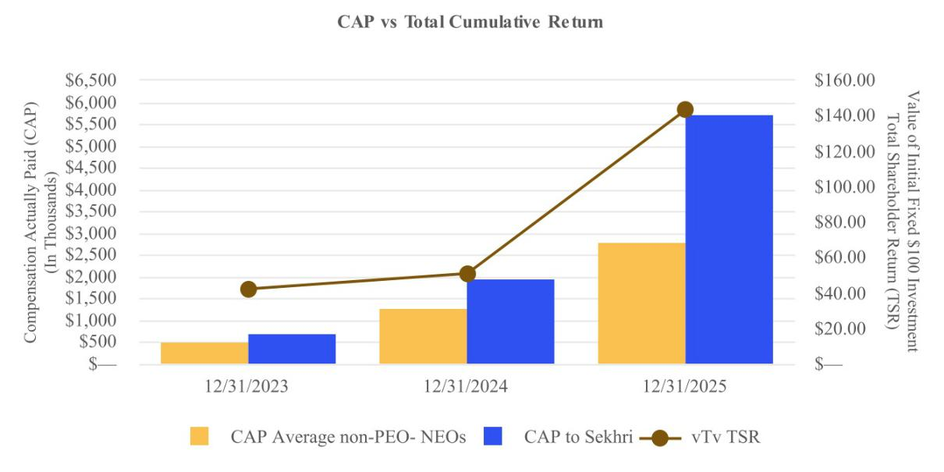

Compensation Actually Paid versus Net Loss

As demonstrated by the following graph, the amount of “compensation actually paid” to the PEOs and the average amount of “compensation actually paid” to the non-PEO NEOs is not directionally aligned with the Company’s net loss over the three years presented in the table due to the weight placed on equity-based compensation in our pay mix, as well as the impact the Company’s stock price has had on the “compensation actually paid” amounts during the applicable fiscal years.
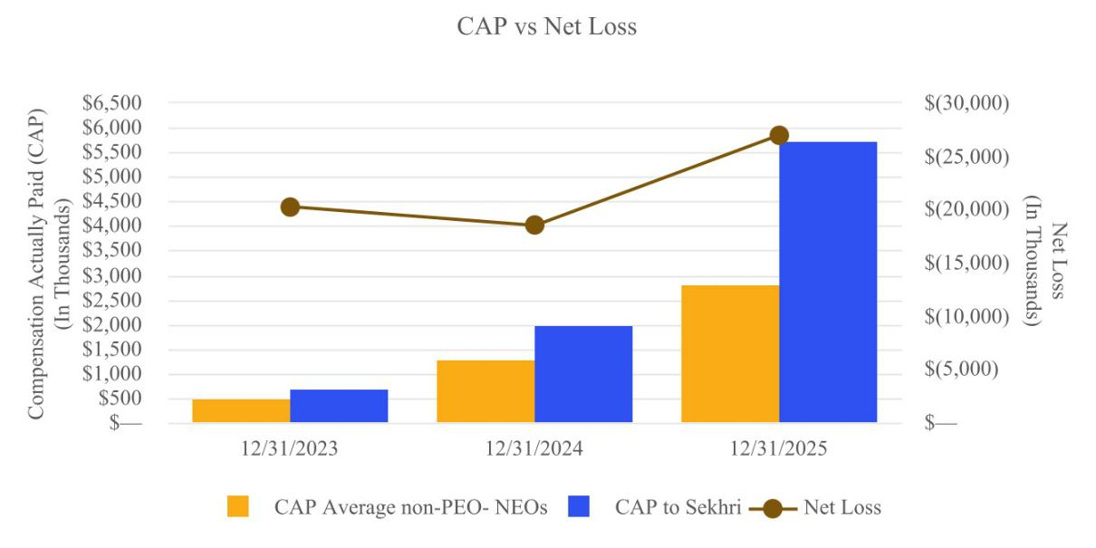

21

PROPOSAL TWO

RATIFICATION OF APPOINTMENT OF INDEPENDENT REGISTERED PUBLIC ACCOUNTING FIRM

Our Board of Directors, including our Audit Committee, has selected Ernst & Young LLP (“EY”), Raleigh, North Carolina, as our independent registered public accounting firm for the fiscal year ending December 31, 2026, and recommends that our stockholders vote to ratify this appointment. If our stockholders ratify this appointment, our Audit Committee, in its discretion, may appoint a different independent registered public accounting firm at any time during the year if it believes that doing so would be in the best interests of our stockholders. If our stockholders do not ratify this appointment, our Audit Committee may reconsider, but might not change, its appointment.

EY has audited our annual financial statements since 2000. Representatives of EY are expected to be present at the Annual Meeting with the opportunity to make a statement if they desire to do so and are expected to be available to respond to appropriate questions.

Summary of Fees

The Audit Committee has adopted a policy for the pre-approval of all audits and permitted non-audit services that may be performed by our independent registered public accounting firm. Under the policy, the Audit Committee must give prior approval for any amount or type of service within four categories—audit, audit-related, tax services or, to the extent permitted by law, other services—that the independent auditor provides. Prior to the annual engagement, the Audit Committee may grant general pre-approval for independent auditor services within these four categories. During the year, circumstances may arise when it may become necessary to engage the independent auditor for additional services not contemplated in the original pre-approval and, in those instances, such service will require separate pre-approval by the Audit Committee if it is to be provided by the independent auditor. For any pre-approval, the Audit Committee will consider whether such services are consistent with the SEC’s rules on auditor independence, whether the auditor is best positioned to provide the most cost-effective and efficient service and whether the service might enhance our ability to manage or control risk or improve audit quality. The Audit Committee may delegate to one or more of its members authority to approve a request for pre-approval, provided the member reports any approval so given to the Audit Committee at its next scheduled meeting.

The following table summarizes the aggregate fees billed for professional services rendered by EY to us in 2025 and 2024. A description of these various fees and services follows the table.

Name |  |  | 2025 |  |  | 2024
Audit Fees |  | $ | 477,266 |  | $ | 442,125
Audit-Related Fees |  |  | — |  |  | —
Tax Fees |  |  | — |  |  | —
All Other Fees |  |  | 40,000 |  |  | 170,000

Audit Fees

The aggregate fees billed to us by EY in 2025 and 2024 reflected as audit fees above include fees associated with the annual audit of our financial statements for the years ended December 31, 2025, and 2024 and reviews of our financial statements included in our Quarterly Reports on Form 10-Q. Audit fees above includes work performed with respect to registration statements prepared in 2025.

All Other Fees

The aggregate fees billed to us by EY in 2025 and 2024 reflected as all other fees above relate to the review of interim financial registration statements and comfort letters.

Required Vote

Approval of the ratification of the appointment of EY as our independent registered public accounting firm requires the affirmative vote of the holders of a majority of the outstanding shares of our Class A common stock and Class B common stock, entitled to vote as a single class, that are present or represented by proxy at the Annual Meeting. Abstentions will be counted for purposes of determining the number of shares present or represented by proxy at the Annual Meeting and accordingly will have the same effect as a vote cast against this proposal. We do not expect to receive broker non-votes on

22

this proposal because brokers will have discretionary authority to vote uninstructed shares, but to the extent we receive broker non-votes they will have no effect on the outcome of this vote.

The Board of Directors unanimously recommends that stockholders vote FOR the ratification of the appointment of EY as our independent registered public accounting firm for the fiscal year ending December 31, 2026.

23

AUDIT COMMITTEE REPORT

Our Audit Committee has (1) reviewed and discussed with EY, our independent registered public accounting firm, and management the audited financial statements for the year ended December 31, 2025, (2) discussed with EY the matters required to be discussed by Auditing Standard No. 61, as adopted by the Public Company Accounting Oversight Board, and (3) received written disclosures and a letter from EY concerning applicable requirements of the Public Company Accounting Oversight Board regarding EY’s communications with the Audit Committee concerning independence, and has discussed with EY its independence. Based upon these discussions and reviews, the Audit Committee recommended to the Board of Directors that the audited financial statements be included in our 2025 Annual Report filed with the SEC on March 10, 2026.

Our Board of Directors has determined that Mr. Spiegelman and Drs. Akkaraju and Phillips are independent within the meaning of the Nasdaq Stock Market listing rules and meet the additional requirements for independence for Audit Committee members imposed by Rule 10A-3 under the Exchange Act (collectively, the “Audit Committee Independence Requirements”). As a result, our Audit Committee is composed entirely of directors who are independent within the meaning of the Nasdaq Stock Market listing rules and meet the Audit Committee Independence Requirements. The Board of Directors has determined that Mr. Spiegelman qualifies as an “audit committee financial expert” as such term is defined in Item 407(d)(5) of Regulation S-K.

Our Audit Committee operates under a written charter adopted by the Board of Directors, a copy of which is available under Documents & Charters in the Media and Investors — Corporate Governance section of our website at www.vtvtherapeutics.com.

EY is responsible for performing an independent audit of the financial statements and expressing an opinion on the conformity of those financial statements with accounting principles generally accepted in the United States of America. The Audit Committee’s responsibility is to monitor, evaluate and oversee these processes. The Audit Committee members are not our employees and are not professional accountants or auditors. The Audit Committee’s primary purpose is to assist the Board of Directors to fulfill its oversight responsibilities by reviewing the financial information provided to stockholders and others, the systems of internal controls that management has established to preserve the Company’s assets and the audit process. It is not the Audit Committee’s duty or responsibility to conduct auditing or accounting reviews or procedures or to determine that our financial statements are complete and accurate and in accordance with accounting principles generally accepted in the United States of America. The Audit Committee has reviewed and discussed the audited financial statements with management and EY. In giving the Audit Committee’s recommendation to the Board of Directors, it has relied on management’s representations that the financial statements have been prepared with integrity and objectivity and in conformity with accounting principles generally accepted in the United States of America and on the representations of EY included in its report on our financial statements.

EY has served as our auditor since 2000.

THE AUDIT COMMITTEE
OF

THE BOARD OF
DIRECTORS

Dan Spiegelman

Srinivas Akkaraju

Anne Phillips

24

SECURITY OWNERSHIP OF CERTAIN BENEFICIAL OWNERS AND MANAGEMENT

The following table sets forth certain information regarding the beneficial ownership of our Class A common stock as of April 1, 2026, unless otherwise noted below for the following:

- each person, or group of affiliated persons, who we know to beneficially own more than 5% of our Class A common stock;

- each of our named executive officers;

- each of our directors and director nominees; and

- all of our executive officers, directors and director nominees as a group.

The number of shares of Class A common stock outstanding and the percentage of beneficial ownership reflected below includes the number of shares of Class B common stock and nonvoting common units of vTv Therapeutics LLC (“vTv Units”) outstanding and after giving effect to the exchange of all outstanding shares of Class B common stock (together with the corresponding vTv Units) into shares of Class A common stock. Pursuant to the Exchange Agreement dated as of July 29, 2015, among vTv Therapeutics LLC, vTv Therapeutics, Inc. and vTv Therapeutics Holdings, Inc. (the "Exchange Agreement"), vTv Units may, subject to the terms of the Exchange Agreement and the vTv Therapeutics LLC Amended and Restated Limited Liability Company Agreement, be exchanged at any time (along with a corresponding number of shares of our Class B common stock) with vTv Therapeutics LLC for shares of our Class A common stock on a one-for-one basis, or for cash, at our option (as the managing member of vTv Therapeutics LLC). See “Certain Relationships and Related Party Transactions—Exchange Agreement.”

Beneficial ownership is determined in accordance with the rules of the SEC. These rules generally attribute beneficial ownership of securities to persons who possess sole or shared voting power or investment power with respect to such securities. Except as otherwise indicated, all persons listed below have sole voting and investment power with respect to the shares beneficially owned by them, subject to applicable community property laws. Common stock subject to options exercisable on or within 60 days after April 1, 2026, are deemed outstanding for the purpose of computing the percentage ownership of the person holding those options but are not deemed outstanding for computing the percentage ownership of any other person. Unless otherwise indicated, the address for each listed stockholder is c/o vTv Therapeutics Inc., 3980 Premier Drive, Suite 110, High Point, North Carolina 27265. As of April 1, 2026, there were 3,938,654 shares of Class A common stock and 241 shares of Class B common stock outstanding, or an aggregate of 3,938,895 shares outstanding on an as-converted-to Class A common stock basis.

25

 |  | Shares |  | Percentage
Name and Address of Beneficial Owner |  | Beneficially |  | Beneficially
 |  | Owned |  | Owned
Paul Sekhri ⁽¹⁾ |  | 150,472 |  | 3.68%
Richard S. Nelson ⁽²⁾ |  | 61,884 |  | 1.55%
Michael Tung |  | 11,250 |  | 0.28%
Fahed Al Marzooqi |  | 8,541 |  | 0.22%
Anne Phillips |  | 5,006 |  | 0.13%
Srinivas Akkaraju |  | 5,234 |  | 0.13%
Raymond Cheong |  | 4,816 |  | 0.12%
Daniel K. Spiegelman |  | 3,833 |  | *
All directors, director nominees and executive officers as a group (8
individuals) |  | 251,036 |  | 5.99%
5% or Greater Stockholders:
MacAndrews & Forbes ⁽³⁾ |  | 1,509,250 |  | 38.13%
Samsara BioCapital GP, LLC ⁽⁴⁾ |  | 403,996 |  | 9.99%
Trails Edge ⁽⁵⁾ |  | 411,513 |  | 9.99%
Invus PE ⁽⁶⁾ |  | 393,098 |  | 9.43%
JDRF T1D Fund LLC ⁽⁷⁾ |  | 346,710 |  | 8.52%
G42 Investments AI Holdings RSC, Ltd. ⁽⁸⁾ |  | 259,657 |  | 6.59%
Millennium Group ⁽⁹⁾ |  | 225,073 |  | 5.71%
Baker Bros. Advisors LP ⁽¹⁰⁾ |  | 198,914 |  | 4.99%

* Less than 0.1%.

- Includes 5,000 of Class A common stock held directly by Mr. Sekhri. Also includes options to purchase up to 145,472 shares of our Class A common stock that are vested and exercisable or will become vested and exercisable within 60 days of April 1, 2026.

- Includes 1,250 shares of Class A common stock held directly by Mr. Nelson and 250 shares of Class A common stock held of record by Mr. Nelson’s spouse as custodian for a minor child under the Uniform Transfer to Minors Act. Mr. Nelson disclaims beneficial ownership of these shares. Also includes options to purchase up to 60,384 shares of our Class A common stock that are vested and exercisable or will become vested and exercisable within 60 days of April 1, 2026.

- Based on the Schedule 13D/A (Amendment No. 45) filed with the SEC on March 22, 2024 by The ROP Revocable Trust dated 1/9/2018, a New York trust (the “ROP Revocable Trust”), MacAndrews & Forbes Incorporated, a Delaware corporation (“MacAndrews & Forbes”), MacAndrews & Forbes LLC, a Delaware limited liability company (“M&F LLC”), MacAndrews & Forbes Group LLC, a Delaware limited liability company (“M&F Group”), MFV Holdings One LLC, a Delaware limited liability company (“MFV”), M&F TTP Holdings LLC, a Delaware limited liability company (“M&F TTP”), M&F TTP Holdings Two LLC, a Delaware limited liability company (“M&F TTP Two”), and RLX Holdings One LLC (“RLX Holdings One”). Consists of: (a) 1,490,090 shares of Class A common stock held beneficially by MacAndrews & Forbes Group LLC (“M&F Group”) and (b) 19,160 shares of Class A common stock issuable to M&F Group upon exercise of Common Stock Purchase Warrants held by M&F Group. Ronald O. Perelman, the sole trustee and sole beneficiary of the ROP Revocable Trust and the director, chairman and chief executive officer of MacAndrews & Forbes, may be deemed to beneficially own all the shares of Class A common stock beneficially owned by the ROP Revocable Trust, MacAndrews & Forbes, M&F LLC, M&F Group, MFV, M&F TTP, M&F TTP Two and RLX Holdings One. Mr. Perelman disclaims any beneficial ownership of the shares of Class A common stock, except to the extent of his pecuniary interest therein. The business address of all of the entities described in this footnote is 31 East 62nd Street New York, NY 10065.

26

- Based on a Schedule 13D filed with the SEC on December 8, 2025 by Samsara BioCapital, L.P. (“Samsara LP”), Samsara BioCapital GP, LLC (“Samsara GP”), Samsara Opportunity Fund, LP ("Samsara Opportunity Fund"), Samsara Opportunity Fund GP, LLC ("Samsara Opportunity Fund GP") and Srinivas Akkaraju. Includes (i) 298,496 shares of Class A common stock held by Samsara LP and (ii) the assumed exercise of 105,500 Pre-funded Warrants based on the number of shares of common stock outstanding on April 1, 2026. Does not include (i) 2,258,138 shares of Class A common stock potentially issuable upon exercise of Pre-funded Warrants held by Samsara LP or (ii) 1,638,737 shares of Class A common stock potentially issuable upon exercise of Common Warrants held by Samsara LP, as such warrants were, as of April 1, 2026, not exercisable within 60 days due to the Samsara Beneficial Ownership Limitation (defined below).

The Pre-funded Warrants and Common Warrants are not exercisable by Samsara LP if, upon giving effect or immediately prior thereto, Samsara LP would beneficially own more than 9.99% of the total number of issued and outstanding Class A common stock, which percentage may change at the holders’ election to any other number less than or equal to 19.99% upon 61 days’ notice to the Company (the “Samsara Beneficial Ownership Limitation”). Samsara GP is the general partner of Samsara LP and Dr. Akkaraju is the Managing Member of Samsara GP. Each of Samsara GP and Dr. Akkaraju shares voting and investment authority over the shares held by Samsara LP. Samsara Opportunity Fund GP is the general partner of Samsara Opportunity Fund and Dr. Akkaraju is the managing member of Samsara Opportunity Fund GP. Each of Samsara Opportunity Fund GP and Dr. Akkaraju shares voting and investment authority over the shares held by Samsara Opportunity Fund. The business address of all of the entities and individuals described in this footnote is 628 Middlefield Road, Palo Alto, CA 94301.

- Based on a Schedule 13D filed with the SEC on September 8, 2025 by Trails Edge Capital Partners, LP (“Trails Edge LP”), Trails Edge Biotechnology Master Fund, LP ("Trails Edge Biotechnology, LP") and Ortav Yehudai. Includes (i) 231,000 shares of Class A common stock held by Trails Edge LP and (ii) the assumed exercise of 180,513 Pre-funded and Common Warrants based on the number of shares of common stock outstanding on April 1, 2026. Does not include (i) 243,858 shares of Class A common stock potentially issuable upon exercise of Pre-funded Warrants and (ii) 655,371 shares of Class A common stock potentially issuable upon exercise of Common Warrants held by Trails Edge LP, as such warrants were, as of April 1, 2026, not exercisable within 60 days due to the Trails Edge LP Beneficial Ownership Limitation (defined below).

The Pre-funded Warrants and Common Warrants are not exercisable by Trails Edge LP if, upon giving effect or immediately prior thereto, Trails Edge LP would beneficially own more than 9.99% of the total number of issued and outstanding Class A common stock, which percentage may change at the holders’ election to any other number less than or equal to 19.99% upon 61 days’ notice to the Company (the “Trails Edge Beneficial Ownership Limitation”). Trails Edge LP is the investment manager to Trails Edge Biotechnology LP and Mr. Yehudai is the Chief Investment Officer of Trails Edge LP. The business address of all of the entities and individuals described in this footnote is 3455 Peachtree Road, NE, 5th Floor, Atlanta, GA 30326.

- Based on a Schedule 13D filed with the SEC on November 12, 2025 by Invus Public Equities, L.P. (“Invus PE”) and Avicenna Life Sci Master Fund LP (“Avicenna” and, together with Invus PE, “Invus”). Includes (i) 143,440 shares of Class A common stock held by Invus PE, (ii) 19,560 shares of Class A common stock held by Avicenna and (iii) the assumed exercise of 230,098 Pre-funded Warrants and Common Warrants based on the number of shares of common stock outstanding on April 1, 2026.

The Pre-funded Warrants and Common Warrants are not exercisable by Invus if, upon giving effect or immediately prior thereto, Invus would beneficially own more than 9.99% of the total number of issued and outstanding Class A common stock, which percentage may change at the holders’ election to any other number less than or equal to 19.99% upon 61 days’ notice to the Company (the “Invus Beneficial Ownership Limitation”). Invus Public Equities Advisors, LLC is the general partner of Invus PE, Invus Global Management, LLC is the managing member of Invus Public Equities Advisors, LLC, and Siren, L.L.C. (“Siren”) is the managing member of Invus Global Management, LLC. Avicenna Life Sci Master GP LLC is the general partner of Avicenna, and Ulys, L.L.C. (“Ulys”) is the managing member of Avicenna Life Sci Master GP LLC. Raymond Debbane is the managing member of each of Siren and Ulys. The business address of all of the entities and individuals described in this footnote is 780 Lexington Avenue, 30th Floor, New York, NY 10022.

27

- Consists of (i) 215,692 shares of our Class A common stock held by T1D Fund: a Breakthrough T1D Venture, LLC, ("T1D Fund") and (ii) 131,018 shares issuable upon the exercise of Common Warrants held by T1D fund. The business address of T1D Fund is 200 Vesey Street, 28th Floor, New York NY 10281.

- Based on a Schedule 13D filed with the SEC on May 31, 2022 by G42 Investments AI Holdings RSC Ltd (G42 Investments) and HH Sheikh Tahnoon Bin Zayed S. Al-Nahyan. HH Sheikh Tahnoon Bin Zayed S. Al-Nahyan exercises sole dispositive and voting control of the common stock. The business address of G42 Investments is Office 801, Floor 8, Al Khatem Tower, Abu Dhabi Global Market Square, Al Maryah Island, Abu Dhabi, United Arab Emirates. The business address of HH Sheikh Tahnoon Bin Zayed S. Al-Nahyan is Office 2458, Floor 24, Al Sila Tower, ADGM, Al Maryah, Abu Dhabi, United Arab Emirates.

- Based on a Schedule 13G/A filed with the SEC on April 16, 2026 by Integrated Core Strategies (US) LLC, Millennium Management LLC (the general partner of Integrated Core Strategies (US) LLC), Millennium Group Management LLC (the managing member of Millennium Management LLC), and Israel A. Englander (the sole voting trustee of the managing member of Millennium Group Management LLC). The business address of all of the entities and individuals described in this footnote is 399 Park Avenue, New York, NY 10022.

- Based on a Schedule 13D filed with the SEC on March 5, 2024 by Baker Bros. Advisors LP (the “ Adviser”), Baker Bros. Advisors (GP) LLC (the “Adviser GP”), Felix J. Baker and Julian C. Baker. Includes (i) 148,314 shares of Class A common stock held by Baker Brothers Life Sciences, L.P. (“Life Sciences”) and 667, L.P. (“667” and, together with Life Sciences, the “Funds”) and (ii) the assumed exercise of 50,600 of the Pre-funded Warrants based on the number of shares of common stock outstanding on April 1, 2026. Does not include (i) 5,598,466 shares of Class A common stock potentially issuable upon exercise of Pre-funded Warrants held by the Funds or (ii) 2,622,057 shares of Class A common stock potentially issuable upon exercise of Common Warrants held by the Funds, as such warrants were, as of April 1, 2026, not exercisable within 60 days due to the Baker Bros. Beneficial Ownership Limitation (defined below).

The Pre-Funded Warrants and Common Warrants are only exercisable to the extent that, following exercise, the Funds, together with their affiliates and any members of a Section 13(d) group with such holders, would beneficially own, for purposes of Rule 13d-3 under the Exchange Act, no more than 4.99% of our outstanding Class A common stock (the “Baker Bros. Beneficial Ownership Limitation”). By written notice to the Company, the Funds may from time to time increase or decrease the Baker Bros. Beneficial Ownership Limitation applicable to that Fund to any other percentage not in excess of 19.99%. Any such increase will not be effective until the 61st day after such notice is delivered to the Company. The Adviser is an entity engaged in investment activities, and the Adviser GP is in the business of acting as its general partner and, through the Adviser, investment activities. The principal business of each of Julian C. Baker and Felix J. Baker is to serve as a managing member of the Adviser GP. The business address of all of the entities and individuals described in this footnote is 860 Washington Street, 3rd Floor, New York, NY 10014.

28

DELINQUENT SECTION 16(a) REPORTS

Section 16(a) of the Exchange Act requires our directors, certain of our officers, and persons who beneficially own more than 10% of a registered class of our equity securities, to file initial reports of ownership and reports of changes in ownership with the SEC. These persons are required by the SEC to furnish us with copies of all Section 16(a) reports that they file.

Based solely on a review of Forms 3 and 4 and amendments thereto furnished to us during 2025, filed by our officers, directors, and any person whom we understand to own more than 10% of our common stock, all Section 16(a) filings were timely filed to our knowledge.

CERTAIN RELATIONSHIPS AND RELATED-PARTY TRANSACTIONS

Other than compensation arrangements for our named executive officers and directors, we describe below each transaction or series of similar transactions, since January 1, 2024, to which we were a party or will be a party, in which:

- the amounts involved exceeded or will exceed the lesser of $120,000 or one percent of the average of the Company’s total assets at year-end for the last two fiscal years; and

- any of our directors, executive officers or holders of more than 5% of our capital stock, or any member of the immediate family of the foregoing persons, had or will have a direct or indirect material interest.

Compensation arrangements for our named executive officers and directors are described in the sections entitled “Executive Compensation - Employment Agreement with Mr. Sekhri,” “Executive Compensation - Employment Agreement with Dr. Tung,” “Employment and Services Agreements” and “Director Compensation”.

Policies and Procedures for Related Party Transactions

We have adopted a written Related Person Transaction Policy, which sets forth our policy with respect to the review, approval, ratification and disclosure of all related person transactions by our Audit Committee. In accordance with our Related Person Transaction Policy, our Audit Committee has overall responsibility for the implementation and compliance with this policy.

For the purposes of our Related Person Transaction Policy, a “related person transaction” is a transaction, arrangement or relationship (or any series of similar transactions, arrangements or relationships) in which we were, are or will be a participant and in which any related person (as defined in our Related Person Transaction Policy) had, has or will have a direct or indirect material interest, in excess of $120,000. A “related person transaction” does not include any employment relationship or transaction involving an executive officer and any related compensation resulting solely from that employment relationship which has been reviewed and approved by our Board of Directors or Compensation Committee.

Our Related Person Transaction Policy requires that notice of a proposed related person transaction be provided to our legal department or our chief financial officer prior to entering into such transaction. If our legal department determines that such transaction is a related person transaction, the proposed transaction will be submitted to our Audit Committee for consideration at its next meeting. Under our Related Person Transaction Policy, only our Audit Committee will be permitted to approve those related person transactions that are in, or not inconsistent with, our best interests. In the event we become aware of a related person transaction that has not been previously reviewed, approved or ratified under our Related Person Transaction Policy and that is ongoing or is completed, the transaction will be submitted to our Audit Committee so that it may determine whether to ratify, rescind or terminate the related person transaction.

Our Related Person Transaction Policy also provides that our Audit Committee will review certain previously approved or ratified related person transactions that are ongoing to determine whether the related person transaction remains in our best interests and the best interests of our stockholders.

Exchange Agreement

In connection with our 2015 initial public offering, we, vTv Therapeutics LLC and vTv Therapeutics Holdings LLC (“Holdings”), and other existing and future holders of the vTv Units (and corresponding shares of Class B common stock) entered into an exchange agreement (the “Exchange Agreement”) under which, from time to time, the holders (or certain transferees thereof) have the right to exchange their vTv Units (along with a corresponding number of our Class B common stock) for (i) shares of our Class A common stock on a one-for-one basis or (ii) cash (based on the market price of the shares of Class A common stock), at our option, subject to customary conversion rate adjustments for stock splits, stock dividends

29

and reclassifications. Any decision to require an exchange for cash rather than shares of Class A common stock will ultimately be determined by our Board of Directors.

On October 5, 2015, Holdings was dissolved and made a liquidating distribution of shares of Class B common stock and the corresponding vTv Units to its members. As a result of the dissolution, M&F TTP Holdings LLC became the successor to Holdings under the Exchange Agreement, Investor Rights Agreement and the Tax Receivable Agreement pursuant to the terms of each respective agreement, and various other holders of Class B common stock became parties to the Exchange Agreement. On December 28, 2015, M&F TTP Holdings LLC contributed its shares of Class B common stock and the corresponding vTv Units to its subsidiary, M&F, which became the successor to M&F TTP Holdings LLC under the Exchange Agreement, Investor Rights Agreement and Tax Receivable Agreement pursuant to the terms of each respective agreement. On September 19, 2025, M&F exchanged all 577,108 vTv Units it held, although with 577,108 corresponding shares of Class B common stock, for shares of Class A common stock pursuant to the Exchange Agreement.

Tax Receivable Agreement

As further described above, our Class B common stock, together with the corresponding number of vTv Units, may be exchanged for shares of our Class A common stock, or for cash, at our option. These future exchanges of Class B common stock, together with the corresponding number of vTv Units, may result in increases in the tax basis of the assets of vTv Therapeutics LLC that otherwise would not have been available. Such increases in tax basis are likely to increase (for tax purposes) depreciation and amortization deductions and therefore reduce the amount of income tax we would otherwise be required to pay in the future and may also decrease gain (or increase loss) on future dispositions of certain assets to the extent the increased tax basis is allocated to those assets. The IRS may challenge all or part of these tax basis increases, and a court could sustain such a challenge.

In connection with our 2015 initial public offering, we entered into a Tax Receivable Agreement with M&F, as successor in interest to Holdings, and M&F TTP Holdings LLC that provides for the payment by us to M&F (or certain of its transferees or other assignees) of 85% of the amount of cash savings, if any, in U.S. federal, state and local income tax or franchise tax that we actually realize (or, in some circumstances, we are deemed to realize) as a result of (a) the exchange of Class B common stock, together with the corresponding number of vTv Units, for shares of our Class A common stock (or for cash), (b) tax benefits related to imputed interest deemed to be paid by us as a result of the Tax Receivable Agreement and (c) certain tax benefits attributable to payments under the Tax Receivable Agreement. Although the actual increase in tax basis and the amount and timing of any payments under the Tax Receivable Agreement will vary depending upon a number of factors, including the timing of exchanges, the price of shares of our Class A common stock at the time of the exchange, the nature of the assets, the extent to which such exchanges are taxable, the tax rates then applicable, and the amount and timing of our income, we expect that the payments that we make to M&F could be substantial.

M&F generally will not reimburse us for any payments that previously have been made under the Tax Receivable Agreement even if the IRS subsequently disallows the tax basis increase or any other relevant tax item. Instead, any excess cash payments made by us to M&F will be netted against any future cash payments that we might otherwise be required to make under the terms of the Tax Receivable Agreement. However, we might not determine that we have effectively made an excess cash payment to M&F for a number of years following the initial time of such payment. As a result, in certain circumstances we could make payments to M&F under the Tax Receivable Agreement in excess of our cash tax savings. Our ability to achieve benefits from any tax basis increase and the payments to be made under the Tax Receivable Agreement, will depend upon a number of factors, including the timing and amount of our future income and the nature of our assets.

To the extent that we are unable to make payments under the Tax Receivable Agreement for any reason, such payments will be deferred and will accrue interest until paid. In addition, the Tax Receivable Agreement provides that, upon a merger, asset sale or other form of business combination or certain other changes of control or if, at any time, we elect an early termination of the Tax Receivable Agreement, our (or our successor’s) obligations with respect to exchanged or acquired Class B common stock, together with the corresponding number of vTv Units (whether exchanged or acquired before or after such change of control or early termination) would be required to be paid significantly in advance of the actual realization, if any, of any future tax benefits and would be based on certain assumptions, including that we would have sufficient taxable income to fully utilize the deductions arising from the increased tax deductions and tax basis and other benefits related to entering into the Tax Receivable Agreement, and, in the case of certain early termination elections, that any Class B common stock, together with the corresponding number of vTv Units, that have not been exchanged will be deemed exchanged for the market value of the Class A common stock at the time of termination. Consequently, it is possible

30

that the actual cash tax savings realized by us will be significantly less than the corresponding Tax Receivable Agreement payments.

We are a holding company, and we have no material assets other than our ownership of vTv Units, and we have no independent means of generating revenue or cash flow. We intend, as its managing member, to cause vTv Therapeutics LLC to make distributions in an amount sufficient to allow us to pay our operating expenses, including any payments due under the Tax Receivable Agreement. However, vTv Therapeutics LLC’s ability to make such distributions may be subject to various limitations and restrictions including, but not limited to, restrictions on distributions that would either violate any contract or agreement to which vTv Therapeutics LLC is then a party, including potential debt agreements, or any applicable law, or that would have the effect of rendering vTv Therapeutics LLC insolvent. If vTv Therapeutics LLC does not distribute sufficient funds for us to pay our operating expenses, including any payments due under the Tax Receivable Agreement, we may have to borrow funds, which could materially adversely affect our liquidity and subject us to various restrictions imposed by any such lenders. To the extent that we are unable to make payments under the Tax Receivable Agreement for any reason, such payments will be deferred and will accrue interest until paid.

Our organizational structure confers certain benefits upon M&F that will not benefit the holders of our Class A common stock to the same extent as it will benefit M&F. Although we will retain 15% of the amount of the tax benefits described above, it is possible that the interests of M&F may in some circumstances conflict with our interests and the interests of our other stockholders. For example, M&F may have different tax positions from us, especially in light of the Tax Receivable Agreement, that could influence their decisions regarding whether and when we should dispose of assets, whether and when we should incur new or refinance existing indebtedness, and whether and when we should terminate the Tax Receivable Agreement and accelerate our obligations thereunder. In addition, the determination of future tax reporting positions, the structuring of future transactions and the handling of any future challenges by any taxing authority to our tax reporting positions may take into consideration M&F’s tax or other considerations, which may differ from the considerations of us or our other stockholders. To the extent that M&F is dissolved or liquidated, MacAndrews and/or its affiliates will succeed to the rights and obligations of M&F under the Tax Receivable Agreement.

Amended Investor Rights Agreement

In connection with our 2015 initial public offering, we entered into an Investor Rights Agreement with M&F, as successor in interest to Holdings. The Investor Rights Agreement, which was amended by the First Amendment, provides M&F with certain demand, shelf and piggyback registration rights with respect to its shares of our common stock and provides M&F with certain governance rights, depending on the size of its holdings of our common stock.

Under the registration rights provisions of the Amended Investor Rights Agreement:

- M&F and its affiliates have the right to cause us to conduct an unlimited number of demand registrations, subject to certain customary restrictions;

- once we are eligible to do so, M&F and its affiliates have the right to cause us to file and have declared effective a shelf registration statement on Form S-3 with respect to all of their shares of our common stock; and

- M&F and its affiliates have the right to include their shares in certain registered offerings by us.

The registration rights provisions also contain customary provisions relating to cooperation with the registration process, black-out periods and customary securities law indemnity provisions in favor of the selling stockholders. With certain customary exceptions, we will be required to bear all registration expenses, other than underwriting discounts and commissions and transfer taxes, associated with any registration of shares pursuant to the agreement. Registration rights may be transferred by M&F and its affiliates, subject to certain restrictions. No predetermined penalties or liquidated damages will be payable by us if we fail to comply with the registration rights provisions of the Amended Investor Rights Agreement.

In February 2024, the Investor Rights Agreement was amended in connection with the 2024 Securities Purchase Agreement. As amended, M&F's registration rights were changed to reflect the registration rights of the 2024 Lead Investors. Further, the amendment modified M&F's corporate governance rights to provide that it has the right to designate two directors to the Board of Directors so long as certain MacAndrews parties continue to beneficially own in the aggregate at least 50% of the shares of common stock of the Company owned by them as of the date of the First Amendment. The Amended Investor Rights Agreement will terminate when MacAndrews and its permitted transferees hold less than 2.5% of our outstanding common stock. To the extent that M&F is dissolved or liquidated, MacAndrews and/or its affiliates will succeed to M&F's rights and obligations under the Investor Rights Agreement. On November 24, 2025, a registration

31

statement with respect to shares of our Class A common stock held by M&F was declared effective by the SEC, satisfying our obligations with respect to M&F's registration rights under the Amended Investor Rights Agreement.

2024 Securities Purchase Agreement

On February 27, 2024, the Company entered into the 2024 Securities Purchase Agreement with certain institutional accredited investors (the “2024 Private Placement Investors”), pursuant to which the Company agreed to issue and sell to the Purchasers in a private placement (the “2024 Private Placement”) (i) an aggregate of 464,377 shares (the “2024 Shares”) of the Company’s Class A common stock, par value $0.01 per share, at a purchase price of $11.81 per share, and (ii) pre-funded warrants (the “2024 Pre-Funded Warrants”) to purchase up to an aggregate of 3,853,997 shares of Class A common stock (the “2024 Warrant Shares”) at a purchase price of $11.80 per 2024 Pre-Funded Warrant (representing the $11.81 per Share purchase price less the exercise price of $0.01 per 2024 Warrant Share). The purchase price of the 2024 Shares and 2024 Warrant Shares were based on a 45-day volume-weighted average price at the time agreed between the 2024 Private Placement Investors and the Company. The 2024 Pre-Funded Warrants are exercisable at any time after their original issuance and will not expire. The 2024 Private Placement closed on February 27, 2024. The Company received aggregate gross proceeds from the 2024 Private Placement of approximately $51.0 million, before deducting offering expenses payable by the Company.

The 2024 Pre-Funded Warrants issued in the 2024 Private Placement provide that the holder of the 2024 Pre-Funded Warrants will not have the right to exercise any portion of its 2024 Pre-Funded Warrants if such holder, together with its affiliates, would beneficially own in excess of 4.99% or 9.99%, as applicable, of the number of shares of the Company’s Class A common stock outstanding immediately after giving effect to such exercise (the “2024 Beneficial Ownership Limitation”); provided, however, that the holder may increase the 2024 Beneficial Ownership Limitation by giving 61 days’ notice to the Company, but not to any percentage in excess of 19.99%.

The Securities Purchase Agreement (i) provides the lead Purchasers with rights to designate an aggregate of three nominees to serve as directors on the Board, subject to the lead Purchasers continuing to own at least 50% of the Shares and Pre-Funded Warrants (including Warrant Shares issued pursuant to the exercise of the Pre-Funded Warrants) purchased by the Purchasers at the closing of the Private Placement, (ii) requires the Company to implement Board voting procedures requiring at least five directors to approve certain Company actions, (iii) grants certain participation rights to the Purchasers giving them the right to purchase their proportionate share of certain future financing transactions, (iv) requires the Company to use commercially reasonable efforts to (a) offer and sell securities for cash and/or (b) receive cash consideration in connection with a royalty or licensing agreement related to a preclinical or clinical drug candidate of the Company, other than TTP 399, that in respect of (a) and/or (b) results in the receipt of gross proceeds of at least an aggregate of $30.0 million and (v) grants the Purchaser the right to purchase up to an additional $30.0 million of Common Stock 18 months following the closing of the Private Placement, subject to certain conditions. The Securities Purchase Agreement also contains customary representations, warranties and covenants of the parties.

2025 Private Placement

On August 29, 2025, the Company entered into a securities purchase agreement (the "2025 Securities Purchase Agreement") with certain institutional accredited investors (the "2025 Private Placement Investors"), pursuant to which the Company agreed to issue and sell to the 2025 Private Placement Investors in a private placement (the "2025 Private Placement") 5,243,732 units (the "Units"), each Unit comprised of (i) either (A) one share of the Company's Class A common stock, par value $0.01 per share, at a purchase price of $15.265 per share, or (B) a pre-funded warrant (the "2025 Pre-Funded Warrants") to purchase one share of Class A common stock (the "2025 Pre-Funded Warrant Shares") at a purchase price of $15.255 per share (representing the per-share purchase price less the 2025 Pre-Funded Warrant's exercise price of $0.01), and (ii) a warrant (the "2025 Common Warrants") to purchase either (x) one share of Class A common stock (the "2025 Warrant Shares") or (y) a pre-funded warrant to purchase one share of Class A common stock (the "2025 Replacement Warrants" and, together with the 2025 Pre-Funded Warrants and the 2025 Common Warrants, the "2025 Warrants"). The 2025 Private Placement closed on September 3, 2025. The Company received aggregate gross proceeds from the 2025 Private Placement of approximately $80.0 million, before deducting offering expenses payable by the Company.

The 2025 Warrants issued in the 2025 Private Placement provide that the holder thereof will not have the right to exercise any portion of its 2025 Warrants if such holder, together with its affiliates, would beneficially own in excess of 4.99% or 9.99%, as applicable, of the number of shares of the Company's Class A common stock outstanding immediately after giving effect to such exercise (the "2025 Beneficial Ownership Limitation"); provided, however, that the holder may

32

increase or decrease the 2025 Beneficial Ownership Limitation by giving 61 days' notice to the Company, but not to any percentage in excess of 19.99%. Indemnification Agreements

We have entered into customary indemnification agreements with our executive officers and directors that provide, in general, that we will provide them with customary indemnification in connection with their service to us or on our behalf.

These indemnification agreements require us, among other things, to indemnify our directors and officers against liabilities that may arise by reason of their status or service as directors or officers, other than liabilities arising from willful misconduct. These indemnification agreements also require us to advance any expenses incurred by the directors or officers as a result of any proceeding against them as to which they could be indemnified and to obtain directors’ and officers’ insurance, if available on reasonable terms.

STOCKHOLDER PROPOSALS

Stockholders may present proposals for action at meetings of stockholders only if they comply with the proxy rules established by the SEC, applicable Delaware law and our By-laws. We have not received any stockholder proposals for consideration at our 2026 Annual Meeting of Stockholders.

Under Rule 14a-8 promulgated by the SEC under the Exchange Act (“Rule 14a-8”), for a stockholder proposal to be included in our proxy solicitation materials for the 2027 Annual Meeting of Stockholders, it must be delivered to our principal executive offices located at 3980 Premier Drive, Suite 110, High Point, North Carolina 27265 by December 26, 2026, at 5:00 p.m. Eastern time. The stockholder proposals must otherwise comply with the requirements of Rule 14a-8. Any stockholder who desires to bring a proposal at our 2027 Annual Meeting of Stockholders without including such proposal in our Proxy Statement or to nominate a directors, including pursuant to the SEC's universal proxy rule, Exchange Act Rule 14a-19, must deliver written notice thereof to our Secretary no earlier than February 10, 2027, and no later than March 12, 2027, provided that if the date of our 2027 Annual Meeting of Stockholders is more than 30 days before or 60 days after the first anniversary of the Annual Meeting, then such proposal or nomination must be delivered to our Secretary no earlier than 120 days before the date of the 2026 Annual Meeting of Stockholders and no later than the later of 90 days before such date and the tenth day after the day on which the notice of such annual meeting was made or publicly disclosed. Proposals and nominations submitted by stockholders must satisfy all applicable requirements in our By-laws and SEC rules.

If a stockholder proposal is not properly submitted for inclusion in the 2027 proxy statement pursuant to the requirements described above (but otherwise complies with the advance notice provisions of our By-laws), management will be permitted to vote proxies in its discretion if it advises stockholders in the 2027 proxy statement about the nature of the matter and how management intends to vote on such matter.

HOUSEHOLDING MATTERS

The SEC has adopted rules that permit companies to deliver a single copy of proxy materials to multiple stockholders sharing an address unless a company has received contrary instructions from one or more of the stockholders at that address. This means that only one copy of the 2025 Annual Report, this Proxy Statement and Notice may have been sent to multiple stockholders in your household. If you would prefer to receive separate copies of the Proxy Statement either now or in the future, please contact our Secretary either by calling 336-841-0300, or by mailing a request to Attn: Secretary, 3980 Premier Drive, Suite 110, High Point, North Carolina 27265. Upon written or oral request to the Secretary, we will promptly provide a separate copy of the 2025 Annual Report and this Proxy Statement and Notice. In addition, stockholders at a shared address who receive multiple copies of proxy statements may request to receive a single copy of proxy statements in the future in the same manner as described above.

OTHER MATTERS

Other than those matters set forth in this Proxy Statement, we do not know of any additional matters to be submitted at the Annual Meeting. If any other matters properly come before the Annual Meeting, it is the intention of the persons named in the enclosed form of proxy to vote the shares they represent as the Board of Directors recommends.

THE BOARD OF DIRECTORS

33

Dated: April 28, 2026

HOW TO ATTEND THE ANNUAL MEETING

Online access to the Annual Meeting will begin 15 minutes prior to the meeting start time of 9:00 a.m. Eastern time on June 10, 2026. To be admitted to the Annual Meeting's live webcast, please visit www.virtualshareholdermeeting.com/VTVT2026.

34

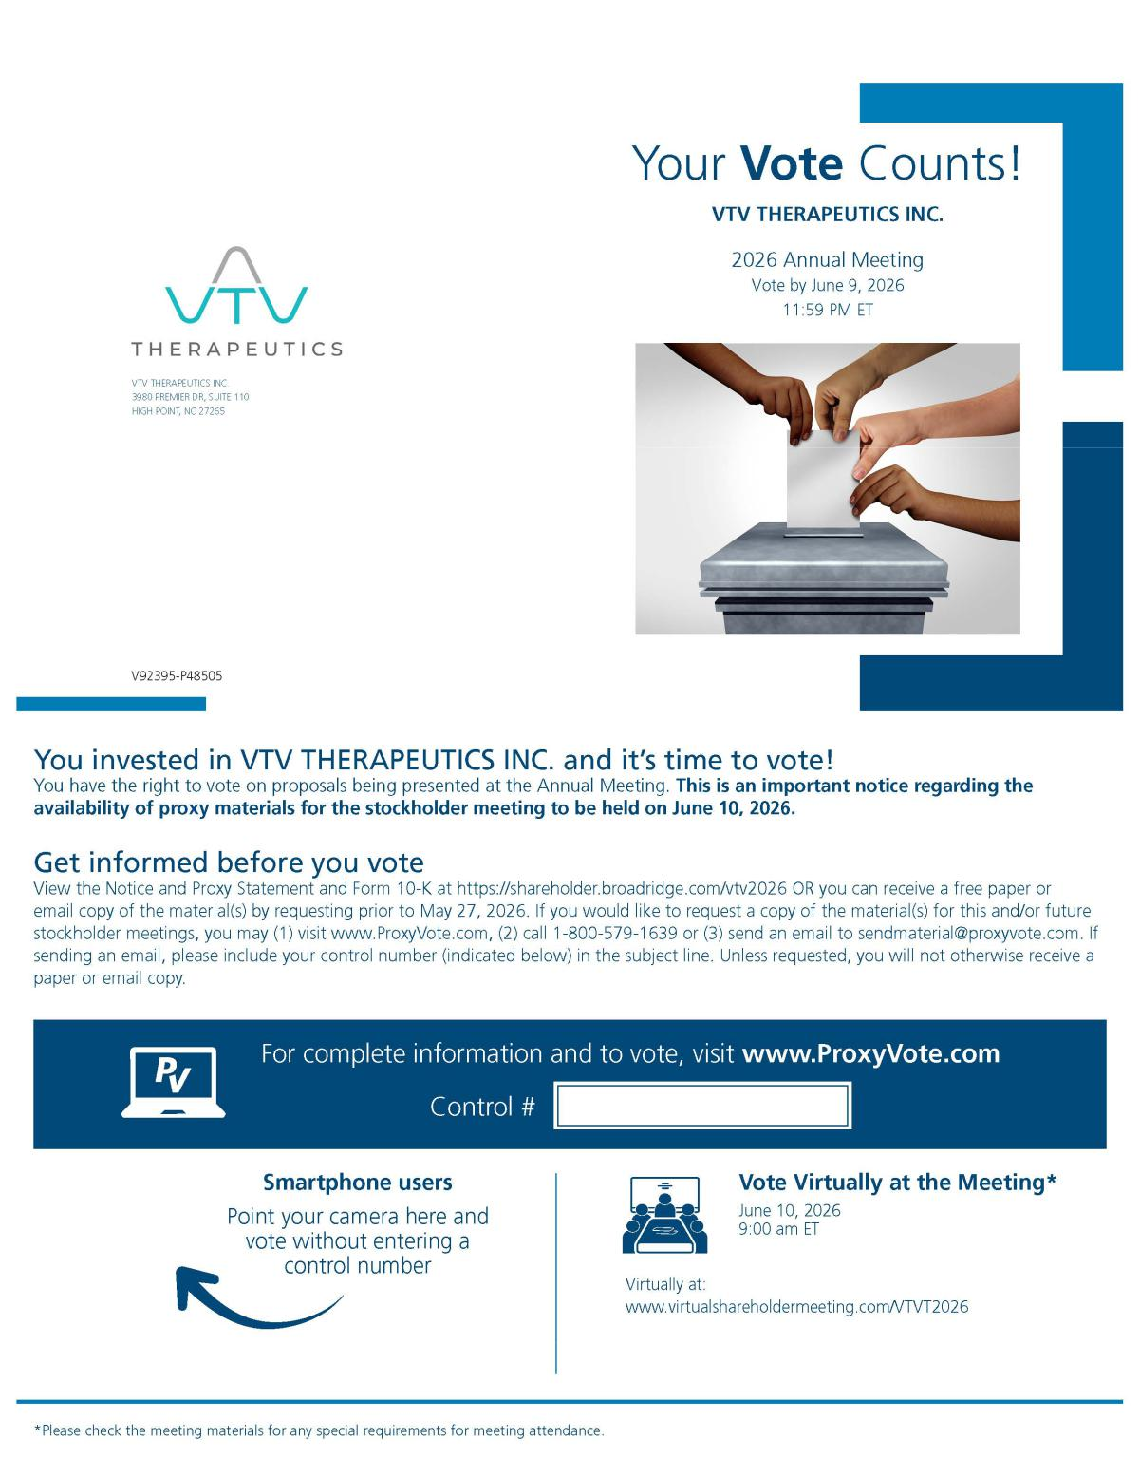

35

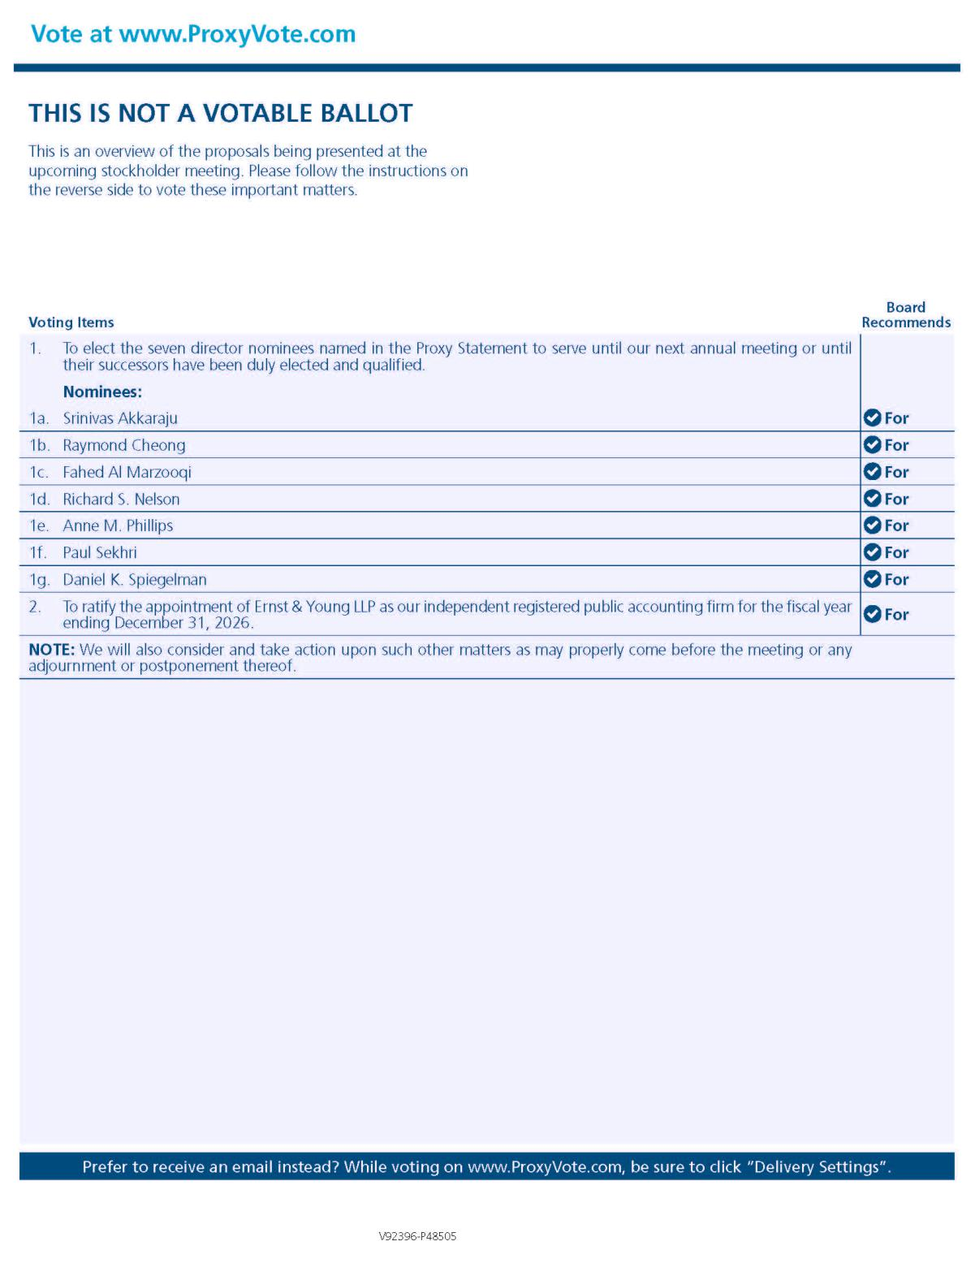

36

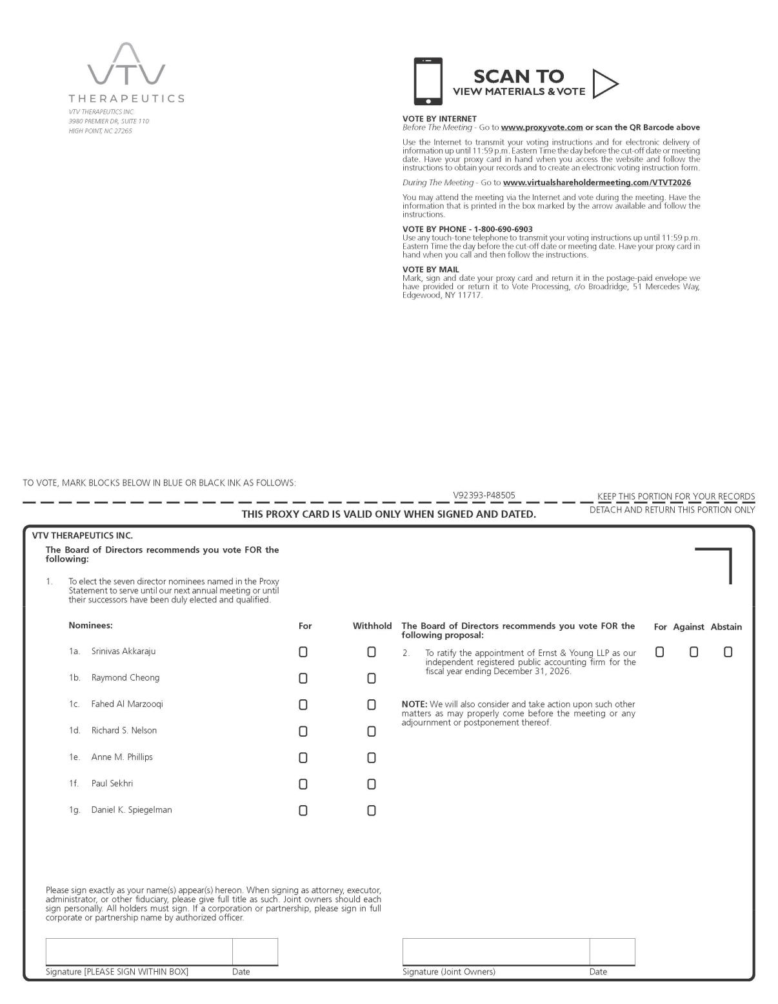

37

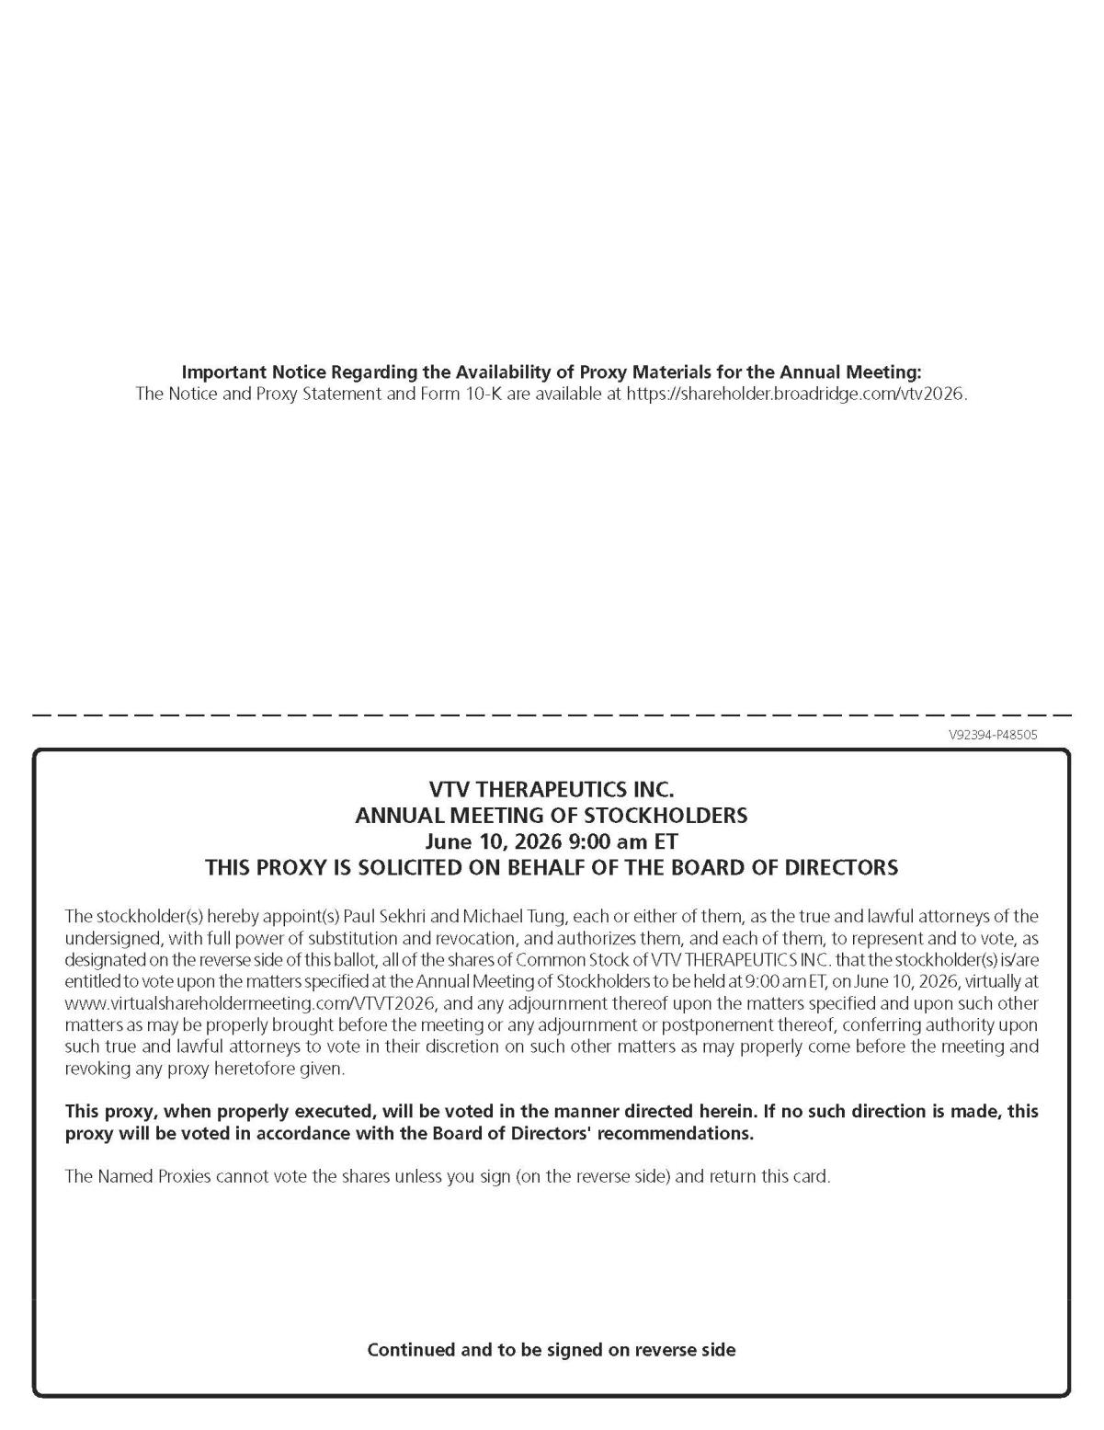

38

