Table of Contents

UNITED STATES

SECURITIES AND EXCHANGE COMMISSION

Washington, D.C. 20549

_____________________________________________________________________________________________________

FORM 10-K

_____________________________________________________________________________________________________

(Mark One)

- ANNUAL REPORT PURSUANT TO SECTION 13 OR 15(d) OF THE SECURITIES EXCHANGE ACT OF 1934

For the fiscal year ended December 31, 2023

Or

- TRANSITION REPORT PURSUANT TO SECTION 13 OR 15(d) OF THE SECURITIES EXCHANGE ACT OF 1934

For the transition period from _______ to _______

Commission file number: 001-37524

_____________________________________________________________________________________________________

vTv Therapeutics Inc.

(Exact name of registrant as specified in its charter)

_____________________________________________________________________________________________________

 | Delaware |  | 47-3916571
(State or other jurisdiction of |  |  | (I.R.S. Employer
incorporation or organization) |  |  | Identification No.)
3980 Premier Dr, Suite 310, High Point, NC |  |  | 27265
(Address of principal executive offices) |  |  | (Zip Code)
 |  | (336) 841-0300
 |  | (Registrant’s telephone number, including area code)
 |  | Securities registered pursuant to Section 12(b) of the Act:
Title of each Class |  | Trading Symbol | Name of each exchange on which registered
Class A Common Stock (Par Value $0.01) |  | VTVT | NASDAQ Capital Market
 |  | Securities registered pursuant to Section 12(g) of the Act: None

Indicate by check mark if the Registrant is a well-known seasoned issuer, as defined in Rule 405 of the Securities Act. Yes o No x

Indicate by check mark if the Registrant is not required to file reports pursuant to Section 13 or Section 15(d) of the Exchange Act. Yes o No x

Indicate by check mark whether the Registrant (1) has filed all reports required to be filed by Section 13 or 15(d) of the Securities Exchange Act of 1934 during the preceding 12 months and (2) has been subject to such filing requirements for the past 90 days. Yes x No o

Indicate by check mark whether the Registrant has submitted electronically every Interactive Data File required to be submitted pursuant to Rule 405 of Regulation S-T (§ 232.405 of this chapter) during the preceding 12 months (or for such shorter period that the Registrant was required to submit such files). Yes x No o

Indicate by check mark whether the Registrant is a large accelerated filer, an accelerated filer, a non-accelerated filer, a smaller reporting company, or an emerging growth company. See the definitions of “large accelerated filer,” “accelerated filer,” “smaller reporting company,” and “emerging growth company” in Rule 12b-2 of the Exchange Act.

Large accelerated filer | o | Accelerated filer | o
Non-accelerated filer | o | Smaller reporting company | x
Emerging growth company | o

If an emerging growth company, indicate by check mark if the registrant has elected not to use the extended transition period for complying with any new or revised financial accounting standards provided pursuant to Section 13(a) of the Exchange Act. o

Indicate by check mark whether the registrant has filed a report on and attestation to its management’s assessment of the effectiveness of its internal control over financial reporting under Section 404(b) of the Sarbanes-Oxley Act (15 U.S.C. 7262(b)) by the registered public accounting firm that prepared or issued its audit report. o

If securities are registered pursuant to Section 12(b) of the Act, indicate by check mark whether the financial statements of the registrant included in the filing reflect the correction of an error to previously issued financial statements. ☐

Indicate by check mark whether any of those error corrections are restatements that required a recovery analysis of incentive-based compensation received by any of the registrant’s executive officers during the relevant recovery period pursuant to §240.10D-1(b). ☐ Indicate by check mark if the Registrant is a shell company (as defined in Rule 12b-2 of the Exchange Act). Yes o No x

The aggregate market value of the registrant’s Common Stock held by non-affiliates on the last business day of the Registrant’s most recently completed second quarter, June 30, 2023, was $22,902,852 (based on the closing sale price as reported on the NASDAQ).

Indicate the number of shares outstanding of each of the Registrant’s classes of common stock, as of March 13, 2024.

 | Class of Stock |  | Shares Outstanding
Class A common stock, par value $0.01 per share |  |  |  |  | 2,432,857
Class B common stock, par value $0.01 per share |  |  | 577,349

DOCUMENTS INCORPORATED BY REFERENCE

Portions of the registrant’s Definitive Proxy Statement relating to its 2024 Annual Meeting of Stockholders to be filed within 120 days after December 31, 2023, are incorporated by reference into Part III of this Annual Report on Form 10-K where indicated.

Table of Contents

 |  |  |  |  |  |  |  |  |  |  |  |  |  |  |  |  |  |  |  |  |  |  | vTv THERAPEUTICS INC. AND SUBSIDIARIES
 |  |  |  |  |  |  |  |  |  |  |  |  |  |  |  |  |  |  |  |  |  |  |  | INDEX TO FORM 10-K
 |  |  |  |  |  |  |  |  |  |  |  |  |  |  |  |  |  |  |  |  |  | FOR THE FISCAL YEAR ENDED December 31, 2023
 |  |  |  |  |  |  |  |  |  |  |  |  |  |  |  |  |  |  |  |  |  |  |  |  |  |  |  |  | PAGE
 |  |  |  |  |  |  |  |  |  |  |  |  |  |  |  |  |  |  |  |  |  |  |  |  |  |  |  |  | NUMBER
 | PART I
 | Item 1. |  |  |  |  | Business |  |  |  |  |  |  |  |  |  |  |  |  |  |  |  |  |  |  |  |  |  |  | 4
 | Item 1A. |  |  |  |  | Risk Factors |  |  |  |  |  |  |  |  |  |  |  |  |  |  |  |  |  |  |  |  |  |  | 18
 | Item 1B. |  |  |  |  | Unresolved Staff Comments |  |  |  |  |  |  |  |  |  |  |  |  |  |  |  |  |  |  |  |  |  |  | 54
 | Item 1C |  |  |  |  | Cybersecurity |  |  |  |  |  |  |  |  |  |  |  |  |  |  |  |  |  |  |  |  |  |  | 54
 | Item 2. |  |  |  |  | Properties |  |  |  |  |  |  |  |  |  |  |  |  |  |  |  |  |  |  |  |  |  |  | 54
 | Item 3. |  |  |  |  | Legal Proceedings |  |  |  |  |  |  |  |  |  |  |  |  |  |  |  |  |  |  |  |  |  |  | 54
 | Item 4. |  |  |  |  | Mine Safety Disclosures |  |  |  |  |  |  |  |  |  |  |  |  |  |  |  |  |  |  |  |  |  |  | 54
 | PART II
 | Item 5. |  |  |  |  | Market for Registrant’s Common Equity, Related Stockholder Matters and Issuer Purchases of Equity Securities |  |  |  |  |  |  |  |  |  |  |  |  |  |  |  |  |  |  |  |  |  |  | 55
 | Item 6. |  |  |  |  | [Reserved] |  |  |  |  |  |  |  |  |  |  |  |  |  |  |  |  |  |  |  |  |  |  | 55
 | Item 7. |  |  |  |  | Management’s Discussion and Analysis of Financial Condition and Results of Operations |  |  |  |  |  |  |  |  |  |  |  |  |  |  |  |  |  |  |  |  |  |  | 56
 | Item 7A. |  |  |  |  | Quantitative and Qualitative Disclosures About Market Risk |  |  |  |  |  |  |  |  |  |  |  |  |  |  |  |  |  |  |  |  |  |  | 65
 | Item 8. |  |  |  |  | Financial Statements and Supplementary Data |  |  |  |  |  |  |  |  |  |  |  |  |  |  |  |  |  |  |  |  |  |  | 65
 | Item 9. |  |  |  |  | Changes in and Disagreements with Accountants on Accounting and Financial Disclosure |  |  |  |  |  |  |  |  |  |  |  |  |  |  |  |  |  |  |  |  |  |  | 66
 | Item 9A. |  |  |  |  | Controls and Procedures |  |  |  |  |  |  |  |  |  |  |  |  |  |  |  |  |  |  |  |  |  |  | 66
 | Item 9B. |  |  |  |  | Other Information |  |  |  |  |  |  |  |  |  |  |  |  |  |  |  |  |  |  |  |  |  |  | 67
 | Item 9C. |  |  |  |  | Disclosure Regarding Foreign Jurisdictions that Prevent Inspections |  |  |  |  |  |  |  |  |  |  |  |  |  |  |  |  |  |  |  |  |  |  | 67
 | PART III
 | Item 10. |  |  |  |  | Directors, Executive Officers and Corporate Governance |  |  |  |  |  |  |  |  |  |  |  |  |  |  |  |  |  |  |  |  |  |  | 68
 | Item 11. |  |  |  |  | Executive Compensation |  |  |  |  |  |  |  |  |  |  |  |  |  |  |  |  |  |  |  |  |  |  | 68
 | Item 12. |  |  |  |  | Security Ownership of Certain Beneficial Owners and Management and Related Stockholder Matters |  |  |  |  |  |  |  |  |  |  |  |  |  |  |  |  |  |  |  |  |  |  | 68
 | Item 13. |  |  |  |  | Certain Relationships and Related Transactions, and Director Independence |  |  |  |  |  |  |  |  |  |  |  |  |  |  |  |  |  |  |  |  |  |  | 68
 | Item 14. |  |  |  |  | Principal Accountant Fees and Services |  |  |  |  |  |  |  |  |  |  |  |  |  |  |  |  |  |  |  |  |  |  | 68
 | PART IV
 | Item 15. |  |  |  |  | Exhibits and Financial Statement Schedules |  |  |  |  |  |  |  |  |  |  |  |  |  |  |  |  |  |  |  |  |  |  | 69
 | Item 16. |  |  |  |  | Form 10-K Summary |  |  |  |  |  |  |  |  |  |  |  |  |  |  |  |  |  |  |  |  |  |  | 72
 |  |  |  |  |  |  |  |  |  |  |  |  |  | 2

Table of Contents

CAUTIONARY NOTE REGARDING FORWARD-LOOKING STATEMENTS

As used in this Annual Report on Form 10-K, the “Company”, the “Registrant”, “we” or “us” refer to vTv Therapeutics Inc., and “vTv LLC” refers to vTv Therapeutics LLC. The following discussion and analysis of our financial condition and results of operations should be read in conjunction with our financial statements and related notes that appear elsewhere in this report. In addition to historical financial information, the following discussion contains forward-looking statements that reflect our plans, estimates, assumptions and beliefs. Our actual results could differ materially from those discussed in the forward-looking statements. Factors that could cause or contribute to these differences include those discussed below and elsewhere in this report under “Part I—Item 1A, Risk Factors.” Forward-looking statements include information concerning our possible or assumed future results of operations, business strategies and operations, financing plans, potential growth opportunities, potential market opportunities, potential results of our drug development efforts or trials, and the effects of competition. Forward-looking statements include all statements that are not historical facts and can be identified by terms such as “anticipates,” “believes,” “could,” “seeks,” “estimates,” “expects,” “intends,” “may,” “plans,” “potential,” “predicts,” “projects,” “should,” “will,” “would” or similar expressions and the negatives of those terms. Given these uncertainties, you should not place undue reliance on these forward-looking statements. Also, forward-looking statements represent our management’s plans, estimates, assumptions and beliefs only as of the date of this report. Except as required by law, we assume no obligation to update these forward-looking statements publicly or to update the reasons actual results could differ materially from those anticipated in these forward-looking statements, even if new information becomes available in the future.

3

Table of Contents

PART I

ITEM 1. BUSINESS

Overview

We are a clinical stage biopharmaceutical company focused on the development of orally administered treatments for metabolic and inflammatory diseases to minimize their long-term complications and improve the lives of patients. On February 27, 2024, we closed (the “Closing”) a private placement (the “Private Placement”) of our Class A common stock and pre-funded warrants, pursuant to which we received aggregate gross proceeds of approximately $51.0 million, before deducting offering expenses payable by us. The securities purchase agreement for the Private Placement, among other things, grants the investors the right to purchase up to an additional $30.0 million of Class A common stock 18 months following the Closing. We anticipate that the financing will enable us to conduct a Phase 3 clinical trial for our lead product candidate, cadisegliatin (TTP399), an orally administered, small molecule, liver-selective glucokinase activator (“GKA”) that is a potential adjunctive therapy to insulin for the treatment of type 1 diabetes.

The U.S. Food and Drug Administration ("FDA") granted Breakthrough Therapy designation in 2021 for cadisegliatin as an adjunctive therapy to insulin for the treatment of type 1 diabetes ("T1D"). The Breakthrough Therapy designation provides a sponsor with added support and the potential to expedite development and review timelines for a promising new investigational medicine. The Breakthrough Therapy designation for cadisegliatin in T1D was supported by the positive results from the Phase 2 SimpliciT-1 Study, a multi-center, randomized, double-blind, adaptive study assessing the safety and efficacy of cadisegliatin as an adjunct to insulin therapy in adults with T1D. In this trial, treatment with cadisegliatin resulted in a statistically significant improvement in HbA1c relative to placebo and a clinically meaningful decrease (40%) in the frequency of severe and symptomatic hypoglycemia. Cadisegliatin demonstrated a favorable safety profile, in which abnormal levels of serum or urine ketones were detected less frequently in patients taking cadisegliatin than those taking placebo. Moreover, a Phase 1 mechanistic study of cadisegliatin in patients with T1D conducted to determine the impact of cadisegliatin on ketone body formation showed no increased risk of ketoacidosis with cadisegliatin during acute insulin withdrawal in patients with T1D. We have also completed a Phase 1 study in healthy male subjects to investigate the absorption, metabolism, and excretion of [¹⁴C]-cadisegliatin following single dose oral administration. Ten participants have been dosed and analysis is ongoing.

In May of 2023, the FDA issued new draft guidance on "Diabetes Mellitus: Efficacy Endpoints for Clinical Trials Investigating Antidiabetic Drugs and Biological Products" which, for the first time, permitted the use of hypoglycemia as an endpoint to support a label claim. Consistent with this guidance and with input from the FDA, we have initiated a Phase 3 double-blind, controlled trial to assess the effect of cadisegliatin on reducing the frequency of Level 2 hypoglycemia (blood glucose levels are less than 54 mg/dL or 3 mmol/L, regardless of symptoms) and Level 3 hypoglycemia ("severe" hypoglycemia e.g., requiring assistance of another person) in 150 patients with T1D. Participants in the trial will be randomized to two doses of cadisegliatin or placebo. Reduction in glycated hemoglobin (HbA1c), a traditional efficacy endpoint in diabetes trials, is a key secondary endpoint to assess the potential of cadisegliatin to reduce hyperglycemia, Following the initial assessment of efficacy after six months of treatment, participants will remain on trial for another six months to assess the durability of potential beneficial effects and safety. The study protocol was submitted to the FDA on February 29, 2024. The trial will be conducted in the U.S. only and is expected to complete enrollment by the fourth quarter in 2024 providing top line 1-year data by the first quarter in 2026.

Concurrently, we will be working on the design for two international registrational studies for cadisegliatin in T1D, which we expect to start in 2026.

In addition, we continue to work with our partner, G42 Investments AI Holding RSC Ltd. (“G42 Investments”), to initiate a double-blind, randomized, controlled Phase 2 trial in the Middle East region in 450 insulin-using patients with type 2 diabetes ("T2D"). We expect that trial to begin in 2024.

In addition to our clinical development program for cadisegliatin, we continue to further the research and development of our other pipeline candidates through collaborations with academic partners and license agreements.

4

Table of Contents

Our Pipeline

The following table summarizes our current drug candidates and their respective stages of development:
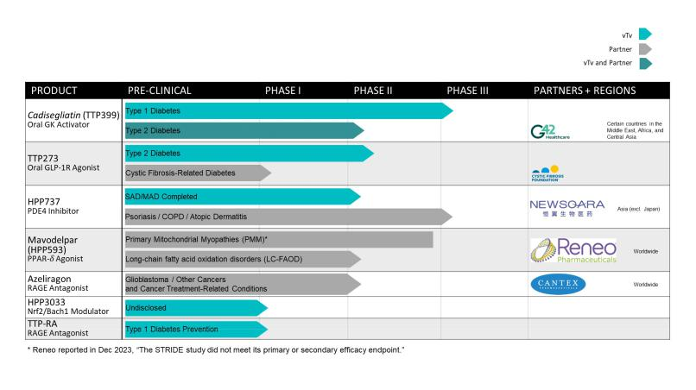

Our Strategy

Our goal is to advance the development of our differentiated pipeline of orally administered, small molecule drug candidates to treat metabolic and inflammatory diseases to minimize their long-term complications and to improve the lives of patients. In December 2021, the Company announced a strategic decision to prioritize the development of its lead program cadisegliatin, a novel, oral, liver-selective glucokinase activator. The recent successful closing of the Private Placement will allow us to further advance our lead program for cadisegliatin (TTP399). We are also actively seeking licensing deals for our other assets. As key components of our strategy, we are focused on:

- Continuing to advance cadisegliatin (TTP399) as a potential treatment for type 1 diabetes. The FDA granted Breakthrough Therapy designation for cadisegliatin as an adjunctive therapy to insulin for the treatment of type 1 diabetes ("T1D") in 2021 which was supported by the positive results from the Phase 2 SimpliciT-1 Study, a multi-center, randomized, double-blind, adaptive study assessing the safety and efficacy of cadisegliatin as an adjunct to insulin therapy in adults with T1D. Consistent with the May 2023 FDA guidance on efficacy endpoints in clinical trials investigating antidiabetic drugs, and with input from the FDA, we now have initiated a Phase 3 double-blind, controlled trial to assess the effect of cadisegliatin on reducing the frequency of Level 2 hypoglycemia (blood glucose levels are less than 54 mg/dL or 3 mmol/L, regardless of symptoms) and Level 3 hypoglycemia ("severe" hypoglycemia e.g., requiring assistance of another person) in 150 patients with T1D. Participants in the trial will be randomized to two doses of cadisegliatin or placebo. Reduction in glycated hemoglobin (HbA1c), a traditional efficacy endpoint in diabetes trials, is a key secondary endpoint to assess the potential of cadisegliatin in reducing hyperglycemia. Following the initial assessment of efficacy after six months of treatment, participants will remain on trial for another six months to assess durability of potential beneficial effects and safety. The study protocol was submitted to the FDA on February 29, 2024. The trial will be conducted in the U.S. only and is expected to complete enrollment by the fourth quarter in 2024 providing top line 1-year data by the first quarter in 2026.

Concurrently, we will be working on the design for two international registrational studies for cadisegliatin in T1D, which we expect to start in 2026.

5

Table of Contents

In addition, we continue to work with our partner, G42 Investments, to initiate a double-blind randomized controlled Phase 2 trial in the Middle East region in 450 insulin-using patients with type 2 diabetes ("T2D"). We expect that trial to begin in 2024.

- Seeking additional strategic collaborations and additional funding to support the continued development and commercialization of our development programs. We will continue to seek additional funding to support the further development of our drug candidates. Such support may come from strategic collaborations with non-profit research funding organizations, such as JDRF International, or from collaboration agreements with other pharmaceutical companies. We are currently in active discussions with respect to financing, partnering and licensing transactions for the further development of cadisegliatin.

Our Type 1 Diabetes Program – Cadisegliatin (TTP399)

Diabetes Overview

Type 1 diabetes is an autoimmune disease in which a person’s pancreas stops producing insulin (a hormone that enables people to get energy from food). T1D results when the body’s immune system attacks and destroys the insulin-producing cells in the pancreas called beta cells. While the causes of TID are not yet entirely understood, scientists believe that both genetic factors and environmental triggers are involved. The onset of T1D is not believed to be affected by diet or lifestyle.

Current Treatments for T1D and Their Limitations

Patients with T1D have difficulty achieving and maintaining consistent glycemic control, defined as HbA1c < 7% as recommended by the American Diabetes Association ("ADA"). In order to maintain appropriate glycemic control, patients with T1D are required to constantly monitor their blood glucose levels, closely manage their diet, and administer insulin via injection in response. While technology has advanced to help people with T1D manage the burden of this monitoring and insulin administration process, including continuous glucose monitors and insulin pumps, patient outcomes have not improved: approximately 80% of people with T1D fail to achieve the ADA’s recommended HbA1c levels. Failure to maintain glycemic control results in dangerous excursions into hyperglycemia or hypoglycemia that are potentially fatal. In addition, the accumulated impact of these glycemic excursions can raise a patient’s risk of potentially serious and life-threatening long-term complications, such as cardiovascular disease, blindness, kidney failure, and nerve damage.

Several existing treatment options for T2D have been investigated to treat T1D, generally without success. While SGLT-1/2 and SGLT-2 inhibitors were initially approved in Europe and Japan with label restrictions to certain sub-groups of people with T1D, and continue to be approved for patients with T2D, these therapies have since been withdrawn from the European market and never received regulatory approval in the U.S. for T1D due to safety risks primarily relating to the risk of diabetic ketoacidosis (“DKA”). Pramlintide (Symlin), an amylin peptide analog approved for meal time injections, has been approved for use in both T1D and T2D since 2005 but has not been adopted widely.

Alternative therapeutic modalities, including monoclonal antibodies, are under clinical investigation and have demonstrated evidence of the potential to delay the onset of T1D. In 2022, the FDA approved Teplizumab (Tzield), a humanized anti-CD3 monoclonal antibody for the treatment of patients with two or more diabetes-related auto-antibodies to delay onset of full-blown disease, and Donislecel (Lantidra), an allogeneic (donor) pancreatic islet cellular therapy for the treatment of patients with T1D who are in poor glycemic control because of recurrent severe hypoglycemia. However, Teplizumab does not address the unmet need of existing patients with T1D or those that are eventually at risk to become patients with T1D following any therapeutic delay in disease onset. The use of Donislecel, on the other hand, is restricted to patients with T1D and recurrent severe hypoglycemic episodes, and requires long-term concurrent immunosuppressive therapy.

Thus, there is a serious unmet medical need to provide people with T1D additional, especially oral, treatment options that can help them to reduce HbA1c and the incidence of hypoglycemia (blood glucose levels below normal) or DKA.

The Role of Glucokinase Activation in Diabetes

Glucokinase (“GK”) is a key regulator of glucose homeostasis and acts as the physiological glucose sensor, changing its conformation, activity, and/or intracellular location in parallel with changes in glucose concentrations. GK has two distinctive characteristics that make it a good choice for blood glucose control. First, its expression is mostly limited to tissues that require glucose-sensing (mainly liver cells and pancreatic β-cells). Second, GK acts as a biological sensor for changes in serum glucose levels and modulates changes in the liver's uptake or release of glucose and changes in insulin secretion by the β-cells. GK activation is attractive as a potential therapy for the treatment of T1D because it may improve

6

Table of Contents

overall glucose control and specifically reduce the frequency and severity of low blood glucose (hypoglycemic) episodes through a mechanism of action that is entirely distinct from currently marketed oral anti-diabetic drugs (“OAD”). Cadisegliatin (TTP399)

Cadisegliatin is an orally administered, small molecule, liver-selective GKA in development as an adjunctive therapy to insulin for the treatment of TID. Cadisegliatin has a novel mechanism of action: liver-selective activation of GK that seeks to provide improved glycemic control and a reduction in the risk of hypoglycemia. Our trials for cadisegliatin to date also suggest that our liver-selective approach to GK activation has the potential to avoid the tolerability issues associated with other GKAs, such as stimulation of insulin secretion independent of ambient blood glucose causing hypoglycemia, increased lipids, and liver toxicity. Based on data from Phase 1 and 2 trials to date, we believe that cadisegliatin, if approved, has the potential to be a first-in-class OAD due to its liver-selectivity and novel mechanism of action. We have completed ten Phase 1 and three Phase 2 clinical trials of cadisegliatin in patients with type 1 and type 2 diabetes, one of which was six months in duration. In these trials, cadisegliatin was well tolerated with negligible incidence of hypoglycemia in the T2D studies and a significant reduction of hypoglycemia observed in the Phase 2 study in TID.

Positive Phase 2 Simplici-T1 Study

In February 2020, we announced positive results from the Simplici-T1 Study, an adaptive Phase 2 clinical trial of cadisegliatin, assessing the pharmacokinetics, pharmacodynamics, safety, and tolerability of cadisegliatin in adult patients with TID over a 12-week period. The Simplici-T1 Study achieved its primary objective by demonstrating statistically significant improvements in HbA1c for cadisegliatin compared to placebo. Moreover, a clinically meaningful decrease (40%) in the frequency of severe and symptomatic hypoglycemia was observed in patients taking cadisegliatin when compared to those taking placebo.

Mechanistic study

In October 2021, we announced positive results from the mechanistic study indicating no increased risk of ketoacidosis with cadisegliatin during acute insulin withdrawal in patients with T1D.

Consistent with previous clinical studies of cadisegliatin, the drug was well tolerated with fewer subjects reporting treatment-emergent adverse events in the group taking cadisegliatin than in the placebo group. Importantly, patients taking cadisegliatin reported no events of hypoglycemia, while four events of hypoglycemia were reported in the placebo group.

ADME study

In August 2023, we completed an Open-Label Phase 1 Study in Healthy Male Subjects to Investigate the Absorption, Metabolism, and Excretion of [¹⁴C]-cadisegliatin (TTP399) Following Single Dose Oral Administration. Ten participants have been dosed, and analysis is ongoing.

Clinical Development Plan

Based upon the positive results of our Phase 2 Simplici-T1 Study, we requested breakthrough treatment designation (BTD) with the FDA which was granted in April 2021.

Consistent with the new 2023 FDA guidance on efficacy endpoints for anti-diabetic drugs, the Company is planning one supportive small and two larger pivotal, placebo-controlled Phase 3 clinical trials of cadisegliatin in patients with T1D and is engaged with the FDA on the optimal clinical trial designs for these studies. The FDA confirmed that the effect size of cadisegliatin on events of hypoglycemia as demonstrated in the Phase 2 SimpliciT-1 Study are clinically meaningful and that a reduction in events of hypoglycemia would be an acceptable clinical endpoint for evaluation of an adjunctive therapy for the treatment of T1D. We now have initiated a Phase 3 double-blind, controlled trial to assess the effect of cadisegliatin on reducing the frequency of Level 2 hypoglycemia (blood glucose levels are less than 54 mg/dL or 3 mmol/L, regardless of symptoms of hypoglycemia) and Level 3 hypoglycemia ("severe" hypoglycemia e.g., requiring assistance of another person) in 150 patients with T1D. Participants in the trial will be randomized to two doses of cadisegliatin or placebo. Reduction in glycated hemoglobin (HbA1c), a traditional efficacy endpoint in diabetes trials, is a key secondary endpoint to assess the potential of cadisegliatin in reducing hyperglycemia. Following the initial assessment of efficacy after six months of treatment, participants will remain on trial for another six months to assess durability of potential beneficial effects and safety. The study protocol was submitted to the FDA on February 29, 2024. The trial will be conducted in the U.S. only and is expected to complete enrollment by the fourth quarter in 2024 providing top line 1-year data by the first quarter in 2026.

Concurrently, we will be working on the design for two international registrational studies for cadisegliatin in T1D, which we expect to start in 2026.

7

Table of Contents

In addition, we continue to work with our partner, G42 Investments, to initiate a double-blind, randomized, controlled Phase 2 trial in the Middle East region in 450 insulin-using patients with T2D. We expect that trial to begin in

2024.

Preclinical Development Plan

Long-term toxicology studies, development and reproductive toxicology studies, have been completed. Carcinogenicity studies are ongoing and expected to be completed by the second quarter of 2024.

Collaboration Agreements

G42 Transaction

The Company and G42 Investments, entered into a Common Stock Purchase Agreement (the “G42 Purchase Agreement”) on May 31, 2022, pursuant to which the Company sold to G42 Investments 259,657 shares of the Company’s Class A common stock at a price per share of approximately $96.40, for an aggregate purchase price of $25.0 million, which was paid (i) $12.5 million in cash at the closing and (ii) $12.5 million in the form of a promissory note.

G42 Investments has agreed to certain transfer restrictions (including restrictions on short sales or similar transactions) and restrictions on further acquisitions of shares, in each case subject to specified exceptions. Following the expiration of a lock up period, from the period May 31, 2022 until December 31, 2024, or if earlier, the date of receipt of FDA approval in the United States for cadisegliatin (the “FDA Approval”), the Company has granted to G42 Investments certain shelf and piggyback registration rights with respect to those shares of Class A common stock issued to G42 Investments pursuant to the G42 Purchase Agreement, including the ability to conduct an underwritten offering to resell such shares under certain circumstances. The registration rights include customary cooperation, cut-back, expense reimbursement, and indemnification provisions.

Contemporaneously with the G42 Purchase Agreement, effective on May 31, 2022, the Company entered into a collaboration and license agreement (the “Cogna Agreement”) with Cogna Technology Solutions LLC, an affiliate of G42 Investments (“Cogna”), which requires Cogna to work with the Company in performing clinical trials for the Company’s compound cadisegliatin (the “Licensed Product”) as well as jointly creating a global development plan to develop, market, and commercialize cadisegliatin in certain countries in the Middle East, Africa, and Central Asia (the “Partner Territory”). Under the terms of the Cogna Agreement, Cogna will obtain a license under certain intellectual property controlled by the Company to enable it to fulfill its obligations and exercise its rights under the Cogna Agreement, including to develop and commercialize the Licensed Product in the Partner Territory, but will not have access to the various intellectual property related to the license and cadisegliatin. Specifically, the Company will share various protocols with Cogna related to conducting the clinical trials and will provide the patient dosages and placebo of cadisegliatin needed to conduct the trials.

Under the Cogna Agreement, Cogna has the right to develop and commercialize the Licensed Product in the Partner Territory at its own cost once restrictions on the use of the IP have been lifted by the Company. The Cogna Agreement determined which specific countries in the Partner Territory that Cogna may pursue development and commercialization and provides the Company with the ability to determine when Cogna can benefit from this IP through the powers granted to the Company to approve the global development plan. Further, the Company may supply at cost, or Cogna may manufacture, cadisegliatin for commercial sale under terms to be agreed upon by the parties at a later date.

Separately, the Company will conduct its clinical trials for cadisegliatin outside of the Partner Territory, at its own cost. The results of each party’s clinical trials will be combined by the Company to seek FDA approval in the United States for cadisegliatin. On December 21, 2022, G42 Healthcare Technology Solutions LLC (formerly known as Cogna Technology Solutions LLC) novated its rights and obligations under the Cogna Agreement to G42 Healthcare Research Technology Projects LLC ("G42 Healthcare"), an affiliate of G42 Investments. As a result of the novation, all references to Cogna herein shall be deemed to refer to G42 Healthcare.

The G42 Purchase Agreement also provides for, following the receipt of the FDA Approval of the Licensed Product, at the option of G42 Investments, either (a) the issuance of the Company’s Class A common stock (the “Milestone Shares”) having an aggregate value equal to $30.0 million or (b) the payment by the Company of $30.0 million in cash (the “Milestone Cash Payment”). The issuance of the Milestone Shares or the payment of the Milestone Cash Payment, as applicable, are conditioned upon receipt of the FDA Approval and subject to certain limitations and conditions set forth in the G42 Purchase Agreement. There can be no assurance that the FDA Approval will be granted or as to the timing thereof.

Once commercialization takes place in the Partner Territory, the Company will receive royalties in the single digits from Cogna on the net sales of the Licensed Product for a period of at least ten years after the first commercial sale of the Licensed Product in the Partner Territory.

8

Table of Contents

On February 28, 2023, the Company and G42 Investments amended the G42 Purchase Agreement and modified the G42 Promissory Note to accelerate the payment due under the note. Pursuant to the amendment, on February 28, 2023, the Company received $12.0 million, which reflected the original amount due under the G42 Promissory Note less a 3.75% discount, in full satisfaction of the note. On February 27, 2024, the Company and G42 Investments further amended the G42 Purchase Agreement in connection with the Private Placement.

CinPax and CinRx Transaction

On July 22, 2022, the Company entered into a Common Stock and Warrant Purchase Agreement (as amended, the "CinRx Purchase Agreement") with CinPax, LLC (“CinPax”), a subsidiary of CinRx Pharma, LLC (“CinRx”), pursuant to which the Company sold to CinPax 103,864 shares of the Company’s Class A common stock at a price per share of approximately $96.40, for an aggregate purchase price of $10.0 million, which was paid (i) $6.0 million in cash at the closing of the transaction and (ii) $4.0 million in the form of a non-interest-bearing promissory note with CinPax and was paid to the Company on November 22, 2022. The Company, CinPax and CinRx subsequently amended the CinRx Purchase Agreement on February 27, 2024, in connection with the Private Placement. The CinRx Purchase Agreement provides CinPax the right for two years following the Closing to designate a board observer, which has been subsequently approved by the Company’s board.

The CinRx Purchase Agreement also provides CinRx warrants to purchase up to 30,000 shares of Class A common stock at an initial exercise of price of approximately $28.80 per share (the “CinRx Warrants”). The CinRx Warrants will become exercisable by CinRx only if (i) the Company receives FDA approval to market and distribute the pharmaceutical product containing the Company’s proprietary candidate, cadisegliatin, or (ii) the Company is acquired by a third party, sells all or substantially all of its assets related to cadisegliatin to a third party or grants a third party an exclusive license to develop, commercialize and manufacture cadisegliatin in the United States. If neither of these events happen within five years of the date of the issuance of the CinRx Warrants, the CinRx Warrants will expire and will not be exercisable by CinRx. The exercise price of the CinRx Warrants and the number of shares issuable upon exercise of the CinRx Warrants are subject to adjustments in accordance with the terms of the CinRx Warrants.

Additionally, in conjunction with the CinRx Purchase Agreement the Company and CinRx entered into a Master Service Agreement whereby CinRx provides the Company with consulting, preclinical and clinical trial services, as enumerated in project proposals negotiated between the Company and CinRx from time to time.

Our Pipeline Programs

TTP273 - GLP-1r Agonist

Overview

Glucagon-like peptide (GLP-1) is a naturally occurring hormone ligand for the GLP-1 receptor (GLP-1R) that has been associated with improved metabolism and decreased inflammation, as well as cardio and neuroprotective effects. Glucagon-like peptide 1 receptor agonists (GLP-1RA) are effective therapies in lowering glycosylated hemoglobin (HbA1c), providing cardio protective benefits and lowering weight. TTP273 is an orally available, small molecule GLP-1RA which has been demonstrated to reduce postprandial glucose excursion in response to an oral glucose test or mixed meal tolerance test in both preclinical and clinical studies. We are currently exploring options to study the therapeutic potential of TTP273 in patients with cystic fibrosis related diabetes ("CFRD").

Cystic Fibrosis Related Diabetes Overview

Cystic fibrosis related diabetes (“CFRD”) shares some features with both type 1 and type 2 diabetes but is distinct, and is categorized as diabetes due to other causes, specifically a disease of the exocrine pancreas, by the American Diabetes Association. In people with cystic fibrosis (“CF”), the thick, sticky mucus that is characteristic of the disease causes scarring of the pancreas. This scarring prevents the pancreas from producing normal amounts of insulin. The damaged pancreas also responds to insulin signaling in a delayed manner. The delay and blunting of the insulin response in patients with CFRD results in postprandial hyperglycemia.

The Role of GLP-1r Activation in Cystic Fibrosis Related Diabetes

GLP-1 is released by the gut in response to nutrients and lowers postprandial glucose by promoting insulin secretion. Abnormally low postprandial stimulation of incretin hormones like GLP-1 has been described in CF patients and improvement in postprandial hyperglycemia has been demonstrated following prandial administration of GLP-1 agonists or dipeptidyl peptidase-4. Although existing GLP-1 mimetics are available for the treatment of CFRD, their use is limited by the gastrointestinal ("GI") side effects and undesired weight loss associated with these agents.

9

Table of Contents

TTP273

TTP273 is an orally available, small molecule GLP-1RA, which has been demonstrated to reduce postprandial glucose excursion in response to an oral glucose test or mixed meal tolerance test in both preclinical and clinical studies. Unlike some other GLP-1RAs, TTP273 exhibits biased increase of cyclic adenosine monophosphate ("cAMP") signaling but does not activate the extracellular signal-regulated kinase ("ERK")/β-arrestin pathway significantly at clinically relevant concentrations which may improve efficacy and tolerability. We believe that TTP273 could be used to treat postprandial hyperglycemia in CFRD patients and CF patients with abnormal postprandial glucose excursions without inducing hypoglycemia or GI side effects. An oral therapy such as TTP273 is needed because the current method of treatment of CFRD is injected insulin, which comes with associated risks of hypoglycemia and poses additional burdens on patients. Other available oral therapies for type 2 diabetes ("T2D") are not recommended for the treatment of CFRD due to side effects, such as hypoglycemia, weight loss, or nausea.

We have completed two Phase 1 clinical trials and one Phase 2 clinical trial of TTP273. Additionally, we have completed nine Phase 1 clinical trials and one Phase 2 clinical trial of TTP054, a predecessor orally administered GLP-1RA. In our Phase 1 and Phase 2 clinical trials, TTP273 has been demonstrated to be well-tolerated with lower incidences of GI side effects, such as nausea and vomiting, than placebo with minimal weight loss, especially in nonobese patients.

In a randomized, double-blind Phase 2 trial in patients with T2D treated with metformin only, TTP273 showed clinically relevant reductions of glycated hemoglobin (HbA1c) and systolic blood pressure after 3 months of treatment.

HPP3033 - Nrf2/Bach1 Modulator

Our candidate, HPP3033, represents a novel, non-electrophilic therapeutic approach to activating the nuclear factor erythroid 2–related factor 2 ("Nrf2") pathway that has the potential to be used in the treatment of chronic diseases associated with oxidative stress.

The Role of Nrf2/Bach1 Modulators

Chronic, unresolved inflammation, oxidative stress, and resulting fibrosis are key features of many diseases. Inflammation is an integral component of the normal immune response that occurs when cells encounter harmful stimuli, such as invading pathogens, damaged cells, or irritants. During inflammation, cells activate inflammatory processes and complexes that increase the production of cytokines, which are proteins that recruit and activate immune cells.

Inflammation and mitochondrial metabolism are closely associated. The mitochondria are often called the “powerhouses” of the cell as they produce the energy that the cell needs to function. This energy is produced by converting fatty acids and glucose into adenosine triphosphate (ATP) by a process called oxidative phosphorylation. During inflammation, mitochondrial metabolism is temporarily reprogrammed to suppress oxidative phosphorylation. Instead of primarily making ATP, the mitochondria divert fatty acids and glucose to increase the production of proinflammatory mediators. During this reprogramming, the mitochondria release chemically reactive molecules called reactive oxygen species (ROS) that can directly attack pathogens and amplify the production of cytokines.

In a normal immune response, the resolution of inflammation begins after the harmful stimuli have been eliminated. Nrf2 is a protein that plays a key role in the resolution of inflammation by regulating the expression of specific genes involved in mitochondrial metabolism, redox balance, and cytokine production. When activated, Nrf2 promotes the resolution of inflammation by normalizing mitochondrial metabolism, restoring redox balance, and suppressing cytokine production.

In many chronic and genetic diseases, Nrf2 activity is suppressed, and the resolution of inflammation fails to occur or is inadequate, leading to persistent mitochondrial dysfunction, excess production of ROS, and production of cytokines. These processes cause chronic inflammation, which can ultimately lead to tissue damage and loss of organ function.

To date, FDA-approved Nrf2 activators, Tecfidera and Skyclarys for patients with multiple sclerosis and Friedreich's ataxia, respectively, are nonspecific alkylating agents relying on reactive, electrophilic biological targets that present safety and tolerability issues. Non-electrophilic activation of the Nrf2 pathway via targeting the transcription factor BTB and CNC homology 1 ("Bach1") transcriptional repressor provides an alternative mechanism by which to increase the activation of Nrf2 to reduce the oxidative stress and inflammation associated with many acute and chronic diseases.

Bach1 is a transcriptional repressor that controls the expression of certain genes involved in the body’s antioxidant response processes. Genetic knock-out models of Bach1 have shown increased expression of multiple antioxidant proteins such as heme oxygenase-1 (HMOX1), leading to a significant level of cellular, tissue and organ protection in a wide variety of mouse models. Hemin and the hemin mimetic cobalt protoporphyrin IX (“CoPP”) are Bach1 ligands that have served as useful tool compounds to investigate the role of Bach1 inhibition in a variety of disease settings. Both molecules have been shown to have beneficial effects on oxidative stress and inflammatory-mediated pathologies in several animal models.

10

Table of Contents

Further, the ubiquity of the response suggests that the observed tissue protective effects are not related to the underlying causes of a particular disease, but instead are an intrinsic outcome of Bach1 modulation along with Nrf2 activation.

HPP3033

Oxidative stress plays an important role in the degeneration of dopaminergic neurons in Parkinson’s disease (PD). In a model of Parkinson's disease, oral administration of HPP3033 attenuated 1-methyl-4-phenyl-1,2,3,6-tetrahydropyridine ("MPTP") neurotoxicity in pre- and post-treatment paradigms. Bach1 inhibitor-induced neuroprotection was associated with the up regulation of Bach1 targeted pathways in concurrence with the results from Bach knock-out ("KO") mice. Nrf2 activators are known to exert protection in the pre-treatment paradigm, but the benefits of pharmacological Nrf2 activation are rarely observed in post-treatment models. Therefore, the results obtained with HPP3033 in this study hold promise for the future development of this compound.

HPP737 - PDE4 Inhibitor

Psoriasis Overview

Psoriasis is a chronic autoimmune inflammatory disease in which the growth cycle of skin is accelerated due to an imbalance in proinflammatory and anti-inflammatory cytokines. This results in the proliferation of skin cells and the development of raised, red, silvery scale plaques (i.e., plaque psoriasis, psoriasis vulgaris) that have not only medical implications but an impact on a patient’s quality of life. While the specific inciting events for this proinflammatory process are unknown, psoriasis may be caused by autoimmunity and genetic predisposition. Events such as trauma to the skin, stress, illness, or infection that triggers the immune systems, obesity, and weather have been identified as triggers for flare ups.

Current Treatment for Psoriasis and Their Limitations

Topical therapies, including glucocorticoids and vitamin D analogs, are the mainstay of treatment for mild psoriasis. The continuous long-term use of glucocorticoids is limited by the risk of skin thinning and/or atrophy and the potential for systemic absorption. Vitamin D analogs are often added to glucocorticoids to improve glucocorticoid efficacy while allowing for reduction in glucocorticoid dose. Moderate to severe disease is treated with systemic therapies including oral phosphodiesterase-4 ("PDE4") inhibition, immunosuppressants, retinoids, and biologics (e.g., anti-tumor necrosis factor ("anti-TNF") agents, interleukin-17 ("IL-17") inhibitors, and interleukin-23 ("IL-23") inhibitors). Biologics, while realizing high efficacy rates in treating psoriasis, are associated with administration by injection, high cost, need for laboratory monitoring and increased risk of infection.

Inhibitors of PDE4 act by increasing intracellular concentrations of cyclic adenosine monophosphate (“cAMP”), which has a broad range of anti-inflammatory effects. PDE4 activity is increased in the skin of patients with psoriasis leading to up-regulation of immune modulatory, proinflammatory genes and cytokines, including IL-17, IL-23, and tumor necrosis factor-alpha (TNF-α). Treatments for psoriasis are aimed at reducing proinflammatory cytokine activity. The therapeutic potential of oral PDE4 inhibitors has been limited by dose limiting adverse events such as nausea, vomiting, diarrhea, and headache.

HPP737

HPP737 is an orally administered, potent and selective, non-central nervous system ("non-CNS") penetrant PDE4 inhibitor that addresses inflammatory diseases and offers the potential for an improved tolerability profile and efficacy over commercially available PDE4 inhibitors. HPP737 has shown potent inhibition of IL-17a and TNF-α production in in vitro studies and activity in several animal models of inflammation. HPP737 has completed Phase 1 single-ascending dose and initial multiple-ascending dose studies, in which it was well tolerated at all doses tested in healthy volunteers. Clinical data generated to date supports achieving target engagement (reduction in ex vivo lipopolysaccharide ("LPS") stimulated TNF-α) at HPP737 plasma concentrations predicted to be efficacious from preclinical models.

In September 2021, we announced the results of a multiple ascending dose Phase 1 study of HPP737 to assess the pharmacokinetics, pharmacodynamics, safety and tolerability of HPP737 in healthy volunteers as part of our psoriasis development program. The trial enrolled 12 subjects in each of two dose cohorts, 15mg and 20mg, randomized to receive HPP737 or placebo (3:1) orally once daily for 14 days. Dose escalation up to 20mg once per day demonstrated dose proportional increases in exposure, while maintaining a favorable safety and tolerability profile with no dose limiting safety

11

Table of Contents

or tolerability findings observed. There were no serious adverse events and no discontinuations due to treatment emergent adverse events.

Partnered Development Programs

PDE4 and Newsoara Biopharma

On May 31, 2018, we entered into a license agreement with Newsoara (the “Newsoara License Agreement”), under which Newsoara obtained an exclusive and sublicensable license to develop and commercialize our PDE4 program, including the compound HPP737, in China and other Pacific Rim territories (collectively, the “Newsoara License Territory”). Additionally, under the Newsoara License Agreement, we obtained a non-exclusive, sublicensable, royalty-free license to develop and commercialize certain Newsoara patent rights and know-how related to our PDE4 program for therapeutic uses in humans outside of the Newsoara License Territory.

Under the terms of the Newsoara License Agreement, as amended, Newsoara paid us an upfront cash payment of $2.0 million. We are eligible to receive additional potential development, regulatory and sales-based milestone payments totaling up to $58.5 million. In addition, Newsoara is obligated to pay us royalty payments at high-single to low-double digit rates, based on tiers of annual net sales of licensed products. Such royalties will be payable on a licensed product-by-licensed product and country-by-country basis until the latest of expiration of the licensed patents covering a licensed product in a country, expiration of data exclusivity rights for a licensed product in a country or a specified number of years after the first commercial sale of a licensed product in a country.

Under the terms of the Newsoara License Agreement, Newsoara will be responsible for the development and commercialization of the licensed products in the Newsoara License Territory, at its cost, and is required to use commercially reasonable efforts with respect to such development and commercialization efforts.

The Newsoara License Agreement, unless terminated earlier, will continue until expiration of all royalty obligations of Newsoara to us. Either party may terminate the Newsoara License Agreement for the other party’s uncured material breach. Newsoara may terminate the Newsoara License Agreement at will upon prior written notice. Upon expiration (but not earlier termination) of the Newsoara License Agreement the licenses granted to Newsoara will survive on a royalty-free basis in perpetuity.

Azeliragon and Cantex Pharmaceuticals, Inc.

On June 22, 2021, vTv Therapeutics Inc. and Cantex Pharmaceuticals, Inc. (“Cantex”) entered into a licensing agreement under which Cantex obtained exclusive worldwide rights to develop and commercialize azeliragon, vTv’s novel antagonist of RAGE (the receptor for advanced glycation end products).

Under the terms of the agreement, Cantex will be responsible for the development and commercialization of azeliragon, and the companies will allocate downstream profits under a tiered arrangement.

On January 9, 2023, Cantex announced that the FDA has granted Orphan Drug Designation to azeliragon for the treatment of glioblastoma. In addition, a Phase 2 trial of azeliragon is in progress in women receiving “neoadjuvant chemotherapy” of breast cancer, which is chemotherapy to prevent cancer from returning after initial potentially curative treatment. In February 2022, Cantex secured a global license from Harvard University to further develop azeliragon as a treatment for inflammatory lung diseases, including COVID-19.

PPAR-δ and Reneo Pharmaceuticals, Inc.

On December 21, 2017, we entered into a License Agreement with Reneo Pharmaceuticals, Inc. (“Reneo”) (the “Reneo License Agreement”), under which Reneo obtained an exclusive, worldwide, sublicensable license to develop and commercialize our peroxisome proliferation activated receptor delta (PPAR-δ) agonist program, including the compound HPP593 (REN001, mavodelpar), for therapeutic, prophylactic, or diagnostic application in humans.

Under the terms of the Reneo License Agreement, Reneo paid us an initial license fee of $3.0 million. We are eligible to receive additional potential development, regulatory and sales-based milestone payments totaling up to $94.5 million. In addition, Reneo is obligated to pay us royalty payments at mid-single to low-double digit rates, based on tiers of annual net sales of licensed products. Such royalties will be payable on a licensed product-by-licensed product and country-by-country basis until the latest of expiration of the licensed patents covering a licensed product in a country, expiration of data exclusivity rights for a licensed product in a country or a specified number of years after the first commercial sale of a licensed product in a country. In addition, we have received common stock and certain participation rights representing a minority interest in Reneo’s outstanding equity.

12

Table of Contents

Under the terms of the Reneo License Agreement, Reneo will be responsible for the worldwide development and commercialization of the licensed products, at its cost, and is required to use commercially reasonable efforts with respect to such development and commercialization efforts.

The Reneo License Agreement, unless terminated earlier, will continue until expiration of all royalty obligations of Reneo to us. Either party may terminate the Reneo License Agreement for the other party’s uncured material breach. Reneo may terminate the Reneo License Agreement at will upon prior written notice. Upon expiration (but not earlier termination) of the Reneo License Agreement, the licenses granted to Reneo will survive on a royalty-free basis in perpetuity.

Reneo has continued to progress the development of mavodelpar for primary mitochondrial myopathy (PMM) and long-chain fatty acid oxidation disorders (LC-FAOD). The Phase 2 study of mavodelpar for glycogen storage disorder type V (McArdle Disease) showed only modest benefits, and Reneo does not plan to proceed further for this indication.

Reneo announced on December 14th, 2023, that its pivotal STRIDE study (NCT04535609) of mavodelpar in adult patients with PMM did not meet its primary efficacy or secondary efficacy endpoint. The primary efficacy endpoint of the trial was the change from baseline in the distance walked during the 12-minute walk test (12MWT) at week 24. The secondary efficacy endpoint was the change from baseline in the PROMIS® Short Form Fatigue 13a score.

GLP-1r and Hangzhou Zhongmei Huadong Pharmaceutical Co., Ltd.

On December 21, 2017, we entered into a License Agreement with Hangzhou Zhongmei Huadong Pharmaceutical Co., Ltd. (“Huadong”) (the “Huadong License Agreement”), under which Huadong obtained an exclusive and sublicensable license to develop and commercialize our glucagon-like peptide-1 receptor agonist (“GLP-1r”) program, including the compound TTP273, for therapeutic uses in humans or animals, in China and certain other Pacific Rim territories, including Australia and South Korea (collectively, the “Huadong License Territory”). Additionally, under the Huadong License Agreement, we obtained a non-exclusive, sublicensable, royalty-free license to develop and commercialize certain Huadong patent rights and know-how related to our GLP-1r program for therapeutic uses in humans or animals outside of the Huadong License Territory.

Under the terms of the Huadong License Agreement, Huadong has paid us an initial license fee of $8.0 million, and we are eligible to receive potential development and regulatory milestone payments totaling up to $22.0 million, as amended in January 2021. Additionally, we are eligible to receive additional potential regulatory milestone of $20.0 million if Huadong receives regulatory approval for a central nervous system indication. Further, we are eligible for an additional $50.0 million in potential sales-based milestones, as well as royalty payments ranging from low-single to low-double digit rates, based on tiered sales of licensed products.

Under the original Huadong License Agreement, we had the obligation to conduct a Phase 2 multi-region clinical trial (the “Phase 2 MRCT”), should Huadong require us to do so. We were also responsible for contributing up to $3.0 million in connection with the Phase 2 MRCT, if it occurs. However, the Huadong License Agreement was amended in January 2021 to remove these obligations. The Phase II study in mainland China and Taiwan has achieved Last Patient Out “LPO” on January 11, 2022. In addition, a milestone was paid in 2022.

Huadong will be responsible for the development and commercialization of the licensed products in the Huadong License Territory, at its cost, and is required to use commercially reasonable efforts with respect to its development efforts. Further, Huadong is required to use commercially reasonable efforts to develop and commercialize at least one GLP-1r compound in China.

The Huadong License Agreement, unless terminated earlier, will continue on a product-by-product and country-by-country basis until expiration of the royalty obligations Huadong owes to us on such licensed product, which extend until the later of the expiration of certain patent or data exclusivity rights covering such licensed product in such country or eight years after the first commercial sale of such product in such country. Either party may terminate the Huadong License Agreement for the other party’s uncured material breach.

On December 18, 2023, Huadong notified us of its intent to terminate the Huadong License Agreement. The termination will not be effective until after both parties negotiate and finalize a termination agreement, which is expected to occur in the first half of 2024.

Nrf2 and Anteris Bio, Inc.

On December 11, 2020, we entered into a license agreement with Anteris Bio, Inc. (“Anteris”) (the “Anteris License Agreement”), under which Anteris obtained a worldwide, exclusive and sublicensable license to develop and commercialize vTv LLC’s Nrf2 activator, HPP971.

13

Table of Contents

Under the terms of the Anteris License Agreement, Anteris paid vTv LLC an initial license fee of $2.0 million. vTv LLC is eligible to receive additional potential development, regulatory, and sales-based milestone payments totaling up to $151.0 million. Anteris is also obligated to pay vTv royalty payments at a double-digit rate based on annual net sales of licensed products. Such royalties will be payable on a licensed product-by-licensed product basis until the latest of expiration of the licensed patents covering a licensed product in a country, expiration of data exclusivity rights for a licensed product in a country, or a specified number of years after the first commercial sale of a licensed product in a country. In addition, vTv LLC received a minority ownership interest in Anteris.

Under the terms of the Anteris License Agreement, Anteris will be responsible for the development and commercialization of the licensed products, at its cost, and is required to use commercially reasonable efforts with respect to such development and commercialization efforts.

The Anteris License Agreement, unless terminated earlier, will continue until expiration of all royalty obligations of Anteris to vTv LLC. Either party may terminate the Anteris License Agreement for the other party’s uncured material breach. Anteris may terminate the Anteris License Agreement at will upon prior written notice. Either party may terminate the Anteris License Agreement for the other party’s insolvency.

On September 25, 2023, Anteris notified the Company that it was terminating the Anteris License Agreement. The termination became effective on December 24, 2023, and Anteris has since liquidated its assets and ceased doing business.

Inbound Partnerships

JDRF Agreement

In August 2017, we entered into a research and collaboration agreement with JDRF International (the “JDRF Agreement”) to support the funding of the Simplici-T1 Study, a Phase 2 study to explore the effects of cadisegliatin in patients with type 1 diabetes. The JDRF Agreement was amended in June 2021 to provide additional funding for the Company’s mechanistic study exploring the effects of cadisegliatin on ketone body formation during a period of insulin withdrawal in people with type 1 diabetes. According to the terms of the JDRF Agreement, as amended, JDRF provided research funding of $3.4 million based on the achievement of research and development milestones. Additionally, the Company has the obligation to make certain milestone payments to JDRF upon the commercialization, licensing, sale or transfer of cadisegliatin as a treatment for type 1 diabetes.

Novo Nordisk

In February 2007, we entered into an Agreement Concerning Glucokinase Activator Project with Novo Nordisk A/S (the “Novo License Agreement”) whereby we obtained an exclusive, worldwide, sublicensable license under certain Novo Nordisk intellectual property rights to discover, develop, manufacture, have manufactured, use, and commercialize products for the prevention, treatment, control, mitigation, or palliation of human or animal diseases or conditions. As part of this license grant, we obtained certain worldwide rights to Novo Nordisk’s GKA program, including rights to preclinical and clinical compounds such as cadisegliatin. This agreement was amended in May 2019 to create milestone payments applicable to certain specific and non-specific areas of therapeutic use. Under the terms of the Novo License Agreement, the Company has additional potential developmental and regulatory milestone payments totaling up to $9.0 million for approval of a product for the treatment of type 1 diabetes, $50.5 million for approval of a product for the treatment of type 2 diabetes, or $115.0 million for approval of a product in any other indication. The Company may also be obligated to pay an additional $75.0 million in potential sales-based milestones, as well as royalty payments, at mid-single digit royalty rates, based on tiered sales of commercialized licensed products. During the year ended December 31, 2021, the Company made a payment of $2.0 million related to the satisfaction of the milestone to complete the Phase 2 trials for cadisegliatin under this agreement.

Third-Party Suppliers and Manufacturers

We do not own or operate, and currently have no plans to establish, any manufacturing facilities. We currently rely, and expect to continue to rely, on third parties to manufacture clinical supplies of our drug candidates and for our other research and discovery programs. We do not have multiple sources of supply for the components used in our drug candidates.

Intellectual Property

Patents

The IP portfolio for cadisegliatin (TTP399) includes issued patents in approximately 35 jurisdictions, including the U.S., over 10 European countries, Japan, Canada, Australia, and China, directed to cadisegliatin as a composition of matter, among other things. The issued U.S. patent covering cadisegliatin as a composition of matter will expire no earlier than 2025,

14

Table of Contents

absent any patent term adjustments or extensions, but may expire as late as 2030 if, after approval by the U.S. Food and Drug Administration (FDA), we apply for and obtain the maximum possible patent term extension (PTE) that is available under the Drug Price Competition and Patent Term Restoration Act of 1984 (the “Hatch-Waxman Act”). Only one U.S. patent applicable to an approved drug may be extended and only those claims covering the approved drug, a method of using it, or a method for manufacturing it may be extended. Patents covering cadisegliatin as a composition of matter outside the United States will expire no earlier than 2025, absent any patent term adjustments or extensions. Provisions that are similar to the U.S. PTE under the Hatch-Waxman Act are available in Europe and some other foreign jurisdictions to extend the term of the patent covering cadisegliatin as a composition of matter. The IP portfolio for cadisegliatin also includes patent families covering crystal forms, salt forms, and solid formulations of cadisegliatin, among other things. The issued patents and patent applications, if issued, in these additional patent families would be expected to expire between 2034 and 2041, absent any patent term adjustments or extensions. The IP portfolio for cadisegliatin further includes additional patent families covering combinations of cadisegliatin with metformin, DPP-4 inhibitors, or GLP-1r agonists, and their use in methods of treatment. The issued patents and patent applications, if issued, in these additional patent families would be expected to expire between 2031 and 2033, absent any patent term adjustments or extensions. In addition, the IP portfolio also includes a patent family covering methods of treating patients with type 1 diabetes using cadisegliatin in combination with insulin. The issued patents and patent applications, if issued in this additional patent family, if issued, would be expected to expire in 2039, absent any patent term adjustments or extensions.

The IP portfolio for HPP737 includes issued patents in the U.S. generically covering HPP737 as a composition of matter and methods of use to treat various indications. The issued U.S. patent generically covering HPP737 as a composition of matter will expire no earlier than 2029, absent any patent term adjustments or extensions, but may expire as late as 2034 if, after approval by the U.S. FDA, we apply for and obtain the maximum possible PTE that is available under the Hatch-Waxman Act. The IP portfolio for HPP737 also includes a patent family specifically covering HPP737 and another patent family covering a crystalline form of HPP737. Any patents issuing from these two patent families will expire in 2040, absent any patent term adjustments or extensions.

The IP portfolio for the GLP-1r program includes issued patents in over 25 countries and regions, including the U.S., over 10 European countries, Japan, Canada, Australia, and China, directed to TTP273 as a composition of matter. The issued U.S. patent covering TTP273 as a composition of matter will expire no earlier than 2030, absent any patent term adjustments or extensions, but may expire as late as 2035, if after approval by the U.S. FDA we apply for and obtain the maximum possible PTE that is available under the Hatch-Waxman Act following approval. Patents covering TTP273 as a composition of matter outside the United States will expire no earlier than 2030, absent any patent term adjustments or extensions. Provisions that are similar to the U.S. PTE under the Hatch-Waxman Act are available in Europe and some other foreign jurisdictions to extend the term of the patent covering TTP273 as a composition of matter. The IP portfolio for TTP273 also includes patent families covering crystalline, non-crystalline, and salt forms, and formulations of TTP273, synthetic precursors to, and methods of manufacture of TTP273, as well as combinations of TTP273 and metformin, and their use in methods of treatment, and dosage regimens of TTP273. The patent applications in these additional patent families, if issued, would be expected to expire between 2034 and 2042, absent any patent term adjustments or extensions.

The IP portfolio for the Nrf2/Bach1 program includes issued patents in approximately 25 countries and regions, including the U.S., Europe, Japan, Canada, Australia, and China, directed to HPP971 and HPP3033 as compositions of matter, among other things. The issued U.S. patent covering HPP971 and HPP3033 as compositions of matter will expire no earlier than 2031, absent any patent term adjustments or extensions. However, this issued U.S. patent may expire as late as 2036, if after approval by the U.S. FDA we apply for and obtain the maximum possible PTE that is available under the Hatch-Waxman Act following approval”), and the patent term adjustments calculated by the USPTO are fully applied. Patents covering HPP971 and HPP3033 as a composition of matter outside the United States will expire no earlier than 2031, absent any patent term adjustments or extensions. Provisions that are similar to the U.S. PTE under the Hatch-Waxman Act are available in Europe and some other foreign jurisdictions to extend the term of the patents covering HPP971 and HPP3033 as a composition of matter. The IP portfolio for the Nrf2/Bach1 program also includes patent families covering backup compounds, methods of use in combination with other Nrf2 activator compounds such as dimethyl fumarate and bardoxolone, and methods to treat sickle cell diseases, osteoporosis, and refractive ocular disorders. The patent applications in these additional patent families, if issued, would be expected to expire between 2035 and 2041, absent any patent term adjustments or extensions.

The IP portfolio for azeliragon also includes patent families covering polymorphs, salt forms, metabolites, degradation products and a synthetic precursor of azeliragon, methods of treatment using select dosage regimens of azeliragon, and methods of treating select patient populations, among other things. The issued patents and patent applications, if issued in these additional patent families, if issued, would be expected to expire between 2028 and 2039. The issued U.S. patent covering the polymorph of azeliragon used in clinical development will expire no earlier than 2028, absent any patent term

15

Table of Contents

adjustments or extensions, but may expire as late as 2033 if after approval by the U.S. FDA we decide to apply for and obtain the maximum PTE under the Hatch-Waxman Act for the U.S. patent covering the polymorph of azeliragon instead of the U.S. patent covering azeliragon as a composition of matter. Only one patent applicable to an approved drug may be extended and only those claims covering the approved drug, a method of using it, or a method for manufacturing it may be extended. Similar provisions available in Europe and some other foreign jurisdictions to extend the term of a patent that covers an approved drug.

Trade Secrets

In addition to patents, we rely on trade secrets and know-how to develop and maintain our competitive position. We seek to protect our proprietary technology and processes, in part, by entering into confidentiality agreements and invention assignment agreements with our employees, consultants, scientific advisors, contractors and commercial partners. These agreements are designed to protect our proprietary information and, in the case of the invention assignment agreements, to grant us ownership of technologies that are developed by employees or through a relationship with a third party. We also seek to preserve the integrity and confidentiality of our data and trade secrets by maintaining physical security of our premises and physical and electronic security of our information technology systems. While we have confidence in these individuals, organizations and systems, agreements or security measures may be breached, and we may not have adequate remedies for any breach. In addition, our trade secrets may otherwise become publicly known or be independently discovered by competitors. To the extent that our contractors use or incorporate intellectual property owned by others in their work for us, disputes may arise as to the rights in related or resulting know-how and inventions.

Competition

The biopharmaceutical industry is characterized by intense competition and rapid innovation. Our potential competitors include large pharmaceutical and biotechnology companies, specialty pharmaceutical companies and generic drug companies. We believe the key competitive factors that will affect the development and commercial success of our drug candidates are efficacy, safety and tolerability profile, mechanism of action, control and predictability, convenience of dosing, price and reimbursement, and availability of comparable alternative therapies.

Many of the companies against which we may compete have significantly greater financial resources and expertise in research and development, manufacturing, preclinical testing, conducting clinical trials, obtaining regulatory approvals, and marketing approved products than we do. Mergers and acquisitions in the pharmaceutical and biotechnology industries may result in even more resources being concentrated among a smaller number of our competitors. Smaller or early-stage companies may also prove to be significant competitors, particularly through collaborative arrangements with large and established companies. These competitors also compete with us in recruiting and retaining qualified scientific and management personnel and establishing clinical trial sites and patient registration for clinical trials, as well as in acquiring technologies complementary to, or necessary for, our programs. Our commercial opportunity could be reduced or eliminated if our competitors develop and commercialize products that are safer, more effective, have fewer or less severe side effects, are more convenient or are less expensive than any products that we may develop. Our competitors also may obtain FDA or other regulatory approval for their products more rapidly than we may obtain approval for ours, which could result in our competitors establishing a strong market position before we are able to enter the market. The key competitive factors affecting the success of all our programs are likely to be their efficacy, safety, convenience, and availability of reimbursement.

Potential Competing Products – Type 1 Diabetes

If approved, we expect that our type 1 diabetes investigational drug candidate will compete with oral non-insulin agents and new insulin formulations or devices that are currently being developed. These include the SGLT-1/2 inhibitor sotagliflozin, being developed by Lexicon, and the oral somatostatin type 2 receptor blocker ZT-01 by Zucara Therapeutics. In addition, Diasome Pharmaceuticals has started a new Phase 2 study in February 2024 to assess the effects of their Hepatic Directed Vesicle (HDV)-based insulin lispro formulation ("HDV Insulin lispro") on the incidence of nocturnal hypoglycemia in patients with T1D. However, none of these treatments are currently approved or marketed for the treatment of type 1 diabetes.

Collaboration Revenue and Customers

Most of our collaboration revenue for the years ended December 31, 2023, 2022 and 2021 is related to our licenses of certain compounds in the preclinical stage or clinical stage, including the Huadong License Agreement, the Reneo License Agreement, and the Newsoara License Agreement. Revenue recognized in these periods relates to initial consideration received in the form of upfront payments and equity interests, research activities performed by our personnel, and the achievement of development milestones.

16

Table of Contents

Government Regulation and Product Approvals

Government authorities in the United States, at the federal, state and local level, and in other countries and jurisdictions, including the European Union (“EU”), extensively regulate, among other things, the research, development, testing, manufacture, pricing, reimbursement, sales, quality control, approval, packaging, storage, recordkeeping, labeling, advertising, promotion, distribution, marketing, post-approval monitoring and reporting, and import and export of biopharmaceutical products. The processes for obtaining marketing approvals in the United States and in foreign countries and jurisdictions, along with compliance with applicable statutes and regulations and other regulatory authorities, require the expenditure of substantial time and financial resources. For a full discussion of the regulatory framework for the approval and regulation of investigational drug candidates, and applicable domestic and foreign healthcare law, please see “Part 1 – Item 1 – Business - Government Regulation and Product Approvals” in our Annual Report on Form 10-K filed on February 21, 2020.

Human Capital

As of December 31, 2023, we had sixteen employees (all but seven of whom work in North Carolina), of which at least ten hold graduate degrees (including eight doctorate degrees) and seven are engaged in full-time research and development activities. None of our employees are represented by a labor union, and we consider our employee relations to be good.

Our Corporate Information

We were incorporated under the laws of the State of Delaware in 2015. Our principal executive offices are located at 3980 Premier Drive, Suite 310, High Point, NC 27265, and our telephone number is (336) 841-0300. We also maintain a corporate website, www.vtvtherapeutics.com, where stockholders and other interested persons may review, without charge, among other things, corporate governance materials and certain Securities Exchange Commission (SEC) filings, which are generally available on the same business day as the filing date with the SEC on the SEC’s website http://www.sec.gov. The contents of our website are not made a part of this Annual Report on Form 10-K.

17

Table of Contents

ITEM 1A. RISK FACTORS

Summary of Principal Risk Factors

Our business is subject to a number of risks, including risks that may prevent us from achieving our business objectives or may adversely affect our business, financial condition, results of operations, cash flows, and prospects.

These risks are discussed more fully below and include, but are not limited to, risks related to:

Our Financial Position and Need for Additional Capital

- our ability to achieve or maintain profitability;

- our ability to generate revenue in absence of any products approved for sale;

- our need for additional capital to continue the development and commercialization of our drug candidates;

- the impact of raising additional capital to our stockholders and the rights of our drug candidates;

The Development and Regulatory Approval of Our Drug Candidates

- the potential failure of our clinical trials or our inability to receive regulatory approval for our drug candidates;

- the identification of serious adverse or unacceptable side effects which are determined to be drug-related;

- the impact of changes in law or regulatory policy on the approval of our drug candidates;

- the impact of delays in the commencement, enrollment and completion of our clinical trials;

- our ability to submit an NDA for the drug candidates we are developing;

Risks Relating to the Commercialization of Our Drug Candidates

- the acceptance of drug candidates in the market, if approved by the appropriate regulatory agencies;

- our ability to establish sales and marketing capabilities or enter into agreements with third parties to sell and market our drug candidates;

- the impact of ongoing obligations and continued regulatory review for our drug candidates post-commercialization;

- competition with other products;

- the impact of healthcare cost containment initiatives and the growth of managed care;

- our ability to obtain marketing approval for our drug candidates and obtain profitable pricing once approved;

- the impact of healthcare laws and regulations on our relationships with healthcare professionals, principal investigators, consultants, customers (actual and potential) and third-party payors;

- our ability to obtain approval to commercialize products outside the United States;

Risks Relating to Our Dependence on Third Parties

- our ability to establish and maintain collaborative relationships to further the development of our drug candidates;

- the professional conduct of third parties we rely on to conduct, supervise and monitor certain of our clinical trials;

- our dependence on limited sources of supply for the components used in cadisegliatin (TTP399) and our other drug candidates;

- our reliance on third-party manufacturers to produce our drug candidates;

Risks Relating to Our Intellectual Property

- our ability to continue to protect proprietary rights to our intellectual property;

- the unauthorized disclosure of our trade secrets or other confidential information;

- the impact of changes to the patent laws in the United States and other jurisdictions;

- the impact of litigation for infringing intellectual property rights of third parties;

- the impact of litigation to protect or enforce our patents or other intellectual property;

- our ability to enforce our intellectual property rights throughout the world;

- our ability to obtain patent term extensions for our drug candidates;

Risks Relating to Employee Matters and Managing Growth

- the impact of expanding our operations and managing growth;

18

Table of Contents

- our ability to attract and retain key personnel;

- the impact of our employees, independent contractors, principal investigators, CROs, consultants and collaborators in the event that they engage in misconduct or other improper activities;

Other Risks Relating to Our Business

- the impact of the widespread outbreak of an illness or any other communicable disease, or any other public health crisis;

- the impact of using our financial and human resources to pursue a particular research program or drug candidate and failing to capitalize on programs or drug candidates that may be more profitable or for which there is a greater likelihood of success;

- the impact of litigation and government investigations, including product liability lawsuits;

- the exposure to uninsured liabilities;

- our ability to remain competitive given the rapidly changing market for our proposed drug candidates;

- the impact of computer system failures, cyber-attacks or a deficiency in our cyber-security;

Risks Related to our Common Stock

- our ability to maintain listing of our Class A common stock on Nasdaq

- the impact of MacAndrews’ substantial influence over our business;

- the potential for conflicts of interest with our directors who have relationships with MacAndrews;

- our ability to pay cash dividends;

- the potential for securities class action litigation;

- the impact of research and reports that equity research analysts publish about us and our business;

- the impact of substantial sales of shares into the market at any time;

- the dilution created by future sales and issuances of our Class A common stock or rights to purchase Class A common stock;

- our reliance upon our “smaller reporting company” status;

- the existence of provisions in our governing documents or state law which may delay or prevent our acquisition by a third party;

- our obligation to make payments under the Tax Receivable Agreement;

- our ability to make distributions from vTv LLC to satisfy our obligations;

- the benefits conferred upon M&F that will not benefit Class A common stockholders to the same extent as it will benefit MacAndrews.

19

Table of Contents

Risks Relating to Our Financial Position and Need for Additional Capital

We have incurred significant losses since inception and anticipate that we will incur continued losses for the foreseeable future. We may never achieve or maintain profitability.

We are a clinical stage pharmaceutical company with limited operating history. We have never been profitable and do not expect to be profitable in the foreseeable future. We have incurred net losses in each year since beginning to develop our drug candidates, including net losses of approximately $20.3 million, $19.2 million and $13.0 million for the years ended December 31, 2023, 2022 and 2021, respectively. As of December 31, 2023, we had a total accumulated deficit of approximately $281.0 million. In addition, we have not commercialized any products and have never generated any revenue from the commercialization of any product. We have devoted most of our financial resources to research and development, including our preclinical development activities and clinical trials. We expect to incur significant additional operating losses for the next several years, at least, as we conduct our research and development activities, advance drug candidates through clinical development, complete clinical trials, seek regulatory approval and, if we receive FDA approval, commercialize our products. Furthermore, the costs of advancing drugs into each succeeding clinical phase tend to increase substantially over time. The total costs to advance any of our drug candidates to marketing approval in even a single jurisdiction would be substantial. Because of the numerous risks and uncertainties associated with pharmaceutical product development, we are unable to accurately predict the timing or amount of increased expenses or when, or if, we will be able to begin generating revenue from the commercialization of products or achieve or maintain profitability. We expect to continue to incur significant additional expenses as we continue the development of cadisegliatin. Furthermore, our ability to successfully develop, commercialize and license our products and generate product revenue is subject to substantial additional risks and uncertainties, as described under “—Risks Relating to the Discovery, Development and Regulatory Approval of Our Drug Candidates” and “—Risks Relating to the Commercialization of Our Drug Candidates.” As a result, we expect to continue to incur net losses and negative cash flows for the foreseeable future. These net losses and negative cash flows have had, and will continue to have, an adverse effect on our stockholders’ equity and working capital. The amount of our future net losses will depend, in part, on the rate of future growth of our expenses and our ability to generate revenues. In addition, we may not be able to enter into any collaborations that will generate significant cash. If we are unable to develop and commercialize one or more of our drug candidates either alone or with collaborators, or if revenues from any drug candidate that receives marketing approval are insufficient, we will not achieve profitability. Even if we do achieve profitability, we may not be able to sustain or increase profitability. If we are unable to achieve and then maintain profitability, the value of our equity securities will be materially and adversely affected.

Currently, we have no products approved for commercial sale, and to date we have not generated any revenue from product sales. As a result, our ability to generate revenue from products, curtail our losses and reach profitability is unproven, and we may never generate substantial product revenue.

We have no products approved for commercialization and have never generated any revenue from the commercialization of any product. Our ability to generate revenue and achieve profitability depends on our ability, alone or with strategic collaboration partners, to successfully complete the development of, and obtain the regulatory and marketing approvals necessary to commercialize one or more of our product candidates. We do not anticipate generating revenue from product sales for several years. Our ability to generate future revenue from product sales depends heavily on our success in many areas, including but not limited to:

- completing research and nonclinical and clinical development of our product candidates;

- obtaining regulatory and marketing approvals for product candidates for which we complete clinical studies;

- establishing collaborations for the development of certain of our drug candidates;

- establishing and maintaining supply and manufacturing relationships with third parties that can provide adequate, in both amount and quality, products and services to support clinical development and the market demand for our product candidates, if approved;

- launching and commercializing product candidates for which we obtain regulatory and marketing approval, either directly or with a collaborator or distributor;

- obtaining market acceptance of our product candidates as viable treatment options;

- obtaining favorable formulary placement with government and third-party payors that allows for favorable reimbursement;

- addressing any competing technological and market developments;

20

Table of Contents

- negotiating favorable terms in any collaboration, licensing, or other arrangements into which we may enter;

- maintaining, protecting and expanding our portfolio of intellectual property rights; and

- attracting, hiring and retaining qualified personnel.

Even if one or more of the product candidates that we develop is approved for commercial sale, we anticipate incurring significant costs associated with commercializing any approved product candidate. Our expenses could increase beyond expectations if we are required by the FDA or other regulatory authorities to perform clinical and other studies in addition to those that we currently anticipate. Even if we are able to generate revenues from the sale of any approved products, we may not become profitable and may need to obtain additional funding to continue operations.

We will need additional capital to complete the development and commercialization of cadisegliatin (TTP399) and our other drug candidate. If we are unable to raise sufficient capital for these purposes, we would be forced to delay, reduce or eliminate our product development programs.

Developing pharmaceutical products, including conducting preclinical studies and clinical trials, is expensive. We expect to continue to incur significant research and development expenses in connection with our ongoing activities, particularly as we undertake additional clinical trials of cadisegliatin and our other drug candidates and continue to work on our other research programs. Although we anticipate that the proceeds from the Private Placement

will enable us to conduct a Phase 3 clinical trial for cadisegliatin, our current capital will not be sufficient for us to complete the development of our drug candidates. As such, we will need to raise additional capital to fund the ongoing and planned trials for our drug candidates and prior to the commercialization of any of our drug candidates. We are seeking possible additional partnering opportunities and grants for our GKA, GLP-1r and other drug candidates which we believe may provide additional cash for use in our operations and the continuation of the clinical trials for our drug candidates. We also continue to evaluate other financing strategies to fund our ongoing trials. Such financing strategies include direct equity investments and future public offerings of our common stock. The timing and availability of such financing are not yet known.

If the FDA or other regulators require that we perform additional studies beyond those we currently expect, or if there are any delays in completing our clinical trials or the development of any of our drug candidates, our expenses could increase beyond what we currently anticipate and the timing of any potential product approval may be delayed. We have no commitments or arrangements for any additional financing to fund our research and development programs other than the funds available to us under our sales agreement (the “TD Cowen Sales Agreement”) with Cowen & Company, LLC (“TD Cowen”) (the “TD Cowen ATM Offering”). Under this arrangement, the Company has the right to sell shares of the Company’s Class A common stock, subject to certain limitations and conditions as set forth in the related agreement. As of March 13, 2024, there remains $50.0 million of availability under the TD Cowen ATM Offering, although the amount of our Class A common stock that we may offer and sell under the TD Cowen ATM Offering during any 12 calendar month period is currently limited to one-third of the aggregate market value of our voting and non-voting common equity held by non-affiliates pursuant to General Instruction I.B.6 of Form S-3. In addition, our ability to use this source of capital is dependent on a number of factors, including the prevailing market price of and the volume of trading in our Class A common stock. We also will need to raise substantial additional capital in the future to conduct further clinical trials of cadisegliatin and to continue developing our other drug candidates. Although we continue to seek financing, partnering and licensing transactions for the further development of cadisegliatin, these efforts may not be successful. Because successful development of our drug candidates is uncertain, we are unable to estimate the actual funds required to complete research and development and commercialize and license our products under development.

Until such time that we can generate substantial revenue from product sales, we expect to finance our operating activities through a combination of equity offerings, debt financings, marketing and distribution arrangements and other collaborations, strategic alliances and licensing arrangements. We may seek to access the public or private capital markets whenever conditions are favorable, even if we do not have an immediate need for additional capital at that time. If worldwide economic conditions and the international equity and credit markets deteriorate and return to depressed states, it will be more difficult for us to obtain additional equity or credit financing, when needed.

Our future capital requirements will depend on many factors, including:

- the progress, costs, results and timing of our planned registrational trial(s) for cadisegliatin as a potential adjunctive therapy to insulin for the treatment of type 1 diabetes;

- the outcome, costs and timing of seeking and obtaining FDA and any other regulatory approvals;

- the number and characteristics of drug candidates that we pursue, including our drug candidates in preclinical development;

21

Table of Contents

- the ability of our drug candidates to progress through clinical development successfully;

- our need to expand our research and development activities;

- the costs associated with securing, establishing and maintaining commercialization capabilities;

- the costs of acquiring, licensing or investing in businesses, products, drug candidates and technologies;

- our ability to maintain, expand and defend the scope of our intellectual property portfolio, including the amount and timing of any payments we may be required to make, or that we may receive, in connection with the licensing, filing, prosecution, defense and enforcement of any patents or other intellectual property rights;

- our need and ability to hire additional management and scientific and medical personnel;

- the effect of competing technological and market developments;

- our need to implement additional internal systems and infrastructure, including financial and reporting systems;

- the economic and other terms, timing and success of our existing licensing arrangements and any collaboration, licensing or other arrangements into which we may enter in the future; and

- the amount of any payments we are required to make to M&F TTP Holdings Two LLC in the future under the Tax Receivable Agreement.

Raising additional capital may cause dilution to our stockholders, restrict our operations or require us to relinquish rights to our technologies or drug candidates.

Until such time, if ever, as we can generate substantial revenue, we may finance our cash needs through a combination of equity offerings, debt financings, marketing and distribution arrangements and other collaborations, strategic alliances and licensing arrangements. We do not currently have any committed external source of funds other than those available to us under the TD Cowen ATM Offering. To the extent that we raise additional capital through the sale of equity or convertible debt securities, the interest of our stockholders will be diluted, and the terms of these securities may include liquidation or other preferences that adversely affect the rights of our common stockholders. Debt financing and preferred equity financing, if available, may involve agreements that include covenants limiting or restricting our ability to take specific actions, such as incurring additional debt, making capital expenditures or declaring dividends.

If we raise additional funds through collaborations, strategic alliances or marketing, distribution or licensing arrangements with third parties, we may be required to relinquish valuable rights to our technologies, future revenue streams or drug candidates or grant licenses on terms that may not be favorable to us. If we are unable to raise additional funds through equity or debt financings when needed, we may be required to delay, limit, reduce or terminate our product development or future commercialization efforts or grant rights to develop and market drug candidates that we would otherwise prefer to develop and market ourselves.

We have a limited operating history, and we expect a number of factors to cause our operating results to fluctuate on a quarterly and annual basis, which may make it difficult to predict our future performance.

We are a clinical stage pharmaceutical company with a limited operating history. Our operations to date have been primarily limited to developing our technology and undertaking preclinical studies and clinical trials of cadisegliatin and our other drug candidates. We have not yet obtained regulatory approvals for any of our drug candidates. Consequently, any statements about our future success or viability are not based on any substantial operating history or commercialized products. Our financial condition and operating results have varied significantly in the past and will continue to fluctuate from quarter-to-quarter or year-to-year due to a variety of factors, many of which are beyond our control. As a result, we may never successfully develop and commercialize a product, which could lead to a material adverse effect on the value of any investment in our securities.

Risks Relating to the Development, Regulatory Approval, and Commercialization of Our Drug Candidates

Our development efforts are focused on the continued development of cadisegliatin (TTP399). There can be no assurance that we will be able to implement our business strategy successfully.

Our development focus is on the continued development of cadisegliatin as a potential adjunctive treatment for patients with type 1 diabetes and supporting our currently partnered programs. If we are not able to successfully execute our business strategy and do not achieve the anticipated benefits, our business, results of operations and financial condition could suffer.

22

Table of Contents

Clinical drug development involves a lengthy and expensive process with an uncertain outcome, and failure can occur at any stage of clinical development. Because the results of earlier clinical trials are not necessarily predictive of future results, any drug candidate we advance through various stages of clinical trials or development may not have favorable results in later stages of clinical trials or development or receive regulatory approval.

Clinical testing is expensive and can take many years to complete, and its outcome is inherently uncertain. Failure can occur at any stage of clinical development. Clinical trials may produce negative or inconclusive results, and we may decide, or regulators may require us, to conduct additional clinical or preclinical trials. In addition, data obtained from trials are susceptible to varying interpretations, and regulators may not interpret our data as favorably as we do, which may delay, limit or prevent regulatory approval. Success in preclinical testing and early clinical trials does not ensure that later clinical trials will generate the same results or otherwise provide adequate data to demonstrate the efficacy and safety of a drug candidate. Frequently, drug candidates that have shown promising results in early clinical trials have subsequently suffered significant setbacks in later clinical trials. In addition, the design of a clinical trial can determine whether its results will support approval of a product and flaws in the design of a clinical trial may not become apparent until the clinical trial is well advanced. While members of our management team have experience in designing clinical trials, our company has limited experience in designing clinical trials, and we may be unable to design and execute a clinical trial to support regulatory approval. Further, clinical trials of potential products often reveal that it is not practical or feasible to continue development efforts. For example, if the results of our future clinical trials of our drug candidates do not achieve the primary efficacy endpoints or demonstrate safety, the prospects for approval of these candidates would be materially and adversely affected. If our drug candidates are found to be unsafe or lack efficacy, we will not be able to obtain regulatory approval for them and our business would be materially harmed.

We cannot be certain that any of our drug candidates will receive regulatory approval, and without regulatory approval we will not be able to market our drug candidates and generate revenue from products. Any delay in the regulatory review or approval of our drug candidates will materially and adversely affect our business.

Our ability to generate revenue related to product sales, which we do not expect will occur for at least the next several years, if ever, will depend on the successful development and regulatory approval of our drug candidates. Our clinical development programs for our drug candidates may not lead to regulatory approval from the FDA and similar foreign regulatory agencies. This failure to obtain regulatory approvals would prevent our drug candidates from being marketed and would prevent us from generating revenue from our drug candidates, which would have a material and adverse effect on our business.

All of our drug candidates require regulatory review and approval prior to commercialization, and generally, only a small percentage of pharmaceutical products under development are ultimately approved for commercial sale.

Moreover, any delays in the regulatory review or approval of our drug candidates would delay market launch, increase our cash requirements and result in additional operating losses.

The process of obtaining FDA and other required regulatory approvals, including foreign approvals, often takes many years and can vary substantially based upon the type, complexity and novelty of the products involved. Furthermore, this approval process is extremely complex, expensive and uncertain, and failure to comply with applicable regulatory requirements can, among other things, result in the suspension of regulatory approval as well as possible civil and criminal sanctions. We may be unable to submit any new drug application (“NDA”), in the United States or any marketing approval application in foreign jurisdictions for any of our products. If we submit an NDA including any amended NDA or supplemental NDA, to the FDA seeking marketing approval for any of our drug candidates, the FDA must decide whether to accept or reject the submission for filing. We cannot be certain that any of these submissions will be accepted for filing and reviewed by the FDA, or that the marketing approval application submissions to any other regulatory authorities will be accepted for filing and review by those authorities. We cannot be certain that we will be able to respond to any regulatory requests during the review period in a timely manner, or at all, without delaying potential regulatory action. We also cannot be certain that any of our drug candidates will receive favorable recommendations from any FDA advisory committee or foreign regulatory bodies or be approved for marketing by the FDA or foreign regulatory authorities. In addition, delays in approvals or rejections of marketing applications may be based upon many factors, including regulatory requests for additional analyses, reports, data and studies, regulatory questions regarding data and results, changes in regulatory policy during the period of product development and the emergence of new information regarding our drug candidates.

Data obtained from preclinical studies and clinical trials are subject to different interpretations, which could delay, limit or prevent regulatory review or approval of any of our drug candidates. Furthermore, regulatory attitudes towards the data and results required to demonstrate safety and efficacy can change over time and can be affected by many factors, such as the emergence of new information, including on other products, policy changes and agency funding, staffing and

23

Table of Contents

leadership. We do not know whether future changes to the regulatory environment will be favorable or unfavorable to our business prospects.

In addition, the environment in which our regulatory submissions may be reviewed changes over time. For example, average review times at the FDA for NDAs have fluctuated over the last ten years, and we cannot predict the review time for any of our submissions with any regulatory authorities. Review times can be affected by a variety of factors, including budget and funding levels and statutory, regulatory and policy as well as personnel changes at the FDA. Moreover, in light of widely publicized events concerning the safety risk of certain drug products, regulatory authorities, members of the U.S. Government Accountability Office, medical professionals and the general public have raised concerns about potential drug safety issues. These events have resulted in the withdrawal of drug products, revisions to drug labeling that further limit use of the drug products and establishment of risk evaluation and mitigation strategies ("REMS"), measures that may, for instance, place restrictions on the distribution of new drug products. The increased attention to drug safety issues may result in a more cautious approach by the FDA to clinical trials. Data from clinical trials may receive greater scrutiny with respect to safety, which may make the FDA or other regulatory authorities more likely to delay or terminate clinical trials before completion, or require longer or additional clinical trials that may result in substantial additional expense and a delay or failure in obtaining approval or may result in approval for a more limited indication than originally sought.

In addition, approval policies, regulations, or the type and amount of clinical data necessary to gain approval may change during the course of a drug candidate’s clinical development and may vary among jurisdictions, and approval in one jurisdiction does not guarantee approval in any other jurisdiction. Our drug candidates could fail to receive regulatory approval for many reasons, including the following:

- the FDA or comparable foreign regulatory authorities may disagree with the design or implementation of our clinical trials;

- we may be unable to demonstrate to the satisfaction of the FDA or comparable foreign regulatory authorities that a drug candidate is safe and effective for its proposed indication;

- the results of clinical trials may not meet the level of statistical significance required by the FDA or comparable foreign regulatory authorities for approval;

- we may be unable to demonstrate that a drug candidate’s clinical and other benefits outweigh its safety risks;

- the FDA or comparable foreign regulatory authorities may disagree with our interpretation of data from preclinical studies or clinical trials;

- the data collected from clinical trials of our drug candidates may not be sufficient to support the submission of an NDA or other submission or to obtain regulatory approval in the United States or elsewhere;

- the FDA or comparable foreign regulatory authorities may fail to approve the manufacturing processes or facilities of third-party manufacturers with which we contract for clinical and commercial supplies;

- the FDA or comparable foreign regulatory authorities may fail to approve the companion diagnostics we contemplate developing with partners; and

- the approval policies or regulations of the FDA or comparable foreign regulatory authorities may significantly change in a manner rendering our clinical data insufficient for approval.

This lengthy approval process as well as the unpredictability of future clinical trial results may result in our failing to obtain regulatory approval to market our drug candidates, which would significantly harm our business, results of operations and prospects.

In addition, even if we were to obtain approval, regulatory authorities may approve any of our drug candidates for fewer or more limited indications than we request, may not approve the price we intend to charge for our products, may grant approval contingent on the performance of costly post-marketing clinical trials, or may approve a drug candidate with a label that does not include the labeling claims necessary or desirable for the successful commercialization of that drug candidate. Any of the foregoing scenarios could materially harm the commercial prospects for our drug candidates.

Changes in law could have a negative impact on the approval of our drug candidates.

The FDA has established regulations, guidelines and policies to govern the drug development and approval process, as have foreign regulatory authorities. Any change in regulatory requirements resulting from the adoption of new legislation, regulations or policies may require us to amend existing clinical trial protocols or add new clinical trials to comply with these changes. Such amendments to existing protocols or clinical trial applications or the need for new ones, may significantly and

24

Table of Contents

adversely affect the cost, timing and completion of the clinical trials for our drug candidates. In addition, the FDA’s policies may change and additional government regulations may be issued that could prevent, limit or delay regulatory approval of our drug candidates, or impose more stringent product labeling and post-marketing testing and other requirements. If we are slow or unable to adapt to any such changes, our business, prospects and ability to achieve or sustain profitability would be adversely affected.

Delays in the commencement, enrollment and completion of our clinical trials could result in increased costs to us and delay or limit our ability to obtain regulatory approval for our drug candidates.

Delays in the commencement, enrollment and completion of clinical trials could increase our product development costs or limit the regulatory approval of our drug candidates. We do not know whether current or future clinical trials of our drug candidates will begin on time or at all or will be completed on schedule or at all. The commencement, enrollment and completion of our clinical trials can be delayed for a variety of reasons, including:

- inability to reach agreements on acceptable terms with prospective contract research organizations (CRO) and trial sites, the terms of which can be subject to extensive negotiation and may vary significantly among different CROs and trial sites;

- regulatory objections to commencing a clinical trial;

- inability to identify and maintain a sufficient number of trial sites, many of which may already be engaged in other clinical trial programs, including some that may be for the same indication as our drug candidates;

- withdrawal of clinical trial sites from our clinical trials as a result of changing standards of care or the ineligibility of a site to participate in our clinical trials;

- inability to obtain institutional review board (“IRB”), approval to conduct a clinical trial;

- difficulty recruiting and enrolling subjects to participate in clinical trials for a variety of reasons, including willingness of subjects to undergo required study procedures, meeting the enrollment criteria for our study and competition from other clinical trial programs for the same indication as our drug candidates;

- inability to recruit and retain subjects in clinical trials due to the treatment protocol, personal issues, side effects from the therapy or lack of efficacy; and

- difficulty in importing and exporting clinical trial materials and study samples.

Patient enrollment, a significant factor in the timing of clinical trials, is affected by many factors including the size and nature of the patient population, the proximity of patients to clinical sites, the eligibility criteria for the trial, the design of the clinical trial, competing clinical trials and clinicians’ and patients’ perceptions as to the potential advantages of the drug being studied in relation to other available therapies, including any new drugs that may be approved for the indications we are investigating. Furthermore, we rely on CROs and clinical trial sites to ensure the proper and timely conduct of our clinical trials and while we have agreements governing their committed activities, we have limited influence over their actual performance.

We could also encounter delays if a clinical trial is suspended or terminated by us, by the IRBs of the institutions in which such trials are being conducted, by the Data and Safety Monitoring Board (DSMB) for such trial or by the

FDA or other regulatory authorities. Such authorities may impose such a suspension or termination due to a number of factors, including:

- failure to conduct the clinical trial in accordance with regulatory requirements or our clinical protocols;

- failure to pass inspection of the clinical trial operations or trial sites by the FDA or other regulatory authorities;

- failure of any contract manufacturing organizations (“CMOs”), that we use to comply with current Good Manufacturing Practices (“cGMPs”);

- unforeseen safety issues or any determination that a clinical trial presents unacceptable health risks;

- failure to demonstrate benefit from using the drug; or

- changes in the regulatory requirement and guidance.

If we experience delays in the completion of, or termination of, any clinical trial of our drug candidates, the commercial prospects of our drug candidates will be harmed, and our ability to generate product revenues from any of these drug candidates will be delayed. In addition, any delays in completing our clinical trials will increase our costs, slow down

25

Table of Contents

our drug candidate development and approval process and jeopardize our ability to commence product sales and generate revenues. Any of these occurrences may harm our business, financial condition and prospects significantly. In addition, many of the factors that cause, or lead to, a delay in the commencement or completion of clinical trials may also ultimately lead to the denial of regulatory approval of our drug candidates.

We have never submitted an NDA before and may be unable to do so for cadisegliatin (TTP399) and our other drug candidates we are developing.

The submission of a successful NDA is a complicated process. As a team, we have limited experience in preparing, submitting and prosecuting regulatory filings, and have not submitted an NDA before. Consequently, we may be unable to successfully and efficiently execute and complete clinical trials in a way that leads to an NDA submission and approval of any of our drug candidates. We may require more time and incur greater costs than our competitors and may not succeed in obtaining regulatory approvals of the drug candidates that we develop. Failure to commence or complete, or delays in, our planned clinical trials would prevent or delay commercialization of the drug candidates we are developing.

Our drug candidates may cause serious adverse events or undesirable side effects which may delay or prevent marketing approval, or, if approval is received, require them to be taken off the market, require them to include safety warnings or otherwise limit their sales.

Serious adverse events or undesirable side effects from any of our drug candidates could arise either during clinical development or, if approved, after the approved product has been marketed. The results of future clinical trials may show that our drug candidates cause serious adverse events or undesirable side effects, which could interrupt, delay or halt clinical trials, resulting in delay of, or failure to obtain, marketing approval from the FDA and other regulatory authorities or could result in a more restrictive label if our drug candidates are approved.

Further, we, and our clinical trial investigators, currently determine if serious adverse or unacceptable side effects are drug-related. The FDA or non-U.S. regulatory authorities may disagree with our or our clinical trial investigators’ interpretation of data from clinical trials and the conclusion by us or our clinical trial investigators that a serious adverse effect or unacceptable side effect was not drug-related. The FDA or non-U.S. regulatory authorities may require more information, including additional preclinical or clinical data to support approval, which may cause us to incur additional expenses, delay or prevent the approval of one of our drug candidates, and/or delay or cause us to change our commercialization plans, or we may decide to abandon the development or commercialization of the drug candidate altogether.

If any of our drug candidates cause serious adverse events or undesirable side effects either during clinical development, or after marketing approval, if obtained:

- regulatory authorities, IRBs, or the DSMB may impose a clinical hold, or we may decide on our own to suspend or terminate a study, which could result in substantial delays and adversely impact our ability to continue development of the product;

- regulatory authorities may require the addition of labeling statements, specific warnings, contraindications or field alerts to study subjects, investigators, physicians or pharmacies;

- we may be required to change the product design or the way the product is administered, conduct additional clinical trials or change the labeling of the product;

- we may be required to implement a REMS, which could result in substantial cost increases or signification limitations on distribution or have a negative impact on our ability to successfully commercialize the product;

- we may be required to limit the patients who can receive the product;

- we may be subject to limitations on how we promote the product;

- sales of the product may decrease significantly;

- regulatory authorities may require us to take our approved product off the market;

- we may be subject to litigation or product liability claims; and

- our reputation may suffer.

Any of these events could prevent us from obtaining approval or achieving or maintaining market acceptance of the affected product, if approved, or could substantially increase commercialization costs and expenses, which in turn could delay or prevent us from generating significant revenues from the sale of our products.

26

Table of Contents

If any of our drug candidates for which we receive regulatory approval do not achieve broad market acceptance, the revenues that are generated from their sales will be limited.

The commercial success of our drug candidates, if approved, will depend upon the acceptance of these products among physicians, healthcare payors, patients and others in the medical community. The degree of market acceptance of our drug candidates will depend on a number of factors, including:

- limitations or warnings contained in a product’s FDA-approved labeling;

- changes in the standard of care or the availability of alternative therapies for the targeted indications for any of our drug candidates;

- limitations in the approved indications for our drug candidates;

- demonstrated clinical safety and efficacy compared to other products;

- lack of significant adverse side effects;

- education, sales, marketing and distribution support;

- availability and degree of coverage and reimbursement from third-party payors;

- timing of market introduction and perceived effectiveness of competitive products;

- cost-effectiveness;

- availability of alternative therapies at similar or lower cost, including generics, biosimilar and over-the-counter products;

- adverse publicity about our drug candidates or favorable publicity about competitive products;

- convenience and ease of administration of our products;

- potential product liability claims; and

- government-imposed pricing restrictions.

If our drug candidates are approved, but do not achieve an adequate level of acceptance by physicians, healthcare payors, patients and others in the medical community, sufficient revenue may not be generated from these products, and we may not become or remain profitable. In addition, efforts to educate the medical community and third-party payors on the benefits of our drug candidates may require significant resources and may not be successful.

If, in the future, we are unable to establish sales and marketing capabilities or enter into agreements with third parties to sell and market our drug candidates, we may not be successful in commercializing our drug candidates if and when they are approved.

We do not have a sales or marketing infrastructure and have no experience in the sale or marketing of pharmaceutical drugs. To achieve commercial success for any approved drug for which sales and marketing is not the responsibility of any strategic collaborator that we may have in the future, we must either develop a sales and marketing organization or outsource these functions to other third parties. In the future, we may choose to build a sales and marketing infrastructure to market our drug candidates, if and when they are approved, or enter into collaborations with respect to the sale and marketing of our drug candidate.

There are risks involved with both establishing our own sales and marketing capabilities and entering into arrangements with third parties to perform these services. For example, recruiting and training a sales force is expensive and time-consuming and could delay any commercial launch of a drug candidate. If the commercial launch of a drug candidate for which we recruit a sales force and establish marketing capabilities is delayed or does not occur for any reason, we would have prematurely or unnecessarily incurred these commercialization expenses. This may be costly, and our investment would be lost if we cannot retain or reposition our sales and marketing personnel.

Factors that may inhibit our efforts to commercialize our drugs on our own include:

- our inability to recruit and retain adequate numbers of effective sales and marketing personnel;

- the inability of sales personnel to obtain access to physicians or persuade adequate numbers of physicians to prescribe any future drugs;

27

Table of Contents

- the lack of complementary drugs to be offered by sales personnel, which may put us at a competitive disadvantage relative to companies with more extensive drug lines;

- unforeseen costs and expenses associated with creating an independent sales and marketing organization; and

- inability to obtain sufficient coverage and reimbursement from third-party payors and governmental agencies.

Entering into arrangements with third parties to perform sales and marketing services may result in lower revenues from the sale of drug or the profitability of these revenues to us than if we were to market and sell any drugs that we develop ourselves. In addition, we may not be successful in entering into arrangements with third parties to sell and market our drug candidates or may be unable to do so on terms that are favorable to us. We likely will have little control over such third parties, and any of them may fail to devote the necessary resources and attention to sell and market our drugs effectively. If we do not establish sales and marketing capabilities successfully, either on our own or in collaboration with third parties, we will not be successful in commercializing our drug candidates.

Even if our drug candidates receive regulatory approval, we will still be subject to ongoing obligations and continued regulatory review, which may result in significant additional expense, and we may still face future development and regulatory difficulties.

Even if regulatory approval is obtained for any of our drug candidates, regulatory authorities may still impose significant restrictions on a product’s indicated uses or marketing or impose ongoing requirements for potentially costly post-approval studies. Given the number of high profile adverse safety events with certain drug products, regulatory authorities may require, as a condition of approval, a costly REMS, which may include safety surveillance, restricted distribution and use, patient education, enhanced labeling, expedited reporting of certain adverse events, pre-approval of promotional materials and restrictions on direct-to-consumer advertising. For example, any labeling approved for any of our drug candidates may include a restriction on the term of its use, or it may not include one or more of our intended indications or patient populations. Furthermore, any new legislation addressing drug safety issues could result in delays or increased costs during the period of product development, clinical trials and regulatory review and approval, as well as increased costs to assure compliance with any new post-approval regulatory requirements.

Our drug candidates will also be subject to ongoing regulatory requirements for the labeling, packaging, storage, advertising, promotion, record-keeping and submission of safety and other post-market information. In addition, sellers of approved products, manufacturers and manufacturers’ facilities are required to comply with extensive FDA requirements, including ensuring that quality control and manufacturing procedures conform to cGMP. As such, we and our CMOs are subject to continual review and periodic inspections to assess compliance with cGMP and the terms and conditions of approvals. Accordingly, we and others with whom we work must continue to expend time, money and effort in all areas of regulatory compliance, including manufacturing, production and quality control. We will also be required to report certain adverse reactions and production problems, if any, to the FDA, and to comply with certain requirements concerning advertising and promotion for our products. Promotional communications with respect to prescription drugs are subject to a variety of legal and regulatory restrictions and must be consistent with the information in the product’s approved label. As such, we may not promote our products for indications or uses for which they do not have approval.

If a regulatory agency discovers problems with a product, such as adverse events of unanticipated severity or frequency, or problems with the facility where the product is manufactured, or objects to the promotion, marketing or labeling of a product, it may impose restrictions on that product or us, including requiring withdrawal of the product from the market. If our drug candidates fail to comply with applicable regulatory requirements, a regulatory agency may:

- issue warning letters or untitled letters;

- mandate modifications to promotional materials or require us to disseminate corrective information to healthcare practitioners or other parties;

- require us to enter into a consent decree or permanent injunction, which can include imposition of various fines, reimbursements for inspection costs, required due dates for specific actions and penalties for noncompliance;

- impose other civil or criminal penalties;

- suspend or withdraw regulatory approval;

- suspend any ongoing clinical trials;

- refuse to approve pending applications or supplements to approved applications filed by us;

- impose restrictions on operations, including costly new manufacturing requirements; or

28

Table of Contents

- seize or detain products or require a product recall.

The FDA’s policies may change, and additional government regulations may be enacted that could prevent, limit or delay regulatory approval of our drug candidates. If we are slow or unable to adapt to changes in existing requirements or the adoption of new requirements or policies, or if we are not able to maintain regulatory compliance, we may lose any marketing approval that we may have obtained, which would adversely affect our business, prospects and ability to achieve or sustain profitability.

We expect that our existing and future drug candidates will face competition, and most of our competitors have significantly greater resources than we do.

The biopharmaceutical industry is characterized by intense competition and rapid innovation. Our potential competitors include large pharmaceutical and biotechnology companies, specialty pharmaceutical companies, generic or biosimilar drug companies, universities and other research institutions. Our drug candidates, if successfully developed and approved, will compete in crowded and competitive markets. In order to compete with approved products, our drug candidates will need to demonstrate compelling advantages. We believe the key competitive factors that will affect the development and commercial success of our drug candidates are efficacy, safety and tolerability profile, mechanism of action, control and predictability, convenience of dosing and price and reimbursement.

Oral non-insulin agents that are currently being developed to treat type 1 diabetes that may compete with cadisegliatin include SGLT-1/2 inhibitors, such as sotagliflozin, being developed by Lexicon and SGLT-2 inhibitors such as AstraZeneca’s dapagliflozin and Eli Lilly/Boehringer Ingelheim’s empagliflozin, and somatostatin type 2 receptor blockers such as Zucara's ZT-01. Some of these SGLT-1 and SGLT-2 inhibitors had been approved for certain sub-groups of type 1 diabetics in Europe and Japan, but are no longer marketed there, and have not been approved for use in the U.S. due to safety risks including those pertaining to diabetic ketoacidosis.

Many of our potential competitors have substantially greater:

- resources, including capital, personnel and technology;

- research and development capability;

- clinical trial expertise;

- regulatory expertise;

- intellectual property rights, including patent rights;

- expertise in obtaining, maintaining, defending and enforcing intellectual property rights, including patent rights;

- manufacturing and distribution expertise; and

- sales and marketing expertise.

In addition, academic and government institutions are increasingly likely to enter into exclusive licensing agreements with commercial enterprises, including our competitors, to market commercial products based on technology developed at such institutions. Many of these competitors have significant products approved or in development that could be competitive with our products.

Accordingly, our competitors may be more successful than us in obtaining regulatory approval for drugs and achieving widespread market acceptance. Our competitors’ drugs may be more effective, less costly, or more effectively marketed and sold, than any drug candidate we may commercialize and may render our drug candidates obsolete or non-competitive before we can recover the expenses of their development and commercialization. We anticipate that we will face intense and increasing competition as new drugs enter the market and advanced technologies become available. Finally, the development of new treatment methods for the diseases we are targeting could render our drug candidates non-competitive or obsolete.

Current and future legislation may increase the difficulty and cost for us and any future collaborators to obtain marketing approval of our other drug candidates and affect the prices we, or they, may obtain.

In the United States and some foreign jurisdictions, there have been a number of legislative and regulatory changes and proposed changes regarding the healthcare system that could, among other things, prevent or delay marketing approval of our drug candidates, restrict or regulate post-approval activities and affect our ability, or the ability of any collaborators, to profitably sell any products for which we, or they, obtain marketing approval. We expect that current laws, as well as other healthcare reform measures that may be adopted in the future, may result in more rigorous coverage criteria and in additional downward pressure on the price that we, or any future collaborators, may receive for any approved products.

29

Table of Contents

The costs of prescription pharmaceuticals in the United States has also been the subject of considerable discussion in the United States, and members of Congress and the Administration have stated that they will address such costs through new legislative and administrative measures. The pricing of prescription pharmaceuticals is also subject to governmental control outside the United States. In these countries, pricing negotiations with governmental authorities can take considerable time after the receipt of marketing approval for a product. To obtain reimbursement or pricing approval in some countries, we may be required to conduct a clinical trial that compares the cost effectiveness of our product candidates to other available therapies. If reimbursement of our products is unavailable or limited in scope or amount, or if pricing is set at unsatisfactory levels, our ability to generate revenues and become profitable could be impaired. In the European Union, similar political, economic and regulatory developments may affect our ability to profitably commercialize our products. In addition to continuing pressure on prices and cost containment measures, legislative developments at the European Union or member state level may result in significant additional requirements or obstacles that may increase our operating costs.

Moreover, legislative and regulatory proposals have also been made to expand post-approval requirements and restrict sales and promotional activities for pharmaceutical drugs. We cannot be sure whether additional legislative changes will be enacted, or whether the FDA regulations, guidance or interpretations will be changed, or what the impact of such changes on the marketing approvals of our drug candidates, if any, may be. In addition, increased scrutiny by the United States Congress of the FDA’s approval process may significantly delay or prevent marketing approval, as well as subject us and any future collaborators to more stringent drug labeling and post-marketing testing and other requirements.

Our current and future relationships with healthcare professionals, principal investigators, consultants, customers (actual and potential) and third-party payors in the United States and elsewhere may be subject, directly or indirectly, to applicable healthcare laws and regulations.

Healthcare providers, physicians and third-party payors in the United States and elsewhere will play a primary role in the recommendation and prescription of any drug candidates for which we obtain marketing approval. Our current and future arrangements with healthcare professionals, principal investigators, consultants, customers (actual and potential) and third-party payors may expose us to broadly applicable fraud and abuse and other healthcare laws, including, without limitation:

- the Food, Drug and Cosmetic Act (“FDCA”) is the statute that provides the FDA with authority to oversee the safety and approval of pharmaceutical products. The FDCA vests authority with the FDA to conduct inspections of sponsors conducting pharmaceutical development, such as vTv, to protect the rights, safety and welfare of clinical trial subjects, ensure the accuracy and reliability of clinical trial data, and verify compliance with FDA regulations. The FDCA sets forth the standards for approval of new and generic drugs, as well as setting forth the prohibition on marketing investigational products that have not been approved by the FDA as safe and effective. The government (FDA and SEC) use the FDCA to ensure that companies do not mislead the medical, patient or investor communities about investigational products prior to their approval. To that end, the FDCA prohibits “off-label promotion” of any investigational or approved product for any uses, doses or populations, except that set forth in the full prescribing information approved by the FDA. While physicians can prescribe a product for any dose, purpose or population in their medical judgment, manufacturers can only market products for their FDA-approved dose, purpose and population. There are significant civil and criminal penalties that attach to violations of the FDCA, including strict liability misdemeanors for responsible corporate officers, even if such officers were not involved in or aware of the underlying wrongdoing;

- the federal Anti-Kickback Statute, which prohibits, among other things, persons from knowingly and willfully soliciting, offering, receiving or providing remuneration, directly or indirectly, in cash or in kind, to induce or reward, or in return for, either the referral of an individual for, or the purchase, lease, order or recommendation of, any good, facility, item or service, for which payment may be made, in whole or in part, under federal and state healthcare programs such as Medicare and Medicaid. A person or entity does not need to have actual knowledge of the statute or specific intent to violate it to have committed a violation. In addition, the Affordable Care Act provided that the government may assert that a claim including items or services resulting from a violation of the federal Anti-Kickback Statute constitutes a false or fraudulent claim for purposes of the False Claims Act;

- federal civil and criminal false claims laws, including the federal False Claims Act, which impose criminal and civil penalties, including civil whistleblower actions, against individuals or entities for, among other things, knowingly presenting, or causing to be presented, to the federal government, including the Medicare and Medicaid programs, claims for payment that are false or fraudulent or making a false statement to avoid, decrease or conceal an obligation to pay money to the federal government;

30

Table of Contents

- the Foreign Corrupt Practices Act ("FCPA") that prohibits payments to foreign public officials relating to official acts. In addition to its prohibition on bribery of foreign government officials, the Act requires companies to maintain accurate records and have vigorous internal controls. The DOJ and SEC have made FCPA enforcement a high priority. In addition, other anti-corruption laws such as the UK Bribery Act are even broader than the FCPA in that they apply to bribes offered to any person, not just government officials. There are significant criminal and civil penalties and fines that attach to violations of the FCPA;

- the civil monetary penalties statute, which imposes penalties against any person or entity who, among other things, is determined to have presented or caused to be presented a claim to a federal health program that the person knows or should know is for an item or service that was not provided as claimed or is false or fraudulent;

- the Health Insurance Portability and Accountability Act of 1996 (HIPAA), which created new federal criminal statutes that prohibit knowingly and willfully executing, or attempting to execute, a scheme to defraud any healthcare benefit program or obtain, by means of false or fraudulent pretenses, representations or promises, any of the money or property owned by, or under the custody or control of, any healthcare benefit program, regardless of the payor (e.g., public or private), knowingly and willfully embezzling or stealing from a healthcare benefit program, willfully obstructing a criminal investigation of a healthcare offense and knowingly and willfully falsifying, concealing or covering up by any trick or device a material fact or making any materially false statements in connection with the delivery of, or payment for, healthcare benefits, items or services relating to healthcare matters. A person or entity does not need to have actual knowledge of the statute or specific intent to violate it to have committed a violation;

- HIPAA, as amended by Health Information Technology for Economic and Clinical Health Act (HITECH), and their respective implementing regulations, which impose obligations on covered entities, including healthcare providers, health plans, and healthcare clearinghouses, as well as their respective business associates that create, receive, maintain or transmit individually identifiable health information for or on behalf of a covered entity, with respect to safeguarding the privacy, security and transmission of individually identifiable health information;

- the federal Physician Payments Sunshine Act and its implementing regulations, which imposed annual reporting requirements for certain manufacturers of drugs, devices, biological products and medical supplies for payments and “transfers of value” provided to physicians and teaching hospitals, as well as ownership and investment interests held by physicians and their immediate family members; and

- analogous state and foreign laws, such as state anti-kickback and false claims laws, which may apply to sales or marketing arrangements and claims involving healthcare items or services reimbursed by non-governmental third-party payors, including private insurers; state laws that require pharmaceutical companies to comply with the pharmaceutical industry’s voluntary compliance guidelines and the relevant compliance guidance promulgated by the federal government or otherwise restrict payments that may be made to healthcare providers; state and foreign laws that require drug manufacturers to report information related to payments and other transfers of value to physicians and other healthcare providers or marketing expenditures; and state and foreign laws governing the privacy and security of health information in certain circumstances, many of which differ from each other in significant ways and often are not preempted by HIPAA, thus complicating compliance efforts.

Efforts to ensure that our future business arrangements with third parties will comply with applicable healthcare laws and regulations may involve substantial costs. It is possible that governmental authorities will conclude that our business activities, including our relationships with physician consultants, some of whom may prescribe our product candidates, if approved, in the future, may not comply with current or future statutes, regulations or case law involving applicable fraud and abuse or other healthcare laws. If our operations are found to be in violation of any of these laws or any other governmental regulations that may apply to us, we may be subject to significant civil, criminal and administrative penalties, including, without limitation, damages, fines, imprisonment, exclusion from participation in government healthcare programs, such as Medicare and Medicaid, and the curtailment or restructuring of our operations, which could significantly harm our business.

If we try to obtain approval to commercialize any products outside the United States, many of the same risks that apply to obtaining approvals in the United States will likely apply to such a process, and even if we obtain approval to commercialize any such products outside of the United States, a variety of risks associated with international operations could materially adversely affect our business.

If we try to obtain approval to commercialize any of our products outside the United States, many of the same risks with respect to obtaining such approvals in the United States will apply to that process. If any of our drug candidates are

31

Table of Contents

approved for commercialization outside of the United States, we intend to enter into agreements with third parties to market them on a worldwide basis or in more limited geographical regions. In that event, we expect that we will be subject to additional risks related to entering into international business relationships, including:

- different regulatory requirements for drug approvals;

- reduced protection for intellectual property rights, including trade secret and patent rights;

- existing tariffs, trade barriers and regulatory requirements and expected or unexpected changes;

- economic weakness, including inflation, or political instability in foreign economies and markets;

- compliance with tax, employment, immigration and labor laws for employees living or traveling abroad;

- foreign taxes, including withholding of payroll taxes;

- foreign currency fluctuations, which could result in increased operating expenses and reduced revenues, and other obligations incident to doing business in another country;

- workforce uncertainty in countries where labor unrest is more or less common than in the United States;

- production shortages resulting from any events affecting raw material supply or manufacturing capabilities abroad;

- business interruptions resulting from geopolitical actions, including war and terrorism, or natural disasters including earthquakes, hurricanes, floods and fires; and

- difficulty in importing and exporting clinical trial materials and study samples.

Risks Relating to Our Dependence on Third Parties

We may not succeed in establishing and maintaining collaborative relationships, which may significantly limit our ability to develop and commercialize our drug candidates successfully, if at all.

We intend to seek collaborative relationships for the development and/or commercialization of our drug candidates, including cadisegliatin. Failure to obtain a collaborative relationship for these candidates, particularly in the European Union and for other markets requiring extensive sales efforts, may significantly impair the potential for our drug candidates. We also will need to enter into collaborative relationships to provide funding to support our other research and development programs. The process of establishing and maintaining collaborative relationships is difficult, time-consuming and involves significant uncertainty, including:

- a collaboration partner may shift its priorities and resources away from our drug candidates due to a change in business strategies, or a merger, acquisition, sale or downsizing;

- a collaboration partner may seek to renegotiate or terminate their relationships with us due to unsatisfactory clinical results, manufacturing issues, a change in business strategy, a change of control or other reasons;

- a collaboration partner may cease development in therapeutic areas which are the subject of our strategic collaboration;

- a collaboration partner may not devote sufficient capital or resources towards our drug candidates;

- a collaboration partner may change the success criteria for a drug candidate thereby delaying or ceasing development of such candidate;

- a significant delay in initiation of certain development activities by a collaboration partner will also delay payment of milestones tied to such activities, thereby impacting our ability to fund our own activities;

- a collaboration partner could develop a product that competes, either directly or indirectly, with our drug candidate;

- a collaboration partner with commercialization obligations may not commit sufficient financial or human resources to the marketing, distribution or sale of a product;

- a collaboration partner with manufacturing responsibilities may encounter regulatory, resource or quality issues and be unable to meet demand requirements;

- a partner may exercise a contractual right to terminate a strategic alliance;

32

Table of Contents

- a dispute may arise between us and a partner concerning the research, development or commercialization of a drug candidate resulting in a delay in milestones, royalty payments or termination of an alliance and possibly resulting in costly litigation or arbitration which may divert management attention and resources; and

- a partner may use our products or technology in such a way as to invite litigation from a third party.

Any collaborative partners we enter into agreements with in the future may shift their priorities and resources away from our drug candidates or seek to renegotiate or terminate their relationships with us. If any collaborator fails to fulfill its responsibilities in a timely manner, or at all, our research, clinical development, manufacturing or commercialization efforts related to that collaboration could be delayed or terminated, or it may be necessary for us to assume responsibility for expenses or activities that would otherwise have been the responsibility of our collaborator. If we are unable to establish and maintain collaborative relationships on acceptable terms or to successfully transition terminated collaborative agreements, we may have to delay or discontinue further development of one or more of our drug candidates, undertake development and commercialization activities at our own expense or find alternative sources of capital.

We rely on third parties to conduct, supervise and monitor certain of our clinical trials, and if those third parties perform in an unsatisfactory manner, it may harm our business.

We rely on CROs and clinical trial sites to ensure the proper and timely conduct of certain of our clinical trials. While we have agreements governing their activities, and continue to monitor their compliance with those agreements as well as federal standards and regulations, we have limited influence over their actual performance. We will control only certain aspects of our CROs’ activities. Nevertheless, we will be responsible for ensuring that our clinical trials are conducted in accordance with the applicable protocol, legal, regulatory and scientific standards and our reliance on the CROs does not relieve us of our regulatory responsibilities.

We and our CROs are required to comply with the FDA’s good clinical practices requirements (“GCPs”) for conducting, recording and reporting the results of clinical trials to assure that data and reported results are credible and accurate and that the rights, integrity and confidentiality of clinical trial participants are protected. The FDA enforces these GCPs through periodic inspections of trial sponsors, principal investigators and clinical trial sites. If we or our CROs fail to comply with applicable GCPs, the clinical data generated in our clinical trials may be deemed unreliable and the FDA may require us to perform additional clinical trials before approving any marketing applications. Upon inspection, the FDA may determine that our clinical trials did not comply with GCPs. In addition, our clinical trials conducted by third parties will require a sufficiently large number of test subjects to evaluate the safety and effectiveness of a drug candidate. Accordingly, if our CROs fail to comply with these regulations or fail to recruit a sufficient number of patients, our clinical trials may be delayed or we may be required to repeat such clinical trials, which would delay the regulatory approval process.

Our CROs are not our employees, and although we monitor their activities related to our trials, we are not able to control whether or not they devote sufficient time and resources to our clinical trials. If our CROs do not successfully carry out their contractual duties or obligations, fail to meet expected deadlines, or if the quality or accuracy of the clinical data they obtain is compromised due to the failure to adhere to our clinical protocols or regulatory requirements, or for any other reasons, our clinical trials may be extended, delayed or terminated, and we may not be able to obtain regulatory approval for, or successfully commercialize our drug candidates. As a result, our financial results and the commercial prospects for such drug candidates would be harmed, our costs could increase, and our ability to generate revenues could be delayed.

We also rely on other third parties to store and distribute drug products for our clinical trials. Any performance failure on the part of our distributors could delay clinical development or marketing approval of our drug candidates or commercialization of our products, if approved, producing additional losses and depriving us of potential product revenue.

We do not have multiple sources of supply for the components used in cadisegliatin (TTP399) and our other drug candidates. If we were to lose a supplier, it could have a material adverse effect on our ability to complete the development of cadisegliatin or our other drug candidates. If we obtain regulatory approval for cadisegliatin or our other drug candidates, we would need to expand the supply of their components in order to commercialize them.

We do not have multiple sources of supply for the components used in our drug candidates. We also do not have long-term supply agreements with any of our suppliers. If for any reason we are unable to obtain drug substance or drug product from the manufacturers we select, we would have to seek to obtain these from other manufacturers. We may not be able to establish additional sources of supply for our drug candidates, or may be unable to do so on acceptable terms. Such suppliers are subject to regulatory requirements, covering manufacturing, testing, quality control and record keeping relating to our drug candidates and subject to ongoing inspections by the regulatory agencies. Failure by any of our suppliers to comply with applicable regulations may result in long delays and interruptions.

33

Table of Contents

The number of suppliers of the raw material components of our drug candidates is limited. In the event it is necessary or desirable to acquire supplies from an alternative supplier, we might not be able to obtain them on commercially reasonable terms, if at all. It could also require significant time and expense to redesign our manufacturing processes to work with another company.

As part of any marketing approval, a manufacturer and its processes are required to be qualified by the FDA prior to commercialization. If supply from the approved supplier is interrupted, there could be a significant disruption in commercial supply. An alternative vendor would need to be qualified through an NDA amendment or supplement which could result in further delay. The FDA or other regulatory agencies outside of the United States may also require additional studies if a new supplier is relied upon for commercial production. Switching vendors may involve substantial costs and is likely to result in a delay in our desired clinical and commercial timelines.

If we are unable to obtain the supplies we need at a reasonable price or on a timely basis, it could have a material adverse effect on our ability to complete the development of our drug candidates or, if we obtain regulatory approval for our drug candidates, to commercialize them.

We intend to rely on third-party manufacturers to produce our drug candidates. If we experience problems with any of these suppliers, the manufacturing of our drug candidates or products could be delayed.

We do not have the capability to manufacture our drug candidates and do not intend to develop that capability. In order to continue to develop our drug candidates, apply for regulatory approvals and ultimately commercialize products, we need to develop, contract for or otherwise arrange for the necessary manufacturing capabilities. The facilities used by our CMOs to manufacture our drug candidates must be approved by the FDA pursuant to inspections that will be conducted after we submit our NDA to the FDA. We do not control the manufacturing process of, and are completely dependent on, our contract manufacturing partners for compliance with the regulatory requirements, known as cGMPs, for manufacture of both active drug substances and finished drug products. If our CMOs cannot successfully manufacture material that conforms to our specifications and the regulatory requirements of the FDA or others, they will not be able to secure and/or maintain regulatory approval for their manufacturing facilities. In addition, although we monitor our suppliers and their compliance with our contractual terms and federal laws and regulations, we do not control the ability of our contract manufacturers to maintain adequate quality control, quality assurance and qualified personnel. If the FDA or a comparable foreign regulatory authority does not approve these facilities for the manufacture of our drug candidates or if it withdraws any such approval in the future, we may need to find alternative manufacturing facilities, which would significantly impact our ability to develop, obtain regulatory approval for or market our drug candidates, if approved.

In addition, there are a limited number of manufacturers that operate under the FDA’s cGMP regulations capable of manufacturing our drug candidates. As a result, we may have difficulty finding manufacturers for our drug candidates with adequate capacity for our needs. If we are unable to arrange for third-party manufacturing of our drug candidates on a timely basis, or to do so on commercially reasonable terms, we may not be able to complete development of our drug candidates or market them.

Reliance on third-party manufacturers entails risks to which we might not be subject if we manufactured drug candidates ourselves, including:

- the limited number of manufacturers that could produce our drug candidates for us;

- the inability to meet our product specifications and quality requirements consistently;

- inability to access production facilities on a timely basis;

- inability or delay in increasing manufacturing capacity;

- manufacturing and product quality issues related to scale-up of manufacturing;

- costs and validation of new equipment and facilities required for commercial level activity;

- a failure to satisfy the FDA’s cGMP requirements and similar foreign standards on a consistent basis;

- the inability to negotiate manufacturing agreements with third parties under commercially reasonable terms;

- termination or nonrenewal of manufacturing agreements with third parties in a manner or at a time that is costly or damaging to us;

- the reliance on a single source of supply which, if unavailable, would delay our ability to complete our clinical trials or to sell any product for which we have received marketing approval;

34

Table of Contents

- the lack of qualified backup suppliers for supplies that are currently purchased from a single source supplier;

- carrier disruptions or increased costs that are beyond our control; and

- the failure to deliver products under specified storage conditions and in a timely manner.

Any of these risks could cause the delay of clinical trials, regulatory submissions, required approvals or commercialization of our products, cause us to incur higher costs and prevent us from commercializing our drug candidates successfully. Manufacturing of our drug candidates and any approved products could be disrupted or halted if our third-party manufacturers do not comply with cGMP or foreign manufacturing standards, even if the compliance failure does not relate to our drug candidates or approved products. Furthermore, if any of our drug candidates are approved and our third-party manufacturers fail to deliver the required commercial quantities of finished product on a timely basis and at commercially reasonable prices and we are unable to find one or more replacement manufacturers capable of production at a substantially equivalent cost, in substantially equivalent volumes and quality and on a timely basis, we would likely be unable to meet demand for our products and could lose potential revenue. It may take several years to establish an alternative source of supply for our drug candidates and to have any such new source approved by the FDA or a foreign regulator.

Risks Relating to Our Intellectual Property

Our success depends on our ability to protect our intellectual property and our proprietary technologies. If we are unable to obtain and maintain sufficient intellectual property protection for our product candidates, or if the scope of the intellectual property protection is not sufficiently broad, our commercial success may be adversely affected.

Our commercial success will depend in part on our ability to:

- apply for, obtain, maintain, and enforce patents;

- protect trade secrets and other confidential and proprietary information; and

- operate without infringing upon the proprietary rights of others.

We generally seek to protect our proprietary position by filing patent applications in the United States and abroad related to our product candidates, proprietary technologies, and their uses that are important to our business. We also seek to protect our proprietary position by acquiring or in-licensing relevant issued patents or pending applications from third parties. We will be able to protect our proprietary technologies from unauthorized use by third parties only to the extent that such proprietary rights are covered by regulatory exclusivity, valid and enforceable patents or are effectively maintained as trade secrets. Any non-confidential disclosure to or misappropriation by third parties of our confidential or proprietary information could enable competitors to quickly duplicate or surpass our technological achievements, thus eroding our competitive position in our market.

The patent application process, also known as patent prosecution, is expensive and time-consuming, and we and our current or future licensors and licensees may not be able to prepare, file and prosecute all necessary or desirable patent applications at a reasonable cost or in a timely manner. It is also possible that we or our current licensors or licensees, or any future licensors or licensees, will fail to identify patentable aspects of inventions made in the course of development and commercialization activities before it is too late to obtain patent protection on them. Therefore, these and any of our patents and patent applications may not be prosecuted and enforced in a manner consistent with the best interests of our business. It is possible that defects of form in the preparation or filing of our patents or patent applications may exist, or may arise in the future, for example with respect to proper priority claims or determination of inventorship. If we or our current licensors or licensees, or any future licensors or licensees, fail to maintain, or protect such patents and other intellectual property rights, such rights may be reduced or eliminated. Moreover, in some circumstances, we may not have the right to control the preparation, filing and prosecution of patent applications, or to maintain the patents, covering technology that we license from or license to third parties. Therefore, such patents and patent applications may not be prosecuted and enforced in a manner consistent with the best interests of our business. If our current licensors or licensees, or any future licensors or licensees, are not fully cooperative or disagree with us as to the prosecution, maintenance or enforcement of any patent rights, such patent rights could be compromised. If there are material defects in the form or preparation of our patents or patent applications, such patents or applications may be invalid and unenforceable. Any of these outcomes could impair our ability to prevent competition from third parties, which may harm our business.

Pending patent applications cannot be enforced against third parties practicing the technology claimed in such applications unless, and until, patents issue from such applications, and then only to the extent the issued claims cover the technology. There can be no assurance that our patent applications or the patent applications of our future licensors will result

35

Table of Contents

in patents being issued or that issued patents will afford sufficient protection against competitors with similar technologies, nor can there be any assurance that the patents issued will not be infringed, designed around or invalidated by third parties.

The patent applications that we own, co-own or license may fail to result in issued patents in the United States or in other countries. Even if patents do issue on such patent applications, third parties may challenge the validity, enforceability, or scope thereof, which may result in such patents being narrowed, invalidated, or held unenforceable. For example, U.S. patents can be challenged by any person before the United States Patent and Trademark Office (“USPTO”) Patent Trial and Appeals Board at any time within the one-year period following that person’s receipt of an allegation of infringement of the patents. Patents granted by the European Patent Office may be similarly opposed by any person within nine months from the publication of the grant. Similar proceedings are available in other jurisdictions. In the United States, Europe, and other jurisdictions, third parties can raise questions of validity with a patent office even before a patent has granted. Furthermore, even if they are unchallenged, our patents and patent applications may not adequately protect our intellectual property or prevent others from designing around our claims. If the breadth or strength of protection provided by the patents and patent applications we hold or pursue with respect to our product candidates is successfully challenged, then our ability to commercialize such product candidates could be negatively affected, and we may face unexpected competition that could harm our business. Further, if we encounter delays in our clinical trials, the period of time during which we or our collaborators could market our product candidates under patent protection would be reduced.

In addition, given the amount of time required for the development, testing and regulatory review of our therapeutic programs and eventual product candidates, patents protecting the product candidates might expire before or shortly after such product candidates are commercialized. As a result, our intellectual property may not provide us with sufficient rights to exclude others from commercializing products similar or identical to ours.

The patent application process is subject to numerous risks and uncertainties, and there can be no assurance that we or any of our potential future collaborators will be successful in protecting our product candidates by obtaining and defending patents. These risks and uncertainties include the following:

- the USPTO and various foreign governmental patent agencies require compliance with a number of procedural, documentary, fee payment and other provisions during the patent process, the noncompliance with which can result in abandonment or lapse of a patent or patent application, and partial or complete loss of patent rights in the relevant jurisdiction;

- patent applications may not result in any patents being issued;

- patents may be challenged, invalidated, modified, revoked, circumvented, found to be unenforceable or otherwise may not provide any competitive advantage;

- our competitors, many of whom may have substantially greater resources than we do and many of whom may have made significant investments in competing technologies, may seek or may have already obtained patents that will limit, interfere with or eliminate our ability to make, use and sell our potential product candidates;

- there may be significant pressure on the U.S. government and international governmental bodies to limit the scope of patent protection both inside and outside the United States for treatments that prove successful, as a matter of public policy regarding worldwide health concerns; and

- countries other than the United States may have patent laws less favorable to patentees than those upheld by U.S. courts, allowing foreign competitors a better opportunity to create, develop and market competing product candidates.

The degree of future protection of our proprietary rights is uncertain. Patent protection may be unavailable or severely limited in some cases and may not adequately protect our rights or permit us to gain or keep our competitive advantage. For example:

- we might not have been the first to invent or the first to file the inventions covered by each of our pending patent applications and issued patents;

- others may be able to make, use, sell, offer to sell, or import products that are similar to our products or product candidates but that are not covered by the claims of our patents; others may independently develop similar or alternative technologies or duplicate any of our technologies;

- the proprietary rights of others may have an adverse effect on our business;

36

Table of Contents

- any proprietary rights we do obtain may not encompass commercially viable products, may not provide us with any competitive advantages or may be challenged by third parties;

- any patents we obtain, or our in-licensed issued patents may not be valid or enforceable; or

- we may not develop additional technologies or products that are patentable or suitable to maintain as trade secrets.

If we or our current licensors or licensees, or any future licensors or licensees, fail to prosecute, maintain, and enforce patent protection for our product candidates, our ability to develop and commercialize our product candidates could be harmed and we might not be able to prevent competitors from making, using, and selling competing products. This failure to properly protect the intellectual property rights relating to our product candidates could harm our business, financial condition, and operating results. Moreover, our competitors may independently develop equivalent knowledge, methods, and know-how.

In addition, although we enter into non-disclosure and confidentiality agreements with parties who have access to patentable aspects of our research and development output, such as our employees, outside scientific collaborators, CROs, third-party manufacturers, consultants, advisors and other third parties, any of these parties may breach such agreements and disclose such output before a patent application is filed, thereby jeopardizing our ability to seek patent protection.

Even where laws provide protection, costly and time-consuming litigation could be necessary to enforce and determine the scope of our proprietary rights, and the outcome of such litigation would be uncertain. If we or one of our collaborators were to initiate legal proceedings against a third party to enforce a patent covering the product candidate, the defendant could assert an affirmative defense or counterclaim that our patent is not infringed, invalid and/or unenforceable. In patent litigation in the United States, defendant defenses and counterclaims alleging noninfringement, invalidity and/or unenforceability are commonplace. Grounds for a validity challenge could be an alleged failure to meet any of several statutory requirements, including novelty, non-obviousness, definiteness, and enablement. Patents may be unenforceable if someone connected with prosecution of the patent withheld material information from the USPTO, or made a misleading statement, during prosecution. The outcomes of proceedings involving assertions of invalidity and unenforceability are unpredictable. It is possible that prior art of which we and the patent examiner were unaware during prosecution exists, which would render our patents invalid. Moreover, it is also possible that prior art may exist that we are aware of, but that we do not believe are relevant to our current or future patents, that could nevertheless be determined to render our patents invalid. If a defendant were to prevail on a legal assertion of invalidity and/or unenforceability of our patents covering one of our product candidates, we would lose at least part, and perhaps all, of the patent protection on such product candidate. Such a loss of patent protection would harm our business. Moreover, our competitors could counterclaim in any suit to enforce our patents that we infringe their intellectual property. Furthermore, some of our competitors have substantially greater intellectual property portfolios, and resources, than we do.

Our ability to stop third parties from using our technology or making, using, selling, offering to sell, or importing our products is dependent upon the extent to which we have rights under valid and enforceable patents that cover these activities. If any patent we currently or in the future may own or license is deemed not infringed, invalid or unenforceable, it could impact our commercial success. We cannot predict the breadth of claims that may be issued from any patent applications we currently or may in the future own or license from third parties.

To the extent that consultants or key employees apply technological information independently developed by them or by others to our product candidates, disputes may arise as to who has the proprietary rights to such information and product candidates, and certain of such disputes may not be resolved in our favor. Consultants and key employees that work with our confidential and proprietary technologies are required to assign all intellectual property rights in their inventions and discoveries created during the scope of their work to our company. However, these consultants or key employees may terminate their relationship with us, and we cannot preclude them indefinitely from dealing with our competitors.

If we are unable to prevent disclosure of our trade secrets or other confidential information to third parties, our competitive position may be impaired.

We also may rely on trade secrets to protect our technology, especially where we do not believe patent protection is appropriate or obtainable. Our ability to stop third parties from obtaining the information or know-how necessary to make, use, sell, offer to sell, or import our products or practice our technology is dependent in part upon the extent to which we prevent disclosure of the trade secrets that cover these activities. Trade secret rights can be lost through disclosure to third parties. Although we use reasonable efforts to protect our trade secrets, our employees, consultants, contractors, outside scientific collaborators, and other advisors may unintentionally or willfully disclose our trade secrets to third parties, resulting in loss of trade secret protection. Moreover, our competitors may independently develop equivalent knowledge, methods, and

37

Table of Contents

know-how, which would not constitute a violation of our trade secret rights. Enforcing a claim that a third party is engaged in the unlawful use of our trade secrets is expensive, difficult and time consuming, and the outcome is unpredictable. In addition, recognition of rights in trade secrets and a willingness to enforce trade secrets differs in certain jurisdictions.

Obtaining and maintaining our patent protection depends on compliance with various procedural, document submission, fee payment, and other requirements imposed by government patent agencies, and our patent protection could be reduced or eliminated for non-compliance with these requirements.

Periodic maintenance fees, renewal fees, annuity fees, and various other government fees on patents and applications will be due to be paid to the USPTO and various government patent agencies outside of the United States over the lifetime of our owned or licensed patents and applications. In certain circumstances, we rely on our licensing partners to pay these fees due to U.S. and non-U.S. patent agencies. The USPTO and various non-U.S. government agencies require compliance with several procedural, documentary, fee payment and other similar provisions during the patent application process. We are also dependent on our licensors to take the necessary action to comply with these requirements with respect to our licensed intellectual property. In some cases, an inadvertent lapse can be cured by payment of a late fee or by other means in accordance with the applicable rules. There are situations, however, in which non-compliance can result in abandonment or lapse of the patent or patent application, resulting in a partial or complete loss of patent rights in the relevant jurisdiction. In such an event, potential competitors might be able to enter the market with similar or identical products or technology, which could have a material adverse effect on our business, financial condition, results of operations, and prospects.

Changes to the patent laws in the United States and other jurisdictions could diminish the value of patents in general, thereby impairing our ability to protect our products candidates and future products.

As is the case with other pharmaceutical companies, our success is heavily dependent on intellectual property, particularly patents. Obtaining and enforcing patents in the pharmaceutical industry involve both technological and legal complexity and is therefore costly, time consuming and inherently uncertain. Changes in either the patent laws or in the interpretations of patent laws in the United States and other countries may diminish the value of our intellectual property and may increase the uncertainties and costs surrounding the prosecution of patent applications and the enforcement or defense of issued patents. We cannot predict the breadth of claims that may be allowed or enforced in our patents or in third-party patents. In addition, Congress or other foreign legislative bodies may pass patent reform legislation that is unfavorable to us.

Assuming that other requirements for patentability are met, prior to March 2013, in the United States, the first to invent the claimed invention was entitled to the patent, while outside the United States, the first to file a patent application was entitled to the patent. After March 2013, under the Leahy-Smith America Invents Act (the “America Invents Act”) enacted in September 2011, the United States transitioned to a first inventor to file system in which, assuming that other requirements for patentability are met, the first inventor to file a patent application would be entitled to the patent on an invention regardless of whether a third party was the first to invent the claimed invention. A third party that files a patent application in the USPTO after March 2013, but before us could therefore be awarded a patent covering an invention of ours even if we had made the invention before it was made by such third party. This requires us to be cognizant of the time from invention to filing of a patent application. Since patent applications in the United States and most other countries are confidential for a period of time after filing or until issuance, we cannot be certain that we or our licensors are the first to either (i) file any patent application related to our product candidates and other proprietary technologies we may develop or (ii) invent any of the inventions claimed in our patents or patent applications.

The America Invents Act also included several significant changes that affect the way patent applications are prosecuted and also affect patent litigation. These include allowing third party protests and submission of prior art to the USPTO during patent prosecution and additional procedures to attack the validity of a patent by USPTO-administered post-grant proceedings, including post-grant review, inter partes review, and derivation proceedings. Because of a lower evidentiary standard in USPTO proceedings compared to the evidentiary standard in United States federal courts necessary to invalidate a patent claim, a third party could potentially provide evidence in a USPTO proceeding sufficient for the USPTO to hold a claim invalid even though the same evidence would be insufficient to invalidate the claim if first presented in a district court action. Accordingly, a third party may attempt to use the USPTO procedures to invalidate our owned and in-licensed patent claims that would not have been invalidated if first challenged by the third party as a defendant in a district court action. An adverse determination in any such submission or proceeding could reduce the scope or enforceability of, or invalidate, our patent rights, which could adversely affect our competitive position.

The U.S. law relating the patentability of certain inventions in the life sciences is uncertain and rapidly changing, which may adversely impact our existing patents or our ability to obtain patents in the future. The U.S. Supreme Court and federal courts have ruled on several patent cases in recent years that impact the scope of patentability of certain inventions or discoveries related to the life, including both narrowing the scope of patent protection available in certain circumstances or

38

Table of Contents

weakening the rights of patent owners in certain situations. The trend of these decisions along with resulting changes in patentability requirements being implemented by the USPTO could make it increasingly difficult for us to obtain and maintain patents on our products, and could jeopardize or otherwise reduce patent term, reduce the scope of, or invalidate or render unenforceable our patent rights. In addition to increasing uncertainty with regard to our ability to obtain patents in the future, this combination of events has created uncertainty with respect to the value of patents, once obtained.

Depending on future actions and/or decisions by the U.S. Congress, the U.S. federal courts, the USPTO, or similar authorities in foreign jurisdictions, the laws and regulations governing patents could change in unpredictable ways that would weaken our ability to obtain new patents or to enforce our existing patent and the patents we might obtain or license in the future.

Similarly, changes in patent law and regulations in other countries or jurisdictions or changes in the governmental bodies that enforce them or changes in how the relevant governmental authority enforces patent laws or regulations may weaken our ability to obtain new patents or to enforce patents that we have licensed or that we may obtain in the future. As an example, beginning June 1, 2023, European patent applications and patents may be subjected to the jurisdiction of the Unified Patent Court (the “UPC”). Also, European patent applications will have the option, upon grant of a patent, of becoming a Unitary Patent, which will be subject to the jurisdiction of the UPC. The UPC and Unitary Patent are significant changes in European patent practice. As the UPC is a new court system, there is no precedent for the court, increasing the uncertainty of any litigation in the UPC.

In 2012, the European Union Patent Package (the “EU Patent Package”) regulations were passed with the goal of providing a single pan-European Unitary Patent and a new European UPC for litigation involving European patents. The EU Patent Package was implemented on June 1, 2023. As a result, all European patents, including those issued prior to ratification of the EU Patent Package, now by default automatically fall under the jurisdiction of the UPC. It is uncertain how the UPC will impact granted European patents in the biotechnology and pharmaceutical industries. Our European patent applications, if issued, could be challenged in the UPC. During the first seven years of the UPC’s existence, the UPC legislation allows a patent owner to opt its European patents out of the jurisdiction of the UPC. We may decide to opt out our future European patents from the UPC, but doing so may preclude us from realizing the benefits of the UPC. Moreover, if we do not meet all of the formalities and requirements for opt-out under the UPC, our future European patents could remain under the jurisdiction of the UPC. The UPC will provide our competitors with a new forum to centrally revoke our European patents, and allow for the possibility of a competitor to obtain pan-European injunction. Such a loss of patent protection could have a material adverse impact on our business and our ability to commercialize our technology and product candidates dues to increased competition and, resultantly, on our business, financial condition, prospects and results of operations.

If the scope of any patent protection we obtain is not sufficiently broad, or if we lose any of our patent protection, our ability to prevent our competitors from commercializing similar or identical product candidates would be adversely affected.

The patent position of biopharmaceutical companies generally is highly uncertain, involves complex legal and factual questions, and has been the subject of much litigation in recent years. As a result, the issuance, scope, validity, enforceability and commercial value of our patent rights are highly uncertain. Our pending and future patent applications and those of our future licensors may not result in patents being issued which protect our product candidates or which effectively prevent others from commercializing competitive product candidates.

Moreover, the coverage claimed in a patent application can be significantly reduced before the patent is issued, and its scope can be reinterpreted after issuance. Even if patent applications we own or in-license in the future issue as patents, they may not issue in a form that will provide us with any meaningful protection, prevent competitors or other third parties from competing with us, or otherwise provide us with any competitive advantage. Any patents that we own or in-license may be challenged or circumvented by third parties or may be narrowed or invalidated as a result of challenges by third parties. Consequently, we do not know whether our product candidates will be protectable or remain protected by valid and enforceable patents. Our competitors or other third parties may be able to circumvent our patents or the patents of our future licensors by developing similar or alternative technologies or products in a non-infringing manner which could materially adversely affect our business, financial condition, results of operations and prospects.

The issuance of a patent is not conclusive as to its inventorship, scope, validity or enforceability, and our patents or the patents of our current or future licensors may be challenged in the courts or patent offices in the United States and abroad. We may be subject to a third-party pre-issuance submission of prior art to the USPTO, or become involved in opposition, derivation, revocation, reexamination, post-grant review (“PGR”) and inter partes review (“IPR”), or other similar proceedings challenging our owned or licensed patent rights. An adverse determination in any such submission, proceeding or litigation could reduce the scope of, or invalidate or render unenforceable, our patent rights, allow third parties to

39

Table of Contents

commercialize our product candidates and compete directly with us, without payment to us, or result in our inability to manufacture or commercialize products without infringing third-party patent rights. Moreover, our patents or the patents of our current or future licensors may become subject to post-grant challenge proceedings, such as oppositions in a foreign patent office, that challenge our priority of invention or other features of patentability with respect to our patents and patent applications and those of our current or future licensors. Such challenges may result in loss of patent rights, loss of exclusivity or in patent claims being narrowed, invalidated or held unenforceable, which could limit our ability to stop others from using or commercializing similar or identical technology and products, or limit the duration of the patent protection of our technologies or product candidates. Such proceedings also may result in substantial cost and require significant time from our scientists and management, even if the eventual outcome is favorable to us. In addition, if the breadth or strength of protection provided by our patents and patent applications or the patents and patent applications of our current or future licensors is threatened, regardless of the outcome, it could dissuade companies from collaborating with us to license, develop or commercialize current or future product candidates.

If we are sued for infringing intellectual property rights of third parties, it will be costly and time consuming, and an unfavorable outcome in that litigation could harm our business.

Our commercial success depends significantly on our ability to operate without infringing, violating or misappropriating the patents and other proprietary rights of third parties. Our own technologies may infringe, violate, or misappropriate the patents or other proprietary rights of third parties, or we may be subject to third-party claims of such infringement. Numerous U.S. and foreign issued patents and pending patent applications owned by third parties, exist in the fields in which we are developing our product candidates. Because some patent applications may be maintained in secrecy until the patents are issued, because publication of patent applications is often delayed, and because publications in the scientific literature often lag behind actual discoveries, we cannot be certain that we were the first to invent the technology or that others have not filed patent applications for technology covered by our pending applications. We may not be aware of patents that have already issued that a third party might assert are infringed by our product candidates. It is also possible that patents of which we are aware, but which we do not believe are relevant to our product candidates, could nevertheless be found to be infringed by our product candidates. Moreover, we may face IPR proceedings before the USPTO, or patent infringement claims from non-practicing entities that have no relevant product revenue and against whom our own patent portfolio may thus have no deterrent effect. In the future, we may agree to indemnify our manufacturing partners against certain intellectual property claims brought by third parties.

Intellectual property litigation involves many risks and uncertainties, and there is no assurance that we will prevail in any lawsuit brought against us. Third parties making claims against us for infringement, violation or misappropriation of their intellectual property rights may seek and obtain injunctive or other equitable relief, which could effectively block our ability to further develop and commercialize our product candidates. Further, if a patent infringement suit were brought against us, we could be forced to stop or delay research, development, manufacturing or sales of the product or product candidate that is the subject of the suit. Defense of these claims, regardless of their merit, would cause us to incur substantial expenses and, would be a substantial diversion of resources from our business. In the event of a successful claim of any such infringement, violation, or misappropriation, we may need to obtain licenses from such third parties and we and our partners may be prevented from pursuing product development or commercialization and/or may be required to pay damages. We cannot be certain that any licenses required under such patents or proprietary rights would be made available to us, or that any offer to license would be made available to us on commercially reasonable terms. If we cannot obtain such licenses, we and our collaborators may be restricted or prevented from manufacturing and selling products employing our technology. These adverse results, if they occur, could adversely affect our business, results of operations and prospects, and the value of our shares.

We may become involved in lawsuits to protect or enforce our patents or other intellectual property, which could be expensive, time consuming and unsuccessful.

The biotechnology and pharmaceutical industries have been characterized by extensive litigation regarding patents and other intellectual property rights. The defense and prosecution of contractual or intellectual property lawsuits, USPTO interference or derivation proceedings, European Patent Office oppositions and related legal and administrative proceedings in the United States, Europe, and other countries, involve complex legal and factual questions. As a result, such proceedings may be costly and time-consuming to pursue, and their outcome is uncertain.

Litigation may be necessary to:

- protect and enforce our patents and any future patents issuing on our patent applications;

- enforce or clarify the terms of the licenses we have granted or been granted or may grant or be granted in the future;

40

Table of Contents

- protect and enforce trade secrets, know-how and other proprietary rights that we own or have licensed, or may license in the future; or

- determine the enforceability, scope, and validity of the proprietary rights of third parties and defend against alleged patent infringement.

Competitors may infringe our intellectual property. As a result, we may be required to file infringement claims to stop third-party infringement or unauthorized use. This can be expensive, particularly for a company of our size, and time-consuming. In addition, in an infringement proceeding, a court may decide that a patent of ours is not valid or is unenforceable or may refuse to stop the other party from using the technology at issue on the grounds that our patent claims do not cover its technology or that the factors necessary to grant an injunction against an infringer are not satisfied. An adverse determination of any litigation or other proceedings could put one or more of our patents at risk of being invalidated, interpreted narrowly, or amended such that they do not cover our product candidates. Moreover, such adverse determinations could put our patent applications at risk of not issuing or issuing with limited and potentially inadequate scope to cover our product candidates or to prevent others from marketing similar products.

IPR, interference, derivation or other proceedings brought at the USPTO, may be necessary to determine the priority or patentability of inventions with respect to our patent applications or those of our licensors or potential collaborators. Litigation or USPTO proceedings brought by us may fail or may be invoked against us by third parties. Even if we are successful, domestic or foreign litigation or USPTO or foreign patent office proceedings may result in substantial costs and distraction to our management. We may not be able, alone or with our licensors or potential collaborators, to prevent misappropriation of our proprietary rights, particularly in countries where the laws may not protect such rights as fully as in the United States.

Furthermore, because of the substantial amount of discovery required in connection with intellectual property litigation or other proceedings, there is a risk that some of our confidential information could be compromised by disclosure during this type of litigation or other proceedings. In addition, during the course of this kind of litigation or proceedings, there could be public announcements of the results of hearings, motions or other interim proceedings or developments or public access to related documents. If investors perceive these results to be negative, the market price for our common stock could be significantly harmed.

Some of our competitors may be able to sustain the costs of patent-related disputes, including patent litigation, more effectively than we can because they have substantially greater resources. In addition, any uncertainties resulting from the initiation and continuation of any litigation could have a material adverse effect on our ability to raise the funds necessary to continue our operations.

Our patent rights may prove to be an inadequate barrier to competition.

The lifespan of any one patent is limited, and each of these patents will ultimately expire and we cannot be sure that pending applications will be granted, or that we will discover new inventions which we can successfully patent. Moreover, any of our granted patents may be held invalid by a court of competent jurisdiction, and any of these patents may also be construed narrowly by a court of competent jurisdiction in such a way that it is held to not directly cover our product candidates. Furthermore, even if our patents are held to be valid and broadly interpreted, third parties may find legitimate ways to compete with our product candidates by inventing around our patent. Finally, the process of obtaining new patents is lengthy and expensive, as is the process for enforcing patent rights against an alleged infringer. Any such litigation could take years, cost large sums of money, and pose a significant distraction to management. Indeed, certain jurisdictions outside of the U.S. and European Union (“E.U.”), where we hope to commercialize our product candidates, have a history of inconsistent, relatively lax or ineffective enforcement of patent rights. In such jurisdictions, even a valid patent may have limited value. Our failure to effectively enforce our patents would have a harmful impact on our ability to commercialize our product candidates in these jurisdictions.

We may not be able to enforce all of our intellectual property rights throughout the world.

Filing, prosecuting and defending patents on our product candidates in all countries throughout the world would be prohibitively expensive. The requirements for patentability may differ in certain countries, particularly in developing countries. Moreover, our ability to protect and enforce our intellectual property rights may be adversely affected by unforeseen changes in foreign intellectual property laws. Additionally, laws of some countries outside of the United States do not afford intellectual property protection to the same extent as the laws of the United States. Many companies have encountered significant problems in protecting and defending intellectual property rights in certain foreign jurisdictions. The legal systems of some countries, particularly developing countries, do not favor the enforcement of patents and other intellectual property rights. This could make it difficult for us to stop the infringement of our patents or the misappropriation

41

Table of Contents

of our other intellectual property rights. For example, many foreign countries have compulsory licensing laws under which a patent owner must grant licenses to third parties. Consequently, we may not be able to prevent third parties from practicing our inventions in all countries outside the United States. Competitors may use our technologies in jurisdictions where we have not obtained patent protection to develop their own products and, further, may export otherwise infringing products to territories where we have patent protection, if our ability to enforce our patents to stop infringing activities is inadequate. These products may compete with our products, and our patents or other intellectual property rights may not be effective or sufficient to prevent them from competing.

Beginning June 1, 2023, European patent applications have the option, upon grant of a patent, of becoming a Unitary Patent which will be subject to the jurisdiction of the Unitary Patent Court (“UPC). This will be a significant change in European patent practice. As the UPC is a new court system, there is no precedent for the court, increasing the uncertainty of any litigation.

In addition, geopolitical actions in the United States and in foreign countries (such as the Russia and Ukraine conflict) could increase the uncertainties and costs surrounding the prosecution or maintenance of our patent applications or those of any future licensors and the maintenance, enforcement or defense of our issued patents which could impair our competitive intellectual property position.

Proceedings to enforce our patent rights in foreign jurisdictions, whether or not successful, could result in substantial costs and divert our efforts and resources from other aspects of our business. Furthermore, while we intend to protect our intellectual property rights in major markets for our products, we cannot ensure that we will be able to initiate or maintain similar efforts in all jurisdictions in which we may wish to market our products. Accordingly, our efforts to protect our intellectual property rights in such countries may be inadequate.

Patent terms may be inadequate to protect our competitive position on our product candidates for an adequate amount of time.

Patents have a limited lifespan. In the United States, if all maintenance fees are timely paid, the natural expiration of a patent is generally 20 years from its earliest U.S. non-provisional filing date. Various extensions may be available, but the life of a patent, and the protection it affords, is limited. Even if patents covering our product candidates are obtained, once the patent life has expired, we may be open to competition from competitive products. Given the amount of time required for the development, testing and regulatory review of new product candidates, patents protecting such candidates might expire before or shortly after such candidates are commercialized. As a result, our intellectual property may not provide us with sufficient rights to exclude others from commercializing products similar or identical to ours. If we do not have sufficient patent life to protect our products, our business, financial condition, results of operations, and prospects will be adversely affected.

If we do not obtain patent term extensions for our drug candidates, the length of our patent exclusivity will be shorter which may harm our business materially.

Depending upon the timing, duration, and specifics of any FDA marketing approval of our drug candidates, one or more of our U.S. patents may be eligible for limited patent term extension under the Drug Price Competition and Patent Term Restoration Act of 1984 (“Hatch-Waxman Act”). The Hatch-Waxman Act permits a patent extension term of up to five years as compensation for patent term lost during the FDA regulatory review process. A patent term extension cannot extend the remaining term of a patent beyond a total of 14 years from the date of product approval, only one patent applicable to each regulatory review period may be granted an extension, and only those claims covering the approved drug, a method for using it or a method for manufacturing it may be extended. However, we may not be granted an extension because of, for example, failing to exercise due diligence during the testing phase or regulatory review process, failing to apply within applicable deadlines, failing to apply prior to expiration of relevant patents or otherwise failing to satisfy applicable requirements. Moreover, the applicable time period or the scope of patent protection afforded could be less than we request. If we are unable to obtain patent term extension or the term of any such extension is less than we request, our competitors may obtain approval of competing products following the original expiration dates of our patents, and our business may be materially harmed.

If our trademarks and trade names are not adequately protected, then we may not be able to build name recognition in our markets of interest and our business may be adversely affected.

We intend to use registered or unregistered trademarks or trade names to brand and market ourselves and our products. Our trademarks or trade names may be challenged, infringed, circumvented or declared generic or determined to be infringing on other marks. We may not be able to protect our rights to these trademarks and trade names, which we need to build name recognition among potential partners or customers in our markets of interest. At times, competitors may adopt

42

Table of Contents

trade names or trademarks similar to ours, thereby impeding our ability to build brand identity and possibly leading to market confusion. In addition, there could be potential trade name or trademark infringement claims brought by owners of other registered trademarks or trademarks that incorporate variations of our registered or unregistered trademarks or trade names. Over the long term, if we are unable to establish name recognition based on our trademarks and trade names, then we may not be able to compete effectively, and our business may be adversely affected. Our efforts to enforce or protect our proprietary rights related to trademarks, trade secrets, domain names, copyrights or other intellectual property may be ineffective and could result in substantial costs and diversion of resources and could adversely affect our financial condition or results of operations.

If we are unable to protect the confidentiality of our trade secrets, the value of our technology could be materially adversely affected, harming our business and competitive position.

In addition, we rely on the protection of our trade secrets, including unpatented know-how, technology and other proprietary information to maintain our competitive position. Any disclosure to or misappropriation by third parties of our confidential proprietary information could enable competitors to quickly duplicate or surpass our technological achievements, thus eroding our competitive position in the market.

Although we have taken steps to protect our trade secrets and unpatented know-how, including entering into confidentiality agreements with third parties, and confidential information and inventions assignment agreements with employees, consultants and advisors, we cannot provide any assurances that all such agreements have been duly executed, and any of these parties may breach the agreements and disclose our proprietary information, including our trade secrets, and we may not be able to obtain adequate remedies for such breaches. Enforcing a claim that a party illegally disclosed or misappropriated a trade secret is difficult, expensive and time-consuming, and the outcome is unpredictable. In addition, some courts inside and outside the United States are less willing or unwilling to protect trade secrets. Moreover, third parties may still obtain this information or may come upon this or similar information independently, and we would have no right to prevent them from using that technology or information to compete with us. If any of these events occurs or if we otherwise lose protection for our trade secrets, the value of this information may be greatly reduced, and our competitive position would be harmed. If we are unable to prevent disclosure of the intellectual property related to our technologies to third parties, we may not be able to establish or maintain a competitive advantage in our market, which would harm our ability to protect our rights and have a material adverse effect on our business. If we do not apply for patent protection prior to such publication or if we cannot otherwise maintain the confidentiality of our proprietary technology and other confidential information, then our ability to obtain patent protection or to protect our trade secret information may be jeopardized.

We may be subject to claims that we or our employees, independent contractors, or consultants have wrongfully used or disclosed alleged confidential information or trade secrets.

We have entered into and may enter in the future into non-disclosure and confidentiality agreements to protect the proprietary positions of third parties, such as outside scientific collaborators, CROs, third-party manufacturers, consultants, advisors, potential partners, and other third parties. We may become subject to litigation where a third party asserts that we or our employees inadvertently or otherwise breached the agreements and used or disclosed trade secrets or other information proprietary to the third parties. Defense of such matters, regardless of their merit, could involve substantial litigation expense and be a substantial diversion of employee resources from our business. We cannot predict whether we would prevail in any such actions. Moreover, intellectual property litigation, regardless of its outcome, may cause negative publicity and could prohibit us from marketing or otherwise commercializing our product candidates and technology. Failure to defend against any such claim could subject us to significant liability for monetary damages or prevent or delay our developmental and commercialization efforts, which could adversely affect our business. Even if we are successful in defending against these claims, litigation could result in substantial costs and be a distraction to our management team and other employees.

Parties making claims against us may be able to sustain the costs of complex intellectual property litigation more effectively than we can because they may have substantially greater resources. Furthermore, because of the substantial amount of discovery required in connection with intellectual property litigation, there is a risk that some of our confidential information could be compromised by disclosure. In addition, any uncertainties resulting from the initiation and continuation of any litigation could have a material adverse effect on our ability to raise additional funds or otherwise have a material adverse effect on our business, operating results, financial condition and prospects.

We may be subject to claims that we have wrongfully hired an employee from a competitor or that we or our employees, independent contractors, or consultants have wrongfully used or disclosed alleged confidential information or trade secrets of their former employers.

As is common in the biotechnology and pharmaceutical industry, we employ individuals and engage the service of consultants, who were previously employed at, may have previously provided, or may be currently providing consulting

43

Table of Contents

services to, other biotechnology or pharmaceutical companies, including our competitors or potential competitors. Many of our employees were previously employed at universities or other biotechnology or pharmaceutical companies, including our competitors or potential competitors. Some of these individuals, including members of our senior management, executed proprietary rights, non-disclosure and non-competition agreements, or similar agreements, in connection with such previous employment. Although we use reasonable efforts to ensure that our employees, independent contractors, and consultants do not use the proprietary information or know-how of others in their work for us, we may be subject to claims that we or these individuals inadvertently or otherwise used or disclosed intellectual property, including trade secrets or other proprietary information, of any such former employers, clients, or third parties. These and other claims that we have misappropriated the confidential information or trade secrets of third parties can have a similar negative impact on our business to the infringement claims discussed above.

Litigation may be necessary to defend against these claims. If we fail in defending any such claims, in addition to paying monetary damages, we may lose valuable intellectual property rights or personnel, which could adversely affect our business. Even if we are successful in defending against these claims, litigation could result in substantial costs and be a distraction to our management team and other employees.

The patent protection and patent prosecution for some of our product candidates may be dependent on third parties.

While we normally seek to obtain the right to control prosecution, maintenance and enforcement of the patents relating to our product candidates, there may be times when the filing and prosecution activities for patents and patent applications relating to our product candidates are controlled by our future licensors or collaboration partners. If any of our future licensors or collaboration partners fail to prosecute, maintain and enforce such patents and patent applications in a manner consistent with the best interests of our business, including by payment of all applicable fees for patents covering our product candidates, we could lose our rights to the intellectual property or our exclusivity with respect to those rights, our ability to develop and commercialize those product candidates may be adversely affected and we may not be able to prevent competitors from making, using and selling competing products. In addition, even where we have the right to control patent prosecution of patents and patent applications we have licensed to and from third parties, we may still be adversely affected or prejudiced by actions or inactions of our licensees, our future licensors and their counsel that took place prior to the date upon which we assumed control over patent prosecution.

Risks Relating to Employee Matters and Managing Growth

We may need to expand our operations and increase the size of our company, and we may experience difficulties in managing growth.

As we advance our drug candidates through preclinical studies and clinical trials and develop new drug candidates, we may need to increase our product development, scientific and administrative headcount to manage these programs. If we commercialize our products, we may need to expand our staff further, particularly in sales and marketing. See “—Risks Relating to the Development, Regulatory Approval, and Commercialization of Our Drug Candidates.” We do not presently have the capability to sell, distribute and market our drug candidates. If we are unable to establish an effective sales force and marketing infrastructure, or enter into acceptable third-party sales and marketing or licensing arrangements, we may not be able to commercialize our drug candidates successfully. In addition, to meet our obligations as a public company, we will need to increase our general and administrative capabilities. Our management, personnel and systems currently in place may not be adequate to support this future growth. Our need to effectively manage our operations, growth and various projects requires that we:

- successfully attract and recruit new employees with the expertise and experience we will require;

- manage our clinical programs effectively, which we anticipate being conducted at numerous clinical sites;

- develop a marketing, distribution and sales infrastructure if we seek to market our products directly, or successfully partner with a third-party organization that will oversee those efforts; and

- continue to improve our operational, manufacturing, financial and management controls, reporting systems and procedures.

If we are unable to successfully manage this growth and increased complexity of operations, our business may be adversely affected.

We may not be able to manage our business effectively if we are unable to attract and retain key personnel.

We may not be able to attract or retain qualified management, finance, scientific and clinical personnel in the future due to the intense competition for qualified personnel among biotechnology, pharmaceutical and other businesses. If we are

44

Table of Contents

not able to attract and retain necessary personnel to accomplish our business objectives, we may experience constraints that will significantly impede the achievement of our development objectives, our ability to raise additional capital and our ability to implement our business strategy.

Our industry has experienced a high rate of turnover of management personnel in recent years. We are highly dependent on the development, regulatory, commercialization and business development expertise of our executive officers and key employees. If we lose one or more of our executive officers or key personnel, our ability to implement our business strategy successfully could be seriously harmed. Any of our executive officers or key employees may terminate their employment at any time. Replacing executive officers and key employees may be difficult, will be costly and may take an extended period of time because of the limited number of individuals in our industry with the mix of skills and experience required to develop, gain regulatory approval of and commercialize products successfully. Competition to hire from this limited pool is intense, and we may be unable to hire, train, retain or motivate these additional key personnel. Our failure to attract and retain key personnel could materially harm our business.

Our employees, independent contractors, principal investigators, CROs, consultants and collaborators may engage in misconduct or other improper activities, including noncompliance with legal, compliance or regulatory standards and requirements.

We are exposed to the risk that our employees, independent contractors, principal investigators, CROs, consultants and collaborators may engage in fraudulent conduct or other illegal activity. Misconduct by these parties could include intentional, reckless and/or negligent conduct or unauthorized activities that violate the regulations of the FDA and non-U.S. regulators, including those laws requiring the reporting of true, complete and accurate information to the FDA and non-U.S. regulators, healthcare fraud and abuse laws and regulations in the United States and abroad, or laws that require the reporting of true and accurate financial information and data. In particular, sales, marketing and business arrangements in the healthcare industry are subject to extensive laws and regulations intended to prevent fraud, misconduct, kickbacks, self-dealing, pre-market promotion, and other abusive practices. These laws and regulations may restrict or prohibit a wide range of pricing, discounting, marketing and promotion, sales commission, customer incentive programs and other business arrangements. These activities also include the improper use or disclosure of information obtained in the course of clinical trials, which could result in regulatory sanctions and cause serious harm to our reputation. We have adopted new comprehensive compliance policies, and revised our code of conduct, but it is not always possible to identify and deter employee or non-employee misconduct, and the precautions we take to detect and prevent this activity may not be effective in controlling unknown or unmanaged risks or losses or in protecting us from governmental investigations or other actions or lawsuits stemming from a failure to comply with these laws or regulations. If any such actions are instituted against us, and we are not successful in defending ourselves or asserting our rights, those actions could have a significant impact on our business, including the imposition of significant civil, criminal and administrative penalties, damages, monetary fines, possible exclusion from participation in Medicare, Medicaid and other federal healthcare programs, contractual damages, reputational harm, diminished profits and future earnings, and curtailment of our operations.

Other Risks Relating to Our Business

The widespread outbreak of an illness or any other communicable disease, or any other public health crisis, could adversely affect our business, results of operations and financial condition.

We could be negatively affected by the widespread outbreak of an illness or any other communicable disease, or any other public health crisis that results in economic and trade disruptions, including the disruption of global supply chains.

Due to the various restrictions put into effect by governments around the world, including the United States and Canada, health professionals may reduce staffing and reduce or postpone meetings with clients in response to the spread of an infectious disease. Such events may result in a period of business disruption, and in reduced operations, any of which could materially affect our business, financial condition and results of operations.

Quarantines, stay-at-home orders and other limitations can disrupt our research and administrative functions, regardless of whether we are actually forced to close our own facilities. Similar disruptions may also affect other organizations and persons that we collaborate with or whose services we are dependent on. The need for our employees and business partners to work remotely also creates greater potential for risks related to cybersecurity, confidentiality and data privacy.

An outbreak could also potentially affect the operations of the FDA, EMA or other health authorities, which could result in delays in meetings related to planned clinical trials. Further, it may also slow potential enrollment of our ongoing clinical trials.

45

Table of Contents

We may use our financial and human resources to pursue a particular research program or drug candidate and fail to capitalize on programs or drug candidates that may be more profitable or for which there is a greater likelihood of success.

Because we have limited financial and human resources, we have here to date focused primarily on the regulatory approval of cadisegliatin (TTP399). As a result, we may have foregone or delayed the pursuit of opportunities with other drug candidates or for other indications that could later prove to have had greater commercial potential. Our future resource allocation decisions may cause us to fail to capitalize on viable commercial products or profitable market opportunities. Our spending on existing and future drug candidates for specific indications may not yield any commercially viable products. If we do not accurately evaluate the commercial potential or target market for a particular drug candidate, we may relinquish valuable rights to that drug candidate through strategic alliance, licensing or other royalty arrangements in cases in which it would have been more advantageous for us to retain sole development and commercialization rights to such drug candidate, or we may allocate internal resources to a drug candidate in a therapeutic area in which it would have been more advantageous to enter into a partnering arrangement.

We may be subject to litigation or government investigations for a variety of claims, which could adversely affect our operating results, harm our reputation or otherwise negatively impact our business.

We may be subject to litigation or government investigations. The outcome of any litigation or government investigation, regardless of its merits, is inherently uncertain. Any lawsuits or government investigations, and the disposition of such lawsuits and government investigations, could be time-consuming and expensive to resolve and divert management attention and resources. Any adverse determination related to litigation or government investigations could adversely affect our financial performance, harm our reputation or otherwise negatively impact our business. In addition, depending on the nature and timing of any such dispute, a resolution of a legal matter or government investigation could materially affect our future operating results, our cash flows or both.

If product liability lawsuits are brought against us, we may incur substantial liabilities and may be required to limit commercialization of any future products we develop.

We face an inherent risk of product liability as a result of the clinical testing of our drug candidates and will face an even greater risk if we commercialize any products. For example, we may be sued if any product we develop allegedly causes injury or is found to be otherwise unsuitable during product testing, manufacturing, marketing or sale. Any such product liability claims may include allegations of defects in manufacturing, defects in design, a failure to warn of dangers inherent in the product, negligence, strict liability and a breach of warranties. Claims could also be asserted under state consumer protection acts. If we cannot successfully defend ourselves against product liability claims, we may incur substantial liabilities or be required to limit commercialization of our products. Even a successful defense would require significant financial and management resources. Regardless of the merits or eventual outcome, liability claims may result in:

- decreased demand for any drug candidates or products we develop;

- injury to our reputation and significant negative media attention;

- withdrawal of clinical trial participants or delay or cancellation of clinical trials;

- costs to defend the related litigation;

- a diversion of management’s time and our resources;

- substantial monetary awards to trial participants or patients;

- regulatory investigations, product recalls, withdrawals or labeling, marketing or promotional restrictions;

- loss of revenue;

- the inability or delay in our ability to commercialize any products we develop; and

- a decline in our share price.

Our inability to obtain and maintain sufficient product liability insurance at an acceptable cost and scope of coverage to protect against potential product liability claims could prevent or inhibit the commercialization of any products we develop. We currently carry clinical trial liability insurance in the amount of $10.0 million in the aggregate. Although we maintain such insurance, any claim that may be brought against us could result in a court judgment or settlement in an amount that is not covered, in whole or in part, by our insurance or that is in excess of the limits of our insurance coverage. Our insurance policies also have various exclusions and deductibles, and we may be subject to a product liability claim for which we have no coverage. We will have to pay any amounts awarded by a court or negotiated in a settlement that exceed

46

Table of Contents

our coverage limitations or that are not covered by our insurance, and we may not have, or be able to obtain, sufficient capital to pay such amounts. Moreover, in the future, we may not be able to maintain insurance coverage at a reasonable cost or in sufficient amounts to protect us against losses. If and when we obtain approval for marketing for any drug product, we intend to expand our insurance coverage to include the sale of that product, however, we may be unable to obtain this liability insurance on commercially reasonable terms.

Our insurance policies are expensive and protect us only from some business risks, which will leave us exposed to significant uninsured liabilities.

We do not carry insurance for all categories of risk that our business may encounter. Some of the policies we currently maintain include general liability, employment practices liability, property, auto, workers’ compensation, umbrella, clinical trial and directors’ and officers’ insurance. We do not know, however, if we will be able to maintain existing insurance with adequate levels of coverage. Any significant uninsured liability may require us to pay substantial amounts, which would adversely affect our cash position and results of operations.

The market for our proposed products is rapidly changing and competitive, and new drugs and new treatments that may be developed by others could impair our ability to maintain and grow our businesses and remain competitive.

The pharmaceutical and biotechnology industries are subject to rapid and substantial technological change. Developments by others may render proposed products noncompetitive or obsolete, or we may be unable to keep pace with technological developments or other market factors. Technological competition from pharmaceutical and biotechnology companies, universities, governmental entities and others diversifying into the field is intense and is expected to increase.

As a company with nominal revenues engaged in the development of drug technologies, our resources are limited, and we may experience technical challenges inherent in such technologies. Competitors have developed or are in the process of developing technologies that are, or in the future may be, the basis for competition. Some of these technologies may have an entirely different approach or means of accomplishing similar therapeutic effects compared to our proposed products. Our competitors may develop drugs that are safer, more effective or less costly than our proposed products and, therefore, present a serious competitive threat to us.

The potential widespread acceptance of therapies that are alternatives to ours may limit market acceptance of our drug candidates, even if commercialized. Some of our targeted diseases and conditions can also be treated by other medication. These treatments may be widely accepted in medical communities and have a longer history of use or be offered at a more competitive price. The established use of these competitive drugs may limit the potential for our technologies, formulations and products to receive widespread acceptance if commercialized.

Therefore, changes in the market for our products and the availability of new or alternative treatments could have a material adverse effect on our businesses, financial conditions and results of operations.

Our business and operations would suffer in the event of computer system failures, cyber-attacks or a deficiency in our cyber-security.

Despite the implementation of security measures, our internal computer systems, and those of third parties on which we rely, are vulnerable to damage from computer viruses, malware, natural disasters, terrorism, war, telecommunication and electrical failures, cyber-attacks or cyber-intrusions over the Internet, attachments to emails, persons inside our organization or persons with access to systems inside our organization. The risk of a security breach or disruption, particularly through cyber-attacks or cyber-intrusion, including by computer hackers, foreign governments and cyber terrorists, has generally increased as the number, intensity and sophistication of attempted attacks and intrusions from around the world have increased. If such an event were to occur and cause interruptions in our operations, it could result in a material disruption of our drug development programs. For example, the loss of clinical trial data from completed or ongoing or planned clinical trials could result in delays in our regulatory approval efforts and significantly increase our costs to recover or reproduce the data. Also, confidential patient and other information may be compromised in a cyber-attack or cyber-intrusion. To the extent that any disruption or security breach was to result in a loss of or damage to our data or applications, or inappropriate disclosure of confidential or proprietary information, we could incur material legal claims and liability, damage to our reputation, and the further development of our drug candidates could be delayed.

47

Table of Contents

Risks Related to our Common Stock

If we are unable to maintain listing of our Class A common stock on the Nasdaq Capital Market or another national stock exchange, it may be more difficult for our stockholders to sell their Class A common stock.

Nasdaq requires issuers to comply with certain standards in order to remain listed on its exchange. On December 13, 2023, we received a letter from Nasdaq notifying us that the Company was not in compliance with the requirement of Nasdaq Listing Rule 5550(b)(2) because our Class A common stock was below the required market value of listed securities (“MVLS”) of $35 million for the prior 30 consecutive business days. In accordance with Nasdaq Listing Rule 5810(c)(3)(C), we have 180 calendar days, or until June 10, 2024, to regain compliance with Nasdaq Listing Rule 5550(b)(2). Compliance can be achieved without further action if our MVLS closes at $35 million or more for a minimum of 10 consecutive business days at any time during the 180-day compliance period. If we do not regain compliance during such period, subject to an appeals process, our Class A Common Stock will be subject to delisting and may be removed from The Nasdaq Capital Market.

If we are unable to maintain our listing on Nasdaq, it may become more difficult for our stockholders to sell our Class A common stock in the public market, and the price of our Class A common stock may be adversely affected due to the likelihood of decreased liquidity resulting from delisting. In addition, it may inhibit or preclude our ability to raise additional financing.

Affiliates of MacAndrews & Forbes Incorporated (together with its affiliates “MacAndrews”) has substantial influence over our business, and their interests may differ from our interests or those of our other stockholders.

MacAndrews holds, directly or indirectly, a significant percentage of our combined voting power. Due to its ownership and rights under our investor rights agreement, amended and restated certificate of incorporation and amended and restated bylaws, MacAndrews has substantial influence over us and our subsidiaries.

The interests of MacAndrews may differ from our interests or those of our other stockholders and the concentration of control in MacAndrews will limit other stockholders’ ability to influence corporate matters. The concentration of ownership and voting power with MacAndrews may also delay, defer or even prevent an acquisition by a third party or other change of control of our company and may make some transactions more difficult or impossible without the support of MacAndrews, even if such events are in the best interests of our other stockholders. The concentration of voting power with MacAndrews may have an adverse effect on the price of our Class A common stock. Our company may take actions that our other stockholders do not view as beneficial, which may adversely affect our results of operations and financial condition and cause the value of our Class A common stock to decline.

Our directors who have relationships with MacAndrews and the investors that participated in the Private Placement (the “Private Placement Investors”) may have conflicts of interest with respect to matters involving our company.

One of our directors is affiliated with MacAndrews and two of our directors are associated with the Private Placement Investors. These directors will have fiduciary duties to us and in addition will have duties to MacAndrews and the Private Placement Investors, as applicable. In addition, our amended and restated certificate of incorporation provides that none of MacAndrews, any of our non-employee directors who are employees, affiliates or consultants of MacAndrews or its affiliates (other than us or our subsidiaries) or any of their respective affiliates will be liable to us or our stockholders for breach of any fiduciary duty by reason of the fact that any such individual directs a corporate opportunity to MacAndrews or its affiliates instead of us, or does not communicate information regarding a corporate opportunity to us that such person or affiliate has directed to MacAndrews or its affiliates. As a result, such circumstances may entail real or apparent conflicts of interest with respect to matters affecting both us and MacAndrews or the Private Placement Investors, whose interests, in some circumstances, may be adverse to ours. In addition, as a result of MacAndrews’ and the Private Placement Investors’ indirect ownership interest, conflicts of interest could arise with respect to transactions involving business dealings between us and MacAndrews, the Private Placement Investors or any of their respective affiliates, including potential business transactions, potential acquisitions of businesses or properties, the issuance of additional securities, the payment of dividends by us and other matters.

Additionally, the Private Placement Investors have certain participation rights giving them the right to purchase their proportionate share of certain future financing transactions. Such participation rights could impact our ability to raise money and deter new investors who may not be able to acquire a large enough stake in the Company. Conversely, if the Private Placement Investors decline to exercise their participation rights it may adversely affect the way the market and potential investors view the Company.

48

Table of Contents

We do not anticipate paying cash dividends on our Class A common stock, and accordingly, stockholders must rely on stock appreciation for any return on their investment.

We have never declared or paid any cash dividend on our Class A common stock and do not anticipate paying cash dividends on our Class A common stock in the future. As a result, the only return to stockholders will be appreciation in the price of our Class A common stock, which may never occur. Investors seeking cash dividends should not invest in our Class A common stock.

Our share price may be volatile, which could subject us to securities class action litigation and result in substantial losses for our stockholders.

The market price of shares of our Class A common stock could be subject to wide fluctuations in response to many risk factors listed in this section, and others beyond our control, including:

- results and timing of our clinical trials and receipt of data from the trials;

- the availability of cash or financing to continue our clinical trials and other operations;

- results of clinical trials of our competitors’ products;

- failure or discontinuation of any of our research programs;

- delays in the development or commercialization of our potential products;

- regulatory actions with respect to our products or our competitors’ products;

- actual or anticipated fluctuations in our financial condition and operating results;

- actual or anticipated changes in our growth rate relative to our competitors;

- actual or anticipated fluctuations in our competitors’ operating results or changes in their growth rate;

- competition from existing products or new products that may emerge;

- announcements by us or our competitors of significant acquisitions, strategic partnerships, joint ventures, collaborations or capital commitments;

- issuance of new or updated research or reports by securities analysts;

- fluctuations in the valuation of companies perceived by investors to be comparable to us;

- share price and volume fluctuations attributable to inconsistent trading volume levels of our shares;

- additions or departures of key management or scientific personnel;

- disputes or other developments related to proprietary rights, including patents, litigation matters and our ability to obtain, maintain, defend or enforce proprietary rights relating to our products and technologies;

- announcement or expectation of additional financing efforts;

- sales of our Class A common stock by us, our insiders or our other stockholders;

- issues in manufacturing our potential products;

- market acceptance of our potential products;

- market conditions for biopharmaceutical stocks in general; and

- general economic and market conditions.

Furthermore, the stock markets have experienced extreme price and volume fluctuations that have affected and continue to affect the market prices of equity securities of many companies. These fluctuations often have been unrelated or disproportionate to the operating performance of those companies. These broad market and industry fluctuations, as well as general economic, political and market conditions such as recessions, interest rate changes or international currency fluctuations, may negatively impact the market price of shares of our Class A common stock. In addition, such fluctuations could subject us to securities class action litigation, which could result in substantial costs and divert our management’s attention from other business concerns, which could potentially harm our business. As a result of this volatility, our stockholders may not be able to sell their common stock at or above the price at which they purchased their shares.

49

Table of Contents

The trading market for our Class A common stock will be influenced by the research and reports that equity research analysts publish about us and our business.

The price of our stock could decline if one or more equity research analysts downgrade our stock or issue other unfavorable commentary or research. If one or more equity research analysts ceases coverage of our company or fails to publish reports on us regularly, demand for our stock could decrease, which in turn could cause our stock price or trading volume to decline.

A substantial portion of our total outstanding shares may be sold into the market at any time. This could cause the market price of our Class A common stock to drop significantly, even if our business is doing well.

The market price of our Class A common stock could decline as a result of sales of a large number of shares of our Class A common stock or the perception that such sales could occur. These sales, or the possibility that these sales may occur, also might make it more difficult for us to sell equity securities in the future at a time and price that we deem appropriate.

As of December 31, 2023, MacAndrews and its affiliates held 577,108 non-voting common units of vTv LLC (“vTv Units”) and the same number of shares of vTv Therapeutics Inc. Class B common stock as well as an aggregate of 912,982 shares of our Class A common stock. As a result, MacAndrews and its affiliates held shares representing approximately 56.0% of the combined voting power of our outstanding common stock. Pursuant to the terms of the Exchange Agreement among the Company, vTv LLC and the holders of vTv Units party thereto (the “Exchange Agreement”), vTv Units (along with the corresponding number of shares of our Class B common stock) will be exchangeable for (i) shares of our Class A common stock on a one-for-one basis or (ii) cash (based on the market price of the shares of Class A common stock), at our option (as the managing member of vTv Therapeutics LLC). Shares of our Class A common stock issuable upon an exchange of vTv Units as described above would be considered “restricted securities,” as that term is defined in Rule 144 under the Securities Act, unless the exchange is registered under the Securities Act.

We also have issued warrants to MacAndrews to purchase 45,595 shares of our Class A common stock.

On February 27, 2024, we issued an aggregate of 464,377 shares of our Class A common stock to the Private Placement Investors. As a result, the Private Placement Investors hold shares representing approximately 14.9% of the combined voting power of our outstanding common stock. We also issued pre-funded warrants to purchase up to an aggregate of 3,853,997 shares of Class A common stock. Such pre-funded warrants provide that each Private Placement Investor will not have the right to exercise any portion of its pre-funded warrant if, together with its affiliates, such Private Placement Investor would beneficially own in excess of 4.99% or 9.99%, as applicable, of the number of shares of our common stock outstanding immediately after giving effect to such exercise (the “Beneficial Ownership Limitation”); provided, however, that each Private Placement Investor may increase the Beneficial Ownership Limitation by giving 61 days’ notice to us, but not to any percentage in excess of 19.99%.

On March 5, 2024, we entered into an exchange agreement pursuant to which the Private Placement Investors exchanged an aggregate of 116,493 shares for pre-funded warrants. As a result, following the exchange, the Private Placement Investors hold shares representing approximately 11.6% of the combined voting power of our outstanding common stock.

Further, we have entered into an investor rights agreement with an affiliate of MacAndrews providing certain governance and registration rights. Pursuant to the investor rights agreement, we filed a shelf registration statement on Form S-3 in June 2019 to register certain shares previously issued to MacAndrews. The investor rights agreement was amended on February 27, 2024 to alter MacAndrews' governance rights.

Additionally, we entered into a securities purchase agreement and a registration rights agreement with the Private Placement Investors providing certain governance and registration rights.

On February 23, 2024, the Board of Directors approved the adoption of an equity incentive plan (the "2024 Plan") to replace the existing 2015 Plan. The 2024 Plan, if approved by the shareholders at the 2024 annual meeting of shareholders, will authorize us to issue equity awards relating to an additional 750,000 shares of our Class A Common Stock.

Future sales and issuances of our Class A common stock or rights to purchase Class A common stock, including pursuant to our equity incentive plans or the exercise of outstanding warrants, could result in additional dilution of the percentage ownership of our stockholders and could cause our stock price to fall.

We expect that significant additional capital will be needed in the future to continue our planned operations. To the extent we raise additional capital by issuing equity securities, our stockholders may experience substantial dilution. We may sell Class A common stock, convertible securities or other equity securities, including under the TD Cowen ATM Offering,

50

Table of Contents

or pursuant to warrants issued to previous investors and lenders, and such sales could result in substantial dilution to existing investors.

We incur significant costs and devote substantial management time as a result of operating as a public company and additional resources would be required if we lose our “smaller reporting company” and “non-accelerated filer” status.

As a public company, we operate in an increasingly demanding regulatory environment, which requires us to comply with applicable provisions of the Sarbanes-Oxley Act of 2002 and the related rules and regulations of the Securities and Exchange Commission, expanded disclosure requirements, accelerated reporting requirements and more complex accounting rules. Company responsibilities required by the Sarbanes-Oxley Act include establishing corporate oversight and adequate internal control over financial reporting and disclosure controls and procedures. Effective internal controls are necessary for us to produce reliable financial reports and are important to help prevent financial fraud.

However, we are currently a “smaller reporting company” and “non-accelerated filer” under the current SEC rules. As such we take advantage of exemptions from certain reporting requirements including exemption from compliance with the auditor attestation requirements of Section 404 of the Sarbanes Oxley Act and reduced disclosure obligations regarding executive compensation in our periodic reports and proxy statements. Should we lose these statuses, we may no longer be exempt from these requirements and expect that compliance with the requirements will increase our legal and financial compliance costs and will make some activities more time consuming and costly. In addition, our management and other personnel will need to divert attention from operational and other business matters to devote substantial time to these public company requirements. In particular, we expect to incur significant expenses and devote substantial management effort toward ensuring compliance with the requirements of Section 404(b) of the Sarbanes-Oxley Act. In that regard, we currently do not have an internal audit function. We will continue to qualify as a smaller reporting company as long as 1) our public float is less than $250 million, or 2) we have less than $100 million in annual revenues and public float of less than $700 million. We cannot predict if investors will find our Class A common stock less attractive if we choose to rely on these exemptions.

However, for as long as we remain a “smaller reporting company” and “non-accelerated filer”, we intend to take advantage of certain exemptions from various reporting requirements that are applicable to other public companies that do not qualify under these categories including, but not limited to, not being required to comply with the auditor attestation requirements of Section 404 of the Sarbanes-Oxley Act, reduced disclosure obligations regarding executive compensation in our periodic reports and proxy statements, and exemptions from the requirements of holding a nonbinding advisory vote on executive compensation and stockholder approval of any golden parachute payments not previously approved. We intend to take advantage of these reporting exemptions as long as we remain eligible to do so under the related rules.

Provisions in our charter and bylaws and investor agreements, and provisions of Delaware law may delay or prevent our acquisition by a third party, which might diminish the value of our common stock.

Our amended and restated certificate of incorporation and amended and restated bylaws contain several provisions that may make it more difficult or expensive for a third party to acquire control of us without the approval of the Board of Directors. These provisions also may delay, prevent or deter a merger, acquisition, tender offer, proxy contest or other transaction that might otherwise result in our stockholders receiving a premium over the market price for their common stock. The provisions include, among others:

- a prohibition on actions by written consent of the stockholders;

- authorized but unissued shares of common stock and preferred stock that will be available for future issuance;

- the ability of our Board of Directors to increase the size of the Board of Directors and fill vacancies without a stockholder vote;

- provisions that have the same effect as a modified version of Section 203 of the Delaware General Corporation Law, an anti-takeover law (as further described below); and

- advance notice requirements for stockholder proposals and director nominations.

Section 203 of the Delaware General Corporation Law may affect the ability of an “interested stockholder” to engage in certain business combinations, including mergers, consolidations or acquisitions of additional shares, for a period of three years following the time that the stockholder becomes an “interested stockholder.” An “interested stockholder” is defined to include persons owning directly or indirectly 15% or more of the outstanding voting stock of a corporation. We have elected in our amended and restated certificate of incorporation not to be subject to Section 203 of the Delaware General Corporation Law. Nevertheless, the amended and restated certificate of incorporation contains provisions that have the same effect as Section 203 of the Delaware General Corporation Law, except that they provide that MacAndrews and its various successors

51

Table of Contents

and affiliates (and transferees of any of them) will not be deemed to be “interested stockholders,” regardless of the percentage of our stock owned by them, and accordingly will not be subject to such restrictions. Further, the Private Placement Investors are also not deemed to be “interested stockholders,” regardless of the percentage of our stock owned by them, and accordingly will not be subject to the restrictions set forth in Section 203 of the Delaware General Corporation Law

The provisions of our amended and restated certificate of incorporation and amended and restated bylaws, the significant common stock ownership of MacAndrews and the ability of the Board of Directors to create and issue a new series of preferred stock or implement a stockholder rights plan could discourage potential takeover attempts and reduce the price that investors might be willing to pay for shares of our common stock in the future, which could reduce the market price of our common stock.

Additionally, pursuant to the investor rights agreement with an affiliate of MacAndrews, MacAndrews has the right to designate two members of our Board of Directors, and as part of the Private Placement, the Private Placement Investors have rights to designate three members of our Board of Directors, making it more difficult for a third party to acquire control of our Board. The agreement with the Private Placement Investors also provides that five of our directors must approve certain actions including any acquisition by a third party, which makes it more difficult for our Board of Directors to approve such a transaction.

We will be required to pay M&F TTP Holdings Two LLC (“M&F”) for certain tax benefits we may claim. In certain circumstances, payments under the Tax Receivable Agreement may be accelerated and/or significantly exceed the actual tax benefits we realize.

The only asset of the Company is its interest in vTv LLC. Class B common stock, together with the corresponding number of vTv Units, may be exchanged for shares of our Class A common stock, or for cash, at our option (as the managing member of vTv LLC). These exchanges of Class B common stock, together with the corresponding number of vTv LLC Units, may result in increases in the tax basis of the assets of vTv LLC that otherwise would not have been available. Such increases in tax basis are likely to increase (for tax purposes) depreciation and amortization deductions and therefore reduce the amount of income tax we would otherwise be required to pay in the future and may also decrease gain (or increase loss) on future dispositions of certain assets to the extent the increased tax basis is allocated to those assets. The IRS may challenge all or part of these tax basis increases and a court could sustain such a challenge.

We have entered into a Tax Receivable Agreement with vTv Therapeutics Holdings (an entity which was dissolved in October 2015, but to which M&F became a successor) that will provide for the payment by us to M&F (or certain of its transferees or other assignees) of 85% of the amount of cash savings, if any, in U.S. federal, state and local income tax or franchise tax that we actually realize (or, in some circumstances, we are deemed to realize) as a result of (a) the exchange of Class B common stock, together with the corresponding number of vTv Units, for shares of our Class A common stock (or for cash), (b) tax benefits related to imputed interest deemed to be paid by us as a result of the Tax Receivable Agreement and (c) certain tax benefits attributable to payments under the Tax Receivable Agreement. Although the actual increase in tax basis and the amount and timing of any payments under the Tax Receivable Agreement will vary depending upon a number of factors, including the timing of exchanges, the price of shares of our Class A common stock at the time of the exchange, the nature of the assets, the extent to which such exchanges are taxable, the tax rates then applicable, and the amount and timing of our income, we expect that the payments that we may make to M&F could be substantial.

M&F generally will not reimburse us for any payments that may previously have been made under the Tax Receivable Agreement even if the IRS subsequently disallows the tax basis increase or any other relevant tax item. Instead, any excess cash payments made by us to M&F will be netted against any future cash payments that we might otherwise be required to make under the terms of the Tax Receivable Agreement. However, we might not determine that we have effectively made an excess cash payment to M&F for a number of years following the initial time of such payment. As a result, in certain circumstances we could make payments to M&F under the Tax Receivable Agreement in excess of our cash tax savings. Our ability to achieve benefits from any tax basis increase and the payments to be made under the Tax Receivable Agreement, will depend upon a number of factors, including the timing and amount of our future income and the nature of our assets.

To the extent that we are unable to make payments under the Tax Receivable Agreement for any reason, such payments will be deferred and will accrue interest until paid. In addition, the Tax Receivable Agreement provides that, upon a merger, asset sale or other form of business combination or certain other changes of control or if, at any time, we elect an early termination of the Tax Receivable Agreement, our (or our successor’s) obligations under the Tax Receivable Agreement with respect to exchanged or acquired Class B common stock, together with the corresponding number of vTv Units (whether exchanged or acquired before or after such change of control or early termination), would be required to be paid significantly in advance of the actual realization, if any, of any future tax benefits and would be based on certain assumptions, including that we would have sufficient taxable income to fully utilize the deductions arising from the increased

52

Table of Contents

tax deductions and tax basis and other benefits related to entering into the Tax Receivable Agreement, and, in the case of certain early termination elections, that any Class B common stock, together with the corresponding number of vTv Units, that have not been exchanged will be deemed exchanged for the market value of the Class A common stock at the time of termination. Consequently, it is possible that the actual cash tax savings realized by us may be significantly less than the corresponding Tax Receivable Agreement payments.

The only asset of the Company is its interest in vTv LLC, and accordingly it will depend on distributions from vTv LLC to pay taxes and expenses, including payments under the Tax Receivable Agreement. vTv LLC’s ability to make such distributions may be subject to various limitations and restrictions.

The Company is a holding company, has no material assets other than its ownership of vTv Units and has no independent means of generating revenue or cash flow. vTv LLC is treated as a partnership for U.S. federal income tax purposes and, as such, is not subject to any entity-level U.S. federal income tax. Instead, taxable income will be allocated to holders of its common units, including us. As a result, we will incur U.S. federal, state and local income taxes on our allocable share of any net taxable income of vTv LLC. Under the terms of vTv LLC’s Amended and Restated LLC Agreement, vTv LLC will be obligated to make tax distributions to holders of its common units, including us. In addition to tax expenses, we will also incur expenses related to our operations, including expenses under the Tax Receivable Agreement, which could be significant. We intend, as its managing member, to cause vTv LLC to make distributions in an amount sufficient to allow us to pay our taxes and operating expenses, including any payments due under the Tax Receivable Agreement. However, vTv LLC’s ability to make such distributions may be subject to various limitations and restrictions including, but not limited to, restrictions on distributions that would either violate any contract or agreement to which vTv LLC is then a party, including the Loan Agreement or any other potential debt agreements, or any applicable law, or that would have the effect of rendering vTv LLC insolvent. If vTv LLC does not distribute sufficient funds for us to pay our taxes or other liabilities, we may have to borrow funds, which could adversely affect our liquidity and subject us to various restrictions imposed by any such lenders. To the extent that we are unable to make payments under the Tax Receivable Agreement for any reason, such payments will be deferred and will accrue interest until paid.

Our organizational structure confers certain benefits upon M&F and certain of its successors and assigns that will not benefit Class A common stockholders to the same extent as it will benefit M&F.

Our organizational structure confers certain benefits upon M&F that will not benefit the holders of our Class A common stock to the same extent as it will benefit M&F. For example, the Tax Receivable Agreement will provide for the payment by us to M&F (or certain of its transferees or other assignees) of 85% of the amount of cash savings, if any, in U.S. federal, state and local income tax or franchise tax that we actually realize (or, in some circumstances, we are deemed to realize) as a result of (a) the exchange of Class B common stock, together with the corresponding number of vTv Units, for shares of our Class A common stock (or for cash), (b) tax benefits related to imputed interest deemed to be paid by us as a result of the Tax Receivable Agreement and (c) certain tax benefits attributable to payments under the Tax Receivable Agreement. Although we will retain 15% of the amount of such tax benefits, it is possible that the interests of M&F may in some circumstances conflict with our interests and the interests of our other stockholders. For example, M&F may have different tax positions from us, especially in light of the Tax Receivable Agreement, that could influence their decisions regarding whether and when we should dispose of assets, whether and when we should incur new or refinance existing indebtedness, and whether and when we should terminate the Tax Receivable Agreement and accelerate our obligations thereunder. In addition, the determination of future tax reporting positions, the structuring of future transactions and the handling of any future challenges by any taxing authority to our tax reporting positions may take into consideration M&F’s tax or other considerations, which may differ from the considerations of us or our other stockholders. To the extent that M&F is dissolved or liquidated, MacAndrews and/or its affiliates will succeed to the rights and obligations of M&F under the Tax Receivable Agreement, and the same considerations described above apply to any such successor parties.

53

Table of Contents

ITEM 1B. UNRESOLVED STAFF COMMENTS

None.

ITEM 1C. CYBERSECURITY

The Audit Committee of our Board of Directors is responsible for overseeing management’s processes for identifying and mitigating risks that affect our operations, including cybersecurity risks. Procedures for assessing, identifying and managing cybersecurity-related risks are incorporated into our overall risk management framework. Senior leadership regularly briefs the Audit Committee and the full Board of Directors on our cybersecurity and information security posture and the Audit Committee is apprised of cybersecurity incidents deemed to pose a critical risk to our information technology ("IT") assets or business. We have an incident response playbook that outlines the steps to be followed from incident detection to mitigation, recovery and notification, including notifying key functional areas, such as legal and financial reporting, as well as senior leadership and the Audit Committee, as appropriate. We rely upon in-house and cybersecurity vendors to monitor our IT systems and assets and have a governance structure and processes to assess, identify, manage, and report cybersecurity risks.

As a biopharmaceutical company, we must comply with extensive regulations, including requirements imposed by the FDA related to adequately safeguarding patient information. We work with our in-house and cybersecurity vendors on assessing cybersecurity risk and on policies and practices aimed at mitigating these risks. We have engaged third-parties to conduct evaluations of our security controls, including through penetration testing, independent audits, and consulting on best practices to address new challenges. We require that our employees and subcontractors report cybersecurity incidents to us so that we can assess the impact of the incident on our systems and operations.

We currently have one full-time employee who manages our day-to-day information technology systems and the third-party vendors engaged to assist in such management, including monitoring and addressing cybersecurity matters and reports to our Chief Financial Officer. Our cybersecurity vendor, which has a SOC 2 Type II Report and is ISO 27001 certified, utilizes industry-leading processes to monitor in real-time cybersecurity threats and risks to our systems. Our in-house IT resource receives immediate notification of incidents and engages regularly with our cybersecurity vendor through weekly and monthly reports and quarterly meetings to address any issues identified through their processes and communicates such issues in accordance with our incident response plan.

Although we have not, as of the date of this Annual Report on Form 10-K, experienced a cybersecurity incident that materially affected our business, financial condition and results of operations, we can provide no assurance that we will not experience a material cybersecurity incident in the future. While we maintain cybersecurity insurance, the costs related to cybersecurity threats or disruptions may not be fully insured. For additional information regarding the risks we face from cybersecurity threats, please see the risk factor titled “Our business and operations would suffer in the event of computer system failures, cyber-attacks or a deficiency in our cyber-security” included in Part I, Item 1A, Risk Factors of this Annual Report on Form 10-K.

ITEM 2. PROPERTIES

Our corporate headquarters is located in High Point, North Carolina, where we lease 8,682 square feet of office space in the Premier Center office park. The term of the lease for this space continues through November 2025.

ITEM 3. LEGAL PROCEEDINGS

We are not currently a party to any material legal proceedings.

ITEM 4. MINE SAFETY DISCLOSURES

None.

54

Table of Contents

PART II

ITEM 5. MARKET FOR REGISTRANT’S COMMON EQUITY, RELATED STOCKHOLDER MATTERS AND ISSUER PURCHASES OF EQUITY SECURITIES Market Information
Our Class A common stock is listed on the Nasdaq Capital Market under the symbol “VTVT”.

Dividend Policy

No cash dividends have ever been declared or paid on the common equity to date by the Company.

Holders

As of March 13, 2024, there were approximately 28 holders of record of our Class A common stock and 6 holders of record of our Class B common stock. Because almost all of the shares of our Class A common stock are held by brokers, nominees and other institutions on behalf of shareholders, we are unable to estimate the total number of shareholders represented by these record holders.

Issuer Purchases of Equity Securities

There have been no repurchases of the Company’s common stock during the fourth fiscal quarter of fiscal 2023.

ITEM 6. RESERVED

55

Table of Contents

ITEM 7. MANAGEMENT’S DISCUSSION AND ANALYSIS OF FINANCIAL CONDITION AND RESULTS OF OPERATIONS

The following discussion and analysis should be read in conjunction with our consolidated financial statements and related notes included elsewhere in this Annual Report on Form 10-K. This discussion and analysis contains forward-looking statements based upon current beliefs, plans and expectations that involve risks, uncertainties and assumptions, such as statements regarding our plans, objectives, expectations, intentions and projections. Our actual results and the timing of selected events could differ materially from those anticipated in these forward-looking statements as a result of several factors, including those set forth in Part I, Item 1A, “Risk Factors” in this Annual Report on Form 10-K. See the sections entitled “Risk Factors” and “Cautionary Note Regarding Forward-Looking Statements.”

Company Overview

We are a clinical stage pharmaceutical company focused on treating metabolic and inflammatory diseases to minimize their long-term complications and improve the lives of patients. We have an innovative pipeline of first-in-class small molecule clinical and preclinical drug candidates. Our lead program is cadisegliatin (TTP399), an orally administered, small molecule, liver-selective glucokinase activator (“GKA”) as an adjunctive therapy to insulin for the treatment of type 1 diabetes ("T1D").

Recent Developments

Private Placement of Class A Common Shares and Pre-Funded Warrants

On February 27, 2024, we entered into a securities purchase agreement (the “Securities Purchase Agreement”) with certain institutional accredited investors (the “Private Placement Investors”), pursuant to which we agreed to issue and sell to the Private Placement Investors in a private placement (the “Private Placement”) (i) an aggregate of 464,377 shares (the “Private Placement Shares”) of our Class A common stock, at a purchase price of $11.81 per share, and (ii) pre-funded warrants (the “Private Placement Pre-Funded Warrants”) to purchase up to an aggregate of 3,853,997 shares of our Class A common stock (the “Private Placement Warrant Shares”) at a purchase price of $11.80 per Private Placement Pre-Funded Warrant (representing the $11.81 per Private Placement Share purchase price less the exercise price of $0.01 per Private Placement Warrant Share). We received aggregate gross proceeds from the Private Placement of approximately $51.0 million, before deducting offering expenses payable by us. The Private Placement Pre-Funded Warrants are exercisable at any time after their original issuance and will not expire.

ATM

On February 28, 2024, we entered into a sales agreement (the “TD Cowen Sales Agreement”) with Cowen and Company, LLC (“TD Cowen”), pursuant to which we may offer and sell, from time to time, through or to TD Cowen, as sales agent or principal, shares of our Class A common stock, having an aggregate offering price of up to $50.0 million (the “TD Cowen ATM Offering”). Pursuant to General Instruction I.B.6 of Form S-3, in no event will we sell securities registered on the registration statement relating to the TD Cowen ATM Offering with a value exceeding more than one-third of our public float in any 12-month period so long as our public float remains below $75.0 million. Under the terms of the TD Cowen Sales Agreement, we will pay TD Cowen a commission of 3% of the aggregate proceeds from the sale of shares and reimburse certain legal fees or other disbursements

Reverse Stock Split

On November 20, 2023, we filed a Certificate of Amendment to the Company’s amended and restated certificate of incorporation, as amended, with the Secretary of State of the State of Delaware, which effected a reverse stock split at a ratio of 1-for-40, such that every 40 shares of our Class A common stock, combined into one issued and outstanding share of Class A common stock, and every 40 shares of our Class B common stock, combined into one issued and outstanding share of Class B Common Stock (the "Reverse Stock Split"). No fractional shares were issued in connection with the Reverse Stock Split. Any fractional shares of Class A common stock and Class B common stock to which a stockholder was entitled resulting from the Reverse Stock Split were rounded up to the nearest whole share. The Class A common stock began trading on a reverse split-adjusted basis on the Nasdaq on November 21, 2023. Our Class A common stock will continue trading under the symbol “VTVT,” and the new CUSIP number for the Class A common stock following the Reverse Stock Split is 91835204.

56

Table of Contents

Our Product Pipeline

The following table summarizes our drug candidates, their partnership status and their respective stages of development:
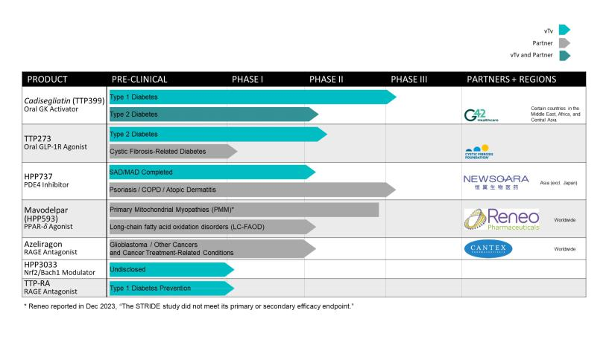

Our Type 1 Diabetes Program – Cadisegliatin (TTP399)

The U.S. Food and Drug Administration (FDA) granted Breakthrough Therapy designation in 2021 for cadisegliatin as an adjunctive therapy to insulin for the treatment of type 1 diabetes ("T1D"). The Breakthrough Therapy designation provides a sponsor with added support and the potential to expedite development and review timelines for a promising new investigational medicine. The Breakthrough Therapy designation for cadisegliatin in T1D was supported by the positive results from the Phase 2 SimpliciT-1 Study, a multi-center, randomized, double-blind, adaptive study assessing the safety and efficacy of cadisegliatin as an adjunct to insulin therapy in adults with T1D. In this trial, treatment with cadisegliatin resulted in a statistically significant improvement in HbA1c relative to placebo and a clinically meaningful decrease (40%) in the frequency of severe and symptomatic hypoglycemia. Cadisegliatin demonstrated a favorable safety profile, in which abnormal levels of serum or urine ketones were detected less frequently in patients taking cadisegliatin than those taking placebo.

In May of 2023, the FDA issued new draft guidance on "Diabetes Mellitus: Efficacy Endpoints for Clinical Trials Investigating Antidiabetic Drugs and Biological Products" which, for the first time, permitted the use of hypoglycemia as an endpoint to support a label claim. Consistent with this guidance and with input from the FDA, we have initiated a Phase 3 double-blind controlled trial to assess the effect of cadisegliatin on reducing the frequency of Level 2 hypoglycemia (blood glucose levels are less than 54 mg/dL or 3 mmol/L, regardless of symptoms) and Level 3 hypoglycemia ("severe" hypoglycemia e.g., requiring assistance of another person) in 150 patients with type 1 diabetes. Participants in the trial will be randomized to two doses of cadisegliatin or placebo. Reduction in glycated hemoglobin (HbA1c), a traditional efficacy endpoint in diabetes trials, is a key secondary endpoint to assess the potential of cadisegliatin to reduce hyperglycemia, Following the initial assessment of efficacy after six months of treatment, participants will remain on trial for another six months to assess the durability of potential beneficial effects and safety. The study protocol was submitted to the FDA on February 29, 2024. The trial will be conducted in the U.S. only and is expected to complete enrollment by the fourth quarter in 2024 providing top line 1-year data by the first quarter in 2026.

Concurrently, we will be working on the design for two international registrational studies for cadisegliatin in type 1 diabetes, which we expect to start in 2026.

57

Table of Contents

In addition, we continue to work with our partner, G42 Investments AI Holding RSC Ltd. (“G42”), to initiate a double-blind, randomized, controlled Phase 2 trial in the Middle East region in 450 insulin-using patients with type 2 diabetes. We expect that trial to begin in 2024.

Holding Company Structure

vTv Therapeutics Inc. is a holding company and its principal asset is a controlling equity interest in vTv Therapeutics LLC (“vTv LLC”), the principal operating subsidiary. We have determined that vTv LLC is a variable-interest entity (“VIE”) for accounting purposes and that vTv Therapeutics Inc. is the primary beneficiary of vTv LLC because (through its managing member interest in vTv LLC and the fact that the senior management of vTv Therapeutics Inc. is also the senior management of vTv LLC) it has the power to direct all of the activities of vTv LLC, which include those that most significantly impact vTv LLC’s economic performance. vTv Therapeutics Inc. has therefore consolidated vTv LLC’s results under the VIE accounting model in its consolidated financial statements.

Financial Overview

Revenue

To date, we have not generated any revenue from drug sales. Our revenue has been primarily derived from milestone payments, up-front proceeds and research fees under collaboration and license agreements.

In the future, we may generate revenue from a combination of product sales, license fees, milestone payments and royalties from the sales of products developed under licenses of our intellectual property. We expect that any revenue we generate will fluctuate from quarter to quarter as a result of the timing and amount of license fees, milestone and other payments, and the amount and timing of payments that we receive upon the sale of our products, to the extent any are successfully commercialized. If we fail to complete the development of our drug candidates in a timely manner or obtain regulatory approval for them, our ability to generate future revenue and our results of operations and financial position will be materially adversely affected.

Research and Development Expenses

Since our inception, we have focused our resources on our research and development activities, including conducting preclinical studies and clinical trials, manufacturing development efforts and activities related to regulatory filings for our drug candidates. We recognize research and development expenses as they are incurred. Our direct research and development expenses consist primarily of external costs such as fees paid to investigators, consultants, central laboratories and clinical research organizations in connection with our clinical trials, and costs related to acquiring and manufacturing clinical trial materials. Our indirect research and development costs consist primarily of cash and share-based compensation costs, the cost of employee benefits and related overhead expenses for personnel in research and development functions. Since we typically use our employee and infrastructure resources across multiple research and development programs such costs are not allocated to the individual projects.

Our research and development expenses by project for the years ended December 31, 2023, 2022 and 2021 were as follows (in thousands):

Years Ended December 31,

 | 2023 |  |  | 2022 |  |  |  | 2021
Direct research and development expense:
Cadisegliatin | $ | 10,182 |  | $ | 9,611 |  | $ | 2,608
HPP737 |  | — |  |  | — |  |  | 2,762
Azeliragon |  | — |  |  | — |  |  | 822
Other projects |  | 676 |  |  | 563 |  |  | 717
Indirect research and development expense |  | 2,737 |  |  | 2,183 |  |  | 6,415
Total research and development expense | $ | 13,595 |  | $ | 12,357 |  | $ | 13,324

We plan to continue to incur significant research and development expenses for the foreseeable future as we continue the development of cadisegliatin and further advance the development of our other drug candidates, subject to the availability of additional funding.

58

Table of Contents

The successful development of our clinical and preclinical drug candidates is highly uncertain. At this time, we cannot reasonably estimate the nature, timing or costs of the efforts that will be necessary to complete the remainder of the development of any of our clinical or preclinical drug candidates or the period, if any, in which material net cash inflows from these drug candidates may commence. This is due to the numerous risks and uncertainties associated with the development of our drug candidates, including:

- the uncertainty of the scope, rate of progress and expense of our ongoing, as well as any additional, clinical trials and other research and development activities;

- the potential benefits of our candidates over other therapies;

- our ability to market, commercialize and achieve market acceptance for any of our drug candidates that we are developing or may develop in the future;

- future clinical trial results;

- our ability to enroll patients in our clinical trials;

- the timing and receipt of any regulatory approvals;

- our ability to secure sufficient capital and cash resources, including access to available debt and equity financing and revenues from operations, to satisfy all of our short-term and longer-term cash requirements and other cash needs, at the times and in the amounts needed;

- legislation and regulatory actions and changes in laws or regulations; and

- the filing, prosecuting, defending and enforcing of patent claims and other intellectual property rights, and the expense of doing so.

A change in the outcome of any of these variables with respect to the development of a drug candidate could mean a significant change in the costs and timing associated with the development of that drug candidate. For example, if the FDA or another regulatory authority were to require us to conduct clinical trials beyond those that we currently anticipate will be required for the completion of clinical development of a drug candidate, or if we experience significant delays in enrollment in any of our clinical trials, we could be required to expend significant additional financial resources and time with respect to the development of that drug candidate.

General and Administrative Expenses

General and administrative expenses consist primarily of salaries, benefits and related costs for employees in executive, finance, corporate development, human resources and administrative support functions. Other significant general and administrative expenses include accounting and legal services, expenses associated with obtaining and maintaining patents, cost of various consultants, occupancy costs and information systems.

Interest Income

Interest income represents noncash interest income related to the imputed interest from the G42 Promissory Note receivable using the effective interest method and cash interest income from dividends and interest from our money market account, all of which are recognized in our Consolidated Statement of Operations.

Interest Expense

The Company’s interest expense is immaterial.

Other Expense, Net

Other expense primarily consists of unrealized gains or losses attributable to the changes in fair value of the equity investment held, the recognition of changes in fair value of the warrants to purchase shares of our Class A common stock held by related parties, the loss from the G42 Promissory Note early redemption on February 28, 2023, the impairment charge from Anteris Bio, Inc. (“Anteris”) liquidation and dissolution and the Common Stock Repurchase Agreement (the "Repurchase Agreement") with Reneo Pharmaceuticals, Inc ("Reneo").

59

Table of Contents

Results of Operations

In this section, we discuss the results of our operations for the year ended December 31, 2023 compared to the year ended December 31, 2022. For a discussion of the year ended December 31, 2022 compared to the year ended December 31, 2021, please refer to Part II, Item 7, “Management's Discussion and Analysis of Financial Condition and Results of Operations” in our Annual Report on Form 10-K for the year ended December 31, 2022.

Comparison of the years ended December 31, 2023 and 2022
 | The following table sets forth certain information concerning our results of operations for the periods shown:
 | (dollars in thousands) |  |  |  |  | Year Ended
 | Statement of operations data: |  | 2023 |  |  | 2022 |  |  | Change
 | Revenue | $ | — |  | $ | 2,018 |  | $ | (2,018)
 | Operating expenses:
 | Research and development |  | 13,595 |  |  | 12,357 |  |  | 1,238
 | General and administrative |  | 11,907 |  |  | 12,201 |  |  | (294)
 | Total operating expenses |  | 25,502 |  |  | 24,558 |  |  | 944
 | Operating loss |  | (25,502) |  |  | (22,540) |  |  | (2,962)
 | Interest income |  | 472 |  |  | 352 |  |  | 120
 | Interest expense |  | (13) |  |  | (15) |  |  | 2
 | Other expense, net |  | (923) |  |  | (2,670) |  |  | 1,747
 | Loss before income taxes and noncontrolling interest |  | (25,966) |  |  | (24,873) |  |  | (1,093)
 | Income tax provision |  | — |  |  | 200 |  |  | (200)
 | Net loss before noncontrolling interest |  | (25,966) |  |  | (25,073) |  |  | (893)
 | Less: Net loss attributable to noncontrolling interest |  | (5,716) |  |  | (5,909) |  |  | 193
 | Net loss attributable to vTv Therapeutics Inc. | $ | (20,250) |  | $ | (19,164) |  | $ | (1,086)

Revenue

There was no revenue for the year ended December 31, 2023. Revenue was $2.0 million for the year ended December 31, 2022. The revenue recognized in 2022 related to the increase to the transaction price for the license performance obligations under the amended license agreement with Huadong due to the satisfaction of a development milestone.

Research and Development Expenses

Research and development expenses were $13.6 million and $12.4 million for the years ended December 31, 2023 and 2022, respectively. The increase in research and development expenses during this period of approximately $1.2 million, or 10.0%, was primarily driven by (i) higher spending on cadisegliatin of $0.6 million due to increases in drug product related costs as well as higher spending on trial preparation costs, and (ii) an increase of $0.6 million in indirect costs and other projects.

General and Administrative Expenses

General and administrative expenses were $11.9 million and $12.2 million for the years ended December 31, 2023 and 2022, respectively. The decrease in general and administrative expenses during this period of approximately $0.3 million, or 2.4%, was primarily driven by (i) a decrease of $3.1 million in legal expense, and (ii) a decrease of $0.8 million in severance costs, partially offset by (iii) an increase in payroll costs of $1.8 million, (iv) an increase in other general and administrative costs of $1.5 million, and (v) an increase in share-based compensation expense of $0.3 million.

Interest Income

Interest income for the year ended December 31, 2023 of $0.5 million is related to imputed interest on the G42 Promissory Note and dividend income from our money market account. Interest income for the year ended December 31, 2022 of $0.4 million is related to the imputed interest on the G42 Promissory Note.

60

Table of Contents

Interest Expense

Interest expense for the years ended December 31, 2023 and 2022, was insignificant.

Other Expense, Net

Other expense was $0.9 million for the year ended December 31, 2023 and was driven by the recording of an impairment charge on a cost-method investment of $4.2 million offset by a realized gain recognized related to the Company’s Repurchase Agreement with Reneo as well as the gains related to the change in the fair value of the outstanding warrants to purchase shares of our Class A common stock issued to related parties. Other expense was $2.7 million for the year ended December 31, 2022, and was driven by an unrealized loss recognized related to the Company’s investment in Reneo as well as the losses related to the change in the fair value of the outstanding warrants to purchase shares of our Class A common stock issued to related parties.

Liquidity and Capital Resources

Liquidity and Going Concern

As of December 31, 2023, we had an accumulated deficit of $281.0 million. Since our inception, we have experienced a history of negative cash flows from operating activities. We anticipate that we will continue to incur losses and negative cash flow from operations for the foreseeable future as we continue our clinical trials. Further, we expect that we will need additional capital to continue to fund our operations. As of December 31, 2023, we had cash and cash equivalents of $9.4 million.

On February 27, 2024, the Company closed a private placement financing of up to $51.0 million and additionally granting investors the right to purchase up to an additional $30.0 million of common stock 18 months following the closing of the private placement financing. (See note 20). The financing raised will allow the Company to further advance its lead program for cadisegliatin (TTP399).

In addition to available cash and cash equivalents and available funds discussed above, we are seeking possible additional partnering opportunities for our GKA, GLP-1r and other drug candidates which we believe may provide additional cash for use in our operations and the continuation of the clinical trials for our drug candidates. We are evaluating several financing strategies to fund our planned and ongoing clinical trials, including direct equity investments and future public offerings of our common stock. The timing and availability of such additional financing are not yet known.

As required by ASC Topic 205-40, Presentation of Financial Statements - Going Concern, management has assessed our ability to continue as a going concern for one year from the consolidated financial statements issuance date for the fiscal year ended December 31, 2023. Based on the cash and cash equivalents currently available to us as discussed above, we have concluded there is not substantial doubt regarding our ability to continue as a going concern for at least twelve months from the issuance of the December 31, 2023 Form 10-K.

ATM

TD Cowen Sales Agreement

On February 28, 2024, we entered into a sales agreement (the "TD Cowen Sales Agreement") with Cowen and Company, LLC (“TD Cowen”) pursuant to which we may offer and sell, from time to time, through or to TD Cowen, as sales agent or principal, shares of our Class A common stock having an aggregate offering price of up to $50.0 million, although we may only offer and sell under the TD Cowen ATM Offering up to one-third of the aggregate market value of our voting and non-voting common equity held by non-affiliates during any 12 calendar month period pursuant to General Instruction I.B.6 of Form S-3. We are not obligated to sell any shares under the TD Cowen Sales Agreement. Under the terms of the TD Cowen Sales Agreement, we will pay TD Cowen a commission of 3% of the aggregate proceeds from the sale of shares and reimburse certain legal fees or other disbursements.

Cantor Fitzgerald Sales Agreement

We previously entered into the Sales Agreement with Cantor Fitzgerald pursuant to which could offer and sell, from time to time, through or to Cantor Fitzgerald, as sales agent or principal, shares of our Class A common stock having an aggregate offering price of up to $68.5 million. As of December 31, 2023, we had sold $31.2 million worth of Class A common stock pursuant to the Sales Agreement for net proceeds of $30.3 million.

The Sales Agreement with Cantor Fitzgerald was terminated on February 26, 2024.

61

Table of Contents

Lincoln Park Purchase Agreement

We entered into the Purchase Agreement with Lincoln Park ("LPC Purchase Agreement"), which provides that, upon the terms and subject to the conditions and limitations set forth therein, we may sell to Lincoln Park up to $47.0 million of shares of our Class A common stock from time to time over the 36-month term of the LPC Purchase Agreement. Upon execution of the Purchase Agreement, we issued 10,643 shares of our Class A common stock to Lincoln Park as commitment shares in accordance with the closing conditions contained within the Purchase Agreement. We have issued 133,282 shares of our Class A common stock to Lincoln Park under the LPC Purchase Agreement through the date of the filing of this Annual Report on Form 10-K.

The LPC Purchase Agreement expired on November 24, 2023.

Cash Flows

 |  | Year Ended December 31,
 | 2023 |  |  |  | 2022
(dollars in thousands)
Net cash used in operating activities | $ | (19,081) |  | $ | (16,022)
Net cash provided by (used in) investing activities |  | 4,404 |  |  | (21)
Net cash provided by financing activities |  | 11,997 |  |  | 14,754
Net decrease in cash and cash equivalents | $ | (2,680) |  | $ | (1,289)

Operating Activities

For the year ended December 31, 2023, our net cash used in operating activities increased by $3.1 million from the prior year. The significant contributor to the change in cash used during the year was working capital changes offset by $6.8 million of cash received related to contract liabilities.

Investing Activities

For the year ended December 31, 2023, net cash provided by investing activities was driven by the sale of our investments in Reneo. For the year ended December 31, 2022, net cash used in investing activities was insignificant.

Financing Activities

For the year ended December 31, 2023, net cash provided by financing activities was driven by the receipt of proceeds of $12.0 million from the G42 Promissory Note early redemption. For the year ended December 31, 2022, net cash provided by financing activities was driven by sales of our Class A common stock to a collaboration partner and from the CinRx Purchase Agreement.

Future Funding Requirements

To date, we have not generated any revenue from drug product sales. We do not know when, or if, we will generate any revenue from drug product sales. We do not expect to generate revenue from drug sales unless and until we obtain regulatory approval of and commercialize any of our drug candidates. At the same time, we expect our expenses to continue or to increase in connection with our ongoing development activities, particularly as we continue the research, development and clinical trials of, and seek regulatory approval for, our drug candidates. In addition, subject to obtaining regulatory approval of any of our drug candidates, we expect to incur significant commercialization expenses for product sales, marketing, manufacturing and distribution. We anticipate that we will need substantial additional funding in connection with our continuing operations.

Based on our current operating plan, we believe that our current cash and cash equivalents will allow us to meet our liquidity requirements for at least the next twelve months. We plan to finance our operations into the first quarter of 2026 through the use of our cash and cash equivalents and based on current operating plans, we are evaluating several financing strategies to fund the ongoing and future clinical trials of cadisegliatin, including direct equity investments and the potential licensing and monetization of other Company programs. The timing of any such transactions is not certain, and we may not be able to complete such transactions on acceptable terms, or at all. Even if we are able to complete such transactions, they may contain restrictions on our operations or cause substantial dilution to our stockholders. We have based our estimates on assumptions that may prove to be wrong, and we may use our available capital resources sooner than we currently expect. Because of the numerous risks and uncertainties associated with the development and commercialization of our drug candidates, we are unable to estimate the amounts of increased capital outlays and operating expenditures necessary to complete the development of our drug candidates. Additionally, we may rely on our ability to sell shares of our Class A

62

Table of Contents

common stock pursuant to the ATM Offering. However, the ability to use this source of capital is dependent on a number of factors, including the prevailing market price of and the volume of trading in the Company’s Class A common stock.

Our future capital requirements will depend on many factors, including:

- the progress, costs, results and timing of our planned trials to evaluate cadisegliatin as a potential adjunctive therapy for the treatment of type 1 diabetes;

- the willingness of the FDA to rely upon our completed and planned clinical and preclinical studies and other work, as the basis for review and approval of our drug candidates;

- our ability to maintain control over our costs in line with our budget to complete the Phase 3 clinical trial for our lead product candidate, cadisegliatin;

- the outcome, costs and timing of seeking and obtaining FDA and any other regulatory approvals;

- the number and characteristics of drug candidates that we pursue, including our drug candidates in preclinical development;

- the ability of our drug candidates to progress through clinical development successfully;

- our need to expand our research and development activities;

- the costs associated with securing, establishing and maintaining commercialization capabilities;

- the costs of acquiring, licensing or investing in businesses, products, drug candidates and technologies;

- our ability to maintain, expand and defend the scope of our intellectual property portfolio, including the amount and timing of any payments we may be required to make, or that we may receive, in connection with the licensing, filing, prosecution, defense and enforcement of any patents or other intellectual property rights;

- our need and ability to hire additional management, scientific, and medical personnel;

- the effect of competing technological and market developments;

- our need to implement additional internal systems and infrastructure, including financial and reporting systems;

- the economic and other terms, timing and success of our existing licensing arrangements and any collaboration, licensing or other arrangements into which we may enter in the future;

- the amount of any payments we are required to make to M&F TTP Holdings Two LLC in the future under the Tax Receivable Agreement.

Until such time, if ever, as we can generate substantial revenue from drug sales, we expect to finance our cash needs through a combination of equity offerings, debt financings, marketing and distribution arrangements and other collaborations, strategic alliances and licensing arrangements.

To the extent that we raise additional capital through the sale of equity or convertible debt securities, the ownership interests of our common stockholders will be diluted, and the terms of these securities may include liquidation or other preferences that adversely affect the rights of our common stockholders. Debt financing and preferred equity financing, if available, may involve agreements that include covenants that will further limit or restrict our ability to take specific actions, such as incurring additional debt, making capital expenditures or declaring dividends. If we raise additional funds through collaborations, strategic alliances or marketing, distribution or licensing arrangements with third parties, we may be required to relinquish valuable rights to our technologies, future revenue streams or drug candidates or grant licenses on terms that may not be favorable to us.

Off-Balance Sheet Arrangements

As of December 31, 2023, we do not currently have outstanding any off-balance sheet arrangements as defined under SEC rules.

Discussion of Critical Accounting Policies and Estimates

Our management’s discussion and analysis of our financial condition and results of operations is based on our consolidated financial statements, which we have prepared in accordance with generally accepted accounting principles in the United States (“GAAP”). The preparation of our consolidated financial statements requires us to make estimates and assumptions that affect the reported amounts of assets and liabilities and the disclosure of contingent assets and liabilities at

63

Table of Contents

the date of our consolidated financial statements, as well as the reported revenues and expenses during the reported periods. We evaluate these estimates and judgments on an ongoing basis. We base our estimates on historical experience and on various other factors that we believe are reasonable under the circumstances, the results of which form the basis for making judgments about the carrying value of assets and liabilities that are not readily apparent from other sources. Actual results may differ from these estimates under different assumptions or conditions.

While our significant accounting policies are more fully described in Note 2, “Summary of Significant Accounting Policies,” to our audited consolidated financial statements, we believe that the following accounting policies related to revenue recognition, research and development, income taxes, and share-based compensation are the most critical for fully understanding and evaluating our financial condition and results of operations.

Revenue Recognition

The majority of our revenue results from its license and collaboration agreements associated with the development of investigational drug products. We account for a contract when it has approval and commitment from both parties, the rights of the parties are identified, payment terms are identified, the contract has commercial substance and collectability of consideration is probable. For each contract meeting these criteria, we identify the performance obligations included within the contract. A performance obligation is a promise in a contract to transfer a distinct good or service to the customer. We then recognize revenue under each contract as the related performance obligations are satisfied.

The transaction price under the contract is determined based on the value of the consideration expected to be received in exchange for the transferred assets or services. Development, regulatory and sales milestones included in our collaboration agreements are considered to be variable consideration. The amount of variable consideration expected to be received is included in the transaction price when it becomes probable that the milestone will be met. For contracts with multiple performance obligations, the contract’s transaction price is allocated to each performance obligation using our best estimate of the standalone selling price of each distinct good or service in the contract. The primary method used to estimate standalone selling price is the expected cost plus margin approach. Revenue is recognized over the related period over which we expect the services to be provided using a proportional performance model or a straight-line method of recognition if there is no discernible pattern over which the services will be provided.

See Note 2 “Summary of Significant Accounting Policies”, to the Consolidated Financial Statements in Item 15 of Part IV of this Annual Report on Form 10-K for further information. Research and Development

Major components of research and development costs include cash compensation to employees, costs of preclinical studies, clinical trials and related clinical manufacturing, costs of drug development, costs of materials and supplies, facilities cost, overhead costs, regulatory and compliance costs, and fees paid to consultants and other entities that conduct certain research and development activities on our behalf. Costs incurred in research and development are expensed as incurred.

We record accruals based on estimates of the services received, efforts expended and amounts owed pursuant to contracts with numerous contract research organizations. In the normal course of business, we contract with third parties to perform various clinical study activities in the ongoing development of potential products. The financial terms of these agreements are subject to negotiation and variation from contract to contract and may result in uneven payment flows. Payments under the contracts depend on factors such as the achievement of certain events and the completion of portions of the clinical study or similar conditions. The objective of our accrual policy is to match the recording of expenses in our consolidated financial statements to the actual services received and efforts expended. As such, expense accruals related to clinical studies are recognized based on our estimate of the degree of completion of the event or events specified in the specific clinical study.

We record nonrefundable advance payments we make for future research and development activities as prepaid expenses. Prepaid expenses are recognized as expense in the statements of operations as we receive the related goods or services.

Income Taxes

In connection with the Initial Public Offering, vTv Therapeutics Inc. was formed. From August 1, 2015, vTv Therapeutics Inc. has been subject to corporate level income taxes. Prior to July 30, 2015, our predecessor entities were taxed as partnerships and all their income and deductions flowed through and were subject to tax at the partner level.

vTv Therapeutics Inc. holds vTv Units and is required to recognize deferred tax assets and liabilities for the difference between the financial reporting and tax basis of its investment in vTv LLC.

64

Table of Contents

Our income tax expense, deferred tax assets and liabilities and reserves for unrecognized tax benefits reflect management’s best assessment of estimated future taxes to be paid. We are subject to income taxes in both the United States and various state jurisdictions. Significant judgments and estimates are required in determining the consolidated income tax expense.

We account for income taxes under the asset and liability method, which requires the recognition of deferred tax assets and liabilities for the expected future tax consequences of events included in the consolidated financial statements. Under this method, we determine deferred tax assets and liabilities on the basis of differences between the consolidated financial statement and tax bases of assets and liabilities by using enacted tax rates in effect for the year in which the differences are expected to reverse. The effect of a change in tax rates on deferred tax assets and liabilities is recognized in income in the period in which the enactment date occurs.

We recognize deferred tax assets to the extent we believe these assets are more-likely-than-not to be realized. In making such a determination, we consider all available positive and negative evidence, including future reversals of existing taxable temporary differences, projected future taxable income, tax planning strategies and recent results of operations.

We record uncertain tax positions on the basis of a two-step process in which (1) we determine whether it is more-likely-than-not that the tax positions will be sustained on the basis of the technical merits of the position and (2) for those tax positions meeting the more-likely-than-not recognition threshold, we recognize the largest amount of tax benefit that is more than 50% likely to be realized upon ultimate settlement with the related tax authority.

Interest and penalties related to income taxes are included in the benefit (provision) for income taxes in our Consolidated Statement of Operations. We have not incurred any significant interest or penalties related to income taxes in any of the periods presented.

Share-Based Compensation

Compensation expense for share-based compensation awards issued is based on the fair value of the award at the date of grant, and compensation expense is recognized for those awards earned over the service period. The grant date fair value of stock option awards is estimated using the Black-Scholes option pricing formula. Expected volatility is based on the historical volatility of the Company’s Class A common stock over the most recent period commensurate with the estimated expected term of the Company’s stock options offering period which is derived from historical experience. The risk-free rate is based on the U.S. Treasury yield curve in effect at the time of grant. Due to a lack of historical exercise data, we estimate the expected life of our outstanding stock options using the simplified method specified under Staff Accounting Bulletin Topic 14.D.2. The fair value of restricted stock units (“RSU”) grants is based on the market value of our Class A common stock on the date of grant. We also estimate the amount of share-based awards that are expected to be forfeited based on historical employee turnover rates.

Effect of Recent Accounting Pronouncements

See discussion of recent accounting pronouncements in Note 2, “Summary of Significant Accounting Policies”, to the Consolidated Financial Statements in Item 15 of Part IV of this Annual Report on Form 10-K.

ITEM 7A. QUANTITATIVE AND QUALITATIVE DISCLOSURES ABOUT MARKET RISK

Interest Rate Risk

We do not currently have any material interest rate exposure.

Market Risk

Our exposure to market risk is limited to our cash and cash equivalents, all of which have maturities of one year or less. The goals of our investment strategy are preservation of capital, fulfillment of liquidity needs and fiduciary control of cash and investments. We also seek to maximize income from our investments without assuming significant risk. To achieve our goals, we maintain cash and cash equivalents with multiple financial institutions that management believes to be of high credit quality.

Foreign Currency Risk

We do not have any material foreign currency exposure.

ITEM 8. FINANCIAL STATEMENTS AND SUPPLEMENTARY DATA

65

Table of Contents

The information required by this Item is included in our Consolidated Financial Statements and Supplementary Data listed in Item 15 of Part IV of this Annual Report on Form 10-K.

ITEM 9. CHANGES IN AND DISAGREEMENTS WITH ACCOUNTANTS ON ACCOUNTING AND FINANCIAL DISCLOSURE

None.

ITEM 9A. CONTROLS AND PROCEDURES

Evaluation of Disclosure Controls and Procedures

Under the supervision and with the participation of our Chief Executive Officer (our principal executive officer) and Chief Financial Officer (our principal financial officer), management has evaluated the effectiveness of the design and operation of our disclosure controls and procedures (as defined in Rules 13a-15(e) or 15d-15(e) of the Securities Exchange Act of 1934) as of December 31, 2023. Based upon that evaluation, our Chief Executive Officer and Chief Financial Officer concluded that, as of December 31, 2023, our disclosure controls and procedures were effective in causing material information relating to us (including our consolidated subsidiaries) to be recorded, processed, summarized and reported by management on a timely basis and to ensure the quality and timeliness of our public disclosures with SEC disclosure obligations.

Our management, including our Chief Executive Officer and Chief Financial Officer, does not expect that our disclosure controls and procedures will prevent all errors and all fraud. A control system, no matter how well conceived and operated, can provide only reasonable, not absolute, assurance that the objectives of the control system are met. Further, the design of a control system must reflect the fact that there are resource constraints, and the benefits of controls must be considered relative to their costs. Because of the inherent limitations in all control systems, no evaluation of controls can provide absolute assurance that all control issues and instances of fraud, if any, with the Company have been detected. These inherent limitations include the realities that judgments in decision-making can be faulty and that breakdowns can occur because of simple error and mistake. Additionally, controls can be circumvented by the individual acts of some persons, by collusion of two or more people or by management override of controls.

The design of any system of controls also is based in part upon certain assumptions about the likelihood of future events, and there can be no assurance that any design will succeed in achieving its stated goals under all potential future conditions. Over time, a control may become inadequate because of changes in conditions or because the degree of compliance with the policies or procedures may deteriorate. Because of the inherent limitations in a cost-effective control system, misstatements due to error or fraud may occur and may not be detected.

Management’s Annual Report on Internal Control Over Financial Reporting

Management is responsible for establishing and maintaining adequate internal control over financial reporting as defined in Rule 13a-15(f) under the Exchange Act. Our internal control over financial reporting is a process designed to provide reasonable assurance regarding the reliability of financial reporting and the preparation of the consolidated financial statements for external reporting purposes in accordance with generally accepted accounting principles. Our internal control over financial reporting includes those written policies and procedures that:

- pertain to the maintenance of records that, in reasonable detail, accurately and fairly reflect the transactions and dispositions of assets;

- provide reasonable assurance that transactions are recorded as necessary to permit preparation of the consolidated financial statements in accordance with generally accepted accounting principles;

- provide reasonable assurance that receipts and expenditures are being made only in accordance with management and director authorization; and

- provide reasonable assurance regarding prevention or timely detection of unauthorized acquisition, use or disposition of assets that could have a material effect on the consolidated financial statements.

Because of its inherent limitations, internal control over financial reporting may not prevent or detect misstatements. Also, projections of any evaluation of effectiveness to future periods are subject to the risk that controls may become inadequate because of changes in conditions, or that the degree of compliance with the policies or procedures may deteriorate.

Management assessed the effectiveness of our internal control over financial reporting as of December 31, 2023. Management based this assessment on criteria described in Internal Control - Integrated Framework (2013) issued

by the

66

Table of Contents

Committee of Sponsoring Organizations of the Treadway Commission (COSO). Based on this assessment, management determined that as of December 31, 2023, we maintained effective internal control over financial reporting. Changes to Internal Control over Financial Reporting

There have been no changes in our internal control over financial reporting during our most recent fiscal quarter that have materially affected, or are reasonably likely to materially affect, our internal control over financial reporting.

ITEM 9B. OTHER INFORMATION

Rule 10b5-1 Trading Plans

During the fourth fiscal quarter ended December 31, 2023, none of our directors or executive officers adopted or terminated any contract, instruction or written plan for the purchase or sale of our securities to satisfy the affirmative defense conditions of Rule 10b5-1(c) or any “non-Rule 10b5-1 trading arrangement.”

ITEM 9C. DISCLOSURE REGARDING FOREIGN JURISDICTIONS THAT PREVENT INSPECTIONS

Not applicable

67

Table of Contents

PART III

ITEM 10. DIRECTORS, EXECUTIVE OFFICERS AND CORPORATE GOVERNANCE

The information required by this item is incorporated by reference to our Proxy Statement for the 2024 Annual Meeting of Stockholders to be filed with the SEC within 120 days of the fiscal year ended December 31, 2023.

ITEM 11. EXECUTIVE COMPENSATION

The information required by this item is incorporated by reference to our Proxy Statement for the 2024 Annual Meeting of Stockholders to be filed with the SEC within 120 days of the fiscal year ended December 31, 2023.

ITEM 12. SECURITY OWNERSHIP OF CERTAIN BENEFICIAL OWNERS AND MANAGEMENT AND RELATED STOCKHOLDER MATTERS

The information required by this item is incorporated by reference to our Proxy Statement for the 2024 Annual Meeting of Stockholders to be filed with the SEC within 120 days of the fiscal year ended December 31, 2023.

ITEM 13. CERTAIN RELATIONSHIPS AND RELATED TRANSACTIONS, AND DIRECTOR INDEPENDENCE

The information required by this item is incorporated by reference to our Proxy Statement for the 2024 Annual Meeting of Stockholders to be filed with the SEC within 120 days of the fiscal year ended December 31, 2023.

ITEM 14. PRINCIPAL ACCOUNTANT FEES AND SERVICES

The information required by this item is incorporated by reference to our Proxy Statement for the 2024 Annual Meeting of Stockholders to be filed with the SEC within 120 days of the fiscal year ended December 31, 2023.

68

Table of Contents
PART IV
ITEM 15. EXHIBITS AND FINANCIAL STATEMENT SCHEDULES
(a)(1) Financial Statements
 |  | The following documents are included on pages F-1 through F-32 attached hereto and are filed as part of this Annual Report on Form 10-K.
 | Report of Independent Registered Public Accounting Firm |  |  |  |  |  |  |  |  |  |  |  |  |  |  |  |  |  |  |  |  |  |  |  | F-2
 | Consolidated Balance Sheets as of December 31, 2023 and 2022 |  |  |  |  |  |  |  |  |  |  |  |  |  |  |  |  |  |  |  |  |  |  |  | F-4
 | Consolidated Statements of Operations for the Years Ended December 31, 2023, 2022 and 2021 |  |  |  |  |  |  |  |  |  |  |  |  |  |  |  |  |  |  |  |  |  |  |  | F-5
 | Consolidated Statements of Changes in Redeemable Noncontrolling Interest and Stockholders’ Deficit for the Years Ended December 31, 2023, 2022 and 2021 |  |  |  |  |  |  |  |  |  |  |  |  |  |  |  |  |  |  |  |  |  |  |  | F-6
 | Consolidated Statements of Cash Flows for the Years Ended December 31, 2022, 2021 and 2020 |  |  |  |  |  |  |  |  |  |  |  |  |  |  |  |  |  |  |  |  |  |  |  | F-7
 | Notes to Consolidated Financial Statements |  |  |  |  |  |  |  |  |  |  |  |  |  |  |  |  |  |  |  |  |  |  |  | F-8
(a)(2) Financial Statement Schedules
 |  | Not applicable
(a)(3) List of Exhibits
 |  | Exhibit |  |  |  |  |  |  |  |  |  |  |  |  | Description
 |  | Number
 |  | 3.1 |  |  | Amended and Restated Certificate of Incorporation dated August 4, 2015 (incorporated by reference from Exhibit 3.1 to the Company’s Form 8-K, filed August 4, 2015 (File No. 001-37524)).
3.2 |  |  |  |  | Certificate of Amendment to Certificate of Incorporation of vTv Therapeutics Inc. dated May 4, 2021 (incorporated by reference from Exhibit 3.1 to the Company’s Form 8-K, filed May 5, 2021 (File No.
 |  |  |  |  | 001-37524)).
3.3* |  |  |  |  | Certificate of Amendment of Certificate of Incorporation dated as of November 20, 2023.
3.4 |  |  |  |  | Second Amended and Restated By-laws (incorporated by reference from Exhibit 3.1 to the Company’s Form 8-K, filed March 3, 2022 (File No. 001-37524)).
4.1 |  |  |  |  | Form of Warrant to Purchase Class A Common Stock (incorporated by reference from Exhibit 4.1 to the Company’s Form 10-K, filed February 24, 2017 (File No. 001-37524)).
4.2 |  |  |  |  | Common Stock Purchase Warrant (incorporated by reference from Exhibit 4.2 to the Company’s Form 10-K, filed February 27, 2018 (File No. 001-37524)).
4.3* |  |  |  |  | Amendment to Common Stock Purchase Warrant dated as December 5, 2018
4.4* |  |  |  |  | Common Stock Purchase Warrant dated as of December 11, 2018
4.5 |  |  |  |  | Warrant to Purchase Common Stock (incorporated by reference from Exhibit 4.1 to the Company’s Form 8-K, filed July 25, 2022 (File No. 001-37524)).
4.6 |  |  |  |  | Form of Pre-Funded Warrant (incorporated by reference from Exhibit 4.1 to the Company's 8-K, filed February 28, 2024 (File No. 001-37524)).
4.7* |  |  |  |  | Description of Capital Stock.
10.1 |  |  |  |  | Reorganization Agreement, dated as of July 29, 2015, among vTv Therapeutics Inc., vTv Therapeutics LLC, vTvx Holdings I LLC, vTvx Holdings II LLC and vTv Therapeutics Holdings LLC (incorporated
 |  |  |  |  | by reference from Exhibit 10.1 to the Company’s Form 8-K, filed August 4, 2015 (File No. 001-37524)).
10.2 |  |  |  |  | Amended and Restated Limited Liability Company Agreement of vTv Therapeutics LLC, dated July 29, 2015 (incorporated by reference from Exhibit 10.2 to the Company’s Form 8-K, filed August 4, 2015
 |  |  |  |  | (File No. 001-37524)).
10.3 |  |  |  |  | Investor Rights Agreement, dated as of July 29, 2015, among vTv Therapeutics Inc., vTv Therapeutics Holdings LLC and other stockholders party thereto from time to time (incorporated by reference from
 |  |  |  |  | Exhibit 10.3 to the Company’s Form 8-K, filed August 4, 2015 (File No. 001-37524)).
 |  |  |  |  | 69

Table of Contents

 | Exhibit |  |  |  |  |  |  |  |  |  |  |  |  |  | Description
 | Number
 | 10.4 |  | Exchange Agreement, dated as of July 29, 2015, among vTv Therapeutics LLC, vTv Therapeutics Inc. and vTv Therapeutics Holdings LLC (incorporated by reference from Exhibit 10.4 to the Company’s
 |  |  | Form 8-K, filed August 4, 2015 (File No. 001-37524)).
10.5 |  |  | Tax Receivable Agreement, dated as of July 29, 2015, among vTv Therapeutics Inc. and the other persons named therein (incorporated by reference from Exhibit 10.5 to the Company’s Form 8-K, filed
 |  |  | August 4, 2015 (File No. 001-37524)).
10.6 |  |  | Form of Indemnification Agreement (incorporated by reference from Exhibit 10.7 to Amendment No. 4 to the Company’s Registration Statement on Form S-1, dated July 23, 2015 (File No. 333-204951)).
 | 10.7† |  | vTv Therapeutics Inc. 2015 Omnibus Equity Incentive Plan (incorporated by reference from Exhibit 10.6 to the Company’s Form 8-K, filed August 4, 2015 (File No. 001-37524)).
 | 10.8† |  | vTv Therapeutics Inc. Form of Nonqualified Option Award Agreement (incorporated by reference from Exhibit 10.7 to the Company’s Form 8-K, filed August 4, 2015 (File No. 001-37524)).
 | 10.9†† |  | Agreement Concerning Glucokinase Activator Project, dated as of February 20, 2007, by and between Novo Nordisk A/S and TransTech Pharma, Inc. (incorporated by reference from Exhibit 10.8 to
 |  |  | Amendment No. 1 to the Company’s Registration Statement on Form S-1, dated June 19, 2015 (File No. 333-204951)).
 | 10.10†† |  | License and Research Agreement, dated as of December 21, 2017, by and between Hangzhou Zhongmei Huadong Pharmaceutical Co., Ltd. And vTv Therapeutics LLC (incorporated by reference from
 |  |  | Exhibit 10.19 to the Company’s Form 10-K, filed February 27, 2018 (File No. 001-37524)).
 | 10.11†† |  | License and Research Agreement, dated as of December 21, 2017, by and between Reneo Pharmaceuticals, Inc. and vTv Therapeutics LLC (incorporated by reference from Exhibit 10.20 to the Company’s
 |  |  | Form 10-K, filed February 27, 2018 (File No. 001-37524)).
 | 10.12†† |  | License Agreement, dated as of May 31, 2018, by and between Newsoara Biopharma Co., Ltd. and vTv Therapeutics LLC (incorporated by reference from Exhibit 10.1 to the Company’s Form 10-Q, filed
 |  |  | August 3, 2018 (File No. 001-37524)).
10.13 |  |  | Controlled Equity Offering |  | SM |  |  | Sales Agreement, dated as of April 24, 2020, by and between vTv Therapeutics Inc. and Cantor Fitzgerald & Co. (incorporated by reference from Exhibit 1.1 to the Company’s
 |  |  | Form 8-K, filed on April 24, 2020 (File No. 001-37524)).
10.14 |  |  | First Amendment to vTv Therapeutics Inc. 2015 Omnibus Equity Incentive Plan (incorporated by reference from Exhibit 3.5 to the Company’s Form S-8, filed August 3, 2020 (File No. 333-240304)).
 | 10.15†† |  | License Agreement, dated December 11, 2020, by and between Anteris Bio, Inc. and vTv Therapeutics LLC.
 | 10.16†† |  | First Amendment to License Agreement, dated as of January 14, 2021, by and between Hangzhou Zhongmei Huadong Pharmaceutical Co., Ltd. And vTv Therapeutics LLC.
 | 10.17† |  | Employment Agreement, dated as of March 1, 2022, by and between vTv Therapeutics LLC and Richard S. Nelson (incorporated by reference from Exhibit 10.2 to the Company’s Form 10-Q, filed May 12,
 |  |  | 2022 (File No. 001-37524)).
10.18 |  |  | Common Stock Purchase Agreement, dated as of May 31, 2022, by and between vTv Therapeutics Inc. and G42 Investments AI Holding RSC Ltd. (incorporated by reference from Exhibit 1.1 to the
 |  |  | Company’s Form 8-K, filed June 1, 2022 (File No. 001-37524)).
10.19 |  |  | Common Stock and Warrant Purchase Agreement, dated as of July 22, 2022, by and among vTv Therapeutics Inc., CinPax, LLC and CinRx Pharma, LLC (incorporated by reference from Exhibit 10.1 to the
 |  |  | Company’s Form 8-K, filed July 25, 2022 (File No. 001-37524).
 | 10.20† |  | Employment Agreement, dated as of July 25, 2022, by and between vTv Therapeutics LLC and Paul Sekhri (incorporated by reference from Exhibit 10.1 to the Company’s Form 8-K, filed July 27, 2022
 |  |  | (File No. 001-37524)).
 | 10.21† |  | Inducement Award Agreement, dated as of July 26, 2022, by and between vTv Therapeutics Inc. and Paul Sekhri (incorporated by reference from Exhibit 10.2 to the Company’s Form 8-K, filed July 27,
 |  |  | 2022 (File No. 001-37524)).
 | 10.22† |  | Employment Agreement, dated as of December 8, 2022, by and between vTv Therapeutics LLC and Steven Tuch (incorporated by reference from Exhibit 10.1 to the Company’s Form 8-K, filed December
 |  |  | 13, 2022(File No. 001-37524)).
 |  |  |  |  |  |  |  |  | 70

Table of Contents

Exhibit |  |  |  |  |  |  |  |  |  |  |  | Description
Number
10.23 |  | Collaboration and License Agreement, dated as of May 31, 2022, by and between vTv Therapeutics, LLC and Cogna Technology Solutions LLC (incorporated by reference from Exhibit 10.1 to the
 |  | Company’s Form 10-Q, filed on August 15, 2022 (File No. 001-37524)).
10.24 |  | Deed of Novation, dated as of December 21, 2022, by and between vTv Therapeutics LLC, G42 Healthcare Technology Projects LLC and G42 Healthcare Technology Solutions LLC (f/k/a Cogna
 |  | Technology Solutions LLC) (incorporated by reference from Exhibit 10.36 (File No. 001-37524)).
10.25 |  | Deed of Variation, dated as of February 28, 2023, by and between vTv Therapeutics Inc., G42 Investments AI Holding RSC Ltd., and Group 42 Holding Limited (incorporated by reference from Exhibit
 |  | 10.37 (File No. 001-37524)).
10.26* |  | Reneo Pharmaceuticals, Inc. Common Stock Repurchase Agreement dated as of October 30, 2023.
10.27 |  | Securities Purchase Agreement, dated February 27, 2024, by and among vTv Therapeutics Inc. and the investors party thereto (incorporated by reference from Exhibit 10.1 to the Company's 8-K, filed
 |  | February 28, 2024 (File No. 001-37524)).
10.28 |  | Registration Rights Agreement, dated February 27, 2024, by and among vTv Therapeutics Inc. and the investors party thereto (incorporated by reference from Exhibit 10.2 to the Company's 8-K, filed
 |  | February 28, 2024 (File No. 001-37524)).
10.29 |  | Amendment to Common Stock and Warrant Purchase Agreement, dated February 27, 2024, by and between vTv Therapeutics Inc. and G42 Investments AI Holdings RSC Ltd (incorporated by reference
 |  | from Exhibit 10.3 to the Company's 8-K, filed February 28, 2024 (File No. 001-37524)).
10.30 |  | Amendment to Common Stock Purchase Agreement, dated February 27, 2024, by and among vTv Therapeutics Inc., CinPax, LLC and CinRx Pharma, LLC (incorporated by reference from Exhibit 10.4 to
 |  | the Company's 8-K, filed February 28, 2024 (File No. 001-37524)).
10.31 |  | Amendment to Investor Rights Agreement, dated February 27, 2024, by and between vTv Therapeutics Inc. and M&F TTP Holdings Two LLC (as successor in interest to vTv Therapeutics Holdings LLC)
 |  | (incorporated by reference from Exhibit 10.5 to the Company's 8-K, filed February 28, 2024 (File No. 001-37524)).
21.1* |  | Subsidiaries of vTv Therapeutics Inc.
23.1* |  | Consent of Ernst & Young LLP, Independent Registered Public Accounting Firm.
31.1* |  | Certification of President and Chief Executive Officer required by Rule 13a-14(a)/15d-14(a) under the Securities Exchange Act of 1934, as amended, as adopted pursuant to Section 302 of the Sarbanes-
 |  | Oxley Act of 2002.
31.2* |  | Certification of Chief Financial Officer required by Rule 13a-14(a)/15d-14(a) under the Securities Exchange Act of 1934, as amended, as adopted pursuant to Section 302 of the Sarbanes-Oxley Act of 2002.
32.1* |  | Certification of President and Chief Executive Officer pursuant to 18 U.S.C. Section 1350, as adopted pursuant to Section 906 of the Sarbanes-Oxley Act of 2002.
32.2* |  | Certification of Chief Financial Officer pursuant to 18 U.S.C. Section 1350, as adopted pursuant to Section 906 of the Sarbanes-Oxley Act of 2002.
97.1 |  | Clawback Policy dated as of October 2, 2023
101*
101* |  | The following materials from the Company’s Annual Report on Form 10-K for the year ended December 31, 2023, formatted in iXBRL (Inline Extensible Business Reporting Language): (i) Consolidated
 |  | Balance Sheets (unaudited), (ii) Consolidated Statements of Operations (unaudited), (iii) Consolidated Statements of Changes in Redeemable Noncontrolling Interest and Stockholders’ Deficit (unaudited),
 |  | (iv) Consolidated Statements of Cash Flows (unaudited) and (v) Notes to Consolidated Financial Statements (unaudited), tagged as blocks of text and including detailed tags
104* |  | The cover page from this Annual Report on Form 10-K for the year ended December 31, 2023, formatted in Inline XBRL

________________________________________________

71

Table of Contents

- Management contract or compensatory plan or arrangement

- Confidential treatment received with respect to portions of this exhibit.

*Filed herewith

ITEM 16. FORM 10-K SUMMARY

None.

72

Table of Contents

SIGNATURES

Pursuant to the requirements of Section 13 or 15(d) of the Securities Exchange Act of 1934, the registrant has duly caused this report to be signed on its behalf by the undersigned, thereunto duly authorized.

Date: March 13, 2024

 | VTV THERAPEUTICS INC.
 | (Registrant)
By: | /s/ Paul J. Sekhri
 | Paul J. Sekhri
 | President and Chief Executive Officer
By: | /s/ Steven Tuch
 | Steven Tuch
 | Executive Vice President and Chief Financial Officer

Pursuant to the requirements of the Securities Exchange Act of 1934, this report has been signed below by the following persons on behalf of the registrant and in the capacities and on the dates indicated.

 | /s/ Paul J. Sekhri | President, Chief Executive Officer and Executive Chairperson | March 13, 2024
 | Paul J. Sekhri | (Principal Executive Officer)
 | /s/ Steven Tuch | Executive Vice President and Chief Financial Officer | March 13, 2024
 | Steven Tuch | (Principal Financial Officer)
 | /s/ John A. Fry | Director | March 13, 2024
 | John A. Fry
 | /s/ Keith Harris | Director | March 13, 2024
 | Keith Harris
 | /s/ Howard L. Weiner | Director | March 13, 2024
 | Howard L. Weiner
 | /s/ Richard Nelson | Director and Executive Vice President, Corporate Development | March 13, 2024
 | Richard Nelson
 | /s/ Fahed Al Marzooqi | Director | March 13, 2024
 | Fahed Al Marzooqi
 | /s/ Raymond Cheong | Director | March 13, 2024
 | Raymond Cheong
 | /s/ Srinivas Akkaraju | Director | March 13, 2024
 | Srinivas Akkaraju
 |  |  | 73

Table of Contents

INDEX TO FINANCIAL STATEMENTS

 |  |  |  |  |  |  |  |  |  |  |  |  |  |  | Page
Report of Independent Registered Public Accounting Firm PCAOB ID No. (42) |  |  |  |  |  |  |  |  |  |  |  |  |  |  | F-2
Financial Statements:
 | Consolidated Balance Sheets as of December 31, 2023 and 2022 |  |  |  |  |  |  |  |  |  |  |  |  |  | F-4
 | Consolidated Statements of Operations for the Years Ended December 31, 2023, 2022 and 2021 |  |  |  |  |  |  |  |  |  |  |  |  |  | F-5
 | Consolidated Statements of Changes in Redeemable Noncontrolling Interest and Stockholders’ Deficit for the Years Ended December 31, 2023, 2022 and 2021 |  |  |  |  |  |  |  |  |  |  |  |  |  | F-6
 | Consolidated Statements of Cash Flows for the Years Ended December 31, 2023, 2022 and 2021 |  |  |  |  |  |  |  |  |  |  |  |  |  | F-7
Notes to Consolidated Financial Statements |  |  |  |  |  |  |  |  |  |  |  |  |  |  | F-8

The financial statements and other disclosures contained in this report include those of vTv Therapeutics Inc. (“we”, the “Company” or the “Registrant”), which is the registrant, and those of vTv Therapeutics LLC (“vTv LLC”), which is the principal operating subsidiary of the Registrant. Unless the context suggests otherwise, references in this Annual Report on Form 10-K to the “Company”, “we”, “us” and “our” refer to vTv Therapeutics Inc. and its consolidated subsidiaries.

F-1

Report of Independent Registered Public Accounting Firm

To the Shareholders and the Board of Directors of vTv Therapeutics Inc.

Opinion on the Financial Statements

We have audited the accompanying consolidated balance sheets of vTv Therapeutics Inc. (the Company) as of December 31, 2023 and 2022, the related consolidated statements of operations, changes in redeemable noncontrolling interest and stockholders’ deficit and cash flows for each of the three years in the period ended December 31, 2023, and the related notes (collectively referred to as the “consolidated financial statements”). In our opinion, the consolidated financial statements present fairly, in all material respects, the financial position of the Company at December 31, 2023 and 2022, and the results of its operations and its cash flows for each of the three years in the period ended December 31, 2023, in conformity with U.S. generally accepted accounting principles.

Basis for Opinion

These financial statements are the responsibility of the Company's management. Our responsibility is to express an opinion on the Company’s financial statements based on our audits. We are a public accounting firm registered with the Public Company Accounting Oversight Board (United States) (PCAOB) and are required to be independent with respect to the Company in accordance with the U.S. federal securities laws and the applicable rules and regulations of the Securities and Exchange Commission and the PCAOB.

We conducted our audits in accordance with the standards of the PCAOB. Those standards require that we plan and perform the audit to obtain reasonable assurance about whether the financial statements are free of material misstatement, whether due to error or fraud. The Company is not required to have, nor were we engaged to perform, an audit of its internal control over financial reporting. As part of our audits we are required to obtain an understanding of internal control over financial reporting but not for the purpose of expressing an opinion on the effectiveness of the Company's internal control over financial reporting. Accordingly, we express no such opinion.

Our audits included performing procedures to assess the risks of material misstatement of the financial statements, whether due to error or fraud, and performing procedures that respond to those risks. Such procedures included examining, on a test basis, evidence regarding the amounts and disclosures in the financial statements. Our audits also included evaluating the accounting principles used and significant estimates made by management, as well as evaluating the overall presentation of the financial statements. We believe that our audits provide a reasonable basis for our opinion.

Critical Audit Matter

The critical audit matter communicated below is a matter arising from the current period audit of the financial statements that was communicated or required to be communicated to the audit committee and that: (1) relates to accounts or disclosures that are material to the financial statements and (2) involved our especially challenging, subjective or complex judgments. The communication of the critical audit matter does not alter in any way our opinion on the consolidated financial statements, taken as a whole, and we are not, by communicating the critical audit matter below, providing a separate opinion on the critical audit matter or on the account or disclosure to which it relates.

F-2

Accrued Development Costs

Description of the

Matter

How We Addressed

the Matter in Our

Audit

/s/ Ernst & Young LLP

We have served as the Company’s auditor since 2000.

Raleigh, North Carolina

March 13, 2024

As discussed in Notes 2 and 8 to the consolidated financial statements, the Company has recorded $4.4 million of accrued development costs at December 31, 2023, which includes costs for clinical trial and contract manufacturing activities (together, clinical related activities) based upon estimates of expenses incurred through

the balance sheet date that have yet to be invoiced by the contract research organizations, clinical study sites, contract manufacturing organizations, or other vendors (together, clinical vendors). This accrual process involves identifying services that have been performed and estimating the level of service performed and the associated cost when the Company has not yet been invoiced or otherwise notified of actual cost incurred.

Auditing the Company’s accrued development costs is judgmental because the timing and pattern of vendor invoicing may not correspond to the level of services provided and the estimate can incorporate significant assumptions such as expected patient enrollment, site activation, and estimated project duration.

To evaluate the accrued development costs, our audit procedures included, among others, reading the Company’s contracts with clinical vendors (including pending change orders), testing the completeness and accuracy of the underlying data used in the estimate of the level of service provided, including evaluating the

applicable significant assumptions as discussed above for the in-process contracts with clinical vendors. To assess the significant assumptions, we corroborated the progress of clinical related activities through inquiry with the Company’s operations personnel that oversee the clinical trials and contract manufacturing activities and with information obtained from third party clinical vendor invoices, as well as tested invoices received from clinical vendors subsequent to the balance sheet

date.

F-3

vTv Therapeutics Inc.

Consolidated Balance Sheets

(dollars in thousands, except per share and share data)

 |  | December 31, |  |  | December 31,
 |  | 2023 |  |  | 2022
Assets
Current assets:
Cash and cash equivalents | $ | 9,446 |  | $ | 12,126
Accounts receivable, net |  | 102 |  |  | 173
Promissory note receivable |  | — |  |  | 12,243
Prepaid expenses and other current assets |  | 1,044 |  |  | 2,537
Current deposits |  | 65 |  |  | 15
Total current assets |  | 10,657 |  |  | 27,094
Property and equipment, net |  | 117 |  |  | 207
Operating lease right-of-use assets |  | 244 |  |  | 349
Long-term investments |  | — |  |  | 5,588
Total assets | $ | 11,018 |  | $ | 33,238
Liabilities, Redeemable Noncontrolling Interest and Stockholders’ Deficit
Current liabilities:
Accounts payable and accrued expenses | $ | 10,242 |  | $ | 7,313
Current portion of operating lease liabilities |  | 169 |  |  | 154
Current portion of contract liabilities |  | 17 |  |  | 17
Current portion of notes payable |  | 191 |  |  | 224
Total current liabilities |  | 10,619 |  |  | 7,708
Contract liabilities, net of current portion |  | 18,669 |  |  | 18,669
Operating lease liabilities, net of current portion |  | 169 |  |  | 338
Warrant liability, related party |  | 110 |  |  | 684
Total liabilities |  | 29,567 |  |  | 27,399
Commitments and contingencies
Redeemable noncontrolling interest |  | 6,131 |  |  | 16,579
Stockholders’ deficit:
Class A common stock, $0.01 par value; 200,000,000 shares authorized and 2,084,973 outstanding as of December 31, 2023 and 2022 (*) |  | 21 |  |  | 21
Class B common stock, $0.01 par value; 100,000,000 shares authorized, and 577,349 outstanding as of December 31, 2023 and 2022 (*) |  | 6 |  |  | 6
Additional paid-in capital (*) |  | 256,335 |  |  | 254,757
Accumulated deficit |  | (281,042) |  |  | (265,524)
Total stockholders’ deficit attributable to vTv Therapeutics Inc. |  | (24,680) |  |  | (10,740)
Total liabilities, redeemable noncontrolling interest and stockholders’ deficit | $ | 11,018 |  | $ | 33,238
(*) Adjusted retroactively for reverse stock split, see Note 1

The accompanying notes are an integral part of the consolidated financial statements.

F-4

vTv Therapeutics Inc.

Consolidated Statements of Operations

(in thousands, except per share and share data)

 |  |  |  |  | Years Ending December 31,
 | 2023 |  |  |  | 2022 |  |  | 2021
Revenue | $ | — |  | $ | 2,018 |  | $ | 4,005
Operating expenses:
Research and development |  | 13,595 |  |  | 12,357 |  |  | 13,324
General and administrative |  | 11,907 |  |  | 12,201 |  |  | 12,343
Total operating expenses |  | 25,502 |  |  | 24,558 |  |  | 25,667
Operating loss |  | (25,502) |  |  | (22,540) |  |  | (21,662)
Other (expense) income |  | (1,497) |  |  | (3,616) |  |  | 2,448
Other income – related party |  | 574 |  |  | 946 |  |  | 1,609
Interest income |  | 472 |  |  | 352 |  |  | 1
Interest expense |  | (13) |  |  | (15) |  |  | (12)
Loss before income taxes and noncontrolling interest |  | (25,966) |  |  | (24,873) |  |  | (17,616)
Income tax provision |  | — |  |  | 200 |  |  | 115
Net loss before noncontrolling interest |  | (25,966) |  |  | (25,073) |  |  | (17,731)
Less: net loss attributable to noncontrolling interest |  | (5,716) |  |  | (5,909) |  |  | (4,744)
Net loss attributable to vTv Therapeutics Inc. | $ | (20,250) |  | $ | (19,164) |  | $ | (12,987)
Net loss attributable to vTv Therapeutics Inc. common shareholders | $ | (20,250) |  | $ | (19,164) |  | $ | (12,987)
Net loss per share of vTv Therapeutics Inc. Class A common stock, basic and diluted (*) | $ | (9.71) |  | $ | (9.98) |  | $ | (8.29)
Weighted average number of vTv Therapeutics Inc. Class A common stock, basic and diluted (*) |  | 2,084,973 |  |  | 1,919,788 |  |  | 1,566,204
(*) Adjusted retroactively for reverse stock split, see Note 1

The accompanying notes are an integral part of the consolidated financial statements.

F-5

vTv Therapeutics Inc.

Consolidated Statements of Changes in Redeemable Noncontrolling Interest and Stockholders’ Deficit

(in thousands, except share data)

For the twelve months ended December 31, 2023

 |  |  |  |  | Class A Common Stock |  |  |  |  | Class B Common Stock
 |  | Redeemable |  |  |  |  |  |  |  |  |  |  |  |  |  | Additional
 |  | Noncontrolling |  |  |  |  |  |  |  |  |  |  |  |  |  | Paid-in |  |  |  |  |  | Total Stockholders'
 |  | Interest |  |  | Shares (*) |  |  | Amount (*) |  | Shares (*) |  | Amount (*) |  |  |  | Capital (*) |  |  | Accumulated Deficit |  |  | Deficit
Balances at December 31, 2020 | $ | 83,895 |  |  | 1,399,160 |  | $ | 14 |  | 577,358 |  | $ | 6 |  | $ | 209,914 |  | $ | (290,036) |  | $ | (80,102)
Net loss |  | (4,744) |  |  | — |  |  | — |  | — |  |  | — |  |  | — |  |  | (12,987) |  |  | (12,987)
Share-based compensation |  | — |  |  | — |  |  | — |  | — |  |  | — |  |  | 2,356 |  |  | — |  |  | 2,356
Issuance of Class A common stock under ATM offering |  | — |  |  | 223,221 |  |  | 2 |  | — |  |  | — |  |  | 17,668 |  |  | — |  |  | 17,670
Exchange of Class B common stock for Class A common stock |  | — |  |  | 9 |  |  | — |  | (9) |  |  | — |  |  | — |  |  | — |  |  | —
Exercise of stock options |  | — |  |  | 519 |  |  | — |  | — |  |  | — |  |  | 47 |  |  | — |  |  | 47
Issuance of Class A common stock under LPC Agreement |  | — |  |  | 98,543 |  |  | 1 |  | — |  |  | — |  |  | 9,086 |  |  | — |  |  | 9,087
Change in redemption value of noncontrolling interest |  | (54,189) |  |  | — |  |  | — |  | — |  |  | — |  |  | — |  |  | 54,189 |  |  | 54,189
Balances at December 31, 2021 |  | 24,962 |  |  | 1,721,452 |  |  | 17 |  | 577,349 |  |  | 6 |  |  | 239,071 |  |  | (248,834) |  |  | (9,740)
Net loss |  | (5,909) |  |  | — |  |  | — |  | — |  |  | — |  |  | — |  |  | (19,164) |  |  | (19,164)
Share-based compensation |  | — |  |  | — |  |  | — |  | — |  |  | — |  |  | 1,272 |  |  | — |  |  | 1,272
Issuance of Class A common stock to collaboration agreement, net of offering costs |  | — |  |  | 259,657 |  |  | 3 |  | — |  |  | — |  |  | 5,037 |  |  | — |  |  | 5,040
Issuance of Class A common stock under CinRx purchase agreement, net of offering
costs |  | — |  |  | 103,864 |  |  | 1 |  | — |  |  | — |  |  | 9,377 |  |  | — |  |  | 9,378
Change in redemption value of noncontrolling interest |  | (2,474) |  |  | — |  |  | — |  | — |  |  | — |  |  | — |  |  | 2,474 |  |  | 2,474
Balances at December 31, 2022 |  | 16,579 |  |  | 2,084,973 |  |  | 21 |  | 577,349 |  |  | 6 |  |  | 254,757 |  |  | (265,524) |  |  | (10,740)
Net loss |  | (5,716) |  |  | — |  |  | — |  | — |  |  | — |  |  | — |  |  | (20,250) |  |  | (20,250)
Share-based compensation |  | — |  |  | — |  |  | — |  | — |  |  | — |  |  | 1,578 |  |  | — |  |  | 1,578
Change in redemption value of noncontrolling interest |  | (4,732) |  |  | — |  |  | — |  | — |  |  | — |  |  | — |  |  | 4,732 |  |  | 4,732
Balances at December 31, 2023 | $ | 6,131 |  |  | 2,084,973 |  | $ | 21 |  | 577,349 |  | $ | 6 |  | $ | 256,335 |  | $ | (281,042) |  | $ | (24,680)
(*) Adjusted retroactively for reverse stock split, see Note 1

The accompanying notes are an integral part of the consolidated financial statements.

F-6

vTv Therapeutics Inc.

Consolidated Statements of Cash Flows

(in thousands)

 |  |  | Twelve Months Ended December 31,
 | 2023 |  |  |  | 2022 |  |  | 2021
Cash flows from operating activities:
Net loss before noncontrolling interest | $ | (25,966) | $ |  | (25,073) |  | $ | (17,731)
Adjustments to reconcile net loss before noncontrolling interest to net cash used in operating activities:
Depreciation expense |  | 90 |  |  | 92 |  |  | 89
Loss from G42 Promissory Note early redemption |  | 313 |  |  | — |  |  | —
Non-cash interest income |  | (100) |  |  | (352) |  |  | —
Interest expense |  | — |  |  | 15 |  |  | —
Share-based compensation expense |  | 1,578 |  |  | 1,272 |  |  | 2,356
Change in fair value of investments |  | — |  |  | 3,585 |  |  | (2,448)
Realized gain on sale of investment in Reneo Pharmaceuticals, Inc. |  | (3,061) |  |  | — |  |  | —
Impairment of investments in Anteris Bio, Inc. |  | 4,245 |  |  | — |  |  | —
Change in fair value of warrants, related party |  | (574) |  |  | (946) |  |  | (1,609)
Changes in assets and liabilities:
Accounts receivable |  | 71 |  |  | (116) |  |  | 101
Prepaid expenses and other current assets |  | 1,443 |  |  | (403) |  |  | (839)
Other assets |  | 105 |  |  | — |  |  | —
Accounts payable and accrued expenses |  | 2,929 |  |  | (856) |  |  | 1,828
Contract liabilities |  | — |  |  | 6,760 |  |  | (1,005)
Other liabilities |  | (154) |  |  | — |  |  | (50)
Net cash used in operating activities |  | (19,081) |  |  | (16,022) |  |  | (19,308)
Cash flows from investing activities:
Proceed from sale of investments in Reneo Pharmaceuticals, Inc. |  | 4,404 |  |  | — |  |  | —
Purchases of property and equipment |  | — |  |  | (21) |  |  | —
Net cash provided by (used in) investing activities |  | 4,404 |  |  | (21) |  |  | —
Cash flows from financing activities:
Proceeds from sale of Class A common stock to collaboration partner, net of offering costs |  | 12,030 |  |  | 5,040 |  |  | —
Proceeds from sale of Class A common stock and warrants, net of offering costs |  | — |  |  | 9,746 |  |  | —
Proceeds from issuance of Class A common stock, net of offering costs |  | — |  |  | — |  |  | 26,757
Proceeds from exercise of stock options |  | — |  |  | — |  |  | 47
Proceeds from debt issuance |  | 566 |  |  | 776 |  |  | 887
Repayment of notes payable |  | (599) |  |  | (808) |  |  | (715)
Net cash provided by financing activities |  | 11,997 |  |  | 14,754 |  |  | 26,976
Net (decrease) increase in cash, cash equivalents |  | (2,680) |  |  | (1,289) |  |  | 7,668
Total cash and cash equivalents, beginning of year |  | 12,126 |  |  | 13,415 |  |  | 5,747
Total cash and cash equivalents, end of year | $ | 9,446 |  | $ | 12,126 |  | $ | 13,415
Supplemental cash flow information:
Cash paid for interest | $ | 14 | $ |  | 15 |  | $ | 11
Cash paid for income taxes | $ | — |  | $ | 200 |  | $ | 115
Non-cash activities:
Notes receivable recorded at fair value from collaboration partner | $ | — | $ |  | 11,891 |  | $ | —
Change in redemption value of noncontrolling interest | $ | (4,732) | $ |  | (2,474) |  | $ | (54,189)

The accompanying notes are an integral part of the consolidated financial statements.

F-7

vTv Therapeutics Inc.

Notes to Consolidated Financial Statements

(dollar amounts are in thousands, unless otherwise noted)

Note 1: Description of Business, Basis of Presentation and Going Concern

Description of Business

vTv Therapeutics Inc. (the “Company,” the “Registrant,” “we” or “us”) was incorporated in the state of Delaware in April 2015. The Company is a clinical stage pharmaceutical company focused on treating metabolic and inflammatory diseases to minimize their long-term complications and improve the lives of patients.

Principles of Consolidation

vTv Therapeutics Inc. is a holding company, and its principal asset is a controlling equity interest in vTv Therapeutics LLC (“vTv LLC”), the Company’s principal operating subsidiary, which is a clinical stage pharmaceutical company engaged in the discovery and development of orally administered small molecule drug candidates to fill significant unmet medical needs.

The Company has determined that vTv LLC is a variable-interest entity (“VIE”) for accounting purposes and that vTv Therapeutics Inc. is the primary beneficiary of vTv LLC because (through its managing member interest in vTv LLC and the fact that the senior management of vTv Therapeutics Inc. is also the senior management of vTv LLC) it has the power and benefits to direct all of the activities of vTv LLC, which include those that most significantly impact vTv LLC’s economic performance. vTv Therapeutics Inc. has therefore consolidated vTv LLC’s results pursuant to Accounting Standards Codification Topic 810, “Consolidation” in its Consolidated Financial Statements. The assets and liabilities of vTv LLC represent substantially all of the Company's consolidated assets and liabilities with the exception of the Warrants.

Various holders own non-voting interests in vTv LLC, representing a 21.7% economic interest in vTv LLC, effectively restricting vTv Therapeutics Inc.’s interest to 78.3% of vTv LLC’s economic results, subject to increase in the future, should vTv Therapeutics Inc. purchase additional non-voting common units (“vTv Units”) of vTv LLC, or should the holders of vTv Units decide to exchange such units (together with shares of the Company’s Class B common stock, par value $0.01 (“Class B common stock”)) for shares of Class A common stock (or cash) pursuant to the Exchange Agreement. vTv Therapeutics Inc. has provided financial and other support to vTv LLC in the form of its purchase of vTv Units with the net proceeds of the Company’s initial public offering (“IPO”) in 2015, its registered direct offering in March 2019, and its agreeing to be a co-borrower under the Venture Loan and Security Agreement (the “Loan Agreement”) with Horizon Technology Finance Corporation and Silicon Valley Bank (together, the “Lenders”) which was entered into in 2016. vTv Therapeutics Inc. entered into the letter agreements with MacAndrews and Forbes Group LLC (“M&F Group”), a related party and an affiliate of MacAndrews & Forbes Incorporated (together with its affiliates “MacAndrews”) in December 2017, July 2018, December 2018, March 2019, September 2019, and December 2019 (each a “Letter Agreement” and collectively, the “Letter Agreements”). vTv Therapeutics Inc. also entered into a common stock purchase agreement with G42 Investments AI Holding RSC Ltd (“G42 Investments”) (the “G42 Purchase Agreement”) and the common stock and warrant purchase agreement with CinPax, LLC and CinRx, LLC, respectively (the “CinRx Purchase Agreement”). In addition vTv Therapeutics Inc also entered into a sales agreement with Cowen and Company, LLC (“TD Cowen”) (“TD Cowen Sales Agreement”). vTv Therapeutics Inc. will not be required to provide financial or other support for vTv LLC. However, vTv Therapeutics Inc. will control its business and other activities through its managing member interest in vTv LLC, and its management is the management of vTv LLC. Nevertheless, because vTv Therapeutics Inc. will have no material assets other than its interests in vTv LLC, any financial difficulties at vTv LLC could result in vTv Therapeutics Inc. recognizing a loss.

Reverse Stock Split

On November 14, 2023, the Board of Directors of the Company approved a reverse stock split at a ratio of 1-for-40, such that every 40 shares of the Company’s Class A common stock, par value $0.01 per share (the “Class A common stock”), would be combined into one issued and outstanding share of Class A common stock, and every 40 shares of the Company’s Class B common stock, par value $0.01 per share (the “Class B common stock”), would be combined into one issued and outstanding share of Class B Common Stock (together, the “Reverse Stock Split”).

On November 20, 2023, the Company filed a Certificate of Amendment to the Company’s amended and restated certificate of incorporation, as amended, with the Secretary of State of the State of Delaware, which effected a reverse stock split of our Class A common stock and Class B common stock at a ratio of 1-for-40. No fractional shares were issued in connection with the Reverse Stock Split. Any fractional shares of Class A common stock and Class B common stock to which a stockholder was entitled resulting from the Reverse Stock Split were rounded up to the nearest whole share. The

F-8

Class A common stock began trading on a reverse split-adjusted basis on the Nasdaq on November 21, 2023. The Company’s Class A common stock will continue trading under the symbol “VTVT,” and the new CUSIP number for the Class A common stock following the Reverse Stock Split is 91835204.

The Reverse Stock Split did not reduce the number of authorized shares of Class A and Class B common stock, which remains at 200,000,000 and 100,000,000, respectively and did not change the par value of the common stock, which remains at $0.01 per share.

The Company retroactively adjusted its consolidated financial statements to reflect the Reverse Stock Split. All issued and outstanding common stock and per share amounts contained in the consolidated financial statements have been retroactively adjusted to reflect this Reverse Stock Split for all periods presented. In addition, a proportionate adjustment was made to the per share exercise price and the number of shares issuable upon the exercise and/or vesting of all warrants to purchase shares of common stock.

A proportionate adjustment was also made to the number of shares reserved for issuance pursuant to the Company’s equity incentive compensation plans to reflect the Reverse Stock Split. The common stock and additional paid-in-capital line items contained in the consolidated financial statements were adjusted to account for the Reverse Stock Split for all periods presented.

The reverse stock split did not have any effect on the number of authorized shares of the Company’s preferred stock, par value of $0.01 per share, remains at 50,000,000 shares. Currently no shares of preferred stock are outstanding.

Going Concern

To date, the Company has not generated any product revenue and has not achieved profitable operations. The continuing development of our drug candidates will require additional financing. From its inception through December 31, 2023, the Company has funded its operations primarily through a combination of private placements of common and preferred equity, research collaboration agreements, upfront and milestone payments for license agreements, debt and equity financings and the completion of its IPO in August 2015. As of December 31, 2023, the Company had an accumulated deficit of $281.0 million and has generated net losses in each year of its existence. As of December 31, 2023, the Company's liquidity sources included cash and cash equivalents of $9.4 million.

On February 27, 2024, we entered into a securities purchase agreement (the “Securities Purchase Agreement”) with certain institutional accredited investors (the “Private Placement Investors”), pursuant to which we agreed to issue and sell to the Private Placement Investors in a private placement (the “Private Placement”) (i) an aggregate of 464,377 shares (the “Private Placement Shares”) of our Class A common stock, at a purchase price of $11.81 per share, and (ii) pre-funded warrants (the “Private Placement Pre-Funded Warrants”) to purchase up to an aggregate of 3,853,997 shares of our Class A common stock (the “Private Placement Warrant Shares”) at a purchase price of $11.80 per Private Placement Pre-Funded Warrant (representing the $11.81 per Private Placement Share purchase price less the exercise price of $0.01 per Private Placement Warrant Share). We received aggregate gross proceeds from the Private Placement of approximately $51.0 million, before deducting offering expenses payable by us. The Private Placement Pre-Funded Warrants are exercisable at any time after their original issuance and will not expire.

Based on our current operating plan, we believe that our current cash and cash equivalents will allow us to meet our liquidity requirements for at least the next twelve months. We plan to finance our operations into the first quarter of 2026 through the use of our cash and cash equivalents and based on current operating plans, we are evaluating several financing strategies to fund the ongoing and future clinical trials of cadisegliatin, including direct equity investments and the potential licensing and monetization of other Company programs.

As of the issuance date of the Company's December 31, 2022 Form 10-K, the Company disclosed, as required under applicable accounting standards, that substantial doubt existed surrounding the Company's ability to continue as a going concern within one year of the issuance date of the December 31, 2022 consolidated financial statements. Based on the cash and cash equivalents currently available to the Company as discussed above, the Company has concluded there is no longer substantial doubt regarding the ability to continue as a going concern for at least twelve months from the issuance of the December 31, 2023 Form 10-K.

On February 28, 2024, we entered into a sales agreement (the “TD Cowen Sales Agreement”) with Cowen and Company, LLC (“TD Cowen”), pursuant to which we may offer and sell, from time to time, through or to TD Cowen, as sales agent or principal, shares of our Class A common stock, having an aggregate offering price of up to $50.0 million (the “TD Cowen ATM Offering”). Pursuant to General Instruction I.B.6 of Form S-3, in no event will we sell securities registered on the registration statement relating to the TD Cowen ATM Offering with a value exceeding more than one-third of our

F-9

public float in any 12-month period so long as our public float remains below $75.0 million. Under the terms of the TD Cowen Sales Agreement, we will pay TD Cowen a commission of 3.0% of the aggregate proceeds from the sale of shares and reimburse certain legal fees or other disbursements See Note 20 for further details.

Note 2: Summary of Significant Accounting Policies

Use of Estimates

The preparation of the consolidated financial statements in conformity with accounting principles generally accepted in the United States of America requires the Company to make estimates and assumptions that affect the reported amounts of assets and liabilities and disclosure of contingent assets and liabilities as of the date of the consolidated financial statements and the reported amounts of revenues and expenses during the reporting period. Actual results could differ from those estimates.

On an ongoing basis, the Company evaluates its estimates, including those related to the grant date fair value of equity awards, the fair value of warrants to purchase shares of its Class A common stock, the fair value of its Class B common stock, the useful lives of property and equipment and the fair value of the Company’s debt, among others. The Company bases its estimates on historical experience and on various other assumptions that it believes to be reasonable, the results of which form the basis for making judgments about the carrying value of assets and liabilities.

Concentration of Credit Risk

Financial instruments that potentially expose the Company to concentrations of credit risk consist principally of cash on deposit with multiple financial institutions. The balance of the cash account frequently exceeds insured limits. The associated risk of concentration for cash and cash equivalents is mitigated by transferring a majority of our cash to a AAA rated money market account with a creditworthy institution.

One customer represented 100% of the revenue earned during the year ended December 31, 2022, and was attributable from the satisfaction of a development milestone from the First Huadong Amendment (as defined herein).

Three customers represented 100% of the revenue earned during the year ended December 31, 2021. The Company did not have any revenue during the year ended December 31, 2023.

Cash and Cash Equivalents

The Company considers any highly liquid investments with an original maturity of three months or less to be cash and cash equivalents.

Collaboration Revenue and Accounts Receivable

The majority of the Company’s collaboration revenue and accounts receivable relates to its agreements to license certain of its potential drug products for development. See Note 3 for further discussion of the Company’s collaboration agreements.

Accounts receivable are stated at net realizable value. On a periodic basis, the Company evaluates its accounts receivable and establishes an allowance based on its history of collections and write-offs and the current status of all receivables.

Property and Equipment and other Long-lived Assets

The Company records property and equipment at cost less accumulated depreciation. Costs of renewals and improvements that extend the useful lives of the assets are capitalized. Maintenance and repairs are expensed as incurred. Depreciation is determined on a straight-line basis over the estimated useful lives of the assets, which generally range from three to ten years. Leasehold improvements are depreciated over the shorter of the useful life of the asset or the term of the related lease. Upon retirement or disposition of assets, the costs and related accumulated depreciation are removed from the accounts with the resulting gains or losses, if any, reflected in results of operations.

F-10

The estimated useful lives of property and equipment are as follows:

Asset Category | Useful Life (in years)
Laboratory equipment | 7
Computers and hardware | 3-5
Furniture and office equipment | 3-7
Software | 3
Leasehold improvements | Shorter of useful life or remaining term of lease

The Company periodically assesses its property and equipment and other long-lived assets for impairment in accordance with the relevant accounting guidance. No such charges were recognized during the years ended December 31, 2023, 2022 or 2021. There were no assets held for sale at December 31, 2023 or 2022.

Investments

Investments in entities in which the Company has no control or significant influence, is not the primary beneficiary, and have a readily determinable fair value are classified as equity investments with readily determinable fair value. The investments are measured at fair value based on a quoted market price per unit in active markets multiplied by the number of units held without consideration of transaction costs (Level 1). Gains and losses are recorded in other (expense) income, net on the Consolidated Statements of Operations.

Equity investments without readily determinable fair value include ownership rights that do not provide the Company with control or significant influence and these investments do not have readily determinable fair values. The Company has elected to measure its equity investments without readily determinable fair values at cost minus impairment, if any, plus or minus changes resulting from observable price changes in orderly transactions for the identical or similar investment.

Revenue Recognition

The Company uses the revenue recognition guidance established by ASC 606, “Revenue From Contracts With Customers” (“ASC 606”). When an agreement falls under the scope of other standards, such as ASC 808, Collaborative Arrangements (“ASC 808”), the Company will apply the recognition, measurement, presentation, and disclosure guidance in ASC 606 to the performance obligations in the agreements if those performance obligations are with a customer. Revenue recognized by analogizing to ASC 606, is recorded as collaboration revenue on the statements of operations.

The majority of the Company’s revenue results from its license and collaboration agreements associated with the development of investigational drug products. The Company accounts for a contract when it has approval and commitment from both parties, the rights of the parties are identified, payment terms are identified, the contract has commercial substance and collectability of consideration is probable. For each contract meeting these criteria, the Company identifies the performance obligations included within the contract. A performance obligation is a promise in a contract to transfer a distinct good or service to the customer. The Company then recognizes revenue under each contract as the related performance obligations are satisfied. The Company will recognize collaboration revenue under ASC 808 as a stand-ready obligation under ASC 606 over time based on the estimated period of performance.

The transaction price under the contract is determined based on the value of the consideration expected to be received in exchange for the transferred assets or services. Development, regulatory and sales milestones included in the Company’s collaboration agreements are considered to be variable consideration. The amount of variable consideration expected to be received is included in the transaction price when it becomes probable that the milestone will be met. For contracts with multiple performance obligations, the contract’s transaction price is allocated to each performance obligation using the Company’s best estimate of the standalone selling price of each distinct good or service in the contract. The primary method used to estimate standalone selling price is the expected cost plus margin approach. Revenue is recognized over the related period over which the Company expects the services to be provided using a proportional performance model or a straight-line method of recognition if there is no discernible pattern over which the services will be provided.

Fair Value of Financial Instruments

The Company uses a three-tier fair value hierarchy to classify and disclose all assets and liabilities measured at fair value on a recurring basis, as well as assets and liabilities measured at fair value on a non-recurring basis, in periods

F-11

subsequent to their initial measurement. The hierarchy requires the Company to use observable inputs when available, and to minimize the use of unobservable inputs, when determining fair value. The three tiers are defined as follows:

- Level 1—Observable inputs that reflect quoted market prices (unadjusted) for identical assets or liabilities in active markets;

- Level 2—Observable inputs other than quoted prices in active markets that are observable either directly or indirectly in the marketplace for identical or similar assets and liabilities; and

- Level 3—Unobservable inputs that are supported by little or no market data, which require the Company to develop its own assumptions.

Research and Development

Major components of research and development costs include cash compensation to employees, depreciation expense on research and development property and equipment, costs of preclinical studies, clinical trials and related clinical manufacturing, costs of drug development, costs of materials and supplies, facilities cost, overhead costs, regulatory and compliance costs, and fees paid to consultants and other entities that conduct certain research and development activities on the Company’s behalf. Research and development costs are expensed as incurred.

The Company records accruals based on estimates of the services received, efforts expended and amounts owed pursuant to contracts with numerous contract research and manufacturing organizations. In the normal course of business, the Company contracts with third parties to perform various clinical study activities in the ongoing development of potential products. The financial terms of these agreements are subject to negotiation and variation from contract to contract and may result in uneven payment flows. Payments under the contracts depend on factors such as the achievement of certain events and the completion of portions of the clinical study or similar conditions. The objective of the Company’s accrual policy is to match the recording of expenses in its consolidated financial statements to the actual services received and efforts expended. As such, expense accruals related to clinical studies are recognized based on the Company’s estimate of the degree of completion of the event or events specified in the specific clinical study.

The Company records nonrefundable advance payments it makes for future research and development activities as prepaid expenses. Prepaid expenses are recognized as expenses in the Consolidated Statements of Operations as the Company receives the related goods or services.

Research and development costs that are reimbursed under a cost-sharing arrangement are reflected as a reduction of research and development expense.

Patent Costs

Patent costs, including related legal costs, are expensed as incurred and recorded within general and administrative operating expenses on the Consolidated Statements of Operations.

Income Taxes

From its formation on August 1, 2015, vTv Therapeutics Inc. has been subject to corporate level income taxes. Prior to July 30, 2015, the Company’s predecessor entities were taxed as partnerships and all their income and deductions flowed through and were subject to tax at the partner level.

vTv Therapeutics Inc. is required to recognize deferred tax assets and liabilities for the difference between the financial reporting and tax basis of its investment in vTv LLC.

The Company’s income tax expense, deferred tax assets and liabilities and reserves for unrecognized tax benefits reflect management’s best assessment of estimated future taxes to be paid. The Company is subject to income taxes in both the United States and various state jurisdictions. Significant judgments and estimates are required in determining the consolidated income tax expense.

The Company accounts for income taxes under the asset and liability method, which requires the recognition of deferred tax assets and liabilities for the expected future tax consequences of events included in the consolidated financial statements. Under this method, the Company determines deferred tax assets and liabilities on the basis of differences between the consolidated financial statement and tax bases of assets and liabilities by using enacted tax rates in effect for the year in which the differences are expected to reverse. The effect of a change in tax rates on deferred tax assets and liabilities is recognized in income in the period in which the enactment date occurs.

The Company recognizes deferred tax assets to the extent it believes these assets are more-likely-than-not to be realized. In making such a determination, the Company considers all available positive and negative evidence, including

F-12

future reversals of existing taxable temporary differences, projected future taxable income, tax planning strategies and recent results of operations.

The Company records uncertain tax positions on the basis of a two-step process in which (1) it determines whether it is more-likely-than-not that the tax positions will be sustained on the basis of the technical merits of the position and (2) for those tax positions meeting the more-likely-than-not recognition threshold, it recognizes the largest amount of tax benefit that is more than 50% likely to be realized upon ultimate settlement with the related tax authority.

Interest and penalties related to income taxes are included in the benefit (provision) for income taxes in the Company’s Consolidated Statements of Operations. The Company has not incurred any significant interest or penalties related to income taxes in any of the periods presented.

Noncontrolling Interest

The Company records the redeemable noncontrolling interest represented by the vTv Units and the Class B common stock at the higher of (1) its initial fair value plus accumulated earnings/losses associated with the noncontrolling interest or (2) the redemption value as of the balance sheet date. See discussion and additional detail of the redeemable noncontrolling interest at Note 13.

Segment and Geographic Information

Operating segments are defined as an enterprise’s components (business activities from which it earns revenue and incurs expenses) for which discrete financial information is (1) available; and (2) is regularly reviewed by the chief operating decision maker (“CODM”) in deciding how to allocate resources and in assessing performance. The Company’s CODM is its President and Chief Executive Officer. The Company’s business operates in one reportable segment comprised of one operating segment.

Leases

The Company determines if an arrangement is a lease at inception. Balances recognized related to operating leases are included in operating lease right-of-use assets and operating lease liabilities in the Consolidated Balance Sheets. Operating lease right-of-use assets and operating lease liabilities are recognized based on the present value of the future minimum lease payments over the lease term at commencement date. Lease terms may include options to extend or terminate the lease if it is reasonably certain that the Company will exercise the option. As most of the Company’s leases do not provide an implicit rate, the Company uses its incremental borrowing rate based on the information available at the commencement date in determining the present value of future payments. The operating lease right-of-use asset also includes any lease payments made and excludes lease incentives and initial direct costs incurred. The Company has elected a practical expedient to not separate its lease and non-lease components and instead account for them as a single lease component.

Lease expense for minimum lease payments is recognized on a straight-line basis over the lease term. Lease payments for short-term leases are recorded to operating expense on a straight-line basis and variable lease payments are recorded in the period in which the obligation for those payments is incurred.

Share-Based Compensation

Compensation expense for share-based compensation awards issued is based on the fair value of the award at the date of grant, and compensation expense is recognized for those awards earned over the service period. The grant date fair value of stock option awards is estimated using the Black-Scholes option pricing formula. Expected volatility is based on the historical volatility of the Company’s common stock over the most recent period commensurate with the estimated expected term of the Company’s stock options offering period which is derived from historical experience. The risk-free rate is based on the U.S. Treasury yield curve in effect at the time of grant. Due to a lack of historical exercise data, the Company estimates the expected life of its outstanding stock options using the simplified method specified under Staff Accounting Bulletin Topic 14.D.2.

In the event the participant’s employment by or engagement with (as a director or otherwise) the Company terminates before exercise of the options granted, the stock options granted to the participant shall immediately expire and all rights to purchase shares there under shall immediately cease and expire and be of no further force or effect, other than applicable exercise rights for vested shares that may extend past the termination date as provided for in the participant’s applicable option award agreement.

The fair value of restricted stock units (“RSU”) grants is based on the market value of the Class A common stock on the date of grant. The Company also estimates the amount of share-based awards that are expected to be forfeited based on historical employee turnover rates.

F-13

Comprehensive Income

The Company does not have any components of other comprehensive income recorded within its Consolidated Financial Statements, and, therefore, does not separately present a statement of comprehensive income in its Consolidated Financial Statements.

Recently Issued Accounting Pronouncements

Fair Value Measurements: In June 2022, the Financial Accounting Standards Board (FASB) issued Accounting Standards Update (ASU) No. 2022-03 “Fair Value Measurements (Topic 820): Fair Value Measurement of Equity Securities Subject to Contractual Sale Restrictions”. These amendments clarify that a contractual restriction on the sale of an equity security is not considered part of the unit of account of the equity security and, therefore, is not considered in measuring fair value. This guidance is effective for public business entities for fiscal years, including interim periods within those fiscal years, beginning after December 15, 2023. Early adoption is permitted. The Company has assessed ASU 2022-03 and early adopted the guidance during the second quarter of 2022. The adoption did not have a material impact on the Company's Consolidated Financial Statements.

Recently Issued Accounting Pronouncements Not Yet Adopted

Segment Reporting: In November 2023, the FASB issued ASU 2023-07, Segment Reporting (Topic 280): “Improvements to Reportable Segment Disclosures” (ASU 2023-07). The ASU expands public entities' segment disclosures by requiring disclosures of significant segment expenses that are regularly provided to the CODM and included within each reported measure of segment profit or loss, an amount and description of its composition for other segment items, and interim disclosures of a reportable segment's profit or loss and assets. Early adoption is permitted. The Company is currently evaluating the impact of adopting this ASU on the Company's Consolidated Financial Statements and disclosures.

Income Taxes: In December 2023, the FASB issued ASU 2023-09: “Improvements to Income Tax Disclosures” (“ASU 2023-09”). The ASU is intended to enhance the transparency and decision usefulness of income tax disclosures. The amendments in the ASU address investor requests for enhanced income tax information primarily through changes to the rate reconciliation and income taxes paid information. ASU 2023-09 will be effective for us in the annual period beginning January 1, 2025, though early adoption is permitted. The Company is currently evaluating the presentational effect that ASU 2023-09 will have on the Company's Consolidated Financial Statements and disclosures, but we expect considerable changes to our income tax footnote.

Note 3: Collaboration Agreements

G42 Purchase Agreement and Cogna Collaborative and License Agreement

The Company and G42 Investments AI Holding RSC Ltd, a private limited company (“G42 Investments”), entered into a Common Stock Purchase Agreement (the “G42 Purchase Agreement”), on May 31, 2022, pursuant to which the Company sold to G42 Investments 259,657 shares of the Company’s Class A common stock at a price per share of approximately $96.40, for an aggregate purchase price of $25.0 million, which was paid (i) $12.5 million in cash at the closing and (ii) $12.5 million in the form of a promissory note of G42 Investments to be paid at May 31, 2023 (the "G42 Promissory Note"). On February 28, 2023, the Company and G42 Investments amended the G42 Purchase Agreement and modified the G42 Promissory Note to accelerate the payment due under the note. Pursuant to the amendment, on February 28, 2023, the Company received $12.0 million, which reflected the original amount due under the G42 Promissory Note less a 3.75% discount, in full satisfaction of the note, resulting in a loss of $0.3 million and was recognized as a component of other (expense)/income in the Company’s Consolidated Statements of Operations.

G42 Investments has agreed to certain transfer restrictions (including restrictions on short sales or similar transactions) and restrictions on further acquisitions of shares, in each case subject to specified exceptions. Following the expiration of a lock up period, from the period May 31, 2022 until December 31, 2024 (or if earlier, the date of receipt of U.S. Food and Drug Administration (“FDA”) approval in the U.S. for cadisegliatin (TTP399), the Company has granted to G42 Investments certain shelf and piggyback registration rights with respect to those shares of Class A common stock issued to G42 Investments pursuant to the G42 Purchase Agreement, including the ability to conduct an underwritten offering to resell such shares under certain circumstances. The registration rights include customary cooperation, cut-back, expense reimbursement, and indemnification provisions.

Contemporaneously with the G42 Purchase Agreement, effective on May 31, 2022, the Company entered into a collaboration and license agreement (the “Cogna Agreement”) with Cogna Technology Solutions LLC, an affiliate of G42 Investments (“Cogna”), which requires Cogna to work with the Company in performing clinical trials for cadisegliatin (TP399) as well as jointly creating a global development plan to develop, market, and commercialize cadisegliatin in certain

F-14

countries in the Middle East, Africa, and Central Asia (the “Partner Territory”). Under the terms of the Cogna Agreement, Cogna will obtain a license under certain intellectual property controlled by the Company to enable it to fulfill its obligations and exercise its rights under the Cogna agreement, including to develop and commercialize cadisegliatin in the Partner Territory, but will not have access to the various intellectual property (“IP”) related to the license and cadisegliatin. Specifically, the Company will share various protocols with Cogna related to conducting the clinical trials and will provide the patient dosages and placebo of cadisegliatin needed to conduct the trials.

Under the Cogna Agreement, Cogna has the right to develop and commercialize cadisegliatin in the Partner Territory at its own cost once restrictions on the use of the IP have been lifted by the Company. The Cogna Agreement determined which specific countries in the Partner Territory that Cogna may pursue development and commercialization and provides the Company with the ability to determine when Cogna can benefit from this IP through the powers granted to the Company to approve the global development plan. Further, the Company may supply at cost, or Cogna may manufacture, cadisegliatin for commercial sale under terms to be agreed upon by the parties at a later date.

Separately, the Company will conduct its clinical trials for cadisegliatin outside of the Partner Territory at its own cost. The results of each party’s clinical trials will be combined by the Company to seek FDA approval in the United States for cadisegliatin. On December 21, 2022, G42 Healthcare Technology Solutions LLC (formerly known as Cogna Technology Solutions LLC) novated its rights and obligation under the Cogna agreement to G42 Healthcare Research Technology Projects LLC ("G42 Healthcare"), an affiliate of G42 Investments. As a result of the novation, all reference to Cogna herein shall be deemed to refer to G42 Healthcare.

The G42 Purchase Agreement also provides for, following the receipt of the cadisegliatin FDA Approval, at the option of G42 Investments, either (a) the issuance of the Company’s Class A common stock (the “Milestone Shares”) having an aggregate value equal to $30.0 million or (b) the payment by the Company of $30.0 million in cash (the “Milestone Cash Payment”). The issuance of the Milestone Shares or the payment of the Milestone Cash Payment, as applicable, is conditioned upon receipt of the cadisegliatin FDA Approval and subject to certain limitations and conditions set forth in the G42 Purchase Agreement. There can be no assurance that the cadisegliatin FDA Approval will be granted or as to the timing thereof.

Once commercialization takes place in the Partner Territory, the Company will receive royalties in the single digits from Cogna on the net sales of cadisegliatin for a period of at least ten years after the first commercial sale of cadisegliatin in the Partner Territory.

Common stock is generally recorded at fair value at the date of issuance. In determining the fair value of the Class A common stock issued to G42 Investments, the Company considered the closing price of the common stock on the effective date. The Company did not make an adjustment to the fair value for sale restrictions on the stock in accordance with guidance recently adopted in ASU 2022-03. See the “Recently Issued Accounting Guidance” in this 10-K for details of the ASU. Accordingly, the Company determined that cash consideration of $5.7 million should be recorded as fair value of the Class A common stock at the effective date, utilizing the Class A common stock closing price of $22.04 at the effective date.

A premium was paid on the Class A common stock by G42 Investments of $18.7 million, net of a note receivable discount of $0.6 million. This premium is determined to be the transaction price for all remaining obligations under the agreements, which will be accounted for under ASC 808 or ASC 606 based on determination of the unit of account.

The Company determined that certain commitments under the agreements are in the scope of ASC 808 as both the Company and Cogna are active participants in the clinical trials of cadisegliatin, and both are exposed to significant risks and rewards based on the success of the clinical trials and subsequent FDA approval. Cogna is determined to be a vendor of the Company during the clinical trial phase, working on the Company’s behalf to complete research and development activities, and not in a customer capacity. The Company accounted for the commitments related to the clinical trials, which includes transfer of trial protocols, supply of clinical trial dosages, and collaboration on the joint development committee (“JDC”) as an ASC 808 unit of account, applying the recognition and measurement principles of ASC 606 by analogy. The Company will recognize collaboration revenue for its development activities under ASC 808 over time based on the estimated period of performance.

By applying the principals in ASC 606 by analogy, the Company identified the performance obligation and considered the timing of satisfaction of the obligation to account for the pattern of revenue recognition. In order to recognize collaboration revenue, generally, the Company would begin satisfying its performance obligation and Cogna would need to be able to use and benefit from delivery of the assets or services. The performance obligation under the agreements that fall within the ASC 808 unit of account are concentrated in the clinical trials. As of December 31, 2023, the clinical trials had not commenced. Accordingly, no collaboration revenue was recognized for the ASC 808 unit of account during the year ended December 31, 2023.

F-15

The Company identified certain commitments that are in the scope of ASC 606 as Cogna’s relationship is that of a customer for these commitments. The significant performance obligations that are in the scope of ASC 606 are

- the development, commercialization and manufacturing license of the IP once restrictions on the use of the IP have been lifted by the Company and (2) a potential material right to a commercial supply agreement. The Company will recognize revenue from the development, commercial and manufacturing license at a point in time when the Company releases the restrictions on the use of the IP, which is expected to be after cadisegliatin is approved by the FDA. The Company will recognize revenue from the material right related to Cogna’s ability to purchase the commercial supply at cost as Cogna purchases the commercial supply from the Company, which will occur after the completion of the initial clinical trials (if Cogna decides to purchase the clinical supply from the Company). As a result, the Company has not recognized any revenue under the ASC 606 unit of account during the years ended December 31, 2023 and 2022.

On February 28, 2023, the Company and G42 Investments amended the G42 Purchase Agreement and modified the G42 Promissory Note to accelerate the payment due under the note. Pursuant to the amendment, on February 28, 2023, the Company received $12.0 million, which reflected the original amount due under the G42 Promissory Note less a 3.75% discount, in full satisfaction of the note, resulting in a loss of $0.3 million and was recognized as a component of other (expense) income in the Company’s Consolidated Statements of Operations. The G42 Promissory Note receivable was classified and accounted for under ASC 310 Receivables (“ASC 310”) and was initially measured at its fair value of $11.9 million. The Company also recorded the $18.7 million as deferred revenue in the Consolidated Balance Sheets, as none of the underlying performance obligations had been satisfied as of and for the
years ended December 31, 2023 and 2022.

Reneo License Agreement

On December 21, 2017, the Company entered into the Reneo License Agreement, under which Reneo Pharmaceuticals, Inc. ("Reneo") obtained an exclusive, worldwide, sublicensable license to develop and commercialize the Company’s peroxisome proliferation activated receptor delta (PPAR-δ) agonist program, including the compound HPP593, for therapeutic, prophylactic or diagnostic application in humans. Under the terms of the Reneo License Agreement, Reneo paid the Company an upfront cash payment of $3.0 million. The Company is eligible to receive additional potential development, regulatory and sales-based milestone payments totaling up to $94.5 million. In addition, Reneo is obligated to pay the Company royalty payments at mid-single to low-double digit rates, based on tiers of annual net sales of licensed products. Such royalties will be payable on a licensed product-by-licensed product and country-by-country basis until the latest of expiration of the licensed patents covering a licensed product in a country, expiration of data exclusivity rights for a licensed product in a country or a specified number of years after the first commercial sale of a licensed product in a country. As additional consideration, the Company has also received common stock and certain participation rights representing a minority equity interest in Reneo.

Pursuant to the terms of the Reneo License Agreement, the Company is required to provide technology transfer services for a defined period after the effective date. In accordance with ASC 606, the Company identified all of the performance obligations at the inception of the Reneo License Agreement. The significant obligations were determined to be the license and the technology transfer services. The Company has determined that the license and technology transfer services represent a single performance obligation because they were not capable of being distinct on their own. The transaction price has been fully allocated to this combined performance obligation.

The Company determined that there was no discernible pattern in which the technology services would be provided during the transfer services period. As such, the Company determined that the straight-line method would be used to recognize revenue over the transfer service period. As of December 31, 2019, revenue allocated to this performance obligation was fully recognized.

During the year ended December 31, 2021, $2.0 million of revenue was recognized due to the satisfaction of a development milestone under the license agreement. This amount was fully recognized as revenue during the year ended December 31, 2021, as the related performance obligation was fully satisfied. The remaining milestone payments that the Company is eligible to receive have not been included in the transaction price as of December 31, 2023, as it is not considered probable that such payments will be received.

Huadong License Agreement

The Company was a party to a license agreement with Hangzhou Zhongmei Huadong Pharmaceutical Co., Ltd. (“Huadong”) (the “Huadong License Agreement”), under which Huadong obtained an exclusive and sublicensable license to develop and commercialize the Company’s glucagon-like peptide-1 receptor agonist (“GLP-1r”) program, including the compound TTP273, for therapeutic uses in humans or animals, in China and certain other Pacific Rim countries, including Australia and South Korea (collectively, the “Huadong License Territory”). Additionally, under the Huadong License Agreement, the Company obtained a non-exclusive, sublicensable, royalty-free license to develop and commercialize certain

F-16

Huadong patent rights and know-how related to the Company’s GLP-1r program for therapeutic uses in humans or animals outside of the Huadong License Territory. Under the terms of the Huadong License Agreement, as amended, Huadong paid the Company an initial license fee of $8.0 million and is obligated to pay potential development and regulatory milestone payments totaling up to $22.0 million, with an additional potential regulatory milestone of $20.0 million if Huadong receives regulatory approval for a central nervous system indication. In addition, the Company is eligible for an additional $50.0 million in potential sales-based milestones, as well as royalty payments ranging from low-single to low-double digit rates, based on tiered sales of licensed products.

On January 14, 2021, the Company entered into the first amendment to the Huadong License Agreement ("First Huadong Amendment") which eliminated the Company’s obligation to sponsor a multi-region clinical trial (the “Phase 2 MRCT”), and corresponding obligation to contribute up to $3.0 million in support of such trial. The amendment also reduced the total potential development and regulatory milestone payments by $3.0 million.

Prior to the First Amendment, the Company had allocated a portion of the transaction price to the obligation to sponsor and conduct a portion of the Phase 2 MRCT. Upon the removal of this performance obligation, the Company evaluated the impact of the modification under the provisions of ASC 606 and performed a reallocation of the transaction price among the remaining performance obligations. This resulted in the recognition of approximately $1.0 million of revenue on a cumulative catch up basis during the year ended December 31, 2021. The majority of the transaction price originally allocated to the Phase 2 MRCT performance obligation was reallocated to the license and technology transfer services combined performance obligation discussed below, which had already been completed. The reallocation of the purchase price in connection with the First Huadong Amendment was made based on the relative estimated selling prices of the remaining performance obligations.

The significant performance obligations under the Huadong License Agreement, as amended, were determined to be (i) the exclusive license to develop and commercialize the Company’s GLP-1r program, (ii) technology transfer services related to the chemistry and manufacturing know-how for a defined period after the effective date, (iii) the Company’s obligation to participate on the JDC, and (iv) other obligations considered to be immaterial in nature.

The Company has determined that the license and technology transfer services related to the chemistry and manufacturing know-how represent a combined performance obligation because they were not capable of being distinct on their own. The Company also determined that there was no discernible pattern in which the technology transfer services would be provided during the transfer service period. As such, the Company recognized the revenue related to this combined performance obligation using the straight-line method over the transfer service period. In the first quarter of 2022, the transaction price for this performance obligation was increased by $2.0 million due to the satisfaction of a development milestone under the license agreement. This amount was fully recognized as revenue during the year ended December 31, 2022 as the related performance obligation was fully satisfied. No revenue related to this combined performance obligation was recognized during the year ended December 31, 2023.

A portion of the transaction price allocated to the obligation to participate in the JDC to oversee the development of products and the Phase 2 MRCT in accordance with the development plan remained deferred as of December 31, 2023, and revenue will be recognized using the proportional performance model over the period of the Company’s participation on the JDC. The unrecognized amount of the transaction price allocated to this performance obligation as of December 31, 2023 was immaterial. An immaterial amount of revenue for this performance obligation was recognized during the years ended December 31, 2022 and 2021. No revenue was recognized during the year ended December 31, 2023.

On December 18, 2023, vTv LLC received notice from Huadong of their intent to terminate the Huadong License Agreement between vTv LLC and Huadong, dated as of December 21, 2017, as amended on January 14, 2021 (both together constituting the "Agreement"). The termination of the Agreement will not be effective until after both parties negotiate and finalize a termination agreement, to be completed at a future date.

Newsoara License Agreement

On May 31, 2018, the Company entered into a license agreement with Newsoara Biopharma Co., Ltd., (“Newsoara”) (the “Newsoara License Agreement”), under which Newsoara obtained an exclusive and sublicensable license to develop and commercialize the Company’s phosphodiesterase type 4 inhibitors (“PDE4”) program, including the compound HPP737, in China and other Pacific Rim territories (collectively, the “Newsoara License Territory”). Additionally, under the Newsoara License Agreement, the Company obtained a non-exclusive, sublicensable, royalty-free license to develop and commercialize certain Newsoara patent rights and know-how related to the Company’s PDE4 program for therapeutic uses in humans outside of the Newsoara License Territory. The Newsoara License Agreement was amended in 2020 to change certain future milestone payments and patent rights (the “First Newsoara Amendment”). Under the terms of the Newsoara License Agreement, Newsoara paid the Company an upfront cash payment of $2.0 million. During the year ended December 31, 2019, the Company received an additional payment of $1.0 million related to the satisfaction of a development milestone

F-17

during the year. As amended, the Company is eligible to receive additional potential development, regulatory and sales-based milestone payments totaling up to $58.5 million. In addition, Newsoara is obligated to pay the Company royalty payments at high-single to low-double digit rates, based on tiers of annual net sales of licensed products. Such royalties will be payable on a licensed product-by-licensed product and country-by-country basis until the latest of expiration of the licensed patents covering a licensed product in a country, expiration of data exclusivity rights for a licensed product in a country or a specified number of years after the first commercial sale of a licensed product in a country.

Pursuant to the terms of the Newsoara License Agreement, the Company is required to provide technology transfer services for a defined period after the effective date. In accordance with ASC 606, the Company identified all of the performance obligations at the inception of the Newsoara License Agreement. The significant obligations were determined to be the license and the technology transfer services. The Company has determined that the license and technology transfer services represent a single performance obligation because they were not capable of being distinct on their own. The transaction price has been fully allocated to this combined performance obligation and the related revenue was recognized during the year ended December 31, 2018.

During the year ended December 31, 2021, the transaction price for this performance obligation was increased by $1.0 million due to the satisfaction of development milestones under the license agreement. This amount was fully recognized as revenue during the year ended December 31, 2021, as the related performance obligations have been fully satisfied.

The remaining milestone payments that the Company is eligible to receive have not been included in the transaction price as of December 31, 2023, as it is not considered probable that such payments will be received. Anteris License Agreement

On December 11, 2020, the Company entered into a license agreement with Anteris Bio, Inc. (“Anteris”) (the “Anteris License Agreement”), under which Anteris obtained a worldwide, exclusive and sublicensable license to develop and commercialize the Company’s Nrf2 activator, HPP971.

Under the terms of the Anteris License Agreement, Anteris paid the Company an initial license fee of $2.0 million. The Company is eligible to receive additional potential development, regulatory, and sales-based milestone payments totaling up to $151.0 million. Anteris is also obligated to pay vTv royalty payments at a double-digit rate based on annual net sales of licensed products. Such royalties will be payable on a licensed product-by-licensed product basis until the latest of expiration of the licensed patents covering a licensed product in a country, expiration of data exclusivity rights for a licensed product in a country, or a specified number of years after the first commercial sale of a licensed product in a country. As additional consideration, the Company received preferred stock representing a minority ownership interest in Anteris.

Pursuant to the terms of the Anteris License Agreement, the Company was required to provide technology transfer services for a 30 day period after the effective date. In accordance with ASC 606, the Company identified all of the performance obligations at the inception of the Anteris License Agreement. The significant obligations were determined to be the license and the technology transfer services. The Company has determined that the license and technology transfer services represent a single performance obligation because they were not capable of being distinct on their own. The transaction price has been fully allocated to this combined performance obligation and consisted of the $2.0 million initial license payment as well as the fair value of the equity interest received in Anteris of $4.2 million. The revenue related to this performance obligation was fully recognized during the year ended December 31, 2020, as the technology transfer services were considered complete as of that date.

On September 25, 2023, Anteris notified the Company that it was terminating the Anteris License Agreement. Under the terms of the Anteris License Agreement, the termination would become effective ninety days following the receipt of notice, or December 24, 2023.

On October 16, 2023, the Company received a Section 228(e) notice from Anteris. that the stockholders voted in favor of the dissolution of the Company and the adoption of a plan of Liquidation and Dissolution (“Plan of Dissolution”). The termination became effective on December 24, 2023, and Anteris has since liquidated its assets and ceased business.

JDRF Agreement

In August 2017, the Company entered into the JDRF Agreement to support the funding of the Simplici-T1 Study, an adaptive Phase 1b/2 study to explore the effects of cadisegliatin in type 1 diabetics. The Company initiated this study in the fourth quarter of 2017. The JDRF Agreement was amended in June 2021 to provide additional funding for the Company’s mechanistic study exploring the effects of cadisegliatin on ketone body formation during a period of insulin withdrawal in people with type 1 diabetes. According to the terms of the JDRF Agreement, as amended, JDRF will provide research funding of up to $3.4 million based on the achievement of research and development milestones, with the total funding

F-18

provided by JDRF not to exceed approximately one-half of the total cost of the project. Additionally, the Company has the obligation to make certain milestone payments to JDRF upon the commercialization, licensing, sale or transfer of cadisegliatin as a treatment for type 1 diabetes.

Payments that the Company receives from JDRF under this agreement are recorded as restricted cash and current liabilities and recognized as an offset to research and development expense, based on the progress of the project, and only to the extent that the restricted cash is utilized to fund such development activities. As of December 31, 2023, the Company had received funding under this agreement of $3.4 million, and research and development costs were offset by $3.4 million.

Note 4: Share-Based Compensation

The Company has issued non-qualified stock option awards to management, other key employees, consultants, and nonemployee directors. These awards generally vest ratably over a three-year period and the option awards expire after a term of ten years from the date of grant. For the years ended December 31, 2023, 2022 and 2021, the Company recognized $1.6 million, $1.3 million and $2.4 million, respectively, of compensation expense related to share-based awards. Given that the Company has established a full valuation allowance against its deferred tax assets, the Company has recognized no tax benefit related to these awards. As of December 31, 2023, the Company had total unrecognized stock-based compensation expense of approximately $1.6 million, which is expected to be recognized on a straight-line basis over a weighted average period of 2.2 years. The weighted average grant date fair value for all option grants during the years ended December 31, 2023, 2022 and 2021 was $24.78, $27.75 and $49.32 per option, respectively. The aggregate intrinsic value of the in-the-money awards outstanding as well as those exercisable as of December 31, 2023, was an insignificant amount. The total fair value of stock options vested during the years ended December 31, 2023, 2022 and 2021 was $2.2 million, $1.5 million and $2.1 million, respectively.

The Company uses the Black-Scholes option pricing model to calculate the fair value of stock options granted. The fair value of stock options granted was estimated using the following assumptions during the years ended

December 31, 2023, 2022 and 2021:

 |  |  | For the Year Ended December 31,
 | 2023 |  | 2022 |  |  |  |  |  | 2021
Expected volatility | 121.01% - 126.76% |  | 118.72% - 128.72% |  |  |  |  | 118.75% - 122.17%
Expected life of option, in years | 5.5 - 6.1 |  | 5.2 - 6.1 |  |  |  |  |  | 5.8 - 6.0
Risk-free interest rate | 3.42% - 4.61% |  | 1.59% - 4.31% |  |  |  |  |  | 1.00% - 1.34%
Expected dividend yield | 0.00% |  | 0.00% |  |  |  |  |  | 0.00%
The following table summarizes the activity related to the stock option awards for the year ended December 31, 2023 (in thousands, except per share amounts):
 |  |  |  | Number of Shares |  |  |  |  | Weighted
 |  |  |  |  |  |  |  |  | Average Exercise Price
Awards outstanding at December 31, 2022 |  |  |  | 208,586 |  |  |  | $ | 87.11
Granted |  |  | 43,786 |  |  |  |  |  | 29.21
Forfeited |  |  | (3,125) |  |  |  |  |  | 39.84
Awards outstanding at December 31, 2023 |  |  |  | 249,247 |  |  |  | $ | 77.53
Options exercisable at December 31, 2023 |  |  |  | 142,349 |  |  |  | $ | 112.25
Weighted average remaining contractual term |  |  |  | 6.6 Years
Options vested and expected to vest at December 31, 2023 |  |  | 215,205 |  |  |  |  | $ | 85.19
Weighted average remaining contractual term |  |  |  | 7.3 Years

Compensation expense related to the grants of stock options is included in research and development and general and administrative expense as follows (in thousands):

F-19

 |  | 2023 |  |  | 2022 |  |  |  | 2021
 | Research and development | $ | 425 |  | $ | 406 |  | $ | 599
 | General and administrative |  | 1,153 |  |  | 866 |  |  | 1,757
 | Total share-based compensation expense | $ | 1,578 |  | $ | 1,272 |  | $ | 2,356
Note 5: Prepaid Expenses and Other Current Assets
 | Prepaid expenses and other current assets consist of the following (in thousands):
 |  |  |  |  |  | December 31,
 |  |  |  |  | 2023 |  |  |  | 2022
 | Prepaid insurance |  |  |  | $ | 680 |  | $ | 755
 | Prepaid - other |  |  |  |  | 364 |  |  | 1,782
 | Total |  |  |  | $ | 1,044 |  | $ | 2,537
Note 6: Property and Equipment
 | Property and equipment consists of the following (in thousands):
 |  |  |  |  |  | December 31,
 |  |  |  |  | 2023 |  |  |  | 2022
 | Leasehold improvements |  |  |  | $ | 406 |  | $ | 406
 | Computers and hardware |  |  |  |  | 69 |  |  | 69
 | Software |  |  |  |  | 80 |  |  | 80
 | Furniture and office equipment |  |  |  |  | 49 |  |  | 49
 | Total property and equipment |  |  |  |  | 604 |  |  | 604
 | Less: accumulated depreciation and amortization |  |  |  |  | (487) |  |  | (397)
 | Property and equipment, net |  |  |  | $ | 117 |  | $ | 207

Depreciation expense was $0.1 million for the years ended December 31, 2023, 2022 and 2021.

Note 7: Investments

In connection with the Reneo and Anteris License Agreements, the Company received equity ownership interests of less than 20% of the voting equity of the investees. Further, the Company does not have the ability to exercise significant influence over the investees. As of December 31, 2023 the Company has no investments classified as long-term investments in the Company’s Consolidated Balance Sheets.

Reneo completed its initial public offering in April 2021. Prior to Reneo becoming a publicly-traded company, the Company’s investment in Reneo did not have a readily determinable fair value and was measured at cost less impairment, adjusted for any changes in observable prices, under the measurement alternative. Subsequent to Reneo’s initial public offering, the Company’s investment in Reneo is considered to have a readily determinable fair value and, as such, is adjusted to its fair value each period with changes in fair value recognized as a component of other (expense) income.

The Company’s investment in Anteris does not have a readily determinable fair value and is measured at cost less impairment, adjusted for any changes in observable prices.

On October 16, 2023, the Company received a Section 228(e) notice from Anteris that the stockholders voted in favor of the dissolution of Anteris and the adoption of the Plan of Dissolution. The Company determined the carrying value of this investment was not expected to be recoverable due to the Plan of Dissolution. As a result, the Company recorded a $4.2 million impairment charge during the year ended December 31, 2023.

On October 30, 2023, the Company entered into the Repurchase Agreement with Reneo to purchase all of its common stock held by vTv LLC for total proceeds to vTv LLC of approximately $4.4 million. The Company

recognized a realized gain on the sale of its investment in Reneo of $3.1 million for the year ended December 31, 2023. The Company recognized an unrealized loss on its investment in Reneo of $3.6 million for the year ended December 31, 2022. These adjustments were recognized as a component of other (expense)/income in the Company’s Consolidated Statements of Operations.

F-20

The Company’s investments consist of the following:

Equity investment with readily determinable fair value:
Reneo common stock

Equity investment without readily determinable fair values assessed under the measurement alternative:

Anteris preferred stock

Total

Note 8: Accounts Payable and Accrued Expenses

Accounts payable and accrued expenses consist of the following (in thousands):

December 31, 2023 |  |  |  | December 31, 2022
$ | — $ |  |  | 1,343

—4,245

$ | — $ |  |  | 5,588
 | December 31,
2023 |  |  |  | 2022

Accounts payable | $ | 4,075 |  | $ | 2,461
Accrued development costs |  | 4,401 |  |  | 3,572
Accrued compensation and related costs |  | 1,466 |  |  | 788
Accrued other |  | 300 |  |  | 492
Total | $ | 10,242 |  | $ | 7,313

Note 9: Leases

In August 2019, the Company leased office space for its headquarters location under an operating lease. This lease commenced in November 2019 after the completion of certain tenant improvements made by the lessor. The lease includes an option to renew for a five-year term as well as an option to terminate after three years, neither of which have been recognized as part of its related right of use assets or lease liabilities as their election is not considered reasonably certain. In November 2022, the Company entered into a second amendment to the lease, (i) to reduce the square footage and (ii) to extend the lease term, which constituted a modification event under ASC 842 and, the lease classification for the asset remains as an operating lease. As a result of the remeasurement of the associated lease liabilities, the Company recognized additional right of use assets and corresponding lease liabilities of $0.1 million. Further, the second amendment to the lease does not include any material residual value guarantee or restrictive covenants.

At December 31, 2023 and 2022, the weighted average incremental borrowing rate for operating leases held by the Company was 9.5%. At December 31, 2023 and 2022, the weighted average remaining lease terms for the operating leases held by the Company were 1.9 years and 2.9 years, respectively.

Maturities of lease liabilities for the Company’s operating leases as of December 31, 2023, were as follows (in thousands):

 | 2024 | $ |  | 194
 | 2025 |  |  | 177
 | 2026 |  |  | —
 | 2027 |  |  | —
 | 2028 |  |  | —
 | Thereafter |  |  | —
 | Total lease payments |  |  | 371
 | Less: imputed interest |  |  | (33)
 | Present value of lease liabilities |  | $ | 338
 |  | F-21

Operating lease cost was $0.2 million for the years ended December 31, 2023, 2022 and 2021, respectively. During the years ended December 31, 2023 and December 31, 2022, cash paid for operating leases was $0.2 million and $0.3 million, respectively.

Note 10: Notes Payable

Notes payable consist of the following (in thousands):

 | December 31, 2023 |  |  |  | December 31, 2022
Short-term financing |  | 191 |  |  | 224
Total notes payable |  | 191 |  |  | 224
Less: Current portion |  | (191) |  |  | (224)
Total notes payable, net of current portion | $ | — |  | $ | —

Note 11: Commitments and Contingencies

Legal Matters

From time to time, the Company is involved in various legal proceedings arising in the normal course of business. If a specific contingent liability is determined to be probable and can be reasonably estimated, the Company accrues and discloses the amount. The Company is not currently a party to any material legal proceedings.

Novo Nordisk

In February 2007, the Company entered into an Agreement (the “Novo License Agreement”) Concerning Glucokinase Activator Project with Novo Nordisk A/S (the “Novo Nordisk”) whereby the Company obtained an exclusive, worldwide, sublicensable license under certain Novo Nordisk intellectual property rights to discover, develop, manufacture, have manufactured, use and commercialize products for the prevention, treatment, control, mitigation or palliation of human or animal diseases or conditions. As part of this license grant, the Company obtained certain worldwide rights to Novo Nordisk’s GKA program, including rights to preclinical and clinical compounds such as cadisegliatin. This agreement was amended in May 2019 to create milestone payments applicable to certain specific and non-specific areas of therapeutic use. Under the terms of the Novo License Agreement, the Company has additional potential developmental and regulatory milestone payments totaling up to $9.0 million for approval of a product for the treatment of type 1 diabetes, $50.5 million for approval of a product for the treatment of type 2 diabetes, or $115.0 million for approval of a product in any other indication. The Company may also be obligated to pay an additional $75.0 million in potential sales-based milestones, as well as royalty payments, at mid-single digit royalty rates, based on tiered sales of commercialized licensed products. During the year ended December 31, 2021, the Company made a payment of $2.0 million related to the satisfaction of the milestone to complete the Phase 2 trials for cadisegliatin under this agreement. No such payments were made during the years ended December 31, 2023 or 2022.

Note 12: Stockholders’ Equity

On July 29, 2015, the Company amended and restated its certificate of incorporation to authorize 100,000,000 shares of Class A common stock, 100,000,000 shares of Class B common stock and 50,000,000 shares of preferred stock, par value $0.01 per share.

On May 4, 2021, the Company filed an amendment to its Amended and Restated Certificate of Incorporation to increase the number of shares of Class A common stock that the Company is authorized to issue from 100,000,000 shares of Class A common stock to 200,000,000 shares of Class A common stock, representing an increase of 100,000,000 shares of authorized Class A common stock, with a corresponding increase in the total authorized common stock, which includes Class A common stock and Class B common stock, from 200,000,000 to 300,000,000, and a corresponding increase in the total authorized capital stock, which includes common stock and preferred stock, from 250,000,000 shares to 350,000,000 shares.

On November 20, 2023, the Company filed an amendment to its Amended and Restated Certificate of Incorporation as amended, to effect a reverse stock split at a ratio of 1-for-40 (the "Reverse Stock Split"). Pursuant to the Reverse Stock Split, every 40 shares of the Company’s Class A common stock was combined into one issued and outstanding share of Class A Common Stock and every 40 shares of the Company’s Class B common stock was combined into one issued and outstanding share of Class B Common Stock. The Reverse Stock Split did not reduce the number of authorized shares of Class A and Class B common stock, which remained at 200,000,000 and 100,000,000 respectively and did not change the par value of the

F-22

common stock, which remained at $0.01 per share. The Reverse Stock Split did not have any effect on the number of authorized shares of the Company’s preferred stock, par value of $0.01 per share, which would remain at 50,000,000 shares. Currently no shares of preferred stock are outstanding.

Holders of Class A common stock and Class B common stock are entitled to one vote for each share held on all matters submitted to stockholders for their vote or approval. The holders of Class A common stock and Class B common stock will vote together as a single class on all matters submitted to stockholders for their vote or approval, except with respect to the amendment of certain provisions of the Company’s amended and restated certificate of incorporation that would alter or change the powers, preferences or special rights of the Class B common stock so as to affect them adversely, which amendments must be approved by a majority of the votes entitled to be cast by the holders of the shares affected by the amendment, voting as a separate class, or as otherwise required by applicable law. The voting power of the outstanding Class B common stock (expressed as a percentage of the total voting power of all common stock) will be equal to the percentage of vTv Units not held by the Company. Holders of Class B common stock are not entitled to receive dividends and will not be entitled to receive any distributions upon the liquidation, dissolution or winding up of the Company.

G42 Investments Transaction

On May 31, 2022, the Company and G42 Investments entered in to the G42 Purchase Agreement (see Note 3), pursuant to which the Company agreed to sell to G42 Investments 259,657 shares of the Company's Class A common stock at a price per share of approximately $96.40, for an aggregate purchase price of $25.0 million, consisting of (i) $12.5 million in cash at the closing of the transaction and (ii) $12.5 million in the form of a promissory note of G42 Investments to be paid at the one-year anniversary of the execution of the G42 Purchase Agreement (the "G42 Promissory Note"). On February 28, 2023, the Company and G42 Investments amended the G42 Purchase Agreement and modified the G42 Promissory Note to accelerate the payment due under the note. Pursuant to the amendment, on February 28, 2023, the Company received $12.0 million, which reflected the original amount due under the G42 Promissory Note less a 3.75% discount, in full satisfaction of the note, resulting in a loss of $0.3 million and was recognized as a component of other (expense)/income in the Company’s Consolidated Statements of Operations.

CinPax and CinRx Transaction

On July 22, 2022 (the “Transaction Date”), the Company entered into the CinRx Purchase Agreement with CinPax, LLC ("CinPax") and CinRx-Pharma, LLC ("CinRx"), pursuant to which the Company agreed to sell to CinPax 103,864 shares of the Company’s Class A common stock at a price per share of approximately $96.40, for an aggregate purchase price of $10.0 million, which was paid (i) $6.0 million in cash at the closing of the transaction and (ii) $4.0 million in the form of a non-interest-bearing promissory note with CinPax and was paid to the Company on November 22, 2022.

Common stock is generally recorded at fair value at the date of issuance. In determining the fair value of the Class A common stock issued to CinPax, the Company considered the closing price of the common stock on the Transaction Date. The Company did not make an adjustment to the fair value for sale restrictions on the stock in accordance with guidance recently adopted in ASU 2022-03. See the “Recently Issued Accounting Guidance” in this 10-K for details of the ASU. Accordingly, the Company determined that cash consideration of $3.0 million should be recorded as fair value of the Class A common stock at the effective date, utilizing the Class A common stock closing price of $28.80 at the effective date.

The CinRx Purchase Agreement also provides CinRx warrants to purchase up to 30,000 shares of common stock at an initial exercise of price of approximately $28.80 per share (the “CinRx Warrants”). The CinRx Warrants were initially measured at fair value of $0.4 million using the Black-Scholes option model at the time of issuance and will be recorded in Warrant liability related party in the Consolidated Balance Sheets and will be subsequently remeasured at fair value through earnings on a recurring basis. (see Note 19)

The CinRx Warrants will become exercisable by CinRx only if (i) the Company receives approval from the U.S. Food and Drug Administration to market and distribute the pharmaceutical product containing the Company’s proprietary candidate, cadisegliatin (the “Product”), or (ii) the Company is acquired by a third party, sells all or substantially all of its assets related to the Product to a third party or grants a third party an exclusive license to develop, commercialize and manufacture the Product in the United States. If neither of these events happen within five years of the date of the issuance of the CinRx Warrants, the CinRx Warrants will expire and not be exercisable by CinRx. The exercise price of the CinRx Warrants and the number of shares issuable upon exercise of the CinRx Warrants are subject to adjustments in accordance with the terms of the CinRx Warrants.

Additionally, in conjunction with the CinRx Purchase Agreement the Company and CinRx entered into a Master Service Agreement (“CinRx MSA”) whereby CinRx provides the Company with consulting, preclinical and clinical trial services, as enumerated in project proposals negotiated between the Company and CinRx from time to time. (see Note 14)

F-23

The Company did not identify any other promises in the CinRx Purchase Agreement (aside from the issuance of common shares and the CinRx Warrants) and determined since there is no value ascribed to the CinRx MSA, the right to appoint a member and observer to the board of directors, that the remaining unallocated amount meets the definition of contributed equity and represents the amount in excess of par. The Company, CinPax and CinRx subsequently amended the CinRx Purchase Agreement on February 27, 2024, in connection with the Private Placement. The CinRx Purchase Agreement provides CinPax the right for two years following the Closing to designate a board observer, which has been subsequently approved by the Company’s board.

Previous ATM Offering

In April 2020, the Company entered into the Sales Agreement with Cantor Fitzgerald as the sales agent, pursuant to which the Company may offer and sell, from time to time, through Cantor Fitzgerald, shares of its Class A common stock, par value $0.01 per share, having an aggregate offering price of up to $13.0 million by any method deemed to be an “at the market offering” as defined in Rule 415(a)(4) under the Securities Act (the “Previous ATM Offering”). The shares were offered and sold pursuant to the Company’s shelf registration statement on Form S-3.

On January 14, 2021 and June 25, 2021, the Company filed a prospectus supplement in connection with the Previous ATM Offering to increase the size of the at-the-market offering pursuant to which the Company may offer and sell, from time to time, through or to Cantor Fitzgerald, as sales agent or principal, shares of the Company’s Class A common stock, by an aggregate offering price of $5.5 million and $50.0 million, respectively.

The Sales Agreement with Cantor Fitzgerald was terminated on February 26, 2024.

Lincoln Park Capital Transaction

On November 24, 2020, the Company entered into the LPC Purchase Agreement and a registration rights agreement, pursuant to which the Company has the right to sell to Lincoln Park shares of the Company’s Class A common stock from time to time over the 36-month term of the LPC Purchase Agreement. The Company has issued 133,282 shares of its Class A common stock to Lincoln Park under the LPC Purchase Agreement through the date of the filing of this Annual Report on Form 10-K.

The LPC Purchase Agreement expired on November 24, 2023.

Letter Agreement Warrants

The Company had previously entered into the Letter Agreements with MacAndrews. Under the terms of the Letter Agreements, the Company has or had the right to sell to MacAndrews shares of its Class A common stock at a specified price per share, and MacAndrews has or had the right (exercisable up to three times) to require the Company to sell to it shares of Class A common stock at the same price. In addition, in connection with and as a commitment fee for the entrance into certain of these Letter Agreements, the Company also issued MacAndrews warrants (the “Letter Agreement Warrants”) to purchase additional shares of the Company’s Class A common stock. Certain terms of each of these Letter Agreements are set forth in Note 14.

The Letter Agreement Warrants were recorded as warrant liability, related party within the Company’s Consolidated Balance Sheets based on their fair value. The issuance of the Letter Agreement Warrants was considered to be a cost of equity recorded as a reduction to additional paid-in capital. During the years ended December 31, 2023, 2022 and 2021 the Company recognized income of $0.3 million, $0.9 million, and $1.6 million, respectively, related to the change in fair value of the Letter Agreement Warrants. These amounts were recognized as a component of other income, related party in the Consolidated Statements of Operations.

Fair value of the Letter Agreement Warrants was calculated as of their issuance date using the methods described in Note 19 using the following assumptions:

 |  | December 5, 2017 |  | July 30, 2018 |  | December 11, 2018 |  | September 26, 2019 |  | December 23, 2019
 | Expected volatility | 90.00% |  | 95.29% |  | 104.46% |  | 110.35% |  | 110.41%
 | Expected life of option, in years | 7.0 |  | 7.0 |  | 7.0 |  | 7.0 |  | 7.0
 | Risk-free interest rate | 2.80% |  | 2.94% |  | 2.77% |  | 1.65% |  | 1.84%
 | Expected dividend yield | 0.00% |  | 0.00% |  | 0.00% |  | 0.00% |  | 0.00%
 |  |  |  | F-24

Loan Agreement Warrants

On October 28, 2016, the Company entered into a Loan Agreement in which the Company issued to the lenders warrants to purchase a total of 3,814 shares of the Company’s Class A common stock at an exercise price of $255.60 per share which expired in October 2023. Additionally, upon funding of the second tranche on March 24, 2017, the Company issued warrants to purchase 950 shares of its Class A common stock at a per share exercise price of $236.80 per share, which aggregate exercise price represents 3.0% of the amount available under the second tranche of the Loan Agreement. The warrants will expire seven years from their date of issuance.

Note 13: Redeemable Noncontrolling Interest

The Company is subject to the Exchange Agreement with respect to the vTv Units representing the outstanding 21.7% noncontrolling interest in vTv LLC (see Note 1). The Exchange Agreement requires the surrender of an equal number of vTv Units and Class B common stock for (i) shares of Class A common stock on a one-for-one basis or (ii) cash (based on the fair market value of the Class A common stock as determined pursuant to the Exchange Agreement), at the Company’s option (as the managing member of vTv LLC), subject to customary conversion rate adjustments for stock splits, stock dividends and reclassifications. The exchange value is determined based on a 20 day volume weighted average price of the Class A common stock as defined in the Exchange Agreement, subject to customary conversion rate adjustments for stock splits, stock dividends and reclassifications.

The redeemable noncontrolling interest is recognized at the higher of (1) its initial fair value plus accumulated earnings/losses associated with the noncontrolling interest or (2) the redemption value as of the balance sheet date. At December 31, 2023 and 2022, the redeemable noncontrolling interest was recorded based on the redemption value as of the balance sheet date of $6.1 million and $16.6 million, respectively.

Changes in the Company’s ownership interest in vTv LLC while the Company retains its controlling interest in vTv LLC are accounted for as equity transactions, and the Company is required to adjust noncontrolling interest and equity for such changes. The following is a summary of net income attributable to vTv Therapeutics Inc. and transfers to noncontrolling interest:

 |  |  |  |  | December 31,
 | 2023 |  |  |  | 2022 |  |  | 2021
Net loss attributable to vTv Therapeutics Inc. common shareholders | $ | (20,250) |  | $ | (19,164) |  | $ | (12,987)
Decrease/(Increase) in vTv Therapeutics Inc. accumulated deficit for purchase of LLC Units as a result of common stock issuances |  | — |  |  | (1,061) |  |  | (5,084)
Change from net loss attributable to vTv Therapeutics Inc. common shareholders and transfers to noncontrolling interest | $ | (20,250) |  | $ | (20,225) |  | $ | (18,071)

Note 14: Related-Party Transactions

MacAndrews & Forbes Incorporated

As of December 31, 2023, MacAndrews directly or indirectly controlled 577,108 shares of Class B common stock and directly or indirectly held 912,982 shares of the Company’s Class A common stock. As a result, as of December 31, 2023 MacAndrews’ holdings represented approximately 56.0% of the combined voting power of the Company’s outstanding common stock.

The Company has entered into several agreements with MacAndrews or its affiliates as further detailed below:

Letter Agreements

The Company had previously entered into the Letter Agreements with MacAndrews. Under the terms of the Letter Agreements, during the one year commitment period beginning on the date of each Letter Agreement, the Company had the right to sell to MacAndrews shares of its Class A common stock at a specified price per share, and MacAndrews had the right (exercisable up to three times) to require the Company to sell to it shares of Class A

common stock at the same price. The commitment period of each of the Letter Agreements has now expired. In addition, in connection with and as a commitment fee for the entrance into certain of these Letter Agreements, the Company also issued the Letter Agreement Warrants to purchase additional shares of the Company’s Class A common stock.

F-25

Certain terms of these Letter Agreements are set forth in the tables below:

 |  | December 5, 2017 Letter |  | July 30 11, 2018 Letter Agreement |  |  |  | December 11, 2018 Letter |  | March 18, 2019 Letter Agreement |  |  | September 26, 2019 Letter Agreement |  |  |  | December 23, 2019 Letter
 |  | Agreement |  |  |  |  |  | Agreement |  |  |  |  |  |  |  |  | Agreement
Aggregate dollar value to be sold under |  | $10.0 million |  |  | $10.0 million |  |  | $10.0 million |  |  | $9.0 million |  |  | $10.0 million |  |  | $10.0 million
agreement |  |  |  |  |  |  |  |  |  |  |  |  |  |  |  |  | $10.0 million
Specified purchase price per share | $ | 175.20 |  | $ | 53.20 |  | $ | 73.60 |  | $ | 66.00 |  | $ | 58.40 |  | $ | 64.00
Expiration date of letter agreement |  | December 5, 2018 |  |  | July 30, 2019 |  |  | December 11, 2019 |  |  | March 18, 2020 |  |  | September 26, 2020 |  |  | December 23, 2020
Shares available to be issued under related |  | 4,956 |  |  | 12,966 |  |  | 8,513 |  |  | — |  |  | 10,024 |  |  | 9,136
warrants |  | 4,956 |  |  | 12,966 |  |  | 8,513 |  |  |  |  |  | 10,024 |  |  | 9,136
Exercise price of related warrants | $ | 201.60 |  | $ | 61.20 |  | $ | 84.80 |  | $ | — |  | $ | 67.20 |  | $ | 73.60
Expiration date of related warrants |  | December 5, 2024 |  |  | July 30, 2025 |  |  | December 11, 2025 |  |  |  |  |  | September 26, 2026 |  |  | December 23, 2026
Total shares issued as of December 31, 2023 |  | 57,077 |  |  | 187,969 |  |  | 135,869 |  |  | 136,363 |  |  | 171,232 |  |  | 156,250
Remaining shares to be issued as of December |  | — |  |  | — |  |  | — |  |  | — |  |  | — |  |  | —
31, 2023 |  |  |  |  |  |  |  |  |  |  |  |  |  |  |  |  | —

Each of the December 5, 2017 and July 30, 2018 Letter Agreements resulted in a deemed capital contribution to the Company as the fair value of the financial instrument received by the Company exceeded the fair value of those financial instruments issued to MacAndrews. The December 11, 2018, March 18, 2019, September 26, 2019, and December 23, 2019 Letter Agreements resulted in a deemed distribution to MacAndrews as the fair value of the financial instruments issued to MacAndrews exceeded the fair value of the financial instrument received by the Company.

Exchange Agreement

Pursuant to the terms of the Exchange Agreement, but subject to the Amended and Restated LLC Agreement of vTv Therapeutics LLC, the vTv Units (along with a corresponding number of shares of the Class B common stock) are exchangeable for (i) shares of the Company's Class A common stock on a one-for-one basis or (ii) cash (based on the fair market value of the Company’s Class A common stock as determined pursuant to the Exchange Agreement), at the Company’s option (as the managing member of vTv Therapeutics LLC), subject to customary conversion rate adjustments for stock splits, stock dividends and reclassifications. Any decision to require an exchange for cash rather than shares of Class A common stock will ultimately be determined by the entire Board of Directors. As of December 31, 2023, MacAndrews had not exchanged any shares under the provisions of the Exchange Agreement.

Tax Receivable Agreement

The Company and MacAndrews are party to a tax receivable agreement (the "Tax Receivable Agreement"), which provides for the payment by the Company, M&F TTP Holdings Two LLC, as successor in interest to vTv Therapeutics Holdings (“M&F”) and M&F TTP Holdings LLC provides for the payment by the Company to M&F (or certain of its transferees or other assignees) of 85% of the amount of cash savings, if any, in U.S. federal, state and local income tax or franchise tax that the Company actually realizes (or, in some circumstances, the Company is deemed to realize) as a result of (a) the exchange of Class B common stock, together with the corresponding number of vTv Units, for shares of the Company’s Class A common stock (or for cash), (b) tax benefits related to imputed interest deemed to be paid by the Company as a result of the Tax Receivable Agreement and (c) certain tax benefits attributable to payments under the Tax Receivable Agreement. As no shares have been exchanged by MacAndrews pursuant to the Exchange Agreement (discussed above), the Company has not recognized any liability nor has it made any payments pursuant to the Tax Receivable Agreement as of December 31, 2023.

Investor Rights Agreement

The Company is party to an investor rights agreement with M&F, as successor in interest to vTv Therapeutics Holdings (the “Investor Rights Agreement”). The Investor Rights Agreement provides M&F with certain demand, shelf and piggyback registration rights with respect to its shares of Class A common stock and also provides M&F with certain governance rights, depending on the size of its holdings of Class A common stock. Under the Investor Rights Agreement, M&F was initially entitled to nominate a majority of the members of the Board of Directors and designate the members of the committees of the Board of Directors. The Investor Rights Agreement was amended on February 27, 2024 to alter M&F

F-26

governance rights that now entitles M&F the right to designate two members of our Board of Directors, and as part of the Private Placement, the Private Placement Investors have rights to designate three members of our Board of Directors, making it more difficult for a third party to acquire control of our Board. The agreement with the Private Placement Investors also provides that five of our directors must approve certain actions including any acquisition by a third party, which makes it more difficult for our Board of Directors to approve such a transaction.

G42 Investments

On May 31, 2022, the Company entered into a common stock purchase agreement with to G42 Investments pursuant to which the Company sold to G42 Investments 259,657 shares of the Company’s Class A common stock at a price per share of approximately $96.40, for an aggregate purchase price of $25.0 million, which was paid (i) $12.5 million in cash at the closing and (ii) $12.5 million in the form of a promissory note of G42 Investments to be paid on May 31, 2023. As part of the G42 Purchase Agreement, G42 Investments put forward a director as appointee and the Company’s board of directors appointed the new director to the Company’s board on July 11, 2022. On February 28, 2023, the Company and G42 Investments entered into an amendment of the common stock purchase agreement pursuant to which G42 Investments agreed to accelerate payment of the amount due under the G42 Promissory Note. On February 28, 2023, the Company received $12.0 million from G42 Investments, which represented a 3.75% discount to the full amount due under the G42 Promissory Note, in full and final satisfaction of the promissory note, resulting in a loss of $0.3 million and was recognized as a component of other (expense)/income in the Company’s Consolidated Statements of Operations.

CinRx Pharma, LLC

Master Services Agreement

On July 22, 2022, the Company entered into the CinRx MSA with CinRx. Under the CinRx MSA, CinRx provides the Company with consulting and clinical trial services, as enumerated in project proposals negotiated between the Company and CinRx from time to time. As of October 10, 2022, the Company agreed to pay CinRx fees of up to $0.2 million per month until approximately December 2024 in respect of ongoing agreed project proposals under the CinRx MSA, plus out-of-pocket expenses incurred by CinRx on the Company’s behalf. Dr. Jonathan Isaacsohn, who was appointed as chair of the Company’s board of directors on August 9, 2022, is the President and Chief Executive Officer of CinRx. CinPax, a subsidiary of CinRx, currently holds 103,864 shares of the Company’s Class A common stock.

Note 15: Employee Benefit Plan

The Company has a 401(k)-retirement plan in which all of its full-time employees are eligible to participate. The plan provides for the Company to make discretionary 50% matching contributions up to a maximum of 6% of employees’ eligible compensation. The Company contributed $0.1 million to the plan for each of the years ended December 31, 2023 and 2021.

The Company contributed a de minimis amount to the plan for the year ended December 31, 2022.

Note 16: Income Taxes

The Company is subject to U.S. federal income taxes as well as state taxes. The Company did not record an income tax provision for the year ended December 31, 2023. The Company's income tax provision for the year ended December 31, 2022 and 2021 was $0.2 million and $0.1 million, respectively, representing foreign withholding taxes incurred in connection with payments received under license agreements with foreign entities.

Management has evaluated the positive and negative evidence surrounding the realization of its deferred tax assets, including the Company’s history of losses, and under the applicable accounting standards determined that it is more likely than not that the deferred tax assets will not be realized. The difference between the effective tax rate of the Company and the U.S. statutory tax rate of 21% on December 31, 2023 is due to the valuation allowance against

the Company’s expected net operating losses.

As discussed in Note 14, the Company is party to a tax receivable agreement with a related party which provides for the payment by the Company to M&F (or certain of its transferees or other assignees) of 85% of the amount of cash savings, if any, in U.S. federal, state and local income tax or franchise tax that the Company actually realizes (or, in some circumstances, the Company is deemed to realize) as a result of certain transactions. As no transactions have occurred which would trigger a liability under this agreement, the Company has not recognized any liability related to this agreement as of December 31, 2023.

In August 2022, the Inflation Reduction Act (“IRA”) and CHIPS and Science Act (“CHIPS Act”) were both enacted. This new legislation includes the implementation of a new corporate alternative minimum tax, an excise tax on

stock

F-27

buybacks, and tax incentives for energy and climate initiatives, among other provisions. The income tax provisions of the IRA or the CHIPS Act had limited applicability to the Company and did not have a material impact on the Company’s consolidated financial statements.

A reconciliation of the U.S. statutory income tax rate to the Company’s effective tax rate is as follows (in thousands):

 |  |  |  |  | December 31,
 | 2023 |  |  | 2022 |  |  |  |  |  | 2021
U.S. statutory tax benefit | $ | (5,453) |  | $ |  | (5,223) |  | $ |  | (3,699)
Partnership income (federal) not subject to tax to the Company |  | 1,200 |  |  |  | 1,241 |  |  |  | 996
Foreign withholding tax |  | — |  |  |  | 158 |  |  |  | 91
State taxes (net of federal benefit) |  | (2) |  |  |  | 28 |  |  |  | (14)
Research and development tax credit |  | (273) |  |  |  | (172) |  |  |  | (173)
Other |  | (64) |  |  |  | 40 |  |  |  | 10
Change in valuation allowance |  | 4,592 |  |  |  | 4,128 |  |  |  | 2,904
Provision for income taxes | $ | — |  | $ |  | 200 |  | $ |  | 115
Effective income tax rate |  | 0.0 % |  |  |  | (0.8)% |  |  |  | (0.7)%
Significant components of our net deferred tax assets/(liabilities) are as follows (in thousands):
 |  |  |  |  |  | December 31,
 |  |  |  |  | 2023 |  |  |  |  | 2022
Deferred tax assets:
Net operating loss carryforwards |  |  |  | $ |  | 23,718 |  | $ |  | 20,314
R&D Tax Credit carryforwards |  |  |  |  |  | 2,215 |  |  |  | 1,931
Investment in partnerships |  |  |  |  |  | 2,726 |  |  |  | 2,202
Charitable contributions |  |  |  |  |  | 3 |  |  |  | 3
Capital loss carryforward |  |  |  |  |  | 380 |  |  |  | —
Total deferred tax assets |  |  |  |  |  | 29,042 |  |  |  | 24,450
Valuation allowance |  |  |  |  |  | (29,042) |  |  |  | (24,450)
Net deferred tax assets |  |  |  |  | $ | — |  |  | $ | —

The Company assesses the available positive evidence and negative evidence to estimate whether sufficient future taxable income will be generated to permit use of existing deferred tax assets. A significant piece of objective negative evidence evaluated was the Company’s recent operating losses. Such objective evidence limits the ability to consider other subjective evidence, such as forecasts of profitability. Based on the weight of objective evidence, including cumulative pre-tax losses in recent years, the Company concluded that its deferred tax assets were not realizable on a more-likely-than-not basis and recorded a full valuation allowance. During the year ended December 31, 2023, the Company’s valuation allowance increased by $4.6 million.

The Company has federal net operating loss carryforwards of $109.5 million that will be available to offset future taxable income. Approximately, $38.8 million of these carryforwards expire in varying amounts starting in 2035 to 2037, if not utilized and are available to offset 100% of future taxable income. The remaining $70.7 million may be carried forward indefinitely but are only available to offset 80% of future taxable income. The Company has federal research and development tax credits of $2.2 million which expire in varying amounts starting in 2035 to 2043. The Company has federal capital loss carryforwards of $1.8 million which expire in 2028.

The Company applies applicable authoritative guidance which prescribes a comprehensive model for the manner in which a company should recognize, measure, present and disclose in its consolidated financial statements all material uncertain tax positions that the Company has taken or expects to take on a tax return. As of December 31, 2023, the Company had no uncertain tax positions. There are no uncertain tax positions for which it is reasonably possible that the total amount of unrecognized tax benefits will significantly increase or decrease within twelve months of December 31, 2023.

The Company files U.S. federal, New York, North Carolina and Virginia tax returns. The earliest open tax years that are still subject to examination by the IRS and the aforementioned state tax authorities are 2019 to 2023.

F-28

Note 17: Restructuring

In October 2021 the Company entered into a retirement and consulting agreement with its former CEO Stephen Holcombe where he will transition to the role of Strategic Advisor to the CEO until December 31, 2022. As of December 31, 2022, the Company completed its cash payment obligations under the retirement and consulting agreement for Mr. Holcombe. The Company made cash payments under the retirement and consulting agreement of $0.6 million and $0.1 million during the year ended December 31, 2022 and 2021, respectively. In addition, the Company recorded $0.5 million and $0.2 million in severance and consulting fees respectively during the year ended December 31, 2021, on the Company’s Consolidated Statements of Operations.

In December 2021, the Company announced a strategic decision to prioritize the development of its lead program cadisegliatin, a novel, oral, liver-selective glucokinase activator. This decision included a reduction in the Company’s workforce affecting approximately 65% of its employees, and as a result the Company recognized severance and benefits costs of $1.6 million on the Consolidated Statement of Operations during the year ended December 31, 2021. The related expense of $0.7 million and $0.9 million has been recognized as a component of research and development and general and administrative expense respectively, within the Consolidated Statements of Operations during the year ended December 31, 2021, based on the responsibilities of the impacted employees. The Company completed its cash payment obligations and made cash payments for severance and benefits costs of $1.5 million and $0.1 million during the year ended December 31, 2022 and 2021, respectively.

Note 18: Net Loss per Share

Basic loss per share is computed by dividing net loss attributable to vTv Therapeutics Inc. by the weighted average number of shares of Class A common stock outstanding during the period. Diluted loss per share is computed giving effect to all potentially dilutive shares. Diluted loss per share for all periods presented is the same as basic loss per share as the inclusion of potentially issuable shares would be antidilutive.

A reconciliation of the numerator and denominator used in the calculation of basic and diluted net loss per share of Class A common stock is as follows (amounts in thousands, except per share amounts):

 |  |  |  |  | Year Ended December 31,
 | 2023 |  |  |  | 2022 |  |  | 2021
Numerator:
Net loss | $ | (25,966) |  | $ | (25,073) |  | $ | (17,731)
Less: Net loss attributable to noncontrolling interests |  | (5,716) |  |  | (5,909) |  |  | (4,744)
Net loss attributable to vTv Therapeutics Inc. |  | (20,250) |  |  | (19,164) |  |  | (12,987)
Net loss attributable to common shareholders of vTv Therapeutics Inc., basic and diluted | $ | (20,250) |  | $ | (19,164) |  | $ | (12,987)
Denominator:
Weighted average vTv Therapeutics Inc. Class A common stock, basic and diluted (*) |  | 2,084,973 |  |  | 1,919,788 |  |  | 1,566,204
Net loss per share of vTv Therapeutics Inc. Class A common stock, basic and diluted (*) | $ | (9.71) |  | $ | (9.98) |  | $ | (8.29)
(*) Adjusted retroactively for reverse stock split, see Note 1

Potentially dilutive securities not included in the calculation of dilutive net loss per share are as follows:

Class B common stock ^{(1) (*)}
Common stock options granted under the Plan (*)
Common stock warrants (*)

Total (*)
- Adjusted retroactively for reverse stock split, see Note 1

________________________________________________

Year Ended December 31,

2023 | 2022 |  |  |  |  | 2021
 | 577,349 |  |  | 577,349 |  | 577,349
 | 249,247 |  |  | 208,586 |  | 176,375
 | 76,545 |  |  | 80,359 |  | 50,359
 | 903,141 |  |  | 866,294 |  | 804,083

F-29

- Shares of Class B common stock do not share in the Company’s earnings and are not participating securities. Accordingly, separate presentation of loss per share of Class B common stock under the two-class method has not been provided. Each share of Class B common stock (together with a corresponding vTv Unit) is exchangeable for one share of Class A common stock.

Note 19: Fair Value of Financial Instruments

The carrying amount of certain of the Company’s financial instruments, including cash and cash equivalents, net accounts receivable, note receivable, accounts payable and other accrued liabilities approximate fair value due to their short-term nature.

The Company measures the value of its equity investments without readily determinable fair values at cost minus impairment, if any, plus or minus changes resulting from observable price changes in orderly transactions for the identical or similar investment.

Assets and Liabilities Measured at Fair Value on a Recurring Basis

The Company evaluates its financial assets and liabilities subject to fair value measurements on a recurring basis to determine the appropriate level in which to classify them for each reporting period. This determination requires

significant judgments. The Company determined that the G42 Promissory Note receivable was level 2 and the fair value measurement was based on the market yield curves. The following table summarizes the conclusions reached regarding fair value measurements as of December 31, 2023, 2022 and 2021 (in thousands):

 |  |  |  |  | Quoted Prices in Active |  |  | Significant Other Observable |  |  | Significant Unobservable
 |  | Balance at December 31, 2023 |  |  | Markets for Identical Assets |  |  | Inputs |  |  | Inputs
 |  |  |  |  | (Level 1) |  |  | (Level 2) |  |  | (Level 3)
Liabilities:
Warrant liability, related party ⁽¹⁾ | $ | 110 |  | $ | — |  | $ | — |  | $ | 110
Total | $ | 110 |  | $ | — |  | $ | — |  | $ | 110
 |  |  |  |  | Quoted Prices in Active |  |  | Significant Other Observable |  |  | Significant Unobservable
 |  | Balance at December 31, 2022 |  |  | Markets for Identical Assets |  |  | Inputs |  |  | Inputs
 |  |  |  |  | (Level 1) |  |  | (Level 2) |  |  | (Level 3)
Warrant liability, related party ⁽¹⁾ | $ | 684 |  | $ | — |  | $ | — |  | $ | 684
Total | $ | 684 |  | $ | — |  | $ | — |  | $ | 684

_____________________________

- Fair value determined using the Black-Scholes option pricing model. Expected volatility is based on the historical volatility of the Company's common stock over the most recent period. The risk-free rate is based on the U.S. Treasury yield curve in effect at the time of valuation.

F-30

 |  |  |  |  | Changes in Level 3 Instruments for the years ended December 31, 2023, 2022 and 2021
 |  |  |  |  | Net Change in |  |  | Purchases / |  |  | Sales /
 |  | Balance at January 1 |  |  | fair value included in |  |  |  |  |  |  |  |  | Balance at December 31,
 |  |  |  |  | earnings |  |  | Issuance |  |  | Repurchases |  |  | Balance at December 31,
2023
Warrant liability, related party | $ | 684 |  | $ | (574) |  | $ | — |  | $ | — |  | $ | 110
Total | $ | 684 |  | $ | (574) |  | $ | — |  | $ | — |  | $ | 110
2022
Warrant liability, related party |  | 1,262 |  |  | (946) |  |  | 368 |  |  | — |  |  | 684
Total | $ | 1,262 |  | $ | (946) |  | $ | 368 |  | $ | — |  | $ | 684
2021
Warrant liability, related party |  | 2,871 |  |  | (1,609) |  |  | — |  |  | — |  |  | 1,262
Total | $ | 2,871 |  | $ | (1,609) |  | $ | — |  | $ | — |  | $ | 1,262

There were no transfers into or out of level 3 instruments and/or between level 1 and level 2 instruments during the years ended December 31, 2023, 2022 and 2021. Gains and losses recognized due to the change in fair value of the warrant liability, related party are recognized as a component of other (expense) income, related party in the Consolidated Statements of Operations

The fair value of the Letter Agreement Warrants was determined using the Black-Scholes option pricing model or option pricing models based on the Company’s current capitalization. Expected volatility is based on the historical volatility of the Company's common stock over the most recent period. The risk-free rate is based on the U.S. Treasury yield curve in effect at the time of valuation. Significant inputs utilized in the valuation of the Letter Agreement Warrants were:

 |  | December 31, 2023 |  |  |  | December 31, 2022
 | Range |  | Weighted Average |  | Range |  | Weighted Average
Expected volatility | 79.96% | - 89.61% | 81.55% |  | 76.94% | - 85.88% | 82.17%
Risk-free interest rate | 4.01% | - 4.87% | 4.15% |  | 4.11% | - 4.43% | 4.19%

The fair value of the CinRx Warrants was determined using the Black-Scholes option pricing model. Expected volatility is based on the historical volatility of the Company’s common stock over the most recent period. The risk-free rate is based on the U.S. Treasury yield curve in effect at the time of valuation. Significant inputs utilized in the valuation of the CinRx Warrants as of December 31, 2023, were:

Expected volatility | 82.1 %
Expected life of options in years | 3.5
Risk-free interest rate | 4.0 %
Expected dividend yield | — %

The weighted average expected volatility and risk-free interest rate was based on the relative fair values of the warrants.

Changes in the unobservable inputs noted above would impact the amount of the liability for the Letter Agreement Warrants and CinRx Warrants. Increases (decreases) in the estimates of the Company’s annual volatility would increase (decrease) the liability and an increase (decrease) in the annual risk-free rate would increase (decrease) the liability.

Note 20: Subsequent Events

Private Placement of Class A Common Shares and Pre-Funded Warrants

On February 27, 2024, we entered into a securities purchase agreement with certain institutional accredited investors, pursuant to which we agreed to issue and sell to the Private Placement Investors in a private placement (the “Private

F-31

Placement”) (i) an aggregate of 464,377 shares of our Class A common stock, at a purchase price of $11.81 per share, and (ii) pre-funded warrants to purchase up to an aggregate of 3,853,997 shares of our Class A common stock at a purchase price of $11.80 per Private Placement Pre-Funded Warrant (representing the $11.81 per Private Placement Share purchase price less the exercise price of $0.01 per Private Placement Warrant Share). We received aggregate gross proceeds from the Private Placement of approximately $51.0 million, before deducting offering expenses payable by us. The Private Placement Pre-Funded Warrants are exercisable at any time after their original issuance and will not expire.

On March 5, 2024, the Company entered into a letter agreement with the Private Placement Investors pursuant to which the Private Placement Investors agreed to exchange an aggregate of 116,493 Private Placement Shares for an aggregate of 116,590 Private Placement Pre-Funded Warrants.

TD Cowen ATM

On February 28, 2024, we entered into a sales agreement (the "TD Cowen Sales Agreement") with Cowen and Company, LLC (“TD Cowen”), pursuant to which we may offer and sell, from time to time, through or to TD Cowen, as sales agent or principal, shares of our Class A common stock, having an aggregate offering price of up to $50.0 million (the “TD Cowen ATM Offering”). Pursuant to General Instruction I.B.6 of Form S-3, in no event will we sell securities registered on the registration statement relating to the TD Cowen ATM Offering with a value exceeding more than one-third of our public float in any 12-month period so long as our public float remains below $75.0 million. Under the terms of the TD Cowen Sales Agreement, we will pay TD Cowen a commission of 3.0% of the aggregate proceeds from the sale of shares and reimburse certain legal fees or other disbursements.

F-32

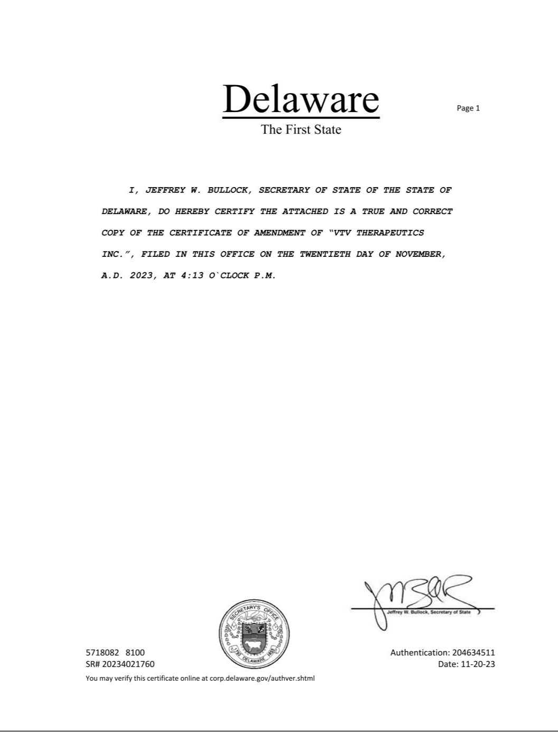

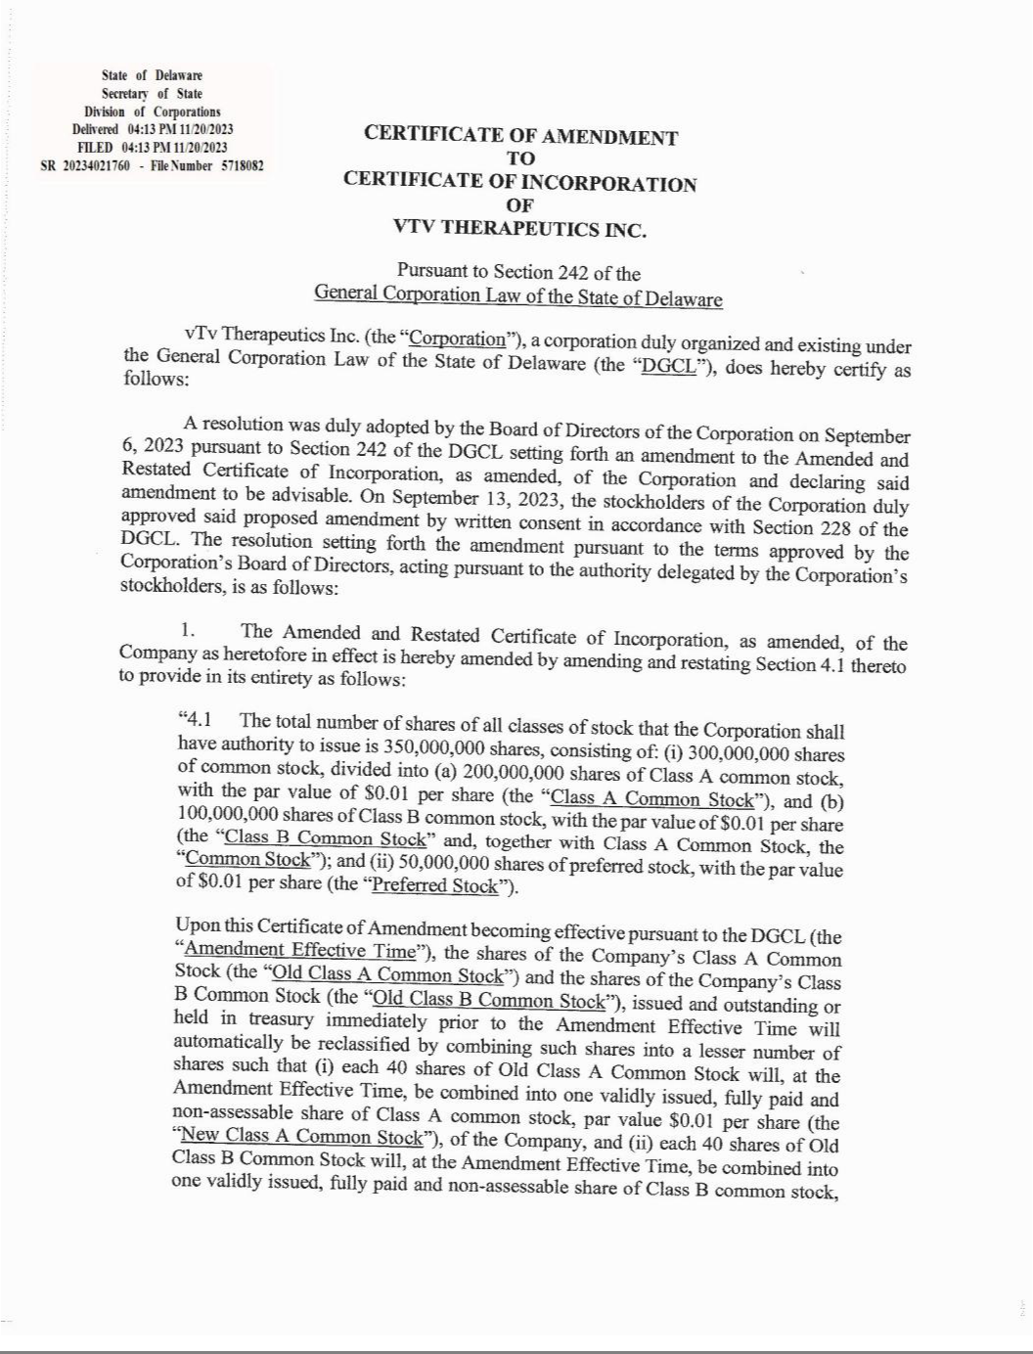

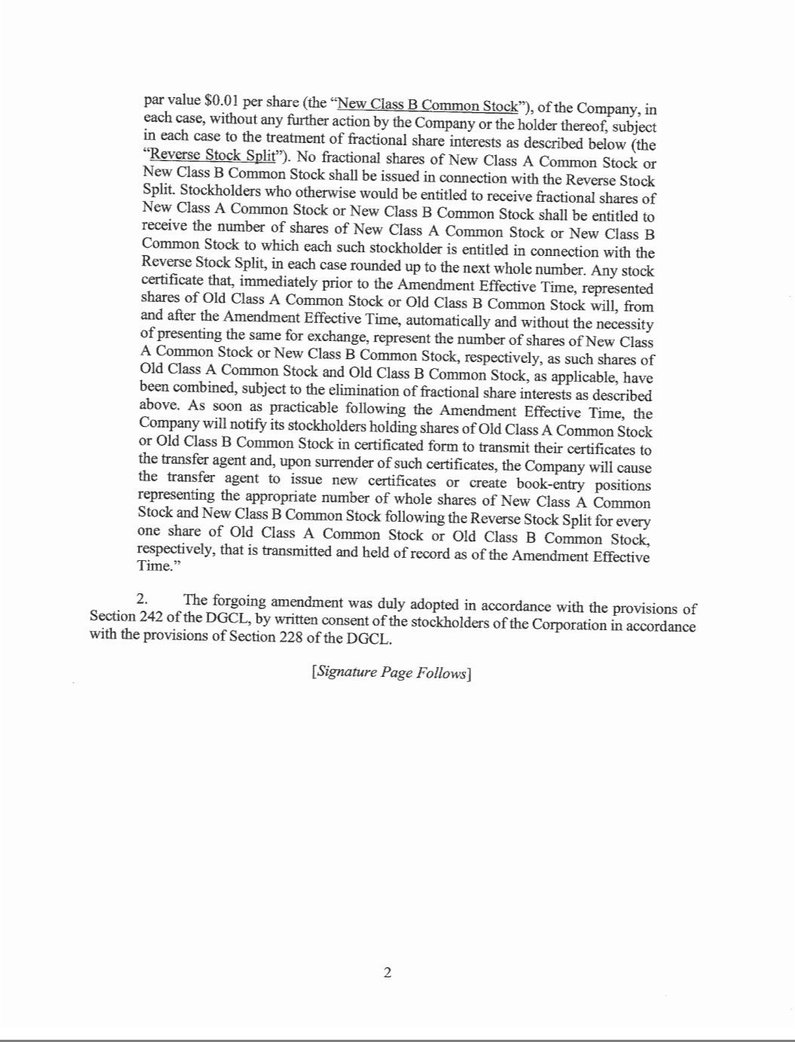



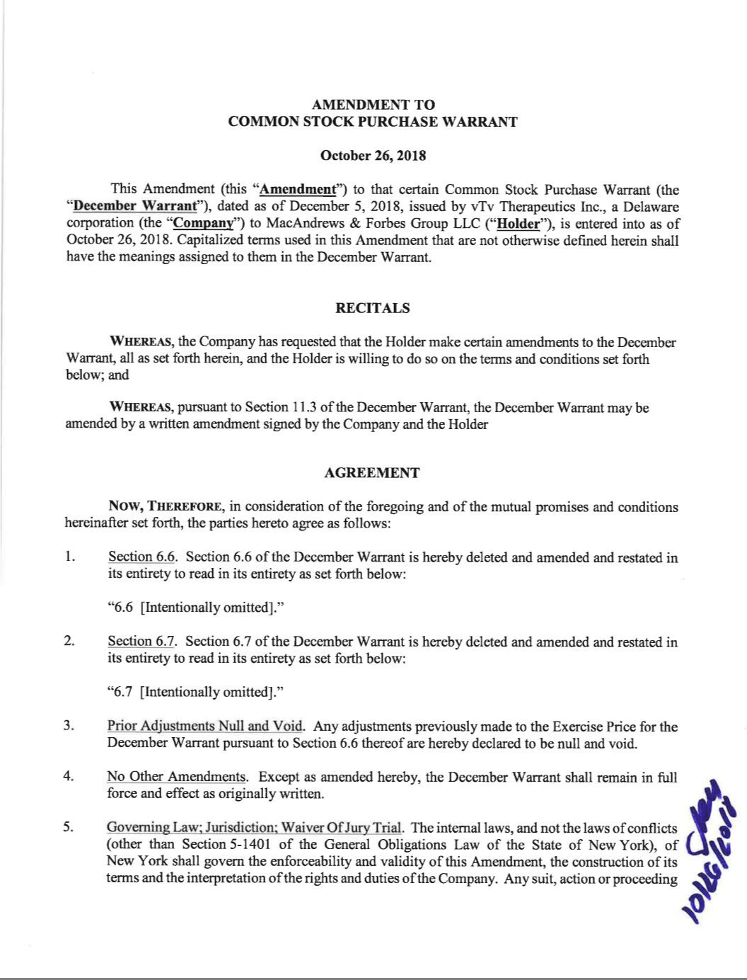

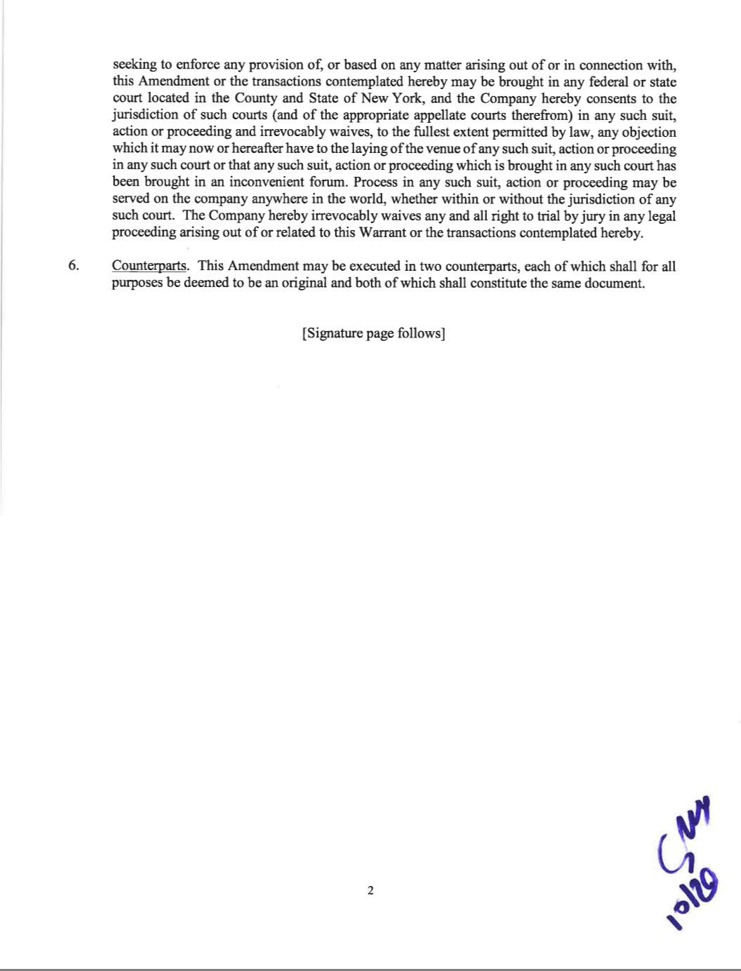

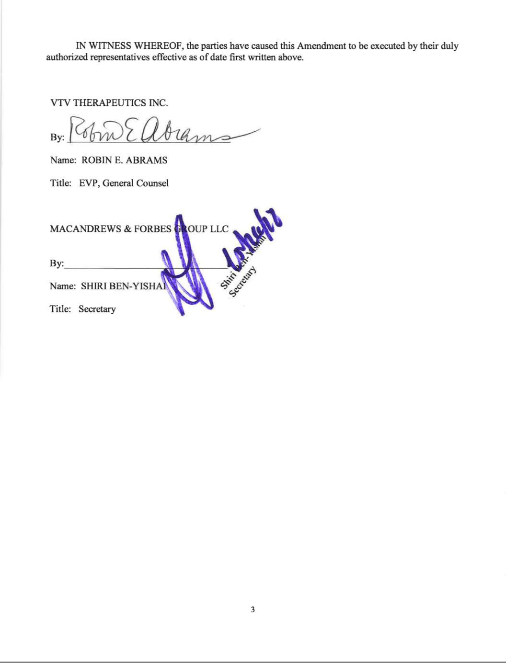

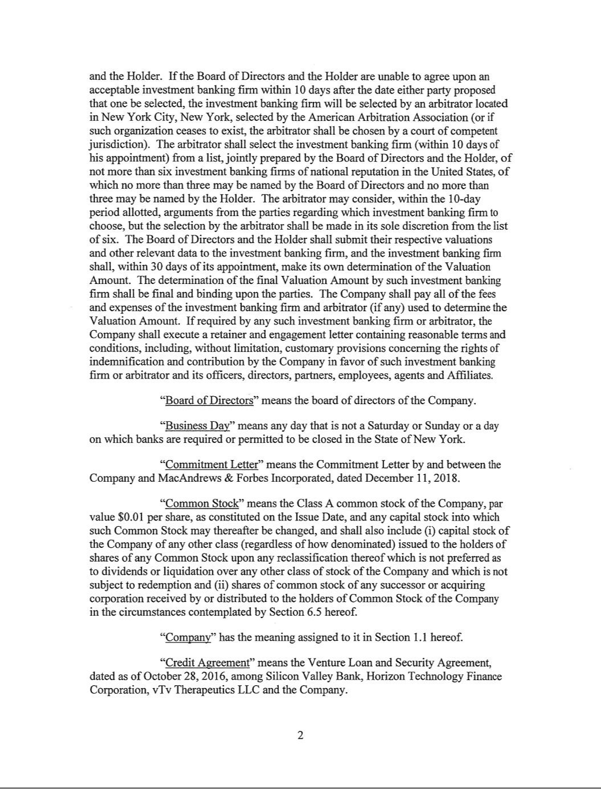

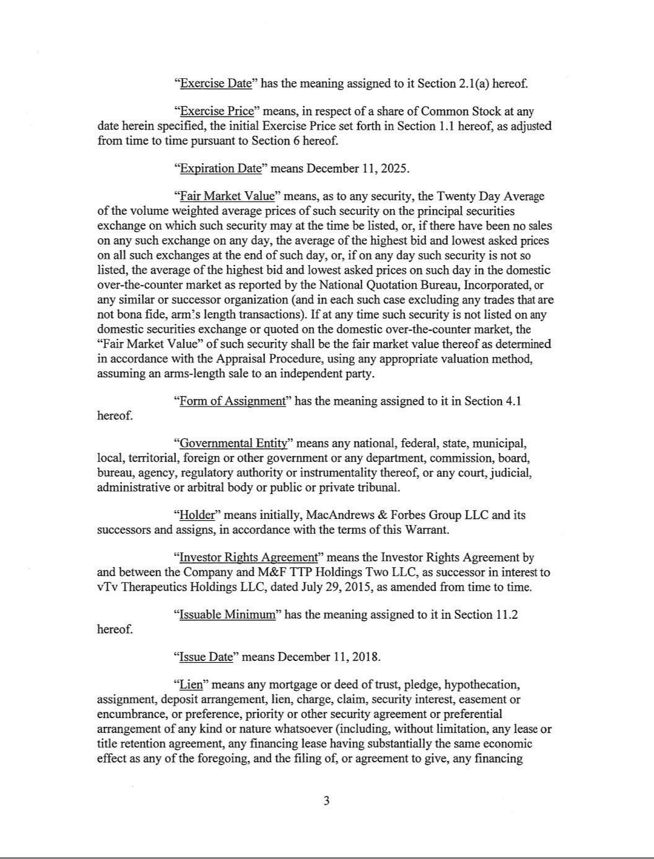

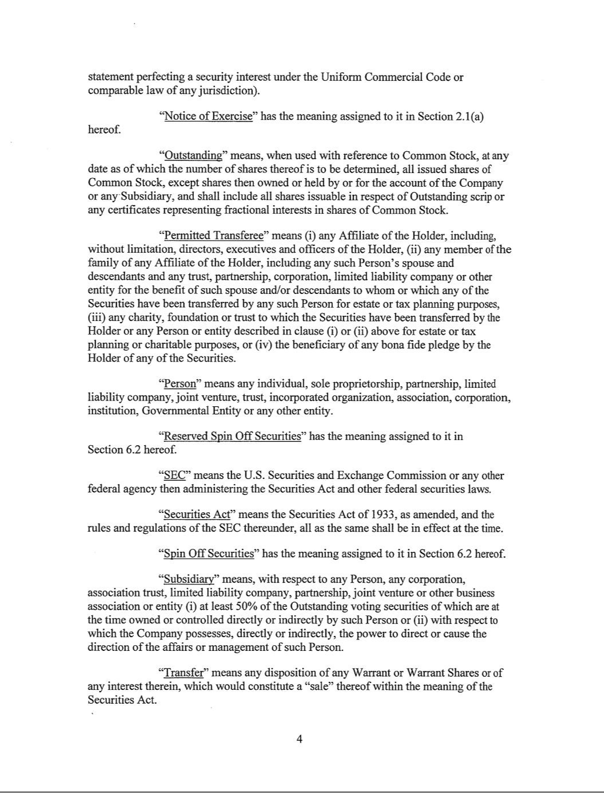

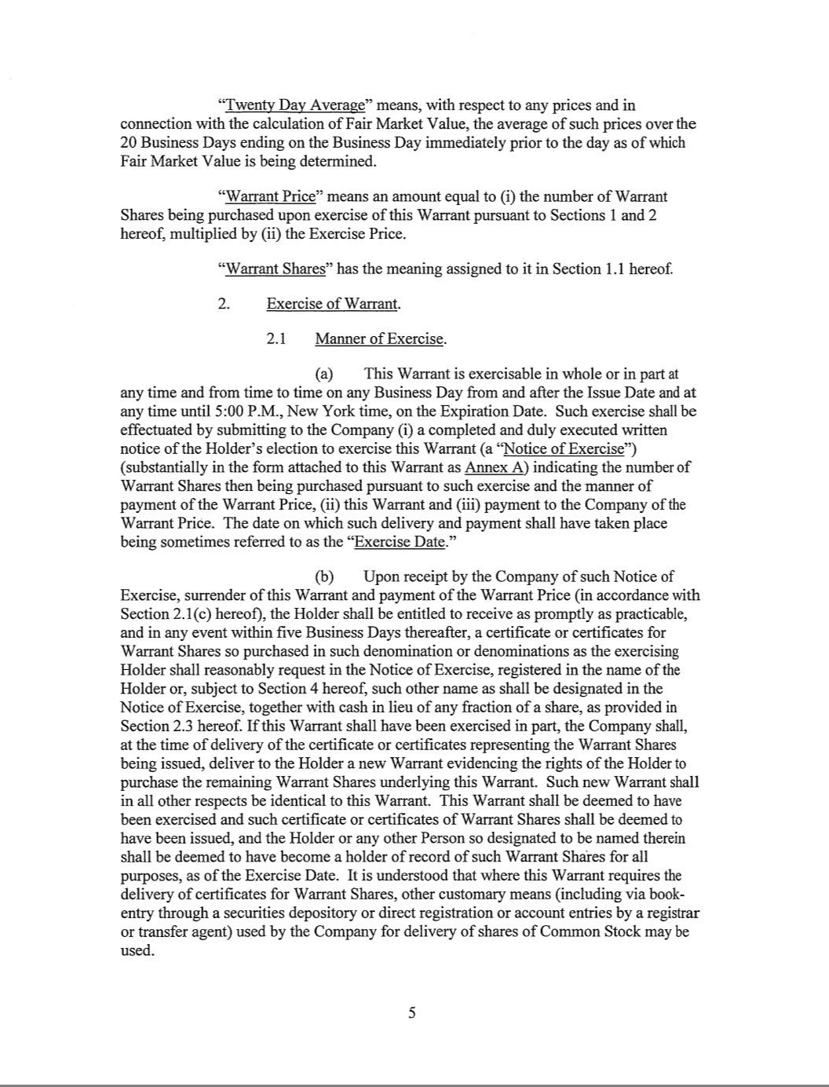

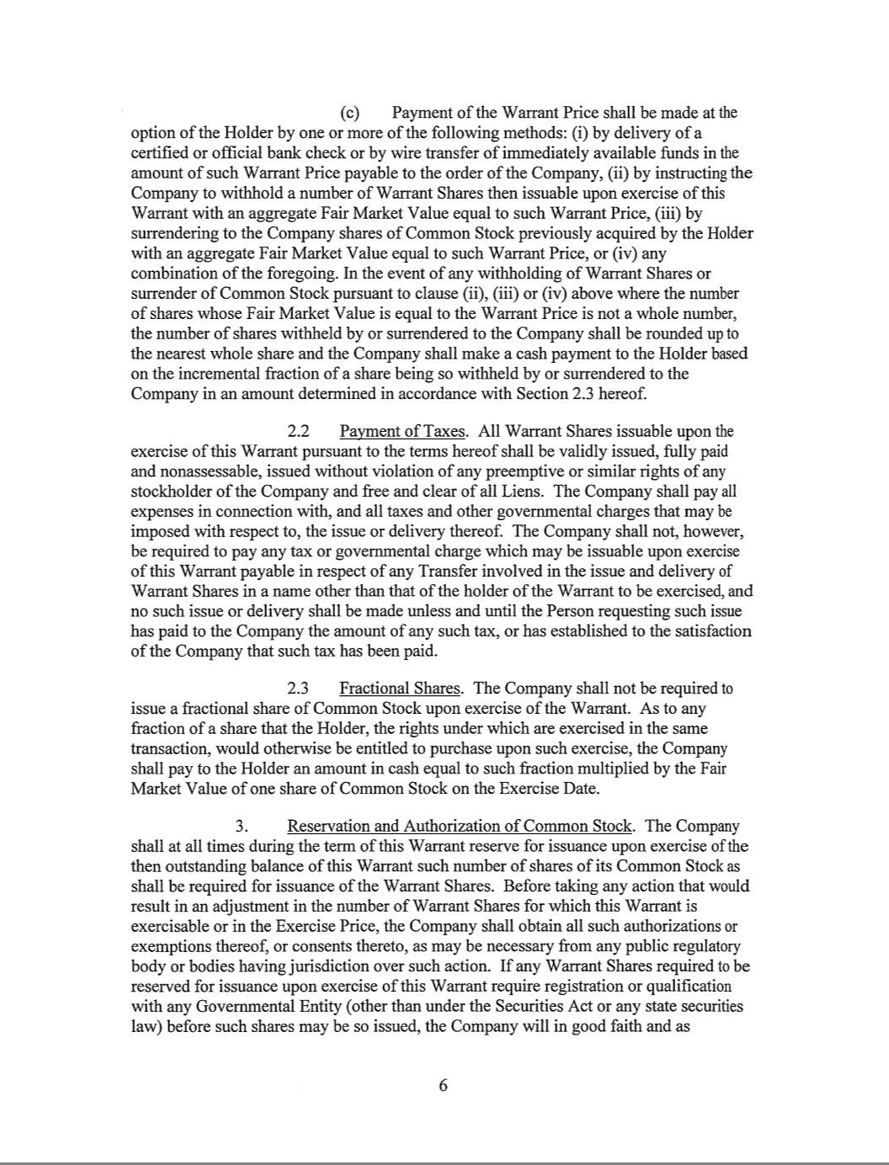

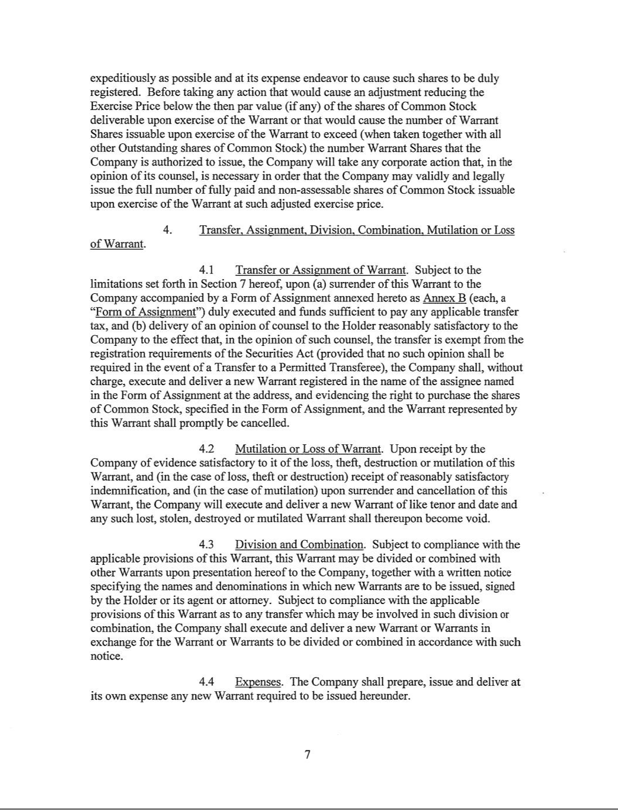

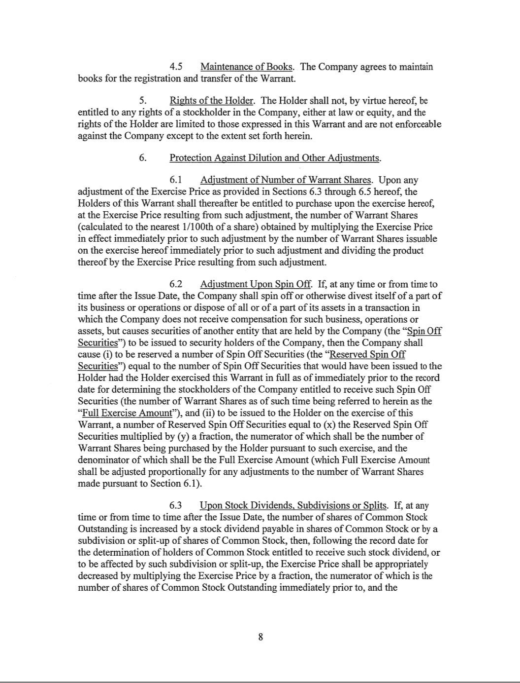

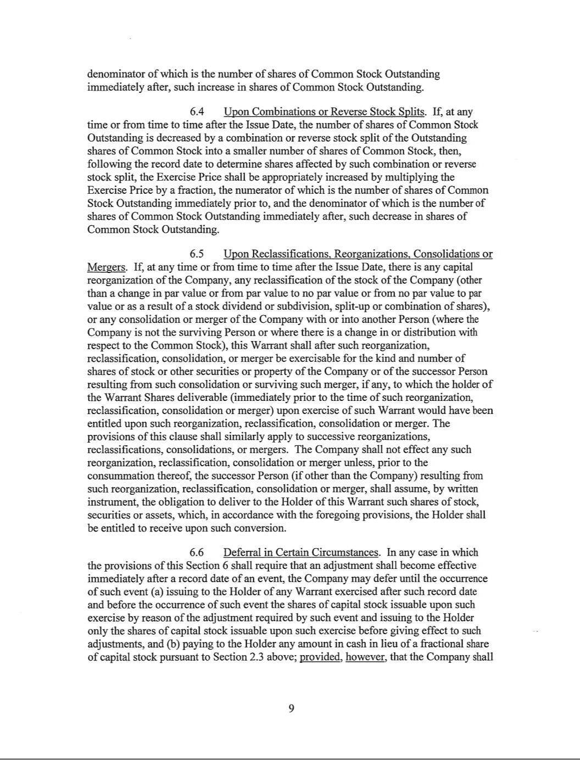

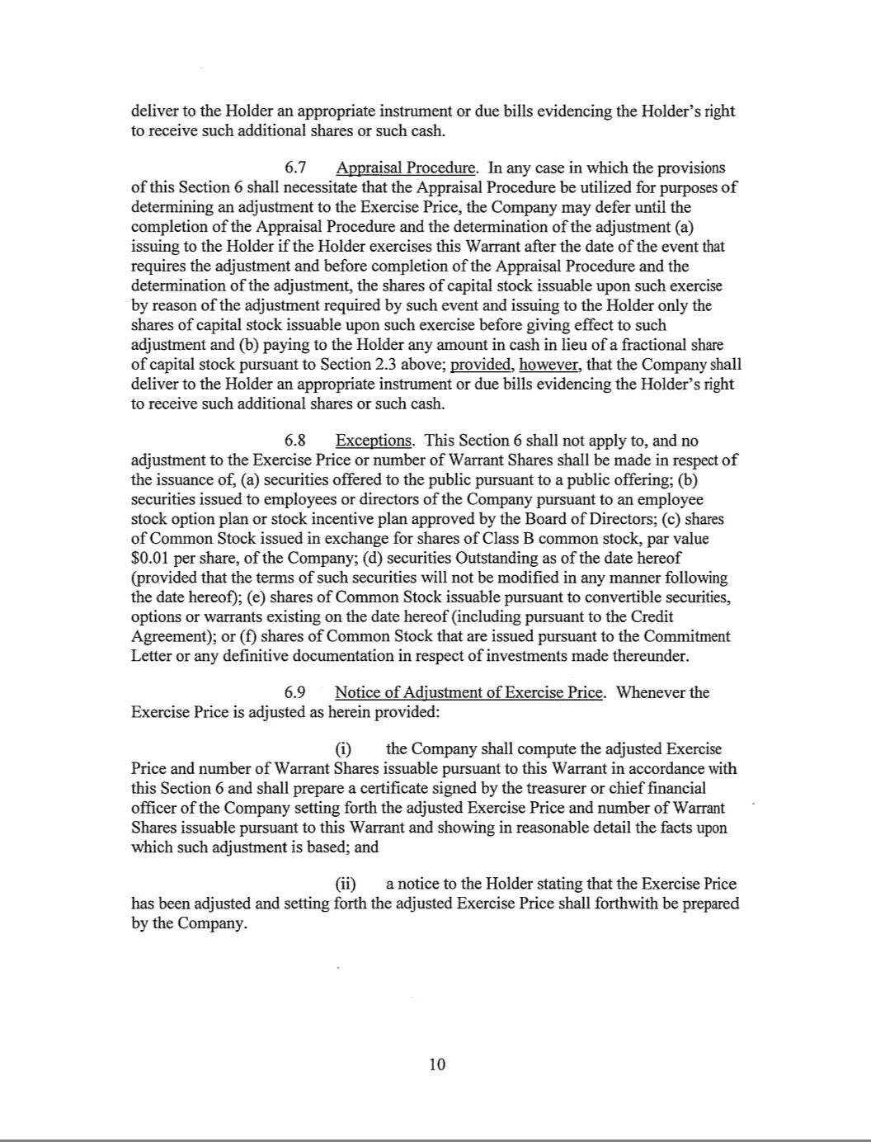

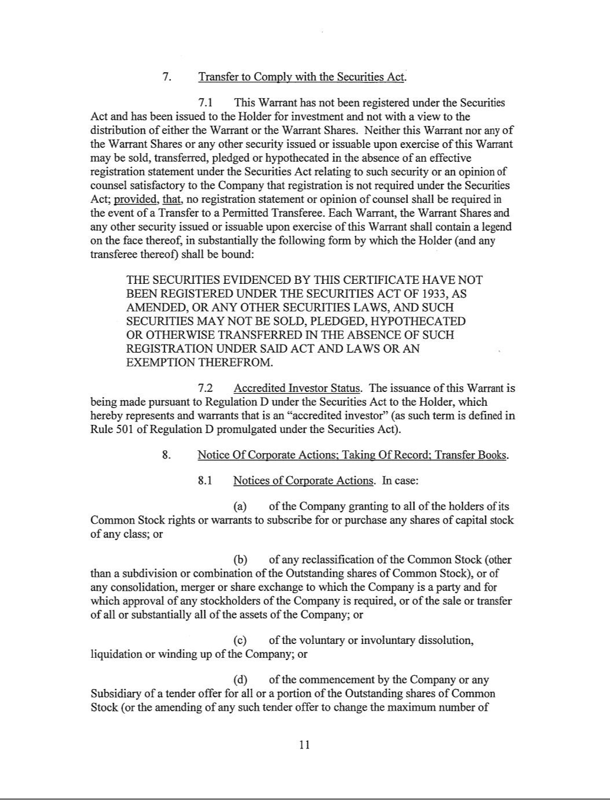

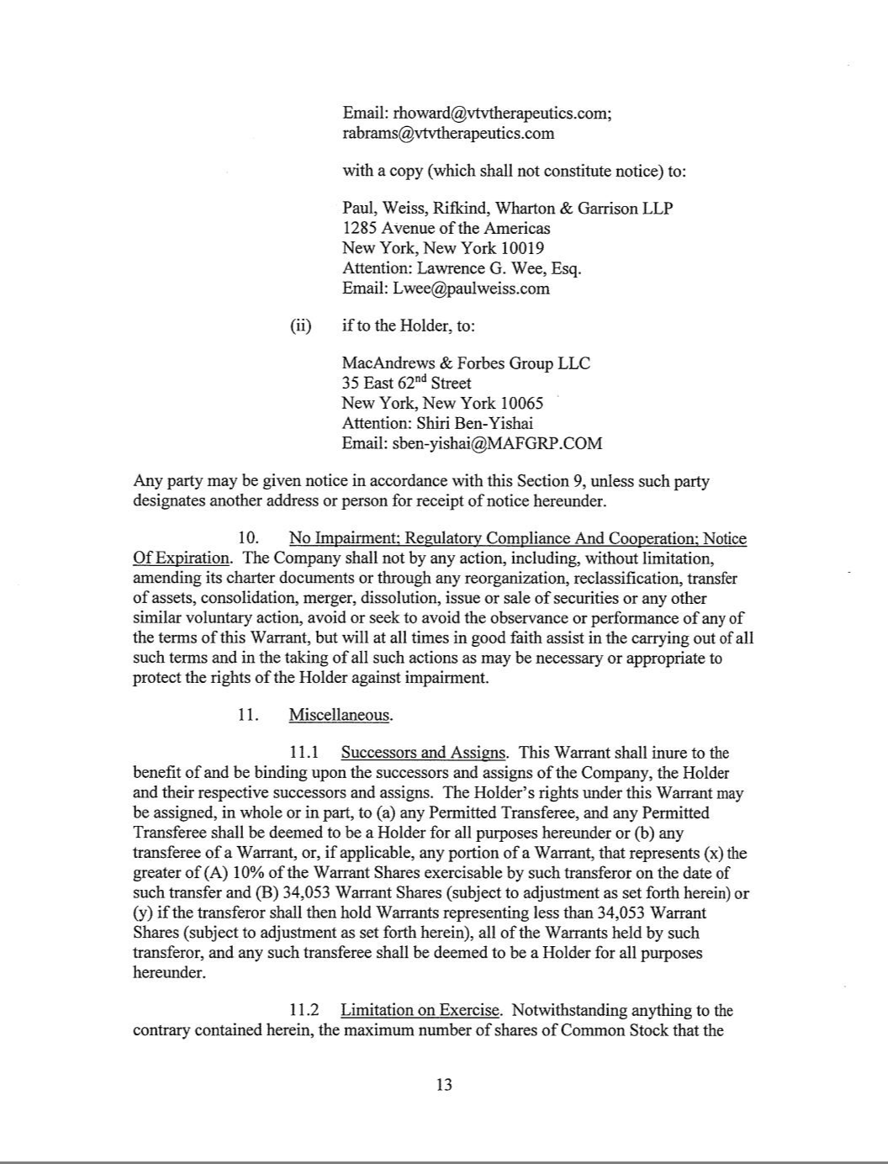

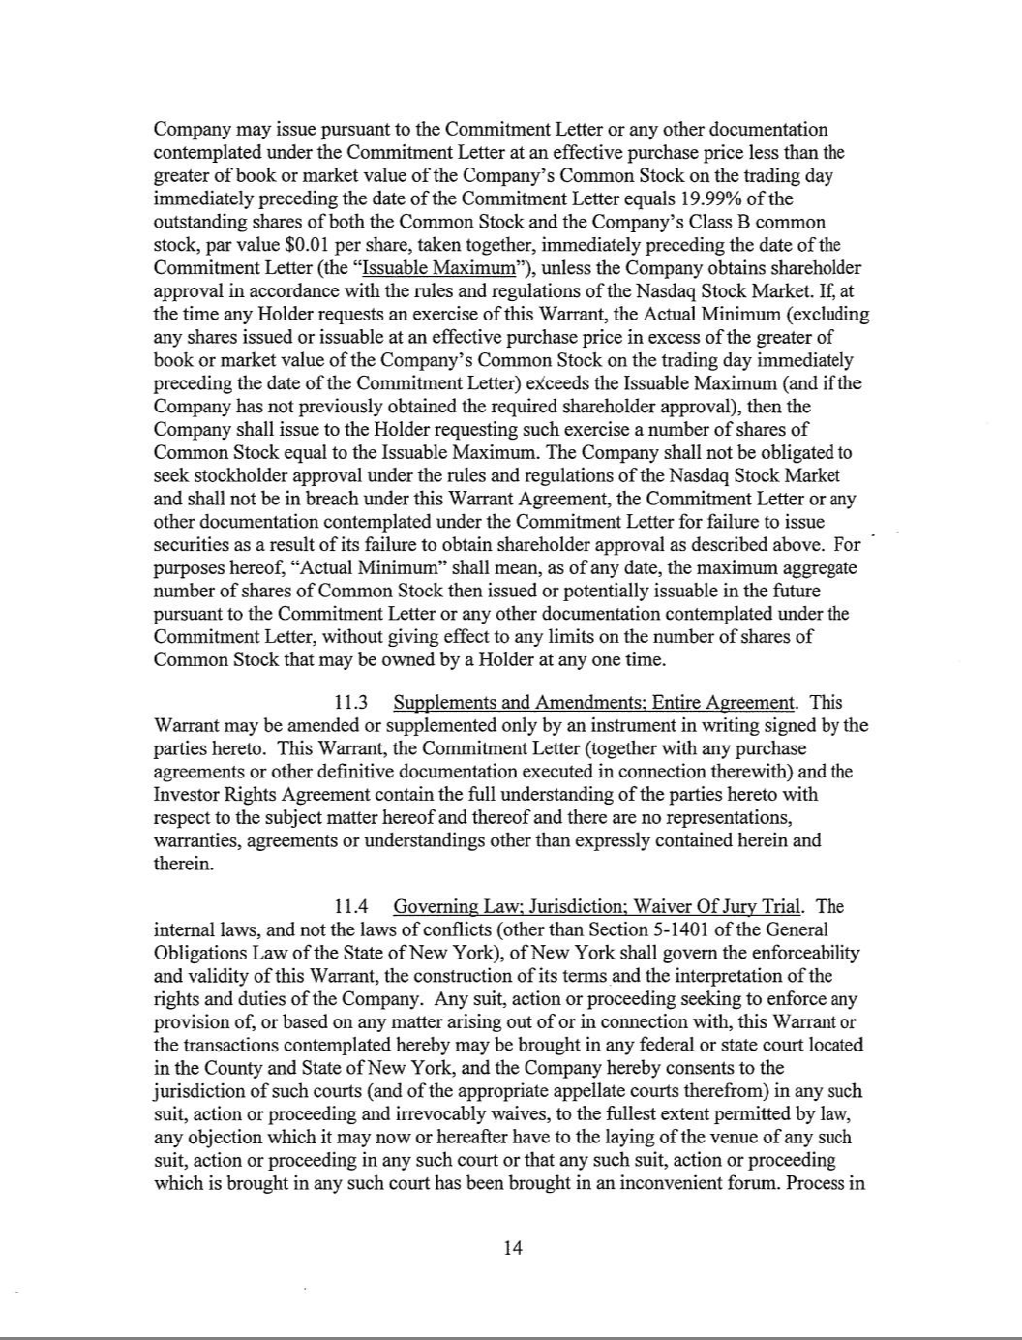

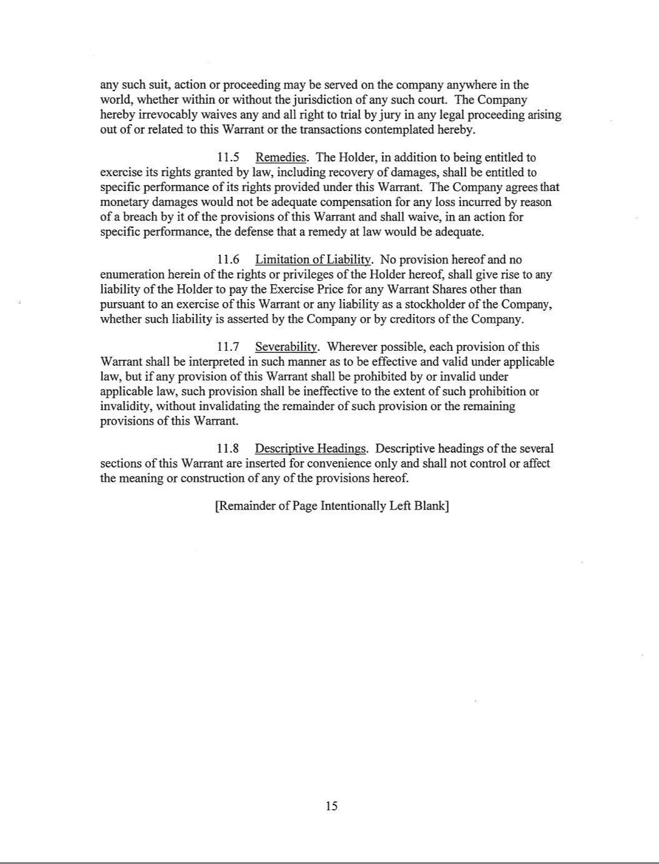



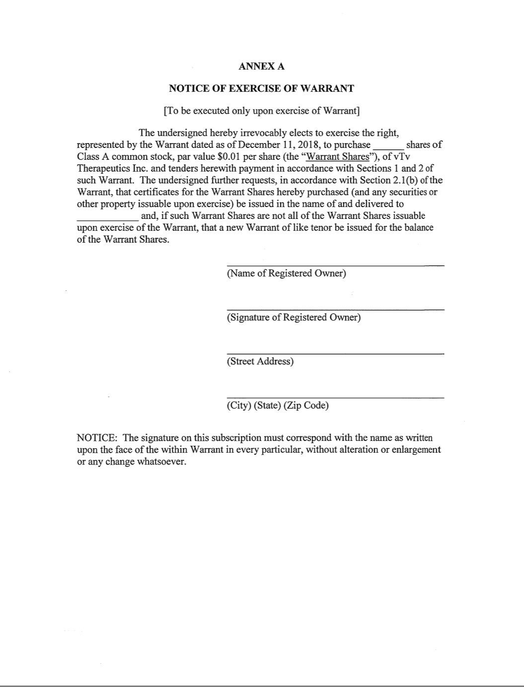

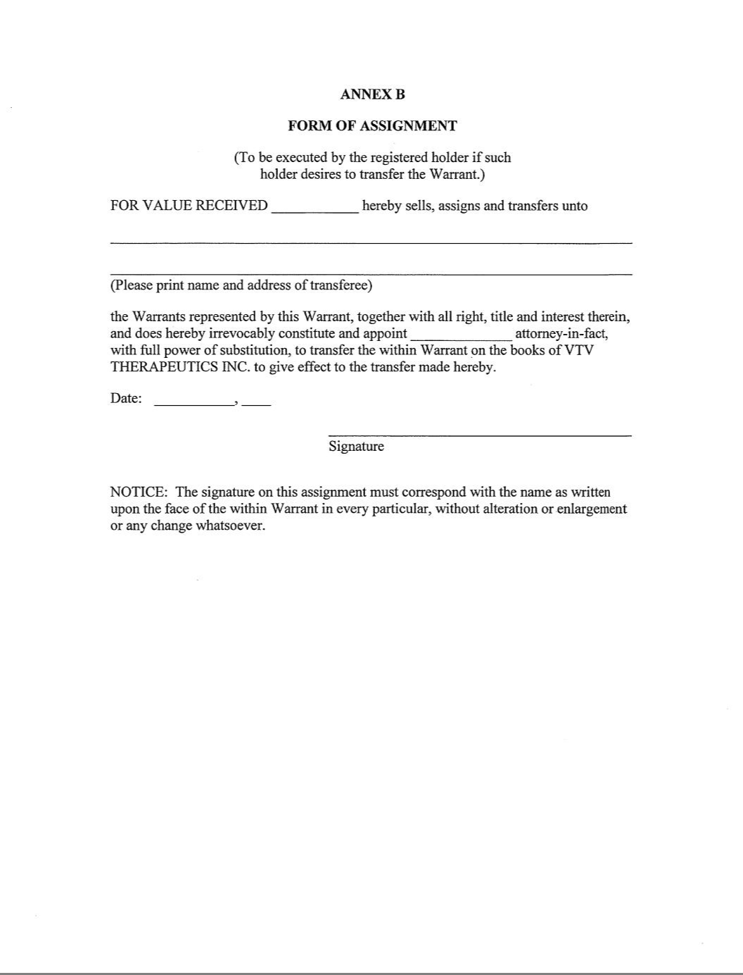

Exhibit 4.6
DESCRIPTION OF THE CAPITAL STOCK

Capital Stock

Our authorized capital stock consists of 200,000,000 shares of Class A common stock, par value $0.01 per share, 100,000,000 shares of Class B common stock, par value $0.01 per share, and 50,000,000 shares of preferred stock, par value $0.01 per share. As of March 13, 2024, we have approximately 2,432,857 shares of our Class A common stock outstanding, 577,349 shares of our Class B common stock outstanding and no shares of preferred stock outstanding. As of March 13, 2024, there were approximately 40 holders of record of our Class A common stock and 6 holders of record of our Class B common stock. Because almost all of the shares of our Class A common stock are

held by brokers, nominees and other institutions on behalf of shareholders, we are unable to estimate the total number of shareholders represented by these record holders.

Common Stock

Voting. Holders of our Class A common stock and Class B common stock are entitled to one vote for each share held on all matters submitted to stockholders for their vote or approval. The holders of our Class A common stock

and Class B common stock vote together as a single class on all matters submitted to stockholders for their vote or approval, except with respect to the amendment of certain provisions of our amended and restated certificate of incorporation that would alter or change the powers, preferences or special rights of the Class B common stock so as to affect them adversely, which amendments must be approved by a majority of the votes entitled to be cast by the holders of the shares affected by the amendment, voting as a separate class, or as otherwise required by applicable law.

As of December 31, 2023, subsidiaries and affiliates of MacAndrews & Forbes Incorporated (collectively “MacAndrews”) held 577,108 shares of our Class B common stock and 912,982 shares of our Class A common stock and therefore control approximately 56.0% of the combined voting power of our outstanding common stock. As a result, MacAndrews is able to control our business policies and affairs and any action requiring the general approval of our stockholders, including the adoption of amendments to our certificate of incorporation and bylaws, the approval of mergers or sales of substantially all of our assets and the removal of members of our Board of Directors with or without

cause. On February 27, 2024, the Investor Rights Agreement was amended to alter MacAndrews governance rights that now entitles MacAndrews the right to designate two members of our Board of Directors. The concentration of ownership and voting power of MacAndrews may also delay, defer or even prevent an acquisition by a third party or other change of control of our company and may make some transactions more difficult or impossible without the support of MacAndrews, even if such events are in the best interests of minority stockholders.

Dividends. The holders of Class A common stock are entitled to receive dividends when, as, and if declared by our Board of Directors out of legally available funds. The holders of our Class B common stock do not have any right to receive dividends other than dividends consisting of shares of our Class B common stock paid proportionally with respect to each outstanding share of our Class B common stock.

Liquidation or Dissolution. Upon our liquidation or dissolution, the holders of our Class A common stock are entitled to share ratably in those of our assets that are legally available for distribution to stockholders after payment

of liabilities and subject to the prior rights of any holders of preferred stock then outstanding. Other than their par value, the holders of our Class B common stock do not have any right to receive a distribution upon a liquidation or dissolution of our company.

Transferability and Exchange. Subject to the terms of an exchange agreement and the operating agreement of vTv Therapeutics LLC (“vTv LLC”), our principal operating subsidiary, units of vTv LLC (along with a

corresponding number of shares of our Class B common stock) are exchangeable for (i) shares of our Class A common stock or (ii) cash (based on the market price of the shares of Class A common stock), at our option (as the managing member of vTv LLC). Any decision to require an exchange for cash rather than shares of Class A common stock will ultimately be determined by our entire Board of Directors. Each such exchange will be on a one-for-one equivalent basis, subject to customary conversion rate adjustments for stock splits, stock dividends and reclassifications. Shares of Class B common stock may not be transferred except in connection with an exchange or transfer of

units of vTv LLC.

Upon exchange, each share of our Class B common stock will be cancelled.

Preferred Stock

We have been authorized to issue up to 50,000,000 shares of preferred stock. Our board of directors has authorized, subject to limitations prescribed by Delaware law and our amended and restated certificate of incorporation, to determine the terms and conditions of the preferred stock, including whether the shares of preferred stock will be issued in one or more series, the number of shares to be included in each series and the powers, designations, preferences

and rights of the shares. Our Board of Directors has also been authorized to designate any qualifications, limitations or restrictions on the shares without any further vote or action by the stockholders. The issuance of preferred stock may have the effect of delaying, deferring or preventing a change in control of our company and may adversely affect the voting and other rights of the holders of our Class A common stock and Class B common stock, which could have an adverse impact on the market price of our Class A common stock. We have no current plan to issue any shares of preferred stock.

Corporate Opportunities

Our amended and restated certificate of incorporation provides that, to the fullest extent permitted by law, the doctrine of “corporate opportunity” will not apply to MacAndrews, any of our non-employee directors who are employees, affiliates or consultants of MacAndrews or its affiliates (other than us or our subsidiaries) or any of their respective affiliates in a manner that would prohibit them from investing in competing businesses or doing business

with our clients or customers. See “Risk Factors—Risks Relating to this Offering and Ownership of Our Class A Common Stock—MacAndrews has substantial influence over our business, and their interests may differ from our interests or those of our other stockholders” in our Annual Report on Form 10-K for the year ended December 31, 2021, which is incorporated herein by reference.

Anti-Takeover Effects of our Certificate of Incorporation and Bylaws

Our amended and restated certificate of incorporation and bylaws contain certain provisions that are intended to enhance the likelihood of continuity and stability in the composition of the Board of Directors and which may have the effect of delaying, deferring or preventing a future takeover or change in control of us unless such takeover or change in control is approved by our Board of Directors.

These provisions include:

Action by Written Consent; Special Meetings of Stockholders. Our amended and restated certificate of incorporation provides that, following the date on which MacAndrews ceases to beneficially own more than 50% of our common stock (the “Triggering Event”), stockholder action can be taken only at an annual or special meeting of stockholders and cannot be taken by written consent in lieu of a meeting. Our amended and restated certificate of incorporation and bylaws also provide that, except as otherwise required by law, special meetings of the stockholders can only be called by the chairman or vice-chairman of the board, the chief executive officer, or pursuant to a

resolution adopted by a majority of the Board of Directors or, until the Triggering Event, at the request of holders of 50% or more of our outstanding shares of common stock. Except as described above, stockholders will not be permitted to call a special meeting or to require the Board of Directors to call a special meeting.

Advance Notice Procedures. Our bylaws establish an advance notice procedure for stockholder proposals to be brought before an annual meeting of our stockholders, including proposed nominations of persons for election to the

Board of Directors. Stockholders at an annual meeting will only be able to consider proposals or nominations specified in the notice of meeting or brought before the meeting by or at the direction of the Board of Directors or by a stockholder who was a stockholder of record on the record date for the meeting, who is entitled to vote at the meeting and who has given our Secretary timely written notice, in proper form, of the stockholder’s intention to bring that business before the meeting. Although the bylaws do not give the Board of Directors the power to approve or disapprove stockholder nominations of candidates or proposals regarding other business to be conducted at a special or

annual meeting, the bylaws may have the effect of precluding the conduct of certain business at a meeting if the proper procedures are not followed or may discourage or deter a potential acquirer from conducting a solicitation of proxies to elect its own slate of directors or otherwise attempting to obtain control of us.

Vacancies and Newly-Created Directorships on the Board of Directors. Our bylaws provide that the Board of Directors can fill vacancies on the Board of Directors. In addition, the Board of Directors will be permitted to increase the number of directors and fill the vacant positions. These provisions could make it more difficult for shareholders to affect the composition of our Board of Directors.

Authorized but Unissued Shares. Our authorized but unissued shares of common stock and preferred stock will be available for future issuance without stockholder approval. These additional shares may be utilized for a

variety of corporate purposes, including future public offerings to raise additional capital, corporate acquisitions and employee benefit plans. The existence of authorized but unissued shares of common stock and preferred stock could render more difficult or discourage an attempt to obtain control of a majority of our common stock by means of a proxy contest, tender offer, merger or otherwise.

Business Combinations with Interested Stockholders. We have elected in our amended and restated certificate of incorporation not to be subject to Section 203 of the Delaware General Corporation Law, an antitakeover law. In

general, Section 203 prohibits a publicly held Delaware corporation from engaging in a business combination, such as a merger, with a person or group owning 15% or more of the corporation’s voting stock for a period of three years following the date the person became an interested stockholder, unless (with certain exceptions) the business combination or the transaction in which the person became an interested stockholder is approved in a prescribed manner. Accordingly, we will not be subject to any anti-takeover effects of Section 203. Nevertheless, our amended and restated certificate of incorporation contains provisions that have the same effect as Section 203, except that they provide

that MacAndrews and its various affiliates, successors and transferees will not be deemed to be “interested stockholders,” regardless of the percentage of our voting stock owned by them, and accordingly will not be subject to such restrictions.

Choice of Forum

Our amended and restated certificate of incorporation provides that the Court of Chancery in the State of Delaware will be the sole and exclusive forum for (i) any derivative action or proceeding brought on our behalf, (ii) any action asserting a claim of breach of a fiduciary duty owed to us or our stockholders by our directors, officers or other employees, (iii) any action asserting a claim arising under the Delaware General Corporation Law, our amended and restated certificate of incorporation and amended and restated by-laws or (iv) any action asserting a claim that is governed by the internal affairs doctrine. It is possible that a court could rule that this provision is not applicable or is

unenforceable. We may consent in writing to alternative forums. Stockholders will be deemed to have consented to the personal jurisdiction of the state and federal courts located within the State of Delaware and having service of process made on such stockholder’s counsel as agent for such stockholder.

Directors’ Liability; Indemnification of Directors and Officers

Our amended and restated certificate of incorporation limits the liability of our directors to the fullest extent permitted by the Delaware General Corporation Law and provides that we will provide them with customary indemnification. We expect to enter into customary indemnification agreements with each of our executive officers and directors that provide them, in general, with customary indemnification in connection with their service to us or on our behalf.

Transfer Agent and Registrar

The transfer agent and registrar for our Class A common stock is Equiniti Trust Company, LLC.

Securities Exchange

Our shares of Class A common stock are listed on The NASDAQ Capital Market under the symbol “VTVT”.

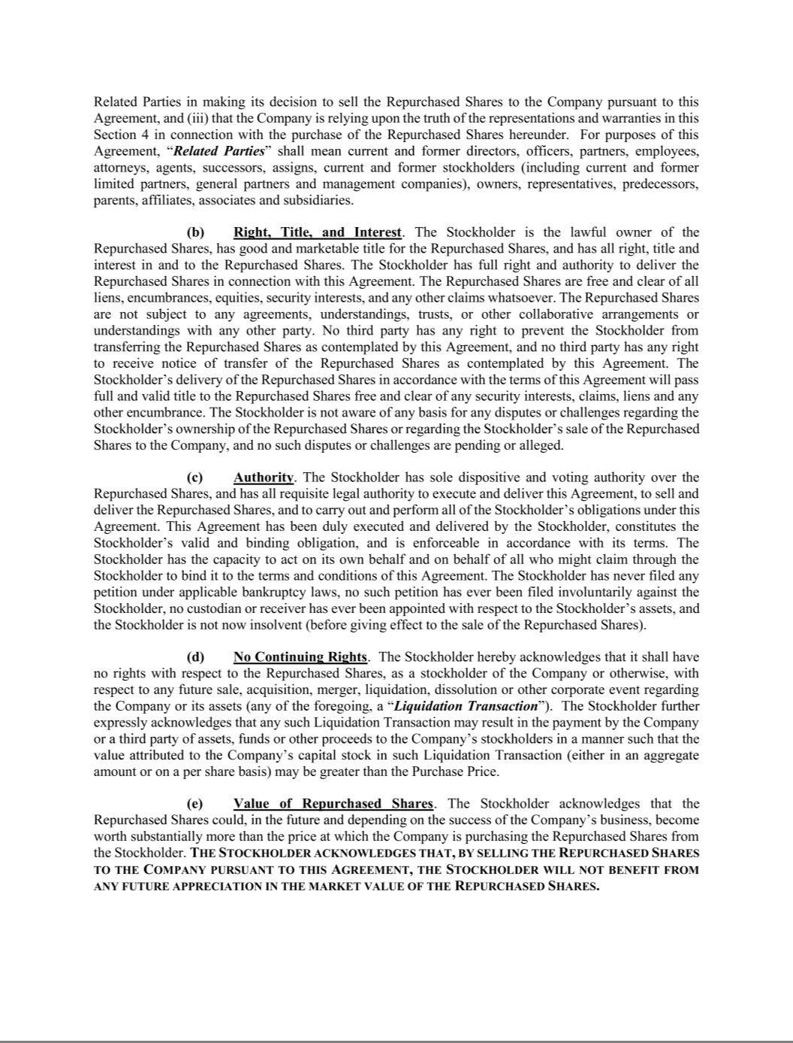

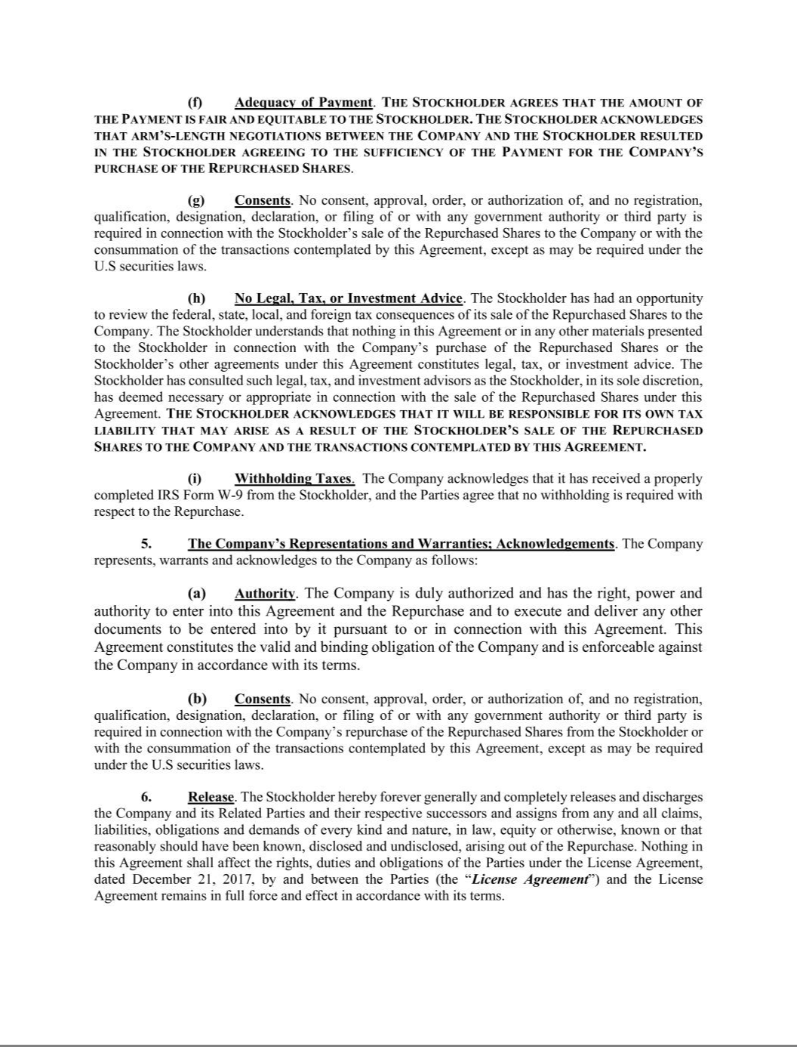

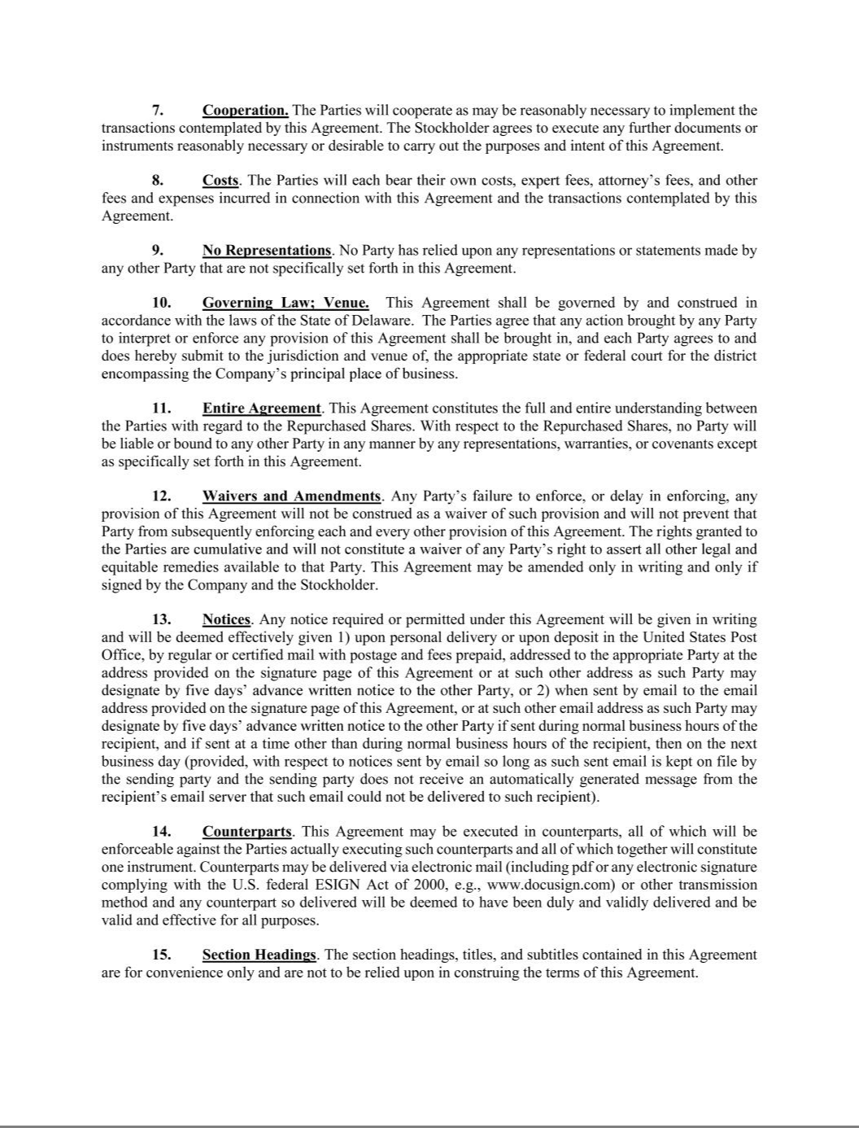

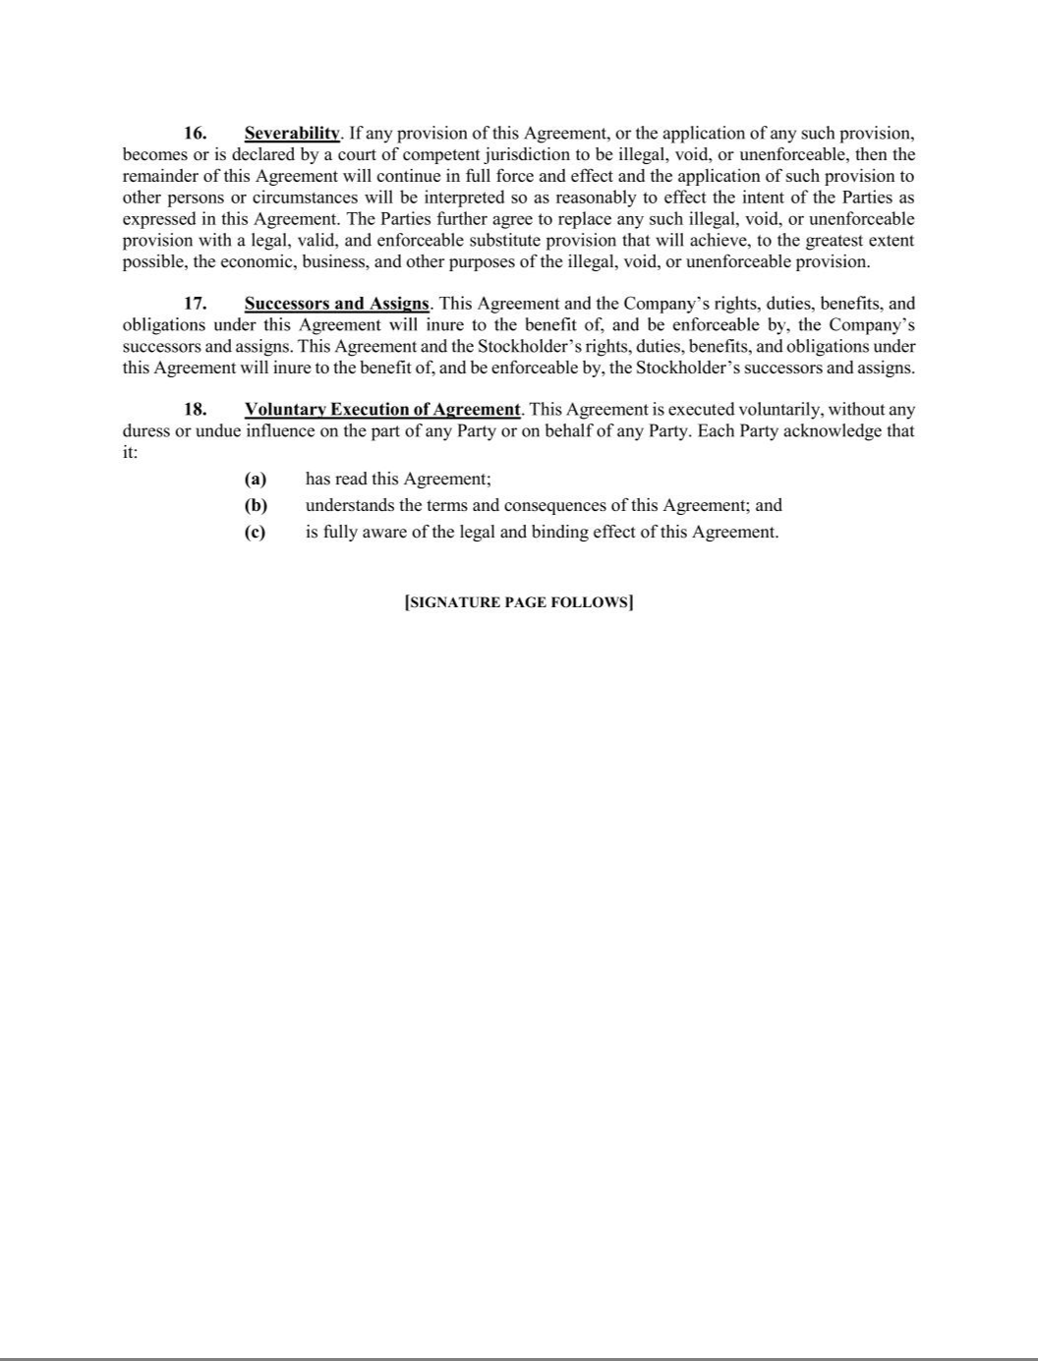

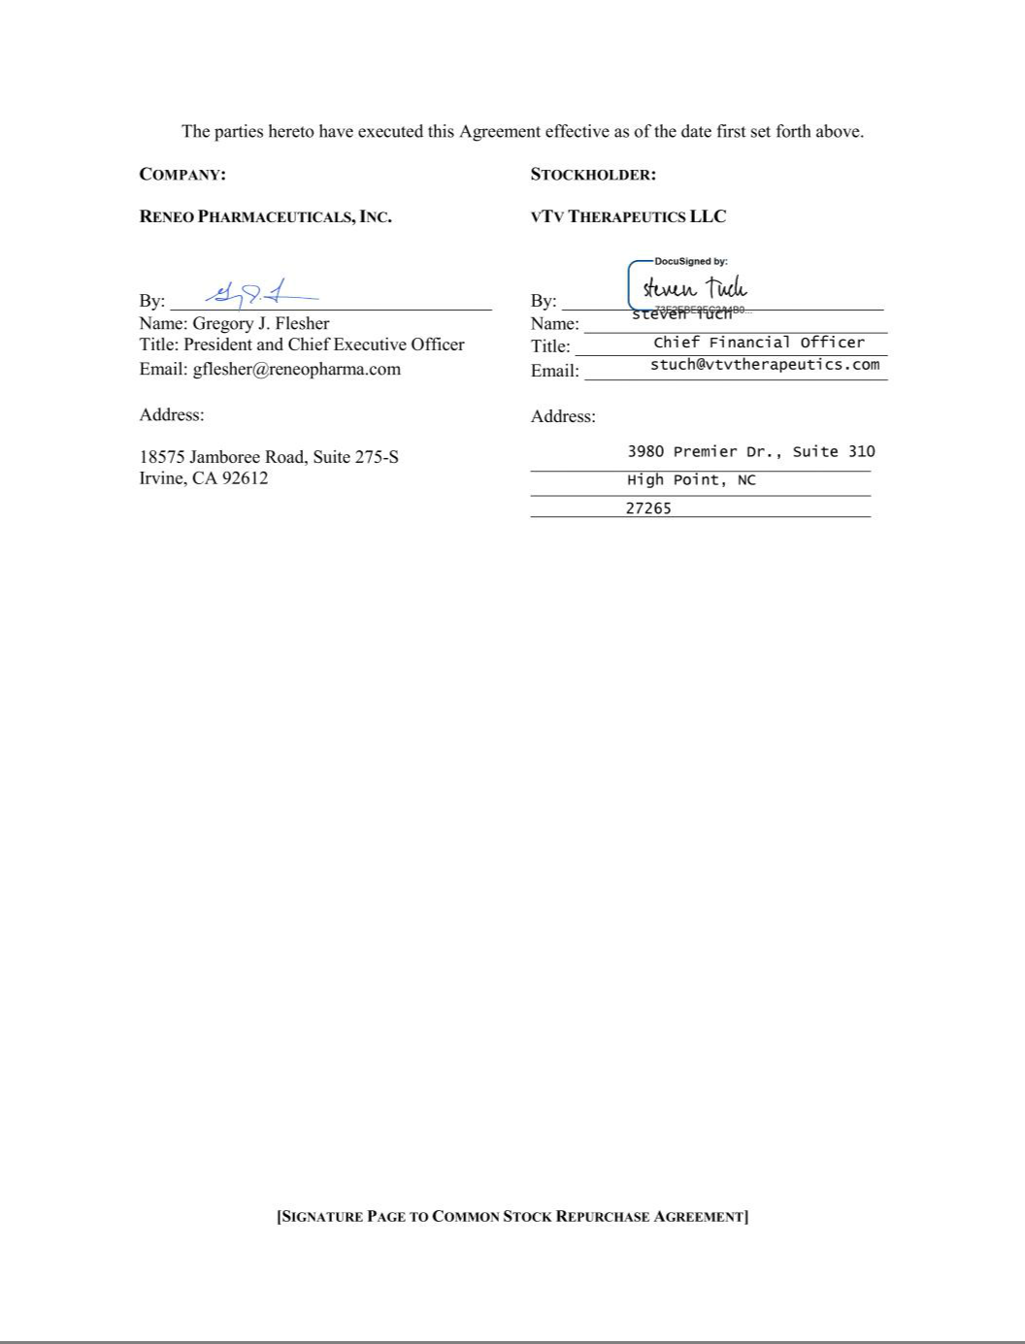

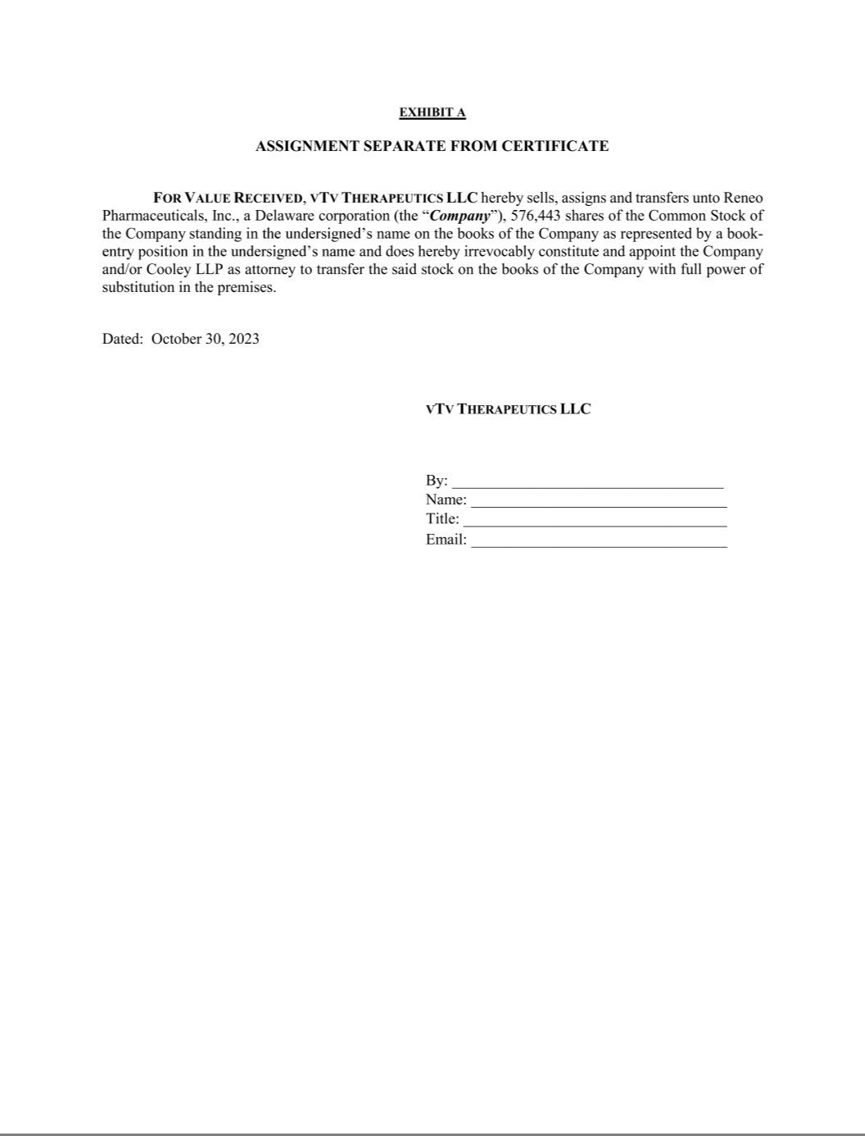

Exhibit 21.1

 | vTv Therapeutics Inc.
 | Corporate Subsidiaries as of March 13, 2024
Subsidiary |  |  | Jurisdiction of Incorporation
vTv Therapeutics LLC |  |  | Delaware

Exhibit 23.1

Consent of Independent Registered Public Accounting Firm

We consent to the incorporation by reference in the following Registration Statements:

- Registration Statement (Form S-8 No. 333-206335) pertaining to the vTv Therapeutics Inc. 2015 Omnibus Equity Incentive Plan,

- Registration Statement (Form S-3 No. 333-232571) of vTv Therapeutics Inc.;

- Registration Statement (Form S-8 No. 333-240304) of vTv Therapeutics Inc.;

- Registration Statement (Form S-1 No. 333-250934) of vTv Therapeutics Inc.;

- Registration Statement (Form S-3 No. 333-254445) of vTv Therapeutics Inc.; and

- Registration Statement (Form S-3 No. 333-256755) of vTv Therapeutics Inc.

of our report dated March 13, 2024, with respect to the consolidated financial statements of vTv Therapeutics Inc. included in this Annual Report (Form 10-K) of vTv Therapeutics Inc. for the year ended December 31, 2023.

/s/ Ernst & Young LLP

Raleigh, North Carolina

March 13, 2024

EXHIBIT 31.1

SECTION 302 CERTIFICATION

I, Paul J. Sekhri, certify that:

- I have reviewed this annual report on Form 10-K of vTv Therapeutics Inc. (the “registrant”);

- Based on my knowledge, this report does not contain any untrue statement of a material fact or omit to state a material fact necessary to make the statements made, in light of the circumstances under which such statements were made, not misleading with respect to the period covered by this report;

- Based on my knowledge, the financial statements, and other financial information included in this report, fairly present in all material respects the financial condition, results of operations and cash flows of the registrant as of, and for, the periods presented in this report;

- The registrant’s other certifying officer(s) and I are responsible for establishing and maintaining disclosure controls and procedures (as defined in Exchange Act Rules 13a-15(e) and 15d-15(e)) and internal control over financial reporting (as defined in Securities Exchange Act Rules 13a-15(f) and 15d-15(f)) for the registrant and have:

  - Designed such disclosure controls and procedures, or caused such disclosure controls and procedures to be designed under our supervision, to ensure that material information relating to the registrant, including its consolidated subsidiaries, is made known to us by others within those entities, particularly during the period in which this report is being prepared;

  - Designed such internal control over financial reporting, or caused such internal control over financial reporting to be designed under our supervision, to provide reasonable assurance regarding the reliability of financial reporting and the preparation of financial statements for external purposes in accordance with generally accepted accounting principles;

  - Evaluated the effectiveness of the registrant’s disclosure controls and procedures and presented in this report our conclusions about the effectiveness of the disclosure controls and procedures, as of the end of the period covered by this report based on such evaluation; and

  - Disclosed in this report any change in the registrant’s internal control over financial reporting that occurred during the registrant’s most recent fiscal quarter (the registrant’s fourth fiscal quarter in the case of an annual report) that has materially affected, or is reasonably likely to materially affect, the registrant’s internal control over financial reporting; and

- The registrant’s other certifying officer(s) and I have disclosed, based on our most recent evaluation of internal control over financial reporting, to the registrant’s auditors and the audit committee of the registrant’s board of directors (or persons performing the equivalent functions):

  - All significant deficiencies and material weaknesses in the design or operation of internal control over financial reporting which are reasonably likely to adversely affect the registrant’s ability to record, process, summarize and report financial information; and

  - Any fraud, whether or not material, that involves management or other employees who have a significant role in the registrant’s internal control over financial reporting.

Date: March 13, 2024

By: /s/ Paul J. Sekhri

Paul J. Sekhri

Chief Executive Officer

EXHIBIT 31.2

SECTION 302 CERTIFICATION

I, Steven Tuch, certify that:

- I have reviewed this annual report on Form 10-K of vTv Therapeutics Inc. (the “registrant”);

- Based on my knowledge, this report does not contain any untrue statement of a material fact or omit to state a material fact necessary to make the statements made, in light of the circumstances under which such statements were made, not misleading with respect to the period covered by this report;

- Based on my knowledge, the financial statements, and other financial information included in this report, fairly present in all material respects the financial condition, results of operations and cash flows of the registrant as of, and for, the periods presented in this report;

- The registrant’s other certifying officer(s) and I are responsible for establishing and maintaining disclosure controls and procedures (as defined in Exchange Act Rules 13a-15(e) and 15d-15(e)) and internal control over financial reporting (as defined in Securities Exchange Act Rules 13a-15(f) and 15d-15(f)) for the registrant and have:

  - Designed such disclosure controls and procedures, or caused such disclosure controls and procedures to be designed under our supervision, to ensure that material information relating to the registrant, including its consolidated subsidiaries, is made known to us by others within those entities, particularly during the period in which this report is being prepared;

  - Designed such internal control over financial reporting, or caused such internal control over financial reporting to be designed under our supervision, to provide reasonable assurance regarding the reliability of financial reporting and the preparation of financial statements for external purposes in accordance with generally accepted accounting principles;

  - Evaluated the effectiveness of the registrant’s disclosure controls and procedures and presented in this report our conclusions about the effectiveness of the disclosure controls and procedures, as of the end of the period covered by this report based on such evaluation; and

  - Disclosed in this report any change in the registrant’s internal control over financial reporting that occurred during the registrant’s most recent fiscal quarter that has materially affected, or is reasonably likely to materially affect, the registrant’s internal control over financial reporting; and

- The registrant’s other certifying officer(s) and I have disclosed, based on our most recent evaluation of internal control over financial reporting, to the registrant’s auditors and the audit committee of the registrant’s board of directors (or persons performing the equivalent functions):

  - All significant deficiencies and material weaknesses in the design or operation of internal control over financial reporting which are reasonably likely to adversely affect the registrant’s ability to record, process, summarize and report financial information; and

  - Any fraud, whether or not material, that involves management or other employees who have a significant role in the registrant’s internal control over financial reporting.

Date: March 13, 2024

By: | /s/ Steven Tuch
 | Steven Tuch
 | Chief Financial Officer

EXHIBIT 32.1

CERTIFICATION PURSUANT TO

18 U.S.C. SECTION 1350

AS ADOPTED PURSUANT TO

SECTION 906 OF THE SARBANES-OXLEY ACT OF 2002

In connection with the Annual Report of vTv Therapeutics Inc. (the “Company”) on Form 10-K for the period ended December 31, 2023 as filed with the Securities and Exchange Commission on the date hereof (the “Report”), I, Paul J. Sekhri, certify, pursuant to 18 U.S.C. Section 1350, as adopted pursuant to Section 906 of the Sarbanes-Oxley Act of 2002, in my capacity as an officer of the Company that, to my knowledge:

- The Report fully complies with the requirements of Section 13(a) or 15(d), as applicable, of the Securities Exchange Act of 1934; and

- The information contained in the Report fairly presents, in all material respects, the financial condition and results of operations of the Company.

Date: March 13, 2024

By: /s/ Paul J. Sekhri

Paul J. Sekhri

Chief Executive Officer

EXHIBIT 32.2

CERTIFICATION PURSUANT TO

18 U.S.C. SECTION 1350

AS ADOPTED PURSUANT TO

SECTION 906 OF THE SARBANES-OXLEY ACT OF 2002

In connection with the Annual Report of vTv Therapeutics Inc. (the “Company”) on Form 10-K for the period ended December 31, 2023 as filed with the Securities and Exchange Commission on the date hereof (the “Report”), I, Steven Tuch, certify, pursuant to 18 U.S.C. Section 1350, as adopted pursuant to Section 906 of the Sarbanes-Oxley Act of 2002, in my capacity as an officer of the Company that, to my knowledge:

- The Report fully complies with the requirements of Section 13(a) or 15(d) of the Securities Exchange Act of 1934; and

- The information contained in the Report fairly presents, in all material respects, the financial condition and results of operations of the Company.

Date: March 13, 2024

By: | /s/ Steven Tuch
 | Steven Tuch
 | Chief Financial Officer

VTV THERAPEUTICS INC.

CLAWBACK POLICY

vTv Therapeutics Inc. (the “Company”) has adopted this clawback policy (“Policy”) in accordance with Nasdaq listing requirements.

- Application of Policy

This Policy applies in the event of any accounting restatement (“Restatement”) due to the Company’s material non-compliance with financial reporting requirements under applicable securities laws, in accordance with Rule 10D-1 of the Securities Exchange Act of 1934 (“Rule 10D”). This Policy shall apply to Incentive-Based Compensation (as defined below) received on or after October 2, 2023 (the
“Effective Date”).

- Executive Officers Subject to the Policy

The executives of the Company who serve or served as an “executive officer” (as defined under Rule 10D) of the Company (the “Executive Officers”) are covered by this Policy. This includes the Company’s current or former principal executive officer, president, principal financial officer, chief accounting officer or controller, any vice-president of the Company in charge of a principal business unit, division or function, and any other current or former officer or person who performs a significant policy-making function for the Company, including executive officers of Company subsidiaries or the Company’s parent.

All of these Executive Officers are subject to this Policy, even if an Executive Officer had no responsibility for the financial statement errors which required restatement.

- Compensation Subject to and Clawback Period of the Policy

This Policy covers all incentive-based compensation (including any cash or equity compensation) that is granted, earned or vested based wholly or in part upon the attainment of any “financial reporting measure” (“Incentive-Based Compensation”). This Policy applies to any Incentive-Based Compensation “received” by an Executive Officer during the period (the “Clawback Period”) consisting of any

of the three fiscal completed years immediately preceding:

- the date that the Company’s Board of Directors (the “Board”) (or Audit Committee) concludes, or reasonably should have concluded, that the Company is required to prepare a Restatement, or

- the date that a court, regulator, or other legally authorized body directs the Company to prepare a Restatement.

Financial reporting measures are those that are determined and presented in accordance with the accounting principles used in preparing the Company’s financial statements and any measures derived wholly or in part from such financial information (including non-GAAP measures, stock price and total shareholder return). For purposes of this Policy, Incentive-Based Compensation is deemed “received”
in the fiscal period during which the applicable financial reporting measure (as specified in the terms of the award) is attained (the “Performance Period”), even if the payment or grant occurs after the end of that
fiscal period. For the avoidance of doubt, the Clawback Period with respect to an Executive Officer applies to Incentive-Based Compensation received by the Executive Officer (a) after beginning services as an Executive Officer (including compensation derived from an award authorized before the individual is newly hired as an Executive Officer, e.g. inducement grants) and (b) if that person served as an Executive

Officer at any time during the Performance Period for such Incentive-Based Compensation.

For the avoidance of doubt, Incentive-Based Compensation does not include (i) base annual salary, (ii) compensation which is awarded based solely on service to the Company

Doc#: US1:18270312v2 | 1

(e.g. a time-vested award, including time-vesting stock options or restricted share units), or (iii) compensation which is awarded based solely on subjective standards, strategic measures (e.g. completion of a merger) or operational measures (e.g. attainment of a certain market share).

- Amount Required to be Repaid Pursuant to this Policy

The amount of Incentive-Based Compensation that must be repaid (subject to the few limitations discussed below) is the amount of Incentive-Based Compensation received by the Executive Officer
that exceeds the amount of Incentive-Based Compensation that otherwise would have been received had it been determined based on the Restatement (the “Recoverable Amount”). Applying this definition, after a Restatement, the Company will recalculate the applicable financial reporting measure and the Recoverable Amount in accordance with SEC and exchange rules. The Company will determine whether, based on that
financial reporting measure as calculated relying on the original financial statements, an Executive Officer received a greater amount of Incentive-Based Compensation than would have been received applying the
recalculated financial measure. Where Incentive-Based Compensation is based only in part on the achievement of a financial reporting measure performance goal, the Company will determine the portion of the original Incentive-Based Compensation based on or derived from the financial reporting measure which was restated and will recalculate the affected portion based on the financial reporting measure as restated to

determine the difference between the greater amount based on the original financial statements and the lesser amount that would have been received based on the Restatement. The Recoverable Amounts will be calculated on a pre-tax basis to ensure that the Company recovers the full amount of Incentive-Based Compensation that was erroneously awarded.

In no event shall the Company be required to award Executive Officers an additional payment if the restated or accurate financial results would have resulted in a higher incentive compensation
payment.

If equity compensation is recoverable due to being granted to the Executive Officer (when the accounting results were the reason the equity compensation was granted) or vested by the Executive Officer (when the accounting results were the reason the equity compensation was vested), in each case in the Clawback Period, the Company will recover the excess portion of the equity award that would not have

been granted or vested based on the Restatement, as follows:

- if the equity award is still outstanding, the Executive Officer will forfeit the excess portion of the award;

- if the equity award has been exercised or settled into shares (the “Underlying Shares”), and the Executive Officer still holds the Underlying Shares, the Company will recover the number of Underlying Shares relating to the excess portion of the award (less any exercise price paid for the Underlying Shares); and

- if the Underlying Shares have been sold by the Executive Officer, the Company will recover the proceeds received by the Executive Officer from the sale of the Underlying Shares relating to the excess portion of the award (less any exercise price paid for the Underlying Shares).

The Board (or its applicable committee) will take such action as it deems appropriate, in its sole and absolute discretion, reasonably promptly to recover the Recoverable Amount, unless a majority of the independent members of the Board (or, if composed of independent directors, the Compensation Committee of the Board) determines that it would be impracticable to recover such amount because (1) the

Company has made a reasonable and documented attempt to recover the Recoverable Amount and has determined that the direct costs of enforcing recovery would exceed the Recoverable Amount, or (2) recovery would, based on an opinion of counsel, likely cause an otherwise tax-qualified retirement plan, under which benefits

2

are broadly available to employees of the Company, to fail to meet the requirements of 26 U.S.C. 401(a)(13) or 26 U.S.C. 411(a) and regulations thereunder.

- Additional Clawback Required by Section 304 of the Sarbanes-Oxley Act of 2002

In addition to the provisions described above, if the Company is required to prepare an accounting restatement due to the material noncompliance of the Company, as a result of misconduct, with any financial reporting requirement under the securities laws, then, in accordance with Section 304 of the Sarbanes-Oxley Act of 2002, the Chief Executive Officer and Chief Financial Officer (at the time the financial document embodying such financial reporting requirement was originally issued) shall reimburse the Company for:

  - any bonus or other incentive-based or equity-based compensation received from the Company during the 12-month period following the first public issuance or filing with the Commission (whichever first occurs) of such financial document; and

  - any profits realized from the sale of securities of the Company during that 12-month period.

F.Crediting of Recovery Amounts

To the extent that subsections A, B, C and D of this Policy (the “Rule 10D-1 Clawback Requirements”) would provide for recovery of Incentive-Based Compensation recoverable by the Company

pursuant to Section 304 of the Sarbanes-Oxley Act, in accordance with subsection E of this Policy (the “Sarbanes-Oxley Clawback Requirements”), and/or any other recovery obligations (including pursuant to employment agreements, or plan awards), the amount such Executive Officer has already reimbursed the Company shall be credited to the required recovery under the Rule 10D-1 Clawback Requirements.

Recovery pursuant to the Rule 10D-1 Clawback Requirements does not preclude recovery under the Sarbanes-Oxley Clawback Requirements, to the extent any applicable amounts have not been reimbursed to the Company.

- General Provisions

This Policy may be amended by the Board or its applicable committee from time to time. Changes to this Policy will be communicated to all persons to whom this Policy applies. The Company will not indemnify or provide insurance to cover any repayment of Incentive-Based Compensation in accordance with this Policy.
The provisions of this Policy apply to the fullest extent of the law; provided however, to the extent that any provisions of this Policy are found to be unenforceable or invalid under any applicable
law, such provision will be applied to the maximum extent permitted, and shall automatically be deemed amended in a manner consistent with its objectives to the extent necessary to conform to any limitations required under applicable law.

This Policy is in addition to (and not in lieu of) any right of repayment, forfeiture or right of offset against any Executive Officer that is required pursuant to any other statutory repayment
requirement (regardless of whether implemented at any time prior to or following the adoption of this Policy). Nothing in this Policy in any way detracts from or limits any obligation that those subject to it have in law or pursuant to a management, employment, consulting, equity award or other plan or agreement with the Company or any of its subsidiaries.

All determinations and decisions made by the Board (or any committee thereof) pursuant to the provisions of this Policy shall be final, conclusive and binding on the Company, its subsidiaries

3

and the persons to whom this Policy applies. Executive Officers (as defined above) are required to acknowledge that they have read this Policy annually. If you have questions about the interpretation of this Policy, please contact the Company’s general counsel, currently Elizabeth M. Keiley at ekeiley@vtvtherapeutics.com.

4

